



Comunicar em língua inglesa

UFCD 6663 Debater os direitos e os deveres dos cidadãos

FORMADORA

Dra. Ana Rua





UFCD

6663

Debater os direitos e os deveres dos cidadãos

Carga horária 25 h

Resultados da Aprendizagem

* Consulta várias fontes de informação.
* Selecciona, organiza e sistematiza a informação recolhida.
* Analisa criticamente a informação.
* Distingue liberdade, direito e dever.
* Defende e exerce, em consciência, os seus direitos e deveres.

Conteúdos

* Devem ser identificados dois temas (um no domínio dos direitos e outro no domínio dos deveres) que se assumam de maior interesse para o grupo.
* Exemplo
* Liberdade de expressão
* Liberdade de informação e liberdade de imprensa
* Direito à segurança e protecção
* Direito à igualdade de oportunidades
* Direito à diferença
* Direito à educação ao longo da vida
* Deveres do cidadão no respeito pelas liberdades individuais e colectivas
* Deveres do cidadão no respeito pelo património cultural e ambiental
* Deveres do cidadão no respeito pela justiça e solidariedade dos países ricos pelos países pobres.

INDEX

**Reading 1 *Timeline: a history of free speech***

**Reading 2 *Fighting for the right to be beautiful***

**Reading 3 *Persecuted for being white***

**Reading 4 *Debate tips***

**Reading 5 *How to prepare?***

Reading 6 *Brainstorming and getting ready for a debate*

Theme 1 *Computers – Can we live without them?*

Theme *2 Facebook – advantages and disadvantages*

Theme 3 *Should smoking be banned in commercial public places?*

Reading 7 *Debate Score Sheet*

Videos

READING 1

Timeline: a history of free speech

David Smith and Luc Torres

Source: *The Observer*, Sunday 5 February 2006

The following correction was printed in the *Observer's* for the record column, Sunday February 10 2006.

*We were muddled to say in the article below that 'the First Amendment of the US Bill of Rights guarantees four freedoms: of religion, speech, the press and the right to assemble'. The first 10 amendments to the US Constitution are collectively known as the Bill of Rights, and there are five, not four, freedoms guaranteed by the First Amendment, the fifth being the right 'to petition the government for a redress of grievances'.*

* 399BC Socrates speaks to jury at his trial: 'If you offered to let me off this time on condition I am not any longer to speak my mind... I should say to you, "Men of Athens, I shall obey the Gods rather than you."'
* 1215 Magna Carta, wrung from the unwilling King John by his rebellious barons, is signed. It will later be regarded as the cornerstone of liberty in England.
* 1516 The Education of a Christian Prince by Erasmus. 'In a free state, tongues too should be free.'
* 1633 Galileo Galilei hauled before the Inquisition after claiming the sun does not revolve around the earth.
* 1644 'Areopagitica', a pamphlet by the poet John Milton, argues against restrictions of freedom of the press. 'He who destroys a good book, kills reason itself.'
* 1689 Bill of Rights grants 'freedom of speech in Parliament' after James II is overthrown and William and Mary installed as co-rulers.
* 1770 Voltaire writes in a letter: 'Monsieur l'abbé, I detest what you write, but I would give my life to make it possible for you to continue to write.'
* 1789 'The Declaration of the Rights of Man', a fundamental document of the French Revolution, provides for freedom of speech.
* 1791 The First Amend-ment of the US Bill of Rights guarantees four freedoms: of religion, speech, the press and the right to assemble.
* 1859 'On Liberty', an essay by the philosopher John Stuart Mill, argues for toleration and individuality. 'If any opinion is compelled to silence, that opinion may, for aught we can certainly know, be true. To deny this is to assume our own infallibility.'
* 1859 On the Origin of Species, by Charles Darwin, expounds the theory of natural selection. TH Huxley publicly defends Darwin against religious fundamentalists.
* 1929 Justice Oliver Wendell Holmes, of the US Supreme Court, outlines his belief in free speech: 'The principle of free thought is not free thought for those who agree with us but freedom for the thought we hate.'
* 1948 The Universal Declaration of Human Rights is adopted virtually unanimously by the UN General Assembly. It urges member nations to promote human, civil, economic and social rights, including freedom of expression and religion.
* 1958 Two Concepts of Liberty, by Isaiah Berlin, identifies negative liberty as an absence or lack of impediments, obstacles or coercion, as distinct from positive liberty (self-mastery and the presence of conditions for freedom).
* 1960 After a trial at Old Bailey, Penguin wins the right to publish D H Lawrence's sexually explicit novel, Lady Chatterley's Lover.
* 1962 One Day In the Life of Ivan Denisovich by Aleksandr Solzhenitsyn describes life in a labour camp during Stalin's era. Solzhenitsyn is exiled in 1974.
* 1989 Iranian leader Ayatollah Khomeini issues a fatwa against Salman Rushdie over the 'blasphemous' content of his novel, The Satanic Verses. The fatwa is lifted in 1998.
* 1992 In Manufacturing Consent, Noam Chomsky points out: 'Goebbels was in favour of free speech for views he liked. So was Stalin. If you're in favour of free speech, then you're in favour of freedom of speech precisely for views you despise.'
* 2001 In the wake of 9/11, the Patriot Act gives the US government new powers to investigate individuals suspected of being a threat, raising fears for civil liberties.
* 2002 Nigerian journalist Isioma Daniel incenses Muslims by writing about the Prophet Mohammed and Miss World, provoking riots which leave more than 200 dead.
* 2004 Dutch film maker Theo van Gogh is killed after release of his movie about violence against women in Islamic societies.
* 2005 The Serious Organised Crime and Police Act bans protest without permit within 1km of the British Parliament.

reading 2

Fighting for the right to be beautiful

Source: *Marie Claire*, May, 1999

(abridged and adapted)

 *In Iran, wearing make-up is punishable by torture, trousers are absolutely banned, even riding a bicycle is considered immoral. However, 10 000 women refuse to accept these male laws. So they gave up their lives, their families and are now in the Middle Eastern desert, training in all aspects of front line battle for the day when they will liberate their homeland. A thirty-seven-year-old Iranian woman tells her experience as one of the female combatants.*

The night before Parvin Firhusan left she stayed awake all night. She was looking at her fourteen-month-old son thinking about what sort of future he would have – would he be humiliated because he did not have a mother? Would she see him again?

It was not safe to take him with her because of the permanent threat of attack to the base. But she was decided, she had to go. When it was time for her to leave, she locked the front door for the last time, she got in a taxi holding her son in her arms. She instructed the driver to head for her mother-in-law's house. She had asked her to baby-sit. Of course, she didn't tell her she was going to join the Rebel forces, the National Liberation Army of Iran (NLA). She used the pretext of visiting friends.

This was not her only sacrifice. Her husband volunteered to join the army too. In the NLA the women know celibacy is inevitable. She knew she would have to divorce and this would be a very difficult choice because she loved her husband.

However she couldn't stand living any more in a country under martial law. There was no future for her. She had already spent her youth in prison because when she was eighteen and a member of the movement opposing the Ayatollah, she was condemned to nine years for distributing leaflets. She was tortured and saw many people slaughtered.

A woman was even taken just because she used nail varnish. The Guard locked her in a dark room and put her hands in two sacks full of cockroaches.

Parvin's story is a testament to the personal sacrifices each woman has made in joining the rebel army. They say, trying to control their sadness, "We are fighting for our daughters' freedom."

WORDS

*banned* - forbidden

*threat* - intention to punish or hurt

*celibacy* - a life without sexual relations

*slaughtered* - killed, massacred

*cockroaches* -large, dark-brown insects

EXPRESSIONS

*head for* - take the direction of, go to

1. Check your vocabulary. Find words that mean the opposite of the following.

|  |  |
| --- | --- |
| 1. allowed: | 1. female: |
| 1. absolve: | 1. ugly: |
| 1. back: | 1. easy: |
| 1. marriage: | 1. conformist: |
| 1. hated: | 1. supporting: |
| 1. happiness: | 1. day: |

1. Read the text again and complete the table accordingly.

|  |  |  |
| --- | --- | --- |
| IRANIAN WOMEN | are not allowed | 10 000 decided |
|  |  |

1. Answer the following questions about the text.
2. Do Iranian women have the same rights as other women? Explain.

1. Did Parvin Firhusan accept Iranian law? Justify.

1. Was this an easy decision? Why?

1. In your opinion, is celibacy inevitable for these rebellious women? Explain.

1. What made Parvin join this rebel army?

1. Is Parvin the only woman to make sacrifices? Explain.

reading 3

Persecuted for being white

Source: *Marie Claire*, January 1999

 *Feared and loathed by their own community and rejected by whites. South Africa’s black albinos inhabit a lonely no-man’s land in the world’s most colour-conscious nation.*

Blondie, pinkie and monkie are just some of the insults Nomasonto Mazibuko has had to endure throughout her life.

Nomasonto suffers from albinism, a congenital disorder in which there is an absence of pigment in the skin. It affects people of all ethnic groups, but in colour-conscious South Africa, being born black without black skin has forced people like Nomasonto to face superstition and discrimination from blacks and whites alike.

Nomasonto was born in Soweto, the second youngest of ten children. Four of her siblings had albinism, and much of her strength comes from the love and support she received in her early childhood.

"People are ignorant," she says. "They don't know what causes albinism."

Nomasonto recently counselled the mother of an albino child. The other children at school didn't want to play with her, touch her or sit next to her, because they thought her condition was contagious. Nomasonto told the girl, "Life is like a garden - you get red, pink, purple and white flowers." "People", she said, "are just the same".

But Nomasonto knows that fell-good metaphors aren't enough to beat discrimination. When she attended the Primary school, life was a silent nightmare. Her family was protective and loving, but at school she was teased and ostracised. To avoid her tormentors, she varied her route to school each day.

Some years later Nomasonto was on her way to a meeting when she overheard a colleague whisper, "Sssh... Here comes Pinkie." What hurts most, she says, is that her colleagues knew she was University educated. "They weren't questioning my intelligence skills or leadership," she says. "They were questioning my colour."

WORDS

*loathed* - disliked very much

*endure* - undergo

*absence* -lack

*overhear* - hear what someone says when he is not talking to you and he doesn't know you're listening

EXPRESSIONS

*no-man's land* - the land of nowhere

*feel-good* - optimistic

*ostracised* - treated in an unfriendly way and not allowed to take part in other people's activities

1. Check your vocabulary. Look at the text and find the synonyms of the following words.

|  |  |
| --- | --- |
| 1. made afraid: | 1. obliged: |
| 1. not accepted: | 1. brothers and sisters: |
| 1. lack: | 1. changed: |

1. Match the sentences a) to e) with the corresponding ones 1) to 5) in order to form correct sentences according to the information in the text.

|  |  |
| --- | --- |
| a) Nomasonto has always suffered | 1) black people, it affects all races. |
| b) Not only did blacks | 2) is the fact that people always question the colour of skin. |
| c) Albinism doesn’t only affect | 3) discriminate against her but also whites. |
| d) Whenever she went to school | 4) she had to change her route to avoid being tormented. |
| e) What she feels hurts her the most | 5) from discrimination. |

1. Answer the following questions about the text.
   1. Why has Nomasonto always been discriminated?

* 1. What’s albinism?

* 1. Was she the only in her family who suffered from albinism? Justify your answer.

* 1. How did she cope with her problem?

* 1. What do you think she meant when she said “Life was a silent nightmare”?

* 1. What hurts her most: being questioned for her skill or for her colour? Justify your answer.

reading 4

Debate tips

1. Introduce the topic

All debates start with a topic, or resolution. Often, this resolution is a proposed course of action that one team will argue for and another will argue against. Choose a topic to which you can relate and perhaps one with practical application. You can make the topic less serious (the cafeteria should include more international dishes on the daily menu) or more serious (the U.S. government should reform its visa application process). In any case, be sure that you understand the issue and any specialized vocabulary that goes with it.

1. Assign the Affirmative and the Negative

There are two sides to any debate. Naturally, one will argue for and another against the resolution. With ESL students, it is best to group your students into teams to research and argue the issue rather than expecting one student to do all the work. This way one student does not have all the pressure to perform, and the other members of the group can help with comprehension and strategy. Ideally, break your class into four groups (you will want at least three students in each group) and assign two groups to each of two resolutions. Then assign one of each pair of student groups to the affirmative. This group will argue for the issues being presented. The other two groups will be the negative and will argue against the resolutions. During the debate, the other groups will serve as the judges and decide which side presented a stronger case voting for the winners of the debate at its conclusion.

1. Give Time for Research

Your students will need time to research the issue. Not only that, they will also need additional instruction on the specific vocabulary that may be involved. Make sure all of your students understand any specialized vocabulary so the efficacy of their arguments does not depend on simple comprehension. Encourage each group to form a strategy as to who will do most of the talking during the debate though remind them that all of them are expected to participate in the research and strategy of the debate. Then, during the preparation time in anticipation of the rebuttal, your students should discuss with their teams the points the opposition made and decide how to refute them.

1. Keep Track of Time

If you are unfamiliar with formal debate, the speakers follow a set order. The following is the most basic of debate structure. First, the affirmative group receives two minutes to present their case to the audience.

The negative group then receives two minutes to present their case.

After both sides have a chance to speak, both teams receive two minutes to prepare a rebuttal and summary. The order of speech is reversed now and the negative side presents their rebuttal and summary for the first two minutes.

The last to speak is the affirmative team who then presents their rebuttal and summary for two minutes. The debate is now concluded.

There are other structures that you can follow for debate, and they may be useful once your class is familiar with the process and strategy of debate, but if this is the first time your students are formally debating, keeping things simple is best.

1. Make a Judgment

Usually in debate, the winner is the one who has presented the strongest case. For ESL classes, the overall purpose of speaking is more important than the specific outcome of the debate. Still, your students will probably want to know who won. To determine the winner, have the audience vote on which team they thought made the most convincing argument. With this, weigh your own opinion as to who communicated clearly and refuted the opponent’s arguments best. This combination will identify your winners.

Your grading process, on the other hand, does not have to name a winner and a loser. As long as your students were able to communicate clearly, use good grammar, and have good pronunciation, the debate was a success, and their grades should reflect that success.

Though debates are often formal and structured, do not let them intimidate you. Controversial issues are always a great resource for ESL students’ speaking practice, and discussing the issues in a formal manner is just as valuable as informal class discussions.

The next time your curriculum brings up a controversial issue, why not use it as an occasion for a class debate and give your students a new and structured experience of spoken English.

READING 5

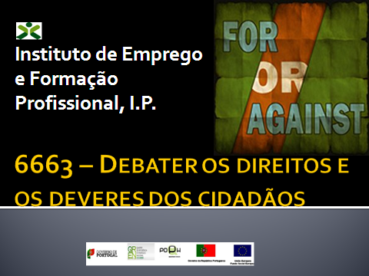

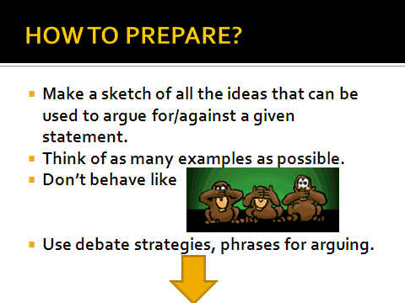

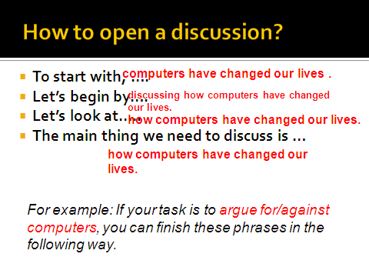

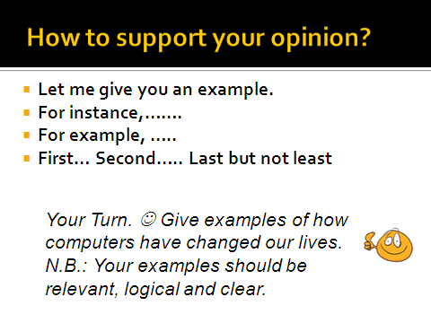

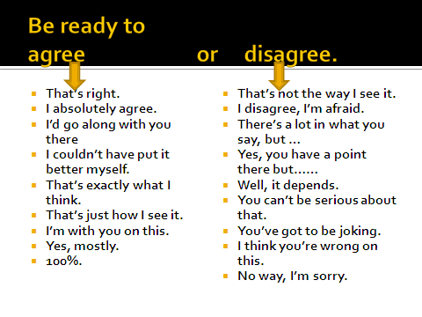

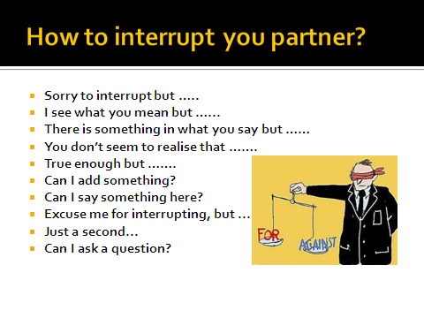

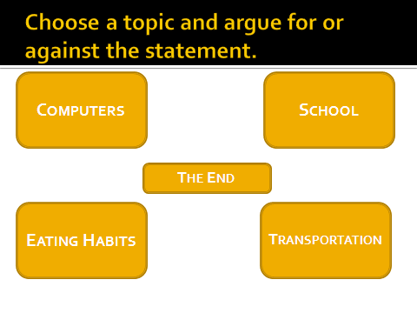

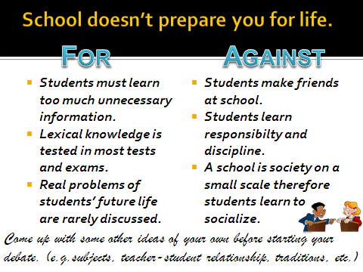

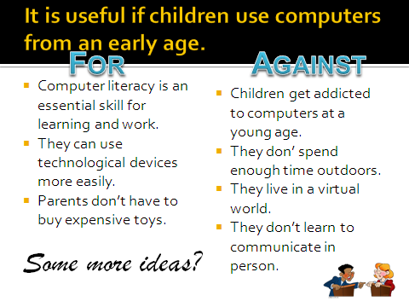

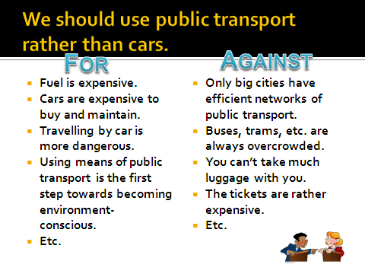

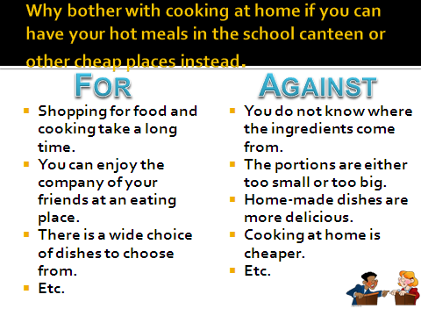

reading 6

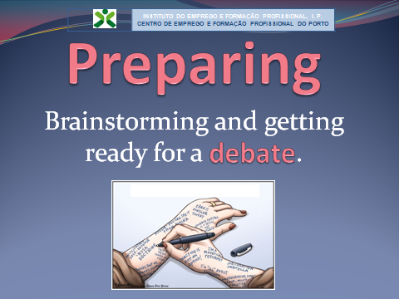

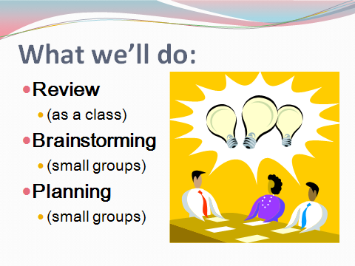

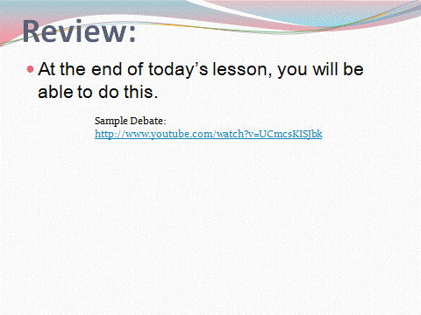

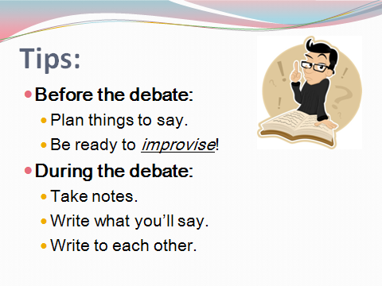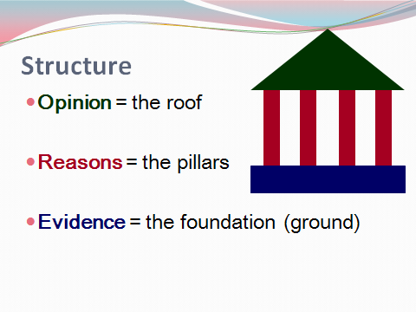

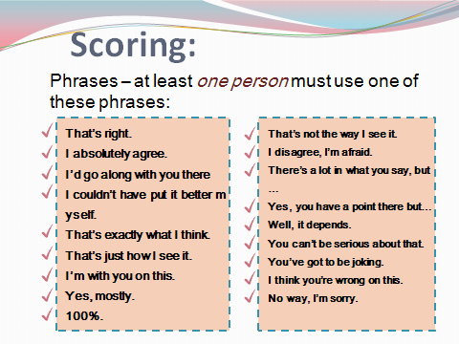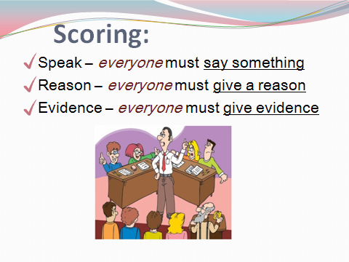

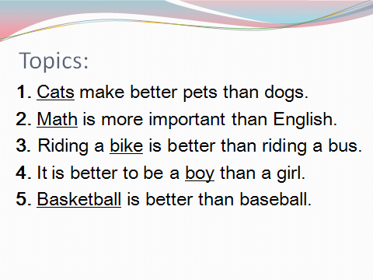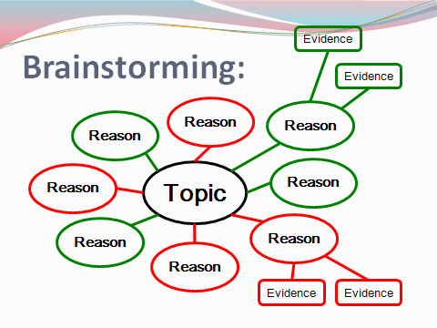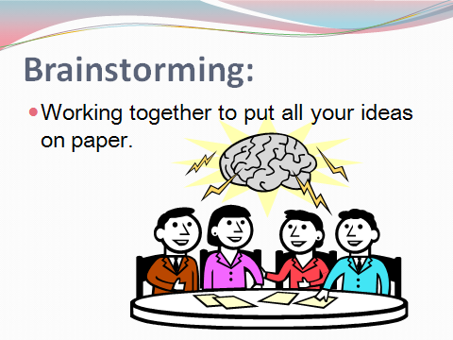

|  |  |
| --- | --- |
| Advantages of Computers | Disadvantages of Computers |
| They allow us to do boring, repetitive tasks quickly and easily. | If we spend too much time using a computer, other areas of our life may be neglected, for example, relationships and study. |
| Computers are more accurate than human beings. For example, calculations done within a spreadsheet will always be correct provided, of course, that the data has been input correctly. | Computers can make us lazy. Older people often argue that young people can’t spell because they rely too much on spell checkers, they can’t count because they use calculators and they can’t think for themselves because they cut and paste from the Internet rather than coming up with original ideas. |
| If used sensibly, computers can save us a great deal of time. | Often, people using the Internet don’t respect the right to privacy of other individuals. They post information and photos of them without their knowledge or consent. |
| They can be fun to use. Playing computer games, using social networking sites like Bebo, downloading music and flirting in chat rooms are all fun ways to pass time. | Those who spend too much time online risk losing touch with the real world. |
| Computers have made communication a lot easier. In the past, the only way we could communicate with people on the other side of the world was via snail mail or phone. Nowadays, we can email, instant message, use a chat room, video conference, use Skype etc. Geography is no longer the barrier to communication that it used to be. | Sometimes, people get so excited about new technology that they overlook older methods of doing things which can often be just as useful. In my opinion, adopting a new program or gadget for the sake of it is unwise; I don’t see the point of using new technology unless it is an improvement on what existed before. |

THEME 1

|  |  |
| --- | --- |
| Advantages of Computers | Disadvantages of Computers |
| Technology has lured a lot of people back into education. Many who would never have considered returning to the classroom have done so because they want to be able to use the latest technology. | Some societal problems are exacerbated by technology because it makes them easier to carry out e.g. credit card fraud, child pornography, gambling and bullying. |
| Computers have made it so much easier to access information. The Internet is a virtual treasure trove of data. Any kind of information on any topic under the sun is just a few keystrokes away. | Computers have contributed to the problem of obesity. In the past, most people had to do a lot of hard physical work. Nowadays, a lot of tasks have been automated and many people spend all day looking at a computer screen. This means that they probably do not burn off enough energy to keep their weight at a healthy level. |
| Computers are great data management tools. Vast amounts of information can be stored on one small computer and this data can be organized, searched and retrieved easily. This also cuts down on the need for paper. | People who can’t afford computers or those who don’t know how to access technology are even more marginalised than before. Computers have led to a widening of the information divide. |
| Many services are conveniently provided online e.g. shopping, banking, job seeking, booking flight tickets and route planning. | Technological advances have made it almost impossible to “switch off” from work. Employees bring home their laptops. They check and reply to emails outside of work hours. Often, employers expect their workers to be contactable at all times. |
|  | In most cases, we still have to put up with unsightly cables in order to use computers. Unfortunately, wireless technology is still in its infancy. |

THEME 2

* You have the ability to find friends and reconnect with them.
* You can keep in touch with your friends, no matter how far apart you’ll be physically.
* You can keep your friends and family members updated about what is happening in your life.
* You can promote yourself and any other work that you do.
* You can make many new friends like minded friends by joining various groups and communities.
* You can share your favorite music and videos with your friends.
* You can play many different games and use many different applications.
* You can communicate with your friends at any time you want.
* You will get bombarded with unwanted requests from many unknown people.
* Your friends and family members will be able to snoop around and know what is happening in your life at all times.
* Your pictures could be misused.
* You might mistakenly befriend an individual with dishonorable intentions.
* You will get unwanted newsfeeds about every single activity that your friends perform on Facebook.
* Your friends will get newsfeeds about every single activity that you perform as well.
* You will get bombarded by spam and annoying advertisements from time to time.
* You will witness unnecessary dramatization of unimportant situations in your friends’ lives.
* Anyone on Facebook will able to see your information and pictures, if you do not update your privacy settings regularly.
* Your friends may tag you in a picture that you don’t want others to see.
* Applications will ask you for many details that you wouldn’t normally give out.
* You will waste many hours because Facebook is addictive for most people.

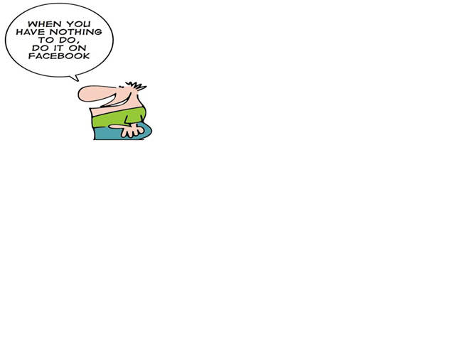

THEME 3

# Should smoking be banned in commercial public places? Yes…..

1. [Smoking increases the risk of pollution, global warming, and diseases in people.](http://www.debate.org/opinions/should-smoking-be-banned-in-public-places/arguments/5BFD76BB-E973-4537-8270-187435019C0D)

People who smoke are more likely to develop diseases such as lung cancer and liver cirrhosis. Cirrhosis is mostly caused by smoking and reduces and even poisons the liver, unable for the organ to perform its function. For example, a healthy lung is pinkish in colour and helps the person breathe in oxygen and exhale carbon dioxide. But a smoker's lung is very dark and is covered with tartar. A smoker's lung is unable to functionally help the person breathe and increases severe asthma, with causes stroke and heart attack.

1. [Smoking is bad for the ones around you](http://www.debate.org/opinions/should-smoking-be-banned-in-public-places/arguments/80AA4EE4-1EBA-4360-9DEC-74F0C52DFDC3).

I think that smoking should be banned because I am a kid, and when I walk by a smoker I always have to cover my mouth which is quiet irritating sometimes. Another reason is that it pollutes the air. Last but not least, people who have asthma can be harmed or even killed if they want to take a walk in the park!

1. Yes it should.

My aunt smoked for years and now it is making it hard for me to breathe. Smoking should be demolished period! It is a useless hobby that people use because they have no life and are too lazy to get one. No offense to those that do smoke but I just think it should be that way. I got lung cancer because of my aunt's stupid hobby! All of you smokers should get a job, get a life, or get some friends. It would be better for the rest of us that don't smoke. Smoking threatens the air that we non-smokers breathe, making us get sick. Yes, smoking should be banned in public places ASAP.

1. Smoking should be banned, it is unhealthy.

First off, it's really unhealthy. It's bad for a person, and bad for the environment. It’s bad for the environment because the smoke goes in the air and causes pollution. It's a major cause for second hand smoke, lung cancer, and death. The poor decisions of some people should not affect the lives of others.

1. Some people are allergic to smoke!

When I lived in Los Angeles, I suffered greatly from second hand cigarette smoke! I later found out that I had a smoke sensitivity and just walking by a smoker made me feel ill. My throat and nasal passage ways were closing up and I had to take many trips to the doctor to get a shot to calm them down. IS CLEAN AIR JUST TOO MUCH TO ASK? You can smell cigarette smoke from MANY feet away and people suffer from it. Why should an innocent person suffer? I didn't make the choice to smoke and yet, I am suffering. Also, I have to think about ways I can avoid smokers. For instance, when I pass a smoker when I am walking on the side walk, I have to run and hold my breath or walk the opposite way and eventually turn around when they disappear. It is ridiculous.

1. Yes, it's bad for everyone.

If smoking was banned, then heart-related sicknesses could possibly lower just like it did in the places where it was banned. I don't like having to walk around smoking areas in public because it's a waste of my time and, if I don't, I'm risking my health. Second-hand smoke is just as bad as directly smoking something.

1. It Harms Everybody and Children.

People shouldn't have the right to smoke wherever they want. What sort of example are they giving to young children and infants? Passive smoking kills so many people it's not fair on others.  
Why would you want to smoke around other people? You’re harming them as well. It smells bad and is bad for the pollution, also it litters our environment making it look disgusting. People should not smoke in public, but in their homes where they are only harming themselves.

1. Smoking should be banned to reduce pollution and disease.

First of all it will significantly reduce the risk of heart attacks and other diseases, particularly among individuals such as children and non-smokers. Secondly, it will help public places be less toxic and we won't have to deal with pollution. Finally, it could also help some people quit smoking. If people were allowed to smoke in public places they may not be as motivated to stop smoking as they are with not being allowed to smoke in public areas.

1. Yes, smoking should be banned.

Yes, it should be banned because people who smoke say that they have paid enough so why should they be forbidden to smoke, but it is not the non-smoker fault that they had spent so much money on cigarettes, it was their own choice. Also, there are many diseases, such as cancer and cirrhosis that can be easily developed in a living body not just in a smoker one but in the liver that is needed by the one that is smoking. Many people today suffer from asthma and they cannot have just a little stroke but die.  Smoking also causes pollution and people who smoke leave their cigarettes everywhere they can (on the ground, in the grass, on the plants). But the biggest concern is that millions of forests have burned in the past decade just because smokers leave them lit up. It is dangerous and I think it is more important to save something then to be sorry later for it, and that it is very selfish from the others who smoke to say that they should be allowed to enjoy the smell of the cigarettes, while others suffer.

1. No they shouldn't!!!

People shouldn't smoke in public places because kids have lung problems and the smoke doesn't help the problem!!!! And for the people who say no is wrong!!!!! i personally have lung problems and when I’m driving by no i don't want the smell of the smoke in my face and no it doesn't help my lung problems and when i am trying to enjoy my food i would not like to smell the smoke while I’m eating. i don't like to smell smoke while I’m going through the park trying to enjoy my day and i smell smoke! For the people who smoke go right ahead one day you might get lung cancer and think back...why? Why did i smoke? Was that a bad choice in my life? No it wasn't and i regret that! If you can get through that cancer you need to thank the lord for your life!!! Ask him for your forgiveness!!! Thank the lord for your life!!! Go to church get to know god more and thank him for everything he has done for you!!!!!

1. Follow Me On Twitter @iLLabAnks

People who smoke clearly have no concern for other people and need to be slapped. Why not smoke at home or in private areas by smoking in public, you are putting others’ lives in jeopardy as well as ruining your own life. All i have to say is keep the smoking behind doors.

1. Yes, it has great results.

I live in NYC. I love that I can go outside to a park or a street and not worry about that scary smoke. No one is proud to be a smoker, and this helps them get into the habit of not smoking, without humiliating or offending them. Let's face it, second-hand smoke is dangerous. While its impact is a bit over-stated, it works and even a good number of smokers say it helps them and the public.

1. In the pursuit of discouraging smoking

It is the choice of people to do as they please with their own health. They should have the right to smoke as they want, eat as they want, and live as they want. However, there are some things that can be avoided, some pains, some deaths, some unnecessary outcomes can be erased if the government added some new rules. The cons of this is that some people might feel a bit oppressed, having been smokers all their lives and not having the privilege of enjoying the psychoactive chemical in cigarettes. But no one said it would be easy, maybe this is why a lot of people might be opposed to such regulations. On the other side of the debate is the realistic difficulty, yes the same difficulty that present smokers are facing with such bans. The difficulty that future smokers might also face if they so much as thought about smoking. Its like having an addiction to sugar and developing diabetes. It is better to not get to the point of the addiction in the first and have to argue about the rights of obese people to an overdose of sugars. Am not saying that we should regulate sugar intake with laws either, but the truth of the matter is that we are sadly easily brought to a paradoxical per sue of happiness in a perpetual cycle of long term health pains, and short term pleasures, it just is very pleasing to us, but more pain is brought throughout the process than pleasure.

1. Unhealthy and stupid

I believe public smoking should be banned in public places for multiple reasons. One of which, smoking causes cancer, triggers asthma attacks, shortens your life span by many years, depending on how much and how often you smoke. Second, unlike other debates in society, say gay marriage, it is affective to those around people who smoke. When my family and I go to the races in Hot Springs, or a concert, the smoke pollutes our clear air, makes my and my sister's head hurt, I start coughing, and it messes with my asthma. Third, when you go to a public place such as Wall Mart, or a park and you take your kids to play, that is really bad for their lings, can cause them to have cancer, get asthma, will make their head hurt, not to mention second hand smoke is worse for someone that smoking a cancer stick themselves, it ruins everyone's day.

1. Yes, it should.

Yes, because around the smoker the other people can get second hand smoke and it's bad for the environment. The people have their own rights, but you get second hand smoke just because of one smoker, then their rights will be nothing and it could be dangerous or cause death.

1. Smoking should be banned

Smoking should be banned because when people throw cigarettes on the ground still lit, it might cause a fire. Some people don't smoke, and they get smoke clogged in their lungs. You should not smoke because cigarettes have bad chemicals and they're really bad for you. You might not be able to taste the chemicals because they put flavouring in them.

1. Smoking and freedom of rights

All of the points I have read online have exclaimed about, “what about the smokers freedom". Well you know what I say to this, WHAT ABOUT THE NON-SMOKERS FREEDOM, they chose to NOT SMOKE so why is it that that the smokers get what they want in terms of right of passage. There are many reasons to not smoke and the only point to smoke is for independents and, well, trying to kill yourself. The main point that I do not understand is that smokers know that what they are doing is harmful to themselves and those around them, so why do they keep doing it. The second hand smoke is annoying to those trying to have a night out and not only does it annoy people, the actual smell of the smoke is revolting. Smoking in public areas MUST be banned it’s a health risk and apparently the risk of someone's life isn't enough, so it also smells bad, is annoying and provokes other peoples freedom and rights!!!!!

1. I don't why it should be legal in public place.

Yes it should. If you want to smoke, smoke. But don't do it around me! Say if you are in a restaurant, should non-smokers be expected to leave the building whilst smokers smoke inside the building? It is far more practical that smokers leave, after all, it is THEIR choice to smoke. It's not like it is totally banned. My mother smokes and she is all for the ban.

1. Stop smoking in public places!

Actually, people don’t understand the importance of their lives and the others. Only for fun, they do dirty activity. They harm themselves and the surroundings. They make air polluted and the people feel uncomfortable... They leave their cigarettes everywhere they can, like on ground, parks, plant, etc. In this way, they polluted our environment..........

1. ...And also in pseudo-public places. An addict's right to use (tobacco or any other drug) falls far beneath others' right to health and life.

I have microvascular disease and reactive airway disease. A short exposure to smoker's aerosolized drug smoke makes me start to wheeze and brings on an ache in my chest. A second exposure increases the fight to breath, sharpens the ache, and adds other symptoms. Microvascular disease is now often called the women's heart disease; it carries the danger of both myocardial infarction (a heart attack) and sudden cardiac death (the entire heart simply stops working). The risk of either of those occurring increases very sharply with a few minutes of exposure to second hand smoke. These are facts...As factual as the lack of anyone's right to yell "Fire!" in a crowded theatre. No addict has to the right to use their recreational drug, legal or not, in a way that forces me or anyone else with such health conditions to participate and take on the risk of sudden death. The same goes for their "right" to use their drug in any way that forces any non-consenting adult or any minor at all to use it too.

# Should smoking be banned in commercial public places? No…

1. [People can smoke if they want to!](http://www.debate.org/opinions/should-smoking-be-banned-in-public-places/arguments/5764F0E6-FE56-4FC8-A52E-8232EFD08DF1)

Smoking is something that everyone doesn't like, but they aren't doing any harm to anyone else by doing it. Smoking only affects you, not the people around you. I think that if people want to smoke they can. Honestly if it was that big of a deal they would have made it illegal years ago. It's just something for everyone to argue about.

1. [You can walk away.](http://www.debate.org/opinions/should-smoking-be-banned-in-public-places/arguments/998494F4-9998-4385-B096-15DE06713AEA)

Look you'll most likely be harmed by the stuff that's already in the air than you will be by tobacco smoke. If you don't like being around smokers, don't be around smokers, simple as that. Sometimes, public places are the only places these people can smoke, so back off. If a guy is smoking next to you, leave, or ask him to move, but don't get all preachy about how bad it is. Besides, people like you won't stop at cigarettes, you'll move to alcohol, then high fructose corn syrup, fumes from cars, etc. etc. Just let us smoke our cigarettes, if you don't like it, walk away.

1. [Tobacco smoke is no worse than exhaust fumes.](http://www.debate.org/opinions/should-smoking-be-banned-in-public-places/arguments/52D42572-A775-4226-BD99-FE57F3CD3432)

People have no problem standing by endless amounts of idling and moving vehicles, so they shouldn't mind someone smoking nearby. Exhaust and smog is just as bad, if not worse, than tobacco. If one tries to argue logically that smoking in public should be banned, the logical extension is that vehicles should be, too.

1. [Say no to ban happy Nazis](http://www.debate.org/opinions/should-smoking-be-banned-in-public-places/arguments/49FE132F-35F5-47B2-A941-385B4C1FBC76)

What kind of person would stop around telling others what to do in their presence? This whole socialistic society is out of control. If you can't handle personal freedoms maybe America is not the place for you. Stop ruining everything we fought so hard to obtain - its shows a complete disrespect for all those who have given their lives for personal freedoms.

1. [Think about it...](http://www.debate.org/opinions/should-smoking-be-banned-in-public-places/arguments/5AABD6A9-64C0-4E62-A9E0-64EF3479C2A9)

I'm not a smoker and don't plan to be. But after reading through these comments, I agree with one thing. It shouldn't be banned. Maybe regulated or banned in certain places, but not completely banned. Think back to the Prohibition. Do you want to live through another one of those? I know for sure that I do not. So if you are going to do anything, regulate it, but we don't need one more right of freedom taken away.

1. [No, smoking should not be banned!](http://www.debate.org/opinions/should-smoking-be-banned-in-public-places/arguments/1BCBCD08-7B2F-4933-FED4-073D5ABF9D00)

Smoking is a personal choice. Have anybody heard of the First Amendment. If they want to kill their selves with cigarettes, let them and If you don’t want to risk your health. Leave it as simple as that!!

1. [Why make it a law that smoking should be banned?](http://www.debate.org/opinions/should-smoking-be-banned-in-public-places/arguments/A020F316-8589-4F4B-8B43-CB71EBD1C34B)

People get others to do what they want all the time just by giving them stares and making them feel uncomfortable. Plus it doesn't matter: people know the risks of smoking. If people want to get all hurt over a little smoke, ask the smoker to stop. Don't go make a law because you're uncomfortable. Once you take away smoking, people start taking other things away that are "harmful" to the public.

1. [Smoking doesn't kill everyone.](http://www.debate.org/opinions/should-smoking-be-banned-in-public-places/arguments/7F7316E2-0424-4AE7-AE0C-0A6BC0364B9D)

Smoking is something that people may not like, but it is unavoidable. The risk of getting cancer or something else from smoking, is about as high as crashing your car. Yes you can die from smoking. You can also die from alcohol poisoning, or food poisoning, or overdosing, or even by crashing your car! But that doesn't mean that people stop drinking, or eating, or doing drugs, or driving!

1. [Not In What People Mean When They Say "Public Places"](http://www.debate.org/opinions/should-smoking-be-banned-in-public-places/arguments/D71530DB-DD35-421F-9546-4AE055FD224D)

These aren't even real public places. A PRIVATE restaurant is PRIVATE. A PRIVATE bar is PRIVATE. It is NOT public. If you don't like that they allow smoking there don't go or leave. Private businesses are not supposed to be required to cater to the whim or concern of every single person. To ensure adequate smoke-free recreation licensing for smoke-allowing establishments should be required but it shouldn't be banned outright.

1. [You cannot force someone else to stop smoking for your preference or health problems: YOUR problems are YOUR problems, not others!!!](http://www.debate.org/opinions/should-smoking-be-banned-in-public-places/arguments/D19AAAF5-76B6-4590-AF0E-60C35D46313B)

If someone chooses to smoke or allow smoking that is their decision. If you choose to not smoke, that is your decision. You have the choice to not be around smoke. You cannot force someone else to stop what they wish to do because of your own preference or need. I do not smoke, I just leave the room when someone does smoke. I cannot force them to quit for me. My problems are not theirs!!!

1. [I don't believe that smoking should be banned in public spaces.](http://www.debate.org/opinions/should-smoking-be-banned-in-public-places/arguments/313259F1-1077-5F6F-8514-DAEEF5F92A14)

I do not support laws being written that ban smoking in public places because for a place to be considered public means that everyone has the full right to utilize this place. If only smokers face restrictions, then the establishment does not meet the public criteria. People should have the right to smoke if they want to. Car exhaust fumes impact people’s lives just the same but there are no laws against driving.

1. no

There should be 50/50 to everyone I do believe not to smoke in a house with kids but you should be able to do it where you want along as your not hurting nothing so get your facts right and do whatever you like along as its ban from public places that's what the rules should be every smoker like myself should smoke out side

1. They have a right to be there.

Smokers have a right to be there, just like any non-smoker. We do not have to go there, we choose to. We choose to go there, so we could leave or go to another area. Everyone has a right to choose where they want to be, whether they are a smoker or not. By a non-smoker not choosing to go somewhere else, they are choosing to be around the smoke. No one forces the non-smoker to inhale any of the smoke. They choose to do so by staying around it.

1. Don't ban smoking.

Because it helps you be independent and it also helps relieve stress from the body. And you know people have rights so you should let them smoke. The reason people or the government should let us is we also have rights and we pay taxes every month until we die.

1. Whatever happened to personal liberty?

If someone smokes outside in a designated area, then BACK OFF if you don't like it. Use the 95% of the remaining area to walk around or sit or be self- righteous. Laws are already in place prohibiting smoking inside public buildings of any kind and many places have laws that limit where someone can smoke outside to certain small areas. Like it or not, YOU do not get to decide whether someone smokes or not. You get to decide whether you smoke. I find women who wear perfume to be offensive. I have an allergy to a component in synthetic perfume and every time I walk past a woman with perfume, my allergy acts up. I want a law against them polluting my environment. How about a law restricting the purchase and use of automobiles? THEY pollute the environment far more than any cigarette ever did.

1. It's a free country

It's a personal choice that will not harm others. Taking a small whiff of second hand smoke will not give you cancer.

1. Smoking ban is unconstitutional

People should have a choice in whether they chose to smoke or not. It is a horrible habit and i don’t partake in it, but some people like it, and its unfair that we would outlaw something that should be our choice to make it. Big papa upstairs should not be able to tell us what we can an cannot do! Enough said!

1. Say no to banning

If people ban smoking in public places then there is nowhere anyone can smoke. People have already banned smoking in some places, which restricts them enough already, so why public places too. If you have a problem with it then stay away from them, they have a right to smoke somewhere so why not in public places. Who are we to say what they can and cannot do? People say we should ban it but where would we draw the line? Do we then start banning people from riding bikes in case they bump into someone or fall of? Do we stop people from drinking sticky substances in fear that they will ruin the floor or precise items?

1. The government should not ban smoking in public places, because people should have the right to smoke anywhere they choose. Public establishments should protect the needs of the public and not restrict certain individuals for their lifestyle choices.

Owners of establishments should have the right to ban smoking in their establishments, the government should not. It is not the job of our government to protect people from every bad influence. If people choose to smoke or to frequent places where people are smoking, then they understand the risk they are taking. We are a capitalist society, so let consumers influence this, not the government. If people do not want to go to, say, a restaurant because people smoke there, then that can influence the owner to not allow smoking there. Leave it up to the individual business owners and their clientele.

reading 7

Debate Scoring Sheet

Debate Topic:

Date:

Moderator:

Team Member Names:

Proposition

1-

2-

3-

Opposition

1-

2-

3-

|  |  |  |
| --- | --- | --- |
| Criteria | **Rate: 1-20** | |
| **PRO Team** | **CON Team** |
| 1. Did the team appear well prepared for the debate? |  |  |
| 1. Did the team appear to work well as a team? |  |  |
| 1. Did the team maintain respectful tone? |  |  |
| 1. Did the team exhibit confidence, energy, and passion? |  |  |
| 1. Were the arguments presented in a logical and coherent way? |  |  |
| 1. Did the team ask questions that were challenging for the other team? |  |  |
| 1. Did the team appear to know well both sides of the debate? |  |  |
| 1. Did the team provide informed answers to the questions? |  |  |
| 1. Were the sentences well formulated and eloquent? |  |  |
| 1. Did the team speak in English? |  |  |
| TOTAL |  |  |

Winners

VIDEOS

1. <http://www.youtube.com/watch?v=G6bFR4_Ppk8&feature=player_embedded>

Short film (2004) on the mistreatment of women in the Islam. The director, Theo van Gogh, was murdered in Novermber 2004 by Mohammed Bouyeri

1. <http://www.youtube.com/watch?v=pBJjBOwk9oI&feature=player_embedded>

A little parable on the pitfalls of free expression....for hamsters

1. <http://www.youtube.com/watch?v=eNtDrUhcKyQ&feature=player_embedded>

Muslim Sensitivity Training in South Park

1. <http://www.youtube.com/watch?v=PxW-XLOm4QU&feature=player_embedded>

Racism in America: Episode One

1. <http://www.youtube.com/watch?v=C75jnx7KKQY&feature=player_embedded>

Racism in America: Episode Four

1. <http://www.youtube.com/watch?v=VzYsRp8ALz4&feature=player_embedded>

The blind date