Extraordinary Resort situated in Litoral Alentejano (Costa Vicentina) in Vila Nova de Mil Fontes
https://www.google.pt/maps/place/37%C2%B043'26.9%22N+8%C2%B044'38.3%22W/@37.7288772,-8.7393828,171m/data=!3m1!1e3!4m5!3m4!1s0x0:0x0!8m2!3d37.7241306!4d-8.7439611

GPS: 37°43'43.9"N 8°44'19.3"W

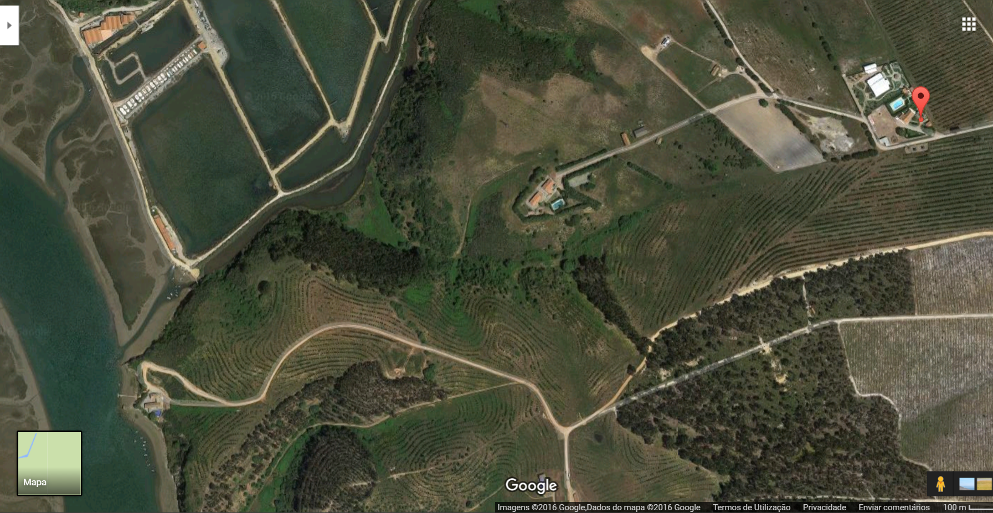

Description of the property.

Property with 4 hectare situated at 600 metres from Mira's River, at 3 Km from Vila Nova de Milfontes / Odemira / Litoral Alentejano / Costa Vicentina.
1 apartment with 2 bedroom, living room, kitchen and toilet.
2 apartment with 3 bedrooms, living room, kitchen and toilet.
5 apartments in construction phase.
Main House with 4 bedrooms, living room, kitchen with tipical alentejo fireplace and toilet
A tent for events with more than 650 m2, equipped with air conditioning, kitchen, washes dishes, industrial refrigerated, 1 office, 5 bathrooms, 1 indoor and 1 outdoor bar.
Swimming pool with 16x7 meters (prepared for heating) with a bar and toilet suport
More than 2000 m2, garden with automatic irrigation.
3 water holes, one with 35 meters, another with 75 meters and finally other with 95 meters
A water well with 10 meters
Water treatment station
A storage of clean water with 40.000 liters
lighting in all garden area

