**Grammar Practice – Past Simple**

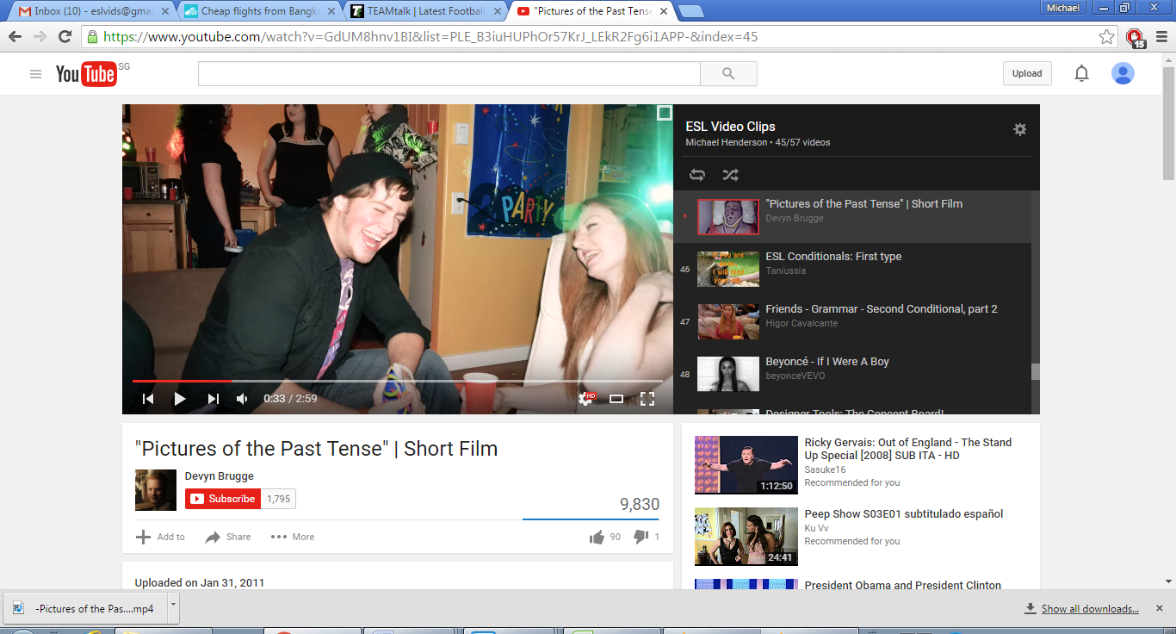

**Photo Story Video**

**Instructions**

1. Watch the short film <https://youtu.be/N_w_p7lto84>. Try and remember all of the events that occur.
2. After watching the short film, put the events below into the correct order, from 1st to 14th.
3. They went for a walk in the park and fed the ducks.
4. Aaron picked Melissa up and they went for ice cream together.
5. Aaron drove them home, but he was feeling tired.
6. He crashed the car.
7. They were taken to hospital in an ambulance.
8. They studied together at the library.
9. He met a girl called Melissa.
10. Aaron went to a party with some friends.
11. They had fun talking to each other at the party.
12. Aaron gave Melissa a necklace as a gift.
13. They went bowling with a group of friends.
14. Both of them were seriously injured.
15. They became friends on Facebook.
16. Melissa gave him back his necklace and didn’t see him anymore.

1st ________________________________________________________________________________

2nd _______________________________________________________________________________

3rd _______________________________________________________________________________

4th _______________________________________________________________________________

5th _______________________________________________________________________________

6th________________________________________________________________________________

7th _______________________________________________________________________________

8th _______________________________________________________________________________

9th _______________________________________________________________________________

10th ______________________________________________________________________________

11th ______________________________________________________________________________

12th ______________________________________________________________________________

13th ______________________________________________________________________________

14th ______________________________________________________________________________

3. Make sentences **a, e and h** **negative**.

______________________________________________________________________________________________________________________________________________________________________________________________________________________________________________________