Língua Portuguesa

Escreve os nomes dos frutos de Outono. Escreve frases.

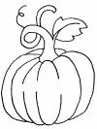 | __________________________________________________________________________________________________
 | __________________________________________________________________________________________________
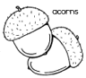 | __________________________________________________________________________________________________
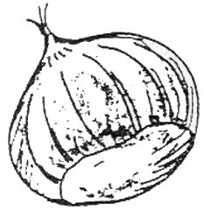 | __________________________________________________________________________________________________
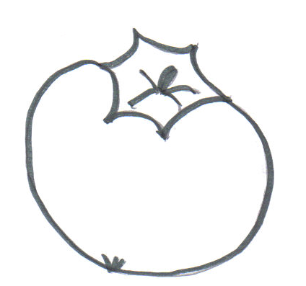 | __________________________________________________________________________________________________
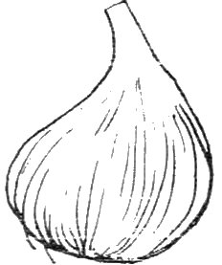 | __________________________________________________________________________________________________
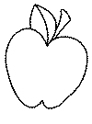 | __________________________________________________________________________________________________
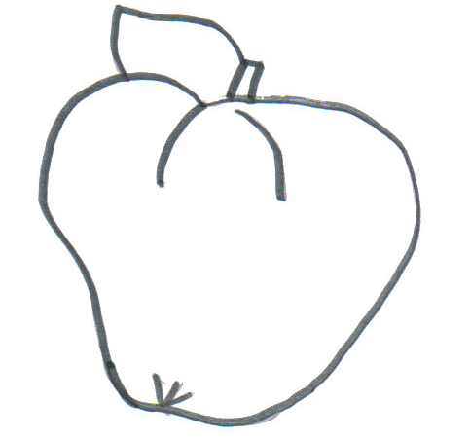 | __________________________________________________________________________________________________
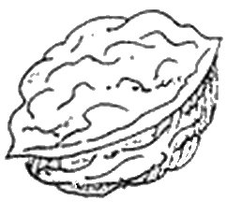 | __________________________________________________________________________________________________
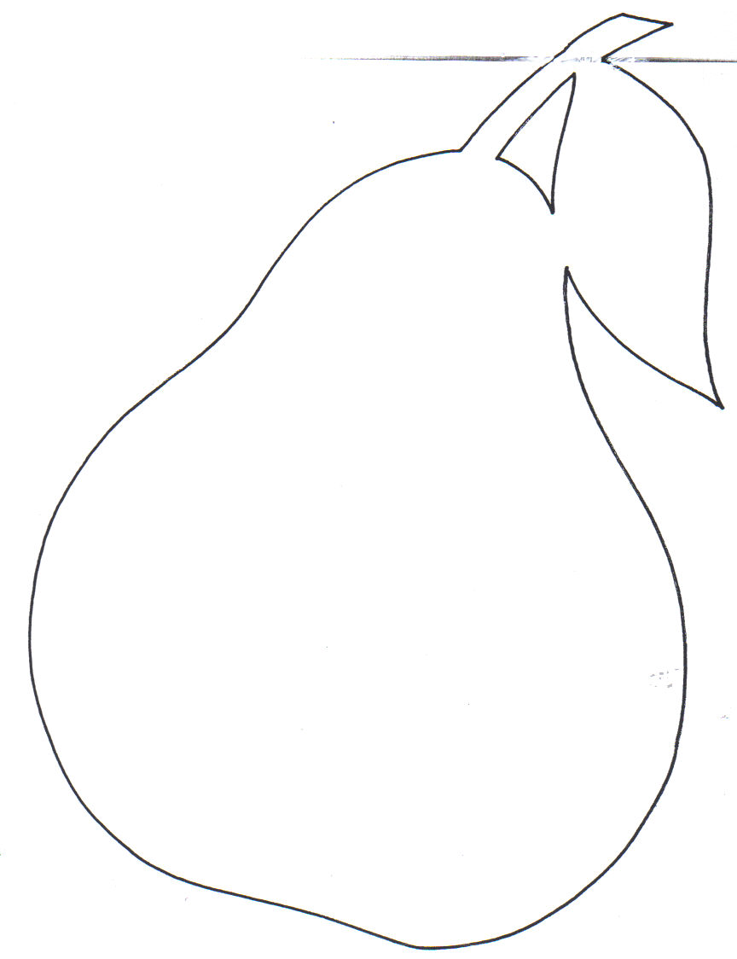 | __________________________________________________________________________________________________
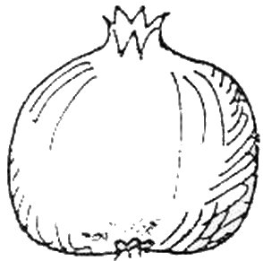 | __________________________________________________________________________________________________
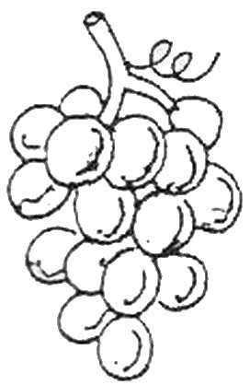 | __________________________________________________________________________________________________
 | __________________________________________________________________________________________________

Nome: _________________________________________________________

Data: __________________________________________________________

