BIOS update on the BLEEP TS9xx range

This document covers the BIOS update for the following models:

TS910 – Single core (N450)

TS910 – Dual core (D510)

TS915 – Single core (N450)

TS915 – Dual core (D510)

**Creating bootable USB pen drive**

1. Copy the **BootPendrive** folder to the hard disk (**For example: C:\BootPendrive**).
2. Run the HP formatting utility as shown on the image below.

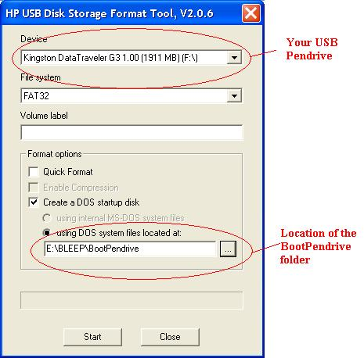

After pressing the Start the USB should be formatted and system boot files transferred to the pen drive.

**Copy BIOS Files to the USB**

On your PC, copy the content of the **BiosFiles** folder to the USB root directory (F:\ or similar). The content of your USB pen drive should look like the image below.

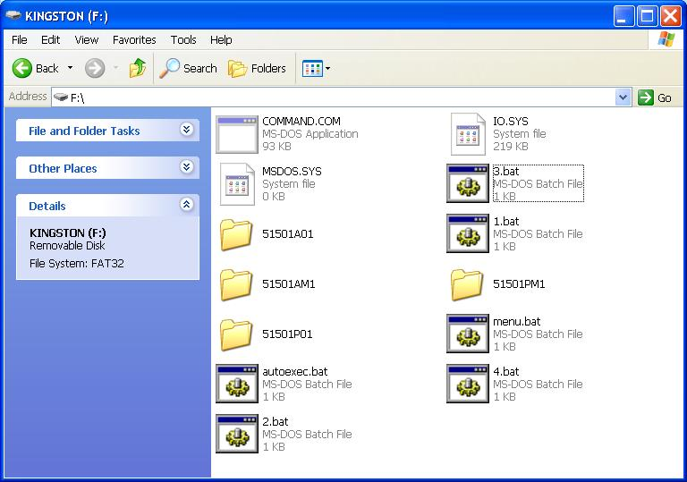

If you have a hard disk or CF card connected set the BIOS to boot from the USB pen drive.

To update the BIOS, boot the system from the USB pen drive and follow the instructions.