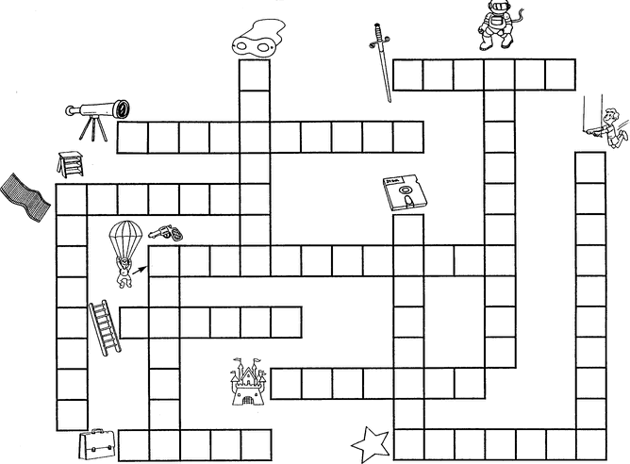
Descobre palavras com as, es, is, os us, separa-as em sílabas e escreve algumas frases.
_____________________________________________________________________________________________________________________________________________________________________________________________________________________________________________________________________________________________________________________________________________________________________________________________________________________

________________________________________________________________________________________________________________________________________________________________________________________________________________________________________________________________________________________________________________________________________________________________________________________________________________________________________________________________________________

