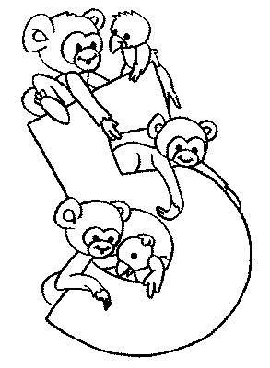
Tabuada
Nome: ______________________________ Data: _____/_____/______
5=____ = ____X____ = ____  5+5=____ = ____X____ = ____  5+5+5=____ = ____X____ = ____  5+5+5+5=____ = ____X____ = ____  5+5+5+5+5=____ = ____X____ = ____  5+5+5+5+5+5=____ = ____X____ = ____  5+5+5+5+5+5+5=____ = ____X____ = ____  5+5+5+5+5+5+5+5=____ = ____X____ = ____  5+5+5+5+5+5+5+5+5=____ = ____X____ = ____  5+5+5+5+5+5+5+5+5+5=____ = ____X____ = ____ | 1X5= ___  2X5= ___  3X5= ___  4X5= ___  5X5= ___  6X5= ___  7X5= ___  8X5= ___  9X5= ___  10X5= ___
Completa:
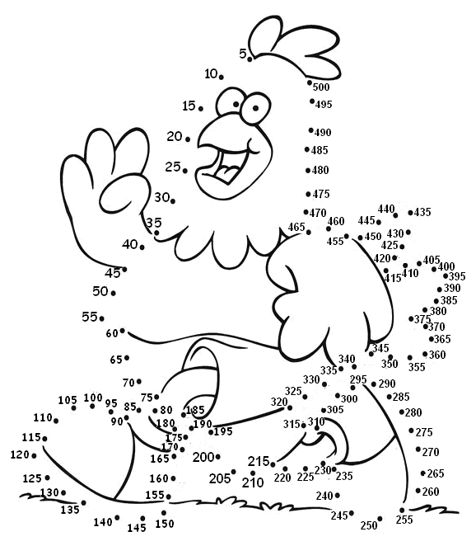
Liga os números de 5 a 500
(de 5 em 5). Pinta.

