

Service/support guide for surge lightning problems

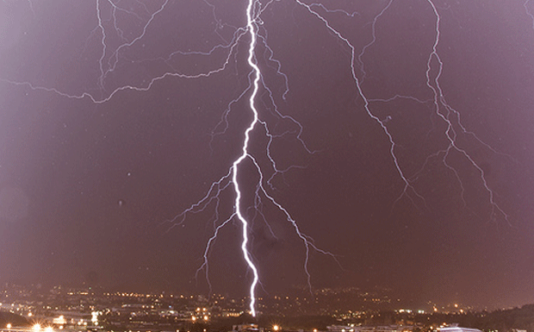

Index

1 Index 1
2 Introduction 3
3 Topology 5
3.1 PFC-stage schematic overview 5
3.1.1 PFC/Boost stage in FP1 family 6
3.1.2 PFC/Boost stage in FP2 family 8
3.2 DC/DC stage schematic overview 9
3.2.1 Full bridge topology with phase shift control. 9
3.2.2 Halfbridge LLC converter 11
4 Surge pulses on the input 13
4.1 The input section 13
4.2 The PFC/boost stage 13
4.3 How can the DC/DC stage be affected ? 14
5 Procedure for assessment of failure due to surge 15
5.1 Site / system check-list 15
5.2 Module check 15
5.2.1 FP2 – family 16
5.2.2 FP1 – family 19

Introduction

Failure rates are read and reported internally in the company and externally to customers, and must therefore be as correct as possible.

Failures within the warranty period are especially focused, and demands very often explanations and reports from R&D to our customers. A large amount of the modules that comes in for investigation proves to have been suffering EOS (Electrical Over Stress) of some kind, and in most cases this is caused by surge and lightning.

A Six sigma project has been run by R&D on failures with the FP1 and FP2 modules, and based on the information gathered on failures classified as normal “component failures” we found that probably more than 50% of these failures could have been classified as surge/lightning. That is a lot of modules and warranty claims, therefore a lot of money, and proves to us that we have a great improvement potential regarding service reporting.

This proves to us that a major part of the failures we suffer in field comes from exposure to much higher and more powerful surge/lightning energies – that rather should have been drained by an external SPD (Surge protection Device). I refer to the document “Guidelines for lightning/Surge protection” for an explanation of the surge/lightning problems, and an overview of how system and site protection should be to protect the modules in a proper way.

More and more service regions are reporting in ETS (Eltek Traceability System), and this system is now also linked to IFS. This means that several people in our organisation will be able to get the failure statistics whenever they want from ETS reporter, with focus on most failing components, types of failures or the regionally distribution of failures.

This is good for the spread of information, but demands more than ever that all data put into the system is correct.

As much as we want total transparency internally in Eltek Valere with regards to failure statistics, we find it difficult to let everyone get access to that data without being filtered through R&D and the QA department for explanation of the data, or to remove “noise” to give a more correct picture. In many cases, we are studying the failure statistics and adding a column for surge/lightning failures when we make reports to customers etc. This job has to be done manually, because the failure mode “External cause electrical” far too seldom is used by service departments.

And there is another aspect in this also; Eltek Valere has over the years taken liability for much more repairs and failure than what we should have, based on the fact that most failures caused by surge lightning are classified as a “component failure” in ETS or IFS.

R&D has received feedback that service regions want better guidance in how to be able to classify failure root cause to be from surge/lightning. This document will hopefully help us to improve the current situation.

To get a more correct picture of these type of failures, what kind of EOS we refer to and what it can do to our rectifiers, this document will start by briefly describing the main differences in topology on FP1 and FP2 based modules. Next, it will explain some changed and improvements that have been introduced on the products and finally a procedure for assessment of failures due to surge/lightning.

Hopefully this will give service and support personnel more insight in surge/lightning problems, and contribute to more correct failure reporting in the future. Even though this document highlights FP1 and FP2 families to be able to explain the differences, this is to be considered a generic guide on all switch mode rectifiers.

This illustration taken from the “Guidelines for lightning/Surge protection” document, show which regions should be most concerned with surge/lightning problems.

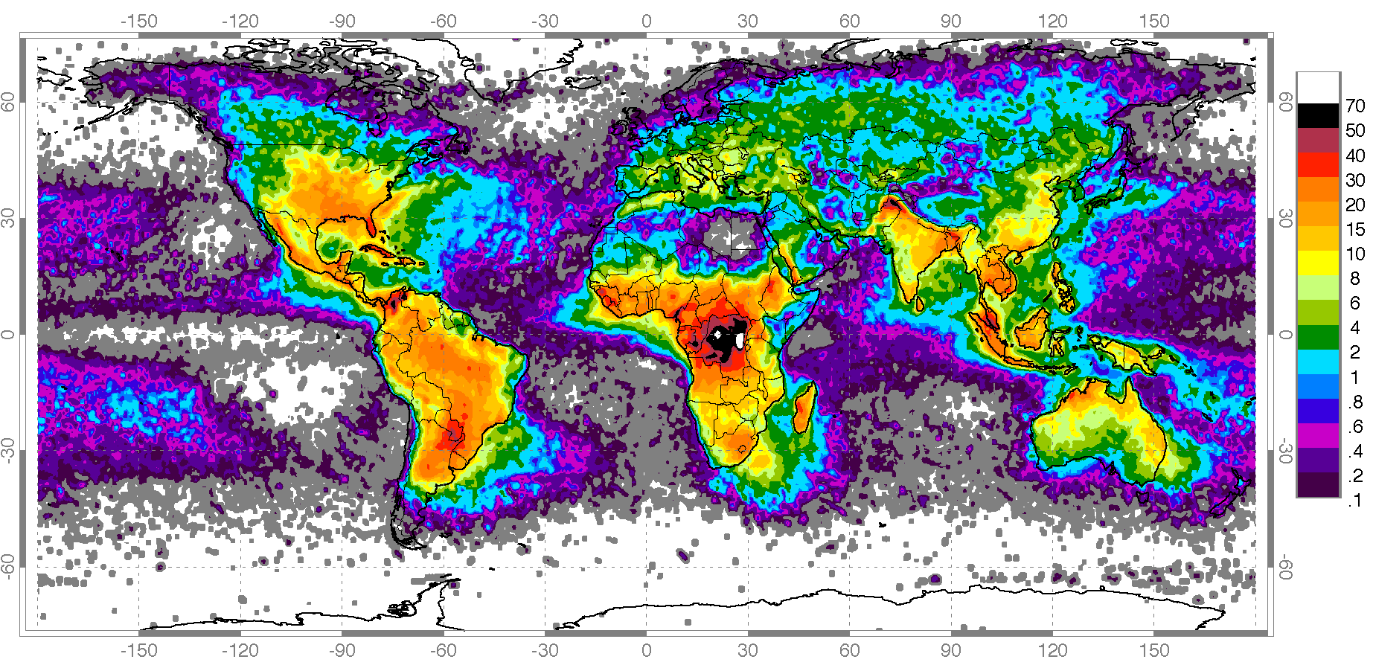
Statistical Lightning density (annual strikes / sq km)

Topology

In general, the DCDC or PFC circuits of rectifiers will have a similar failure pattern if exposed to surge/lightning/transients, and we have therefore included some generic info regarding PFC stage and DCDC stage in a rectifier. In addition, we have explained briefly the difference between the different topologies used on Flatpack1 and Flatpack 2 related products and also how the designs has been upgraded over time to have better immunity towards surge and lightning problems. This to be able to understand how a surge/lightning pulse can damage the rectifier, both PFC and DCDC stage, and how a service engineer can identify such damages during repair.

PFC-stage schematic overview

The boost converter is included for the purpose of Power Factor Correction. It does this by actively shaping the mains current to the same shape as the mains voltage. The resulting mains current has low harmonic content and hence high power factor. In addition, storage of energy is done (½ * C * V²) to be able to achieve enough hold-up time.

Figure 1-1 gives a generic overview of the input stage and PFC stage of the module, showing the basic power components. The input stage consists of an EMI filter, fuses, inrush current limitation circuitry, varistor (MOV) and a diode bridge (DB). The PFC boost stage consists of a choke (L), boost transistor (Q), diode (D), shunt resistor (R_{sense}) and capacitors (C).

EMI filter
DB
L
D
C
Q
R_{inrush}
REL_{ovp}
REL_{inrush}
fuse
fuse
MOV
Input stage
PFC boost stage
R_{sense}
Figure 1-1 Input and PFC stage schematic overview

One important detail in a PFC circuit that has been used on FP2 topology from the start is the bypass diode across the boost choke and boost diode. See updated schematics below. This diode shall bypass surge pulses directly to the 450V capacitors, to prevent saturation of L and shortage of D. On Fp1, the bypass diode was introduced on 48V and 60V from rev 8.4 (241114.100 - 48V) and rev 3.2 (241114.700 – 60V). See below under 2.1.1.

It is also important that the inrush relay is capable with the inrush currents we dimention our module for, so that the inrush relay does not weld in a closed state – and destroy the inrush current limitation function. The inrush relay is an important component to check (check functionality) if a module has been exposed to a large inrush current from surge/lightning.

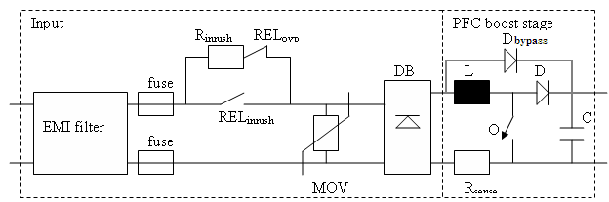
Figure 1-2 Input and PFC stage with bypass diode

PFC/Boost stage in FP1 family

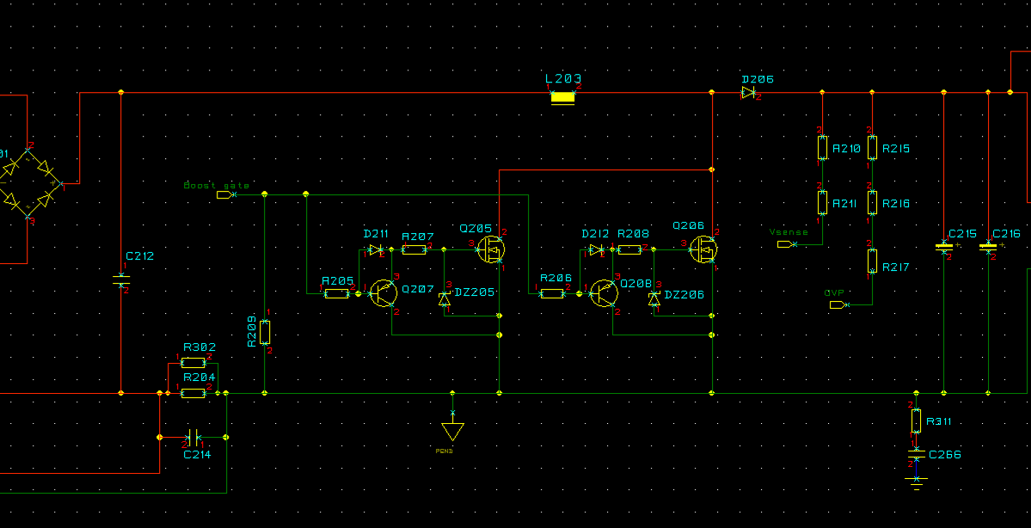
The boost of 241114.100 up to rev 8.3

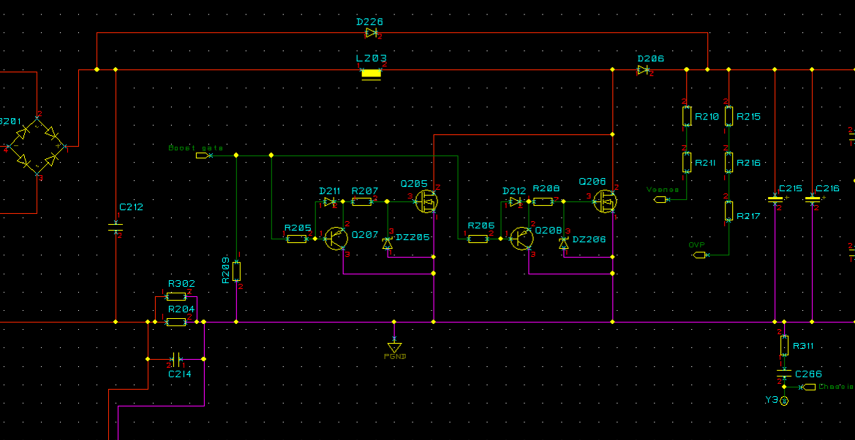
The boost of 241114.100 from rev 8.4

Topologies:
241114.xxx: 2x one transistor (in parallel), and one diode, hardswitched
Except;
241114.60x: 2x two transistors (in parallel), and one diode, hardswitched

Switcing frequency: 50-70kHz, varying over the sinewave.
Output voltage: 400-420 Vdc.

The boost is controlled by the boost PWM Controller, L4981B from ST (ROHS 48V and 60V).
Earlier non-ROHS revisions of 48V and 60V, and all revisions of 24V revision used ML4821 from Microlinear/Fairchild.

PFC/Boost stage in FP2 family

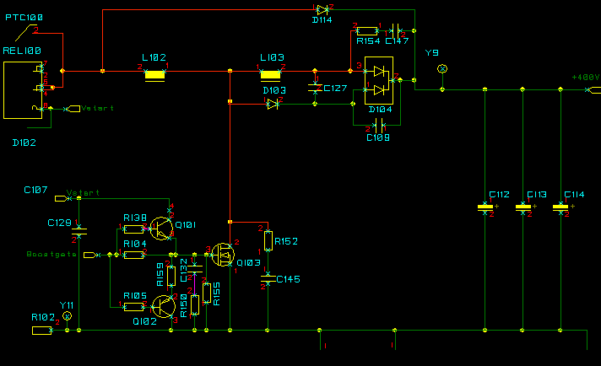

The boost of 241115.100

Topologies:
241115.001: One transistor and one diode, hardswitched
241115.100 / 241119.100: One transistor, and a di/dt turn-on snubber
241115.200: 2x One transistor (in parallel) and one diode, hardswitched.
241115.901: Two transistor, double diode interleaved topology and a di/dt turn-on snubber

Switcing frequency: 90-125kHz, varying over the sinewave.
Output voltage: 350 to 435Vdc, load dependant.

The boost is controlled by the primary controller card.

DC/DC stage schematic overview

Full bridge topology with phase shift control.

L
D
DC/DC stage
Output stage
D
Q1
Q2
Q3
Q4
C1
T
C2
Full bridge topology with phase shift control

Used in SMPS1000/700, SMPS4000, Flatpack1 product families

The DC/DC stage consists of input capacitors (C1), four transistors (Q1-4), a choke (L), transformer (T), output diodes (D) and output capacitors (C2). The DC/DC stage is fed from the PFC boost stage, thus the input voltage is 400-420V_{dc}. The transistors are operated in pairs (Q1&2, Q3&4), each pair referred to as one leg. The two transistors in one leg are switched in such a way that when one is on the other is off. There is a short dead time between the switching to avoid the two switches to be on simultaneously thus shorting the bridge. It is of importance to keep the current in the transformer balanced to avoid saturation of the core.

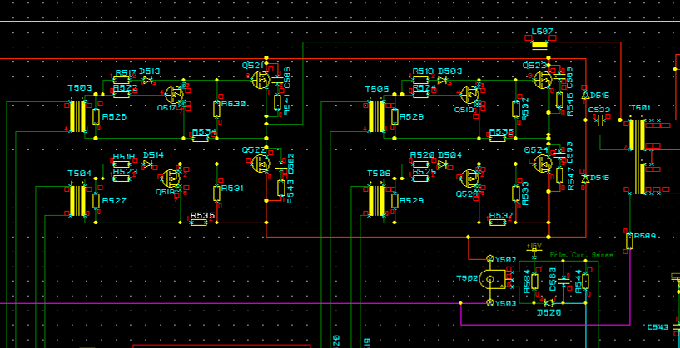

DC/DC stage in a Flatpack 1500 48V, 241114.100

This is a fullbridge, phase shifted and zero voltage transition DCDC stage used in Flatpack1. The switch frequency has been set to 125kHz.

The DC/DC converter is a full-bridge topology which provides control of the output voltage by phase shifting one half-bridge with respect to the other. It allows constant switching frequency combined with resonant zero voltage switching. This ensures high efficiency and low EMI emission.

The main differences between a phase shifted power converter and a traditional full-bridge power converter are the resonance inductor L507 and the freewheeling diodes D515 and D516. The resonance inductor together with the parasitic drain-source capacitances in the switching transistors is utilised for resonant-transition zero voltage switching.

In a phase shift converter, all the transistors run with a constant duty cycle of slightly less than 50 %. A little dead-time is necessary to prevent simultaneous conduction of both transistors in a bridge leg and provides the resonant transition time.

Halfbridge LLC converter

Half bridge LLC resonant converter topology

LLC resonant converters have demonstrated significant improvements over PWM topologies. With high frequencies and high efficiency, the power density of LLC resonant converters are improving the industry.

Cr, Lr and Lm works as the “LLC” resonant tank (reservoir). This converter has two resonant frequencies, where Lr and Cr sets the highest frequency. The converter is designed to work around the highest resonant frequency, in the ZVS (Zero Voltage Switching) area of the DC characteristics to be as efficient as possible.

LLC resonant converter with splitting resonant cap and clamping diodes

Splitting the resonant caps gives us more advantages; Smoother input current (less ripple), which alleviates the stress put on the high voltage bus capacitor. In addition, the clamping diodes will give over load protection and thus reduce stress (both current and voltage limitation) on the resonant capacitors.

Used in Flatpack2 family

DC/DC stage in a Flatpack2 2kW and 1.8kW, 241115.100 and 241115.001

The DC/DC is a resonant half bridge LLC converter with splitting resonant caps (C203 + C204) and clamping diodes (D200 + D201). The converter is working between 200 and 400kHz, and the duty-cycle over the transformer is constantly 50% and is not used for regulation.

Regulation is accomplished by;

- Frequency variation
- Boost voltage variation

In addition, the deadtime between the upper and lower transistor varies with load condition.

Surge pulses on the input

The input section

The input stage consisting of input filter, fuses, MOV(Metal Oxide Varistor) and the diode bridge will be the first affected components if the modules are exposed to a lightning surge.

Signs of that can be visual cracks in the filter capacitors, visual burn-marks from flash-over to chassis and blown fuses.
The rectifiers bridge is very rugged, but it is not unusual that we get returns from the field where at least one of the diodes in the diode bridge is shorted – which is a clear sign of exposure to surge current or over voltage.

So cracks in the filter capacitors, flash-over to chassis or between power lines or shorted diode bridge are clear signs of a surge current. This also goes for blown fuses (cracks, exploded), not necessarily without any other faults inside the rectifier. But very often, a blown fuse has occurred due to a shortage further inside the rectifier – and is not necessary a sign of more than that.

The MOV’s mission is to clamp over voltage to protect the electronics inside the rectifier. The Flatpack1 family has one varistor (VDR201) between power lines, and one from each power line to chassis (VDR202 and 203). The Flatpack2 family has one varistor between power lines (VDR100). There are pros and cons with both solutions, but we have ended up with the Flatpack2 solution as the preferred. Basically, if the VDR is broken/cracked it is a clear sign of heavy overvoltage, with long duration (>10 ms).

A proper coordination between the external SPD (Surge Protection Device) (Zone 1 and zone 2 boundary) and the varistors (Zone3 boundary) inside the rectifiers – is the best insurance against lightning surge problems. (Ref. Eltek’s “Guidelines for lightning/surge protection”, for more information on how to better protect the system).

A transient (pulsewith in millisecond area or more and voltages of 500-600V peak or more) will pass the MOV’s protection zone, and can do damage further inside the rectifier as described below.

The PFC/boost stage

Most of the modules that fail due to a lightning pulse also have PFC failure with the boost diode (D) shorted or blown open. If the boost diode is shorted the boost transistor will short the boost capacitors when it is turned on, it is exposed to an excessive peak current, and thus it will be destroyed as a consequence of the shorted boost diode. Destruction of the boost transistor is considered as a secondary effect of shorting the boost diode.

What shorts a diode is too high reverse voltage or excessive peak current. The energy dissipated in the diode and the starting junction temperature of the diode will determine if the diode is shorted or blown open. Due to the voltage rating of the boost diode (600V), break down of the diode due to too high reverse voltage can be ruled out. This leaves one failure mode; excessive peak current.

There are two important safety features in a PFC boost stage; peak current limitation and high voltage shutdown of the boost voltage. The current is measured with the shunt resistor (R_{sense}) and the boost transistor is kept off if the current is for some reason too high. The PFC resumes operation when the current level returns to normal operating conditions. The same happens if the boost voltage rises above safe operating levels, typically 450V_{dc}.

If the input stage is exposed to a voltage higher than the boost voltage, e.g. high mains, transients or surges, the PFC boost stage is not able to limit or divert the current flowing into the converter, it can only stop operating. Consequently, the voltage across the boost choke is positive and the current in the boost choke will increase. The higher the input voltage, the steeper the increase in the input current will be. At high current levels the boost choke will run into saturation and loose its impedance. Because the boost transistor is off, the current is conducted through the boost diode and the boost capacitors are charged. For long transients, i.e. in the milliseconds range, the boost voltage will be charged to the same level as the input voltage.

For short duration, high amplitude surges like the 1.2/50 surge voltage and 10/350 surge current, the current in the boost choke and boost diode will rise to extreme levels and consequently short the boost diode. The duration of the surge is not long enough to charge the boost capacitors to dangerous levels. Longer transient of less amplitude will typically not short the boost diode, but charge the boost voltage to dangerous levels, which again will destroy the DC/DC stage of the module.

How can the DC/DC stage be affected ?

As described in the previous section, a low amplitude, long duration (milliseconds or longer) transient or surge will charge the boost voltage to dangerous levels and destroy the DC/DC stage. This happens because the DC/DC stage has no over voltage shutdown and continues operation. The switches used in the DC/DC stage have 500V or 600V avalanche rating. When an avalanche rated transistor is exposed to voltage beyond the absolute maximum rating it behaves like a zener diode and start to drain current in reverse direction when it is in the off state. The device has a maximum avalanche reverse current rating (I_{AR}), which specifies the maximum current it can drain in avalanche mode. There is also a corresponding maximum avalanche energy the device can withstand.

The voltage level where the transistor runs into avalanche mode increases somewhat with increasing junction temperature; however at a high junction temperature the avalanche energy rating is derated. This means the transistor is less sensitive for the voltage rating when it is warm, but it breaks down faster due to the power dissipation.

If the boost voltage is charged to dangerous levels, the DC/DC stage continues to operate and one of the switches in the bridge leg is on, the other is off. The one which is off will be exposed to the high boost voltage and run into avalanche mode. Consequently, the transistor breaks down and shorts. The inhibited self protection in the other transistor limits the current in the bridge leg, but the power dissipation in the second transistor causes the transistor to breakdown and short or blow open.

Procedure for assessment of failure due to surge

Site / system check-list

If you are at a site, please perform the following system test;

- Have SPD been installed on the site?
  - Is it installed according to the Eltek guidelines?
  - Is it still intact? (If it has a surge counter – check that)
- Check the alarm log
  - Check for SPD alarm
  - If more than a single module has failed, have they failed simultaneously?
- Have any other equipment on the site been affected?
- How was the weather situation on the day of failure?

These points are very valuable to ask/check, and please forward the information to the repair center of R&D (incase of an investigation). It might make the root cause analyses easier.

ETS service reporting

Make sure to use the “External Cause Electrical” as “Failure Type” in ETS / Service reporting in all cases where a lightning surge or a transient/over-voltage is the root cause, regardless of how the customer is handled (if the customer by some reason is given warranty or not).

In addition to get a better overview of Eltek Valeres liabilities, we will also get a much more precise failure statistics – and it makes it easier to discuss root cause with the customer.

Module check

We have made a list of the components that very often are damaged during a lightning surge, or a transient/over-voltage attack. To be able to refer to component positions, we have divided this into the two families, FP1 and FP2. However, this information (apart from the actual position numbers) is generic, and can at any time be transferred to any other rectifier.

FP2 – family

This check covers the following part numbers:

P/N | Description
241115.001 and 002x | Flatpack 2 1800 / 48V
241115.100xx | Flatpack 2 2000 / 48V
241115.102 | Flatpack 2 2000 / 48V (50V output)
241115.110xx | Flatpack 2 2000 / 48V (reversed fan)
241115.120xx | Flatpack 2 2000 / 48 (reversed fan – high temp)
241115.200 | Flatpack 2 2000 / 24V
241115.901* | Flatpack 2 1400 / 48V TEC 25
*Note: Components failing in boost will differ slightly from the below, as the boost in TEC25 is different (as stated above.) Just compare the functionality of the components, and the principle is the same.

FP2 Component failures due to lightning surge
If one or more of the following components have failed, the failure is most likely due to surge currents or over voltage beyond what the modules are designed and specified for.

Position | Function | Typical status of the component | How to measure?
C100/108 | Filter Cap | Cracks in plastic housing | Visual
F100/101 | Input Fuse | Cracks, exploded | Visual, Multimeter
DB100 | Diode bridge | Shorted one or more diode | Multimeter (check all diodes in both directions)
VDR100 | Over voltage protection | Cracks, partly opened | Visual, and multimeter (check for short)
Q103 | Boost mosfet | Shorted or O/C (often burn-marks / cracks due to the high energy drained from the bulk caps) | Visual, Multimeter, tracker
D104 | Boost diode | Shorted | Multimeter
Q105** | Power management for LLC drive | Shorted | Multimeter, tracker
REL100 | Inrush relay | Welded / stuck | Test by injecting voltage on coil – and measure that contact pins switch normally
D114 | Bypass diode | short | Multimeter

Secondary component failures (as a function of the above failures:
Q102 | Boost driver transistor | Shorted | Multimeter
F100/F101 | Input Fuse | Open circuit | Multimeter
D100/D101 | Rectifier diodes for power management | Shorted as a function of Q105 failure | Multimeter
DZ100/DZ101 | In power management circuit | Shorted as a function of Q105 failure | Multimeter

FP2 Component failures due to transients (over voltage pulses (milliseconds or longer))

Position | Function | Typical status of the component | How to measure?
Q200/201 | DC/DC Mosfets | Shorted or O/C (often burn-marks around due to the high energy drained from the bulk caps) | Visual, Multimeter, Tracker
D200/D201 | Clamp diodes on resonant capacitors | Shorted | Multimeter
Q105** | Power management for LLC drive | Shorted | Multimeter, tracker
C110-114 | Bulk Caps, on 400V | Gas vent open or swelled (weak-links in top) | Visual

Secondary component failures (as a function of the above failures:
DB100 | Diode bridge | Shorted one or more diode | Multimeter (check all diodes in both directions)
F100/F101 | Input fuses | Open circuit | Multimeter
D100/D101 | Rectifier diodes for power management | Shorted | Multimeter
D206/D207 | Output diodes | Shorted | Multimeter

** Note: Q105 was rated 600V up till rev 2.15, and was the “weak link” that would break first when the module was exposed to transients above 600V. It is very often a stand alone failure. Especially if the module manage to shut down due to high voltage, this transistor is still connected to mains (through D100/D101) – and in a shut-down state the bypass diode and bulk caps will be disconnected, and thus not be draining the surges. From rev 2.2 it is rated 900V, and will not often be seen failing as a function of a transient anymore. This failure was over-represented in the India region on earler versions due to poor/erratic mains and fast surges with peaks on 6-700 V. After upgrading the modules for India with Q105 = 900V, this failure almost disappeared.

FP1 – family

P/N | Description
241114.1xx | Flatpack 1500 48V variants
241114.3xx | Flatpack 1500 24V variants
241114.400 | Flatpack 700 48V
241114.60x*** | Flatpack 2500/2880 48V
241114.700 | Flatpack 1500 60V
241114.800 | Flatpack 1800 48V
241114.90x | Slimpack 20A / 48V 19” (uses Flatpack 1500 main board)
***Note: Components failing in boost will differ slightly from the below, as the boost in Flatpack 2500/2880 is different (as stated above). Just compare the functionality of the components, and the principle is the same.

FP1 Component failures due to lightning surge
If one or more of the following components have failed, the failure is most likely due to surge currents or over voltage caused by lightning surges beyond what the modules are designed and specified for.

Position | Function | Typical status of the component | How to measure?
D206 | Boost diode | Shorted | Multimeter
Q205/Q206 | Boost Mosfets | Shorted or O/C (often burn-marks / cracks due to the high energy drained from the bulk caps) | Visual, Multimeter, Tracker
D226 | Bypass diode**** | Shorted | Multimeter
F201/F202 | Input fuses | Cracks, exploded | Visual, Multimeter
REL201 | Inrush relay | Welded / stuck | Test by injecting voltage on coil – and measure that contact pins switch normally
VDR201-203 | Over Voltage Protection | Cracks, partly opened | Visual, and multimeter (check for short)
D203/D204 | Rectifier diodes mains detection | Shorted | Multimeter
C201 | Input filter cap | Cracked in plastic housing | Visual
****Note: Designed in from rev. 8.4 of 241114.100 (Surge/lightning upgrade)

Secondary component failures (as a function of the above failures):
Q207/Q208 | Boost driver transistors | Shorted | Multimeter
DB201 | Diode Bridge | Shorted one or more diode | Multimeter (check all diodes in both directions)
U205 | Boost Controller | Stop functioning – damaged internally on driver output pin (Boost gate) or Vcc | Change / test

FP1 Component failures due to transients (over voltage pulses (milliseconds or longer))

Position | Function | Typical status of the component | How to measure?
Q521 – Q524 | DC/DC Mosfets | Shorted or O/C (often burn-marks around due to the high energy drained from the bulk caps) | Visual, Multimeter, Tracker
C215-C217  C513-C514 | Bulk Caps on 400V | Gas vent open or swelled (weak-links in top) | Visual

Secondary component failures (as a function of the above failures):
F201/F202 | Input fuses | Open Circuit (O/C) | Visual, Multimeter
D206 | Boost diode | Shorted | Multimeter
Q517-Q520 | DC/DC driver transistors | Shorted | Multimeter
U510-U511 | DCDC driver IC | Output defect | Change / test
U506 | DC/DC Controller
Q205-Q206 | Boost Mosfets | Shorted | Multimeter, Tracker
U205 | Boost Controller | Stop functioning – damaged internally on driver output pin (Boost gate) or Vcc | Change / test
DB201 | Diode Bridge | Shorted one or more diode | Multimeter (check all diodes in both directions)

