Completa as lagartas.



1
6

Em cada grupo, rodeia o maior.

4 2 1 3 2




2 1 6
5 3 3 4 1 4

Completa as sequências.

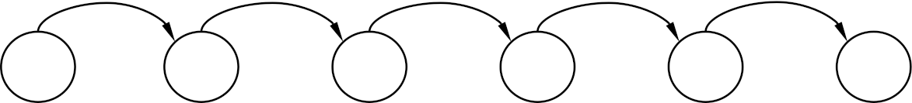

1 + 1 + 1
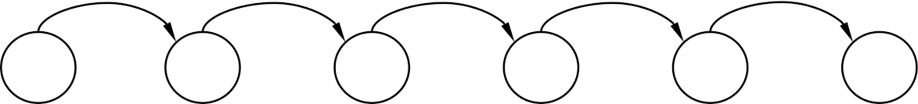

+ 1 + 1 + 1

6 − 1 − 1
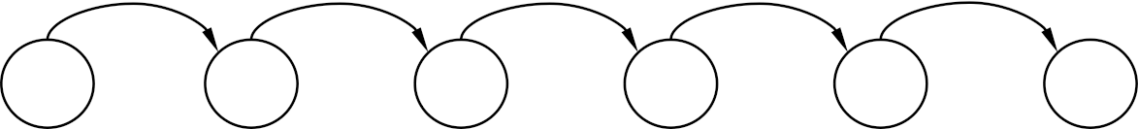

− 1 − 1 − 1

5 + 1 − 3
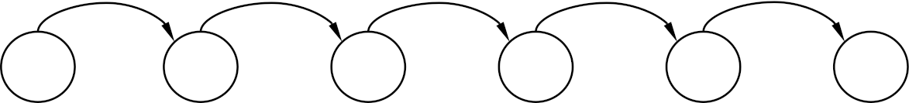

+ 1 − 2 + 4

4 + 1 − 2
+ 3 − 4 + 2

Resolve as tabelas.

+ | 1 | 2 | 3 | 4 | 5
1
2
3
4
5

+ | 1 | 2 | 3
1
2
3

Observa e completa.

6 − 1 =
6 − 2 =
6 − 3 =
6 − 4 =
6 − 5 =

4 − 1 =
4 − 2 =
4 − 3 =
5 − 1 =
5 − 2 =
5 − 3 =
5 − 4 =

Efectua.

5 = 3 +

5 = 2 +

5 = 1 + 3 +
6 = 4 +

6 = 2 + 2 +

6 = 1 + +

