Wireless Barcode Scanner
Setting Manual

Disclaimer
Pleasse read all content of this manual carefully before using product which is described in this manual. This manual is helpful for using product safely. Please keep well for next use.

Do not dismantle terminal equipment or tear up sealed bidding, otherwise our company will do not be responsible for repairing or replacing the terminal.

The pictures in this manual are for reference only. Please refer to the actual product if there is any discrepancy between individual pictures and actual product. For the improvement and update of this product, our company reserves the right to modify the document at any time without notice.

All information contained in this manual is protected by copyright. Our company reserves all rights. Units and individuals are not allowed to extract, copy or combine all or part of this document in any way or for any reason without permision. The products described in this manual may include the copyrighted software of our company or a third party. Units and individuals are not allowed to copy, distribute, modify, excerpt, reverse editing, decode, reverse engineering, lease, transfer, sublicense or other violations of software copyright for the aforementioned software in any form unless permission is obtained from the relevant right holder.

Our company has the final right to interpret this statement.
Version
Version | Description | Data
V1.0 | Initial Version | 2017-06-07
V1.01 | Add National Keyboard Layout | 2017-08-16
V1.02 | Add virtual Bluetooth function (supported by some products) | 2018-04-25
V1.03 | Add end character setting and case conversion | 2019-02-27
V1.04 | Add “Custom default setting”function | 2019-03-18
V1.05 | Add GS character replacement and display GS hidden characters | 2019-04-05
V1.06 | Add QR code setting function | 2019-04-25
V1.07 | Add the function of adding prefix and suffix and hidden character | 2019-05-21
V1.08 | Add virtual serial port settings | 2019-10-25
V1.1 | Add multiple national language settings, and add Chinese output settings. | 2020-03-13
V1.11 | Add virtual Bluetooth pairing steps | 2020-05-09
V3.0 | Added clock control function, escape character set (supported by wireless version 3.0 and above) | 2020-08-01
Note: When the 2.4G wireless scanner is selected separately, the related Bluetooth function is not supported.
Content
Wireless Factory Default 6
Custom Default Setting 7
Version 7
Sound 8
Frequency 9
Vibration (Optional) 10
Battery Level 10
Sleeping Time 11
Data Format 13
Wireless Working Mode 14
Instant Upload Mode 14
Storage Mode 15
Data Control 16
Upload All Code 16
Upload Total Count 17
Clear All Codes 17
Communication Setting 18
USB-COM 18
Wireless 2.4G Mode 18
Virtual Bluetooth Mode 19
Bluetooth HID Mode 20
Bluetooth SPP Mode 21
Bluetooth BLE Mode 21
Wireless Pairing 22
2.4 Wireless Pairing Steps (Dongle Pairing) 22
Virtual Bluetooth Pairing Steps 24
Bluetooth HID Pairing Steps 25
Bluetooth SPP Pairing Steps 27
Bluetooth BLE Pairing Steps 28
Bluetooth Mode Function Setting 29
Press and hold for 8s to enter HID Mode 29
IOS System HID Virtual Keyboard Setting 30
Bluetooth HID Upload Speed 32
Bluetooth Name 33
Get the Bluetooth Name 35
National Keyboard Layout 36
Case Conversion 42
GS Replacement function 43
Custom GS Replacement 43
Cancel GS Replacement 44
Custom Prefix/Suffix 45
Add Custom Prefix 45
Clear Custom Prefix 46
Add Custom Suffix 47
Clear Custom Suffix 48
Hide First/Last Characters 49
Clear Hidden characters 51
Terminator 52
Clock Function 54
Control character set escape settings 56
Appendix-Enter/Exit Settings 57
Appendix-LED indicator description 58
Appendix-description of buzzer sound 60
Appendix-Control Character List 61
Appendix-ASCII code character table 64

Wireless Factory Default
All scanners have a factory default setting. All the scanner's wireless properties will be set to the default state of the software with scanning the "Wireless Factory Default" setup code.
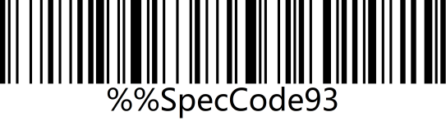 | 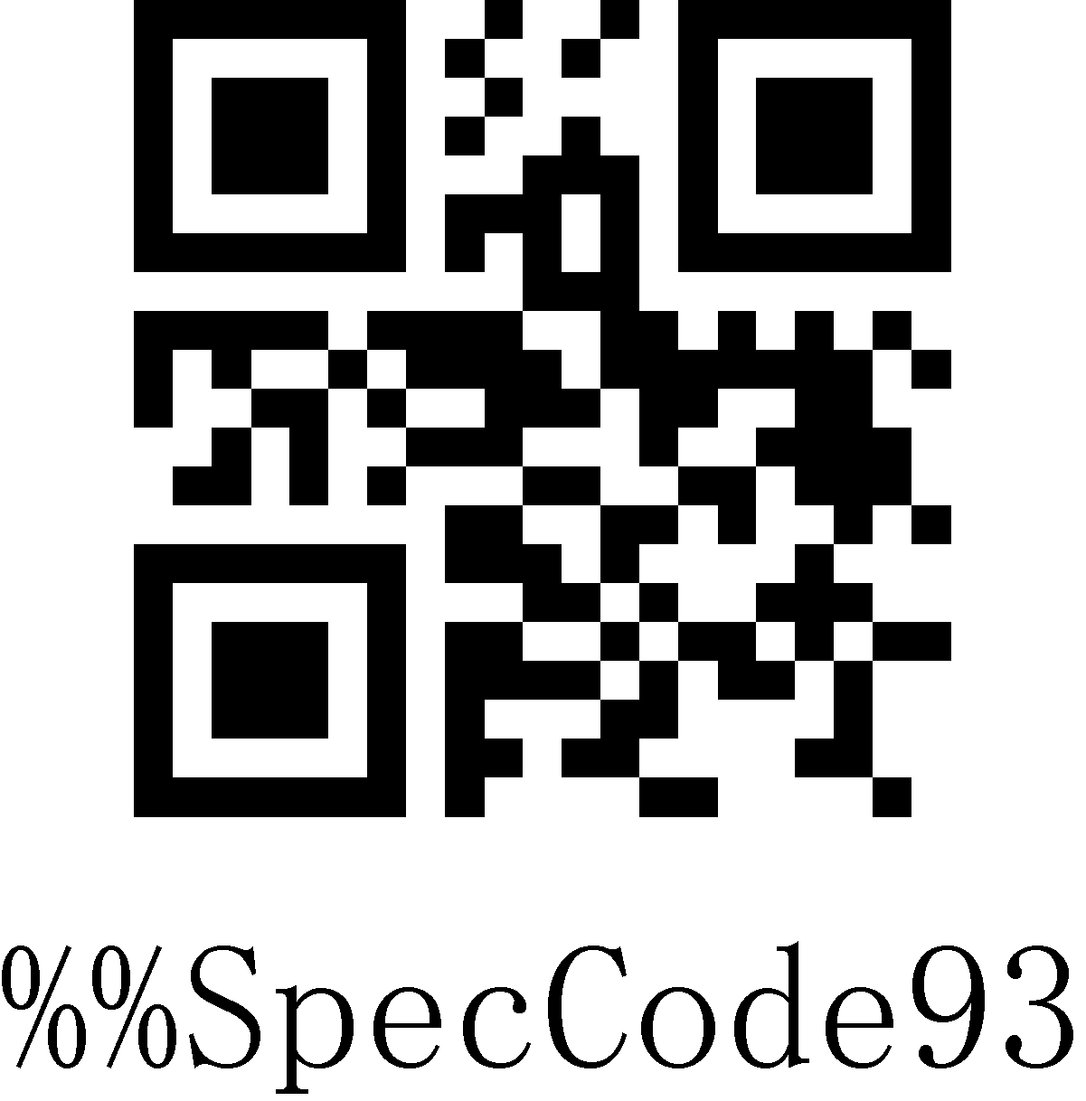
Wireless Factory Default

Instruction:
You could use it in the following situations:
1. Scanner settings are wrong, such as barcodes that cannot be recognized.
2. You forgot what settings you made to the scanner and you do not want to use the previous settings.
3. Some infrequent functions were set and do not want to keep using it.

Custom Default Setting
You can set the default values of the wireless parameters of the wireless barcode device to the required functions by setting custom default settings. Scan the "Enter Setting Mode" setup code first, then scan the required wireless parameter function, and then scan the "Exit Setting Mode" setup code after the setting is complete. After the setting is completed, the existing functions will replace the original factory default values, and the wireless parameters will not be restored to the original state even if the settings are restored.
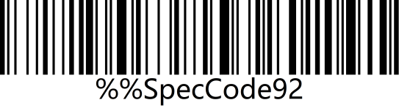 | 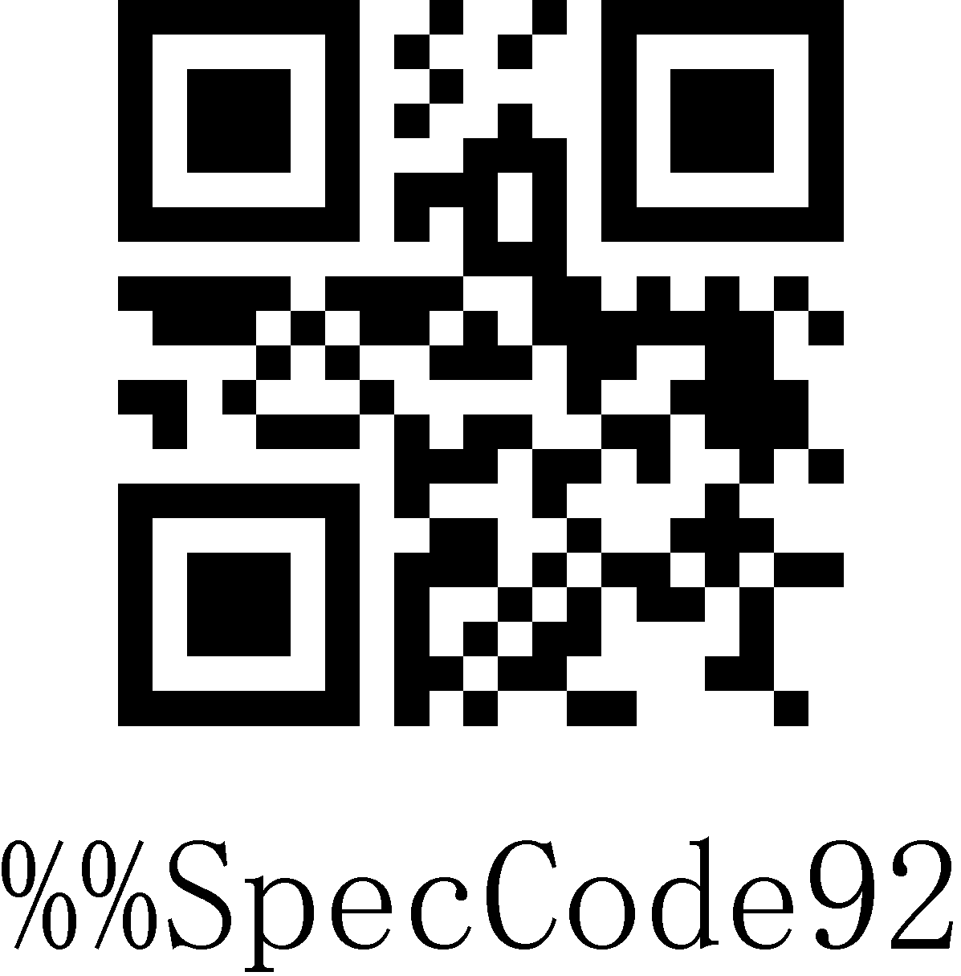
Custom Default Setting

Version
Use the scanner to scan the version barcode and you will view the information of current scanner version.
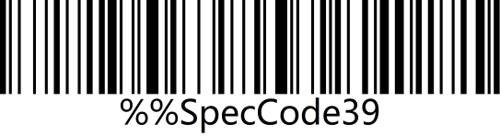 | 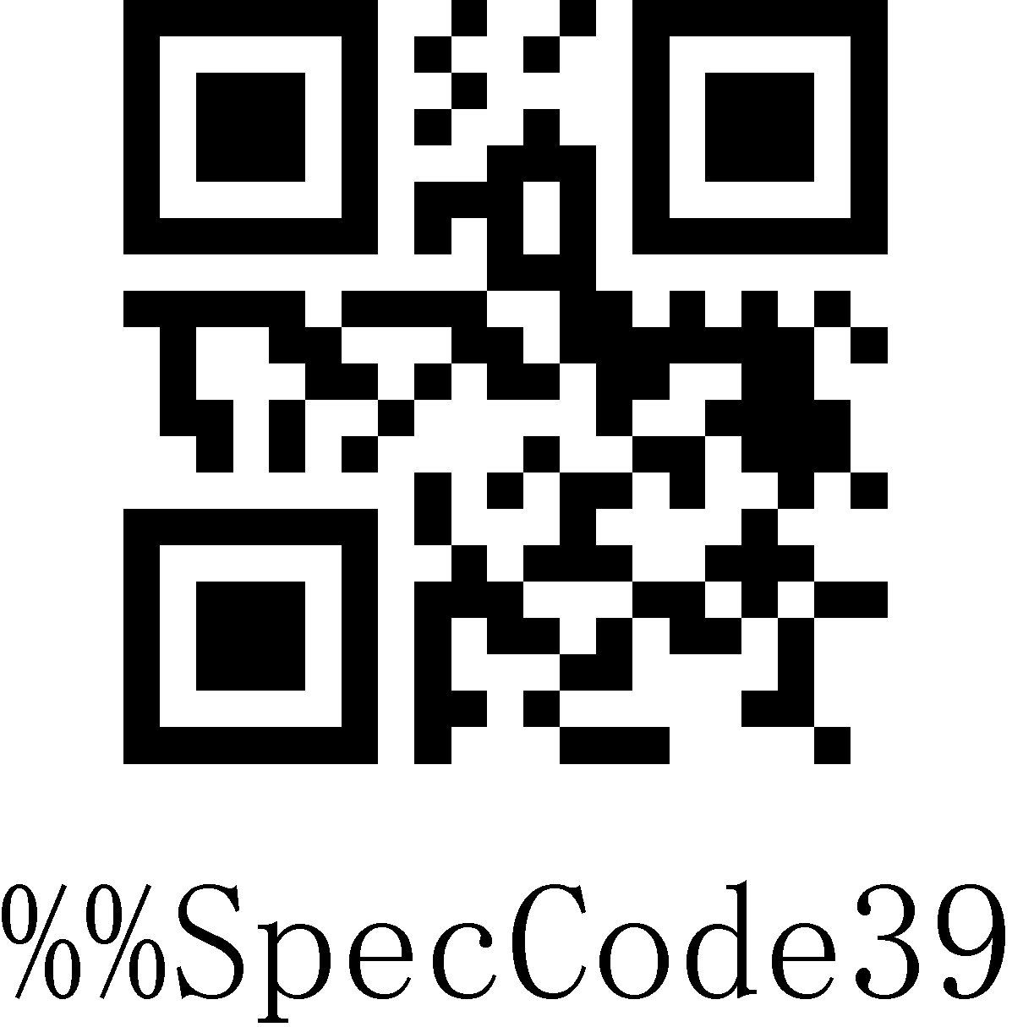
Version

Sound
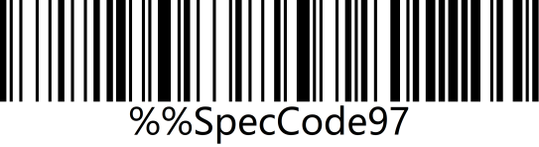 | 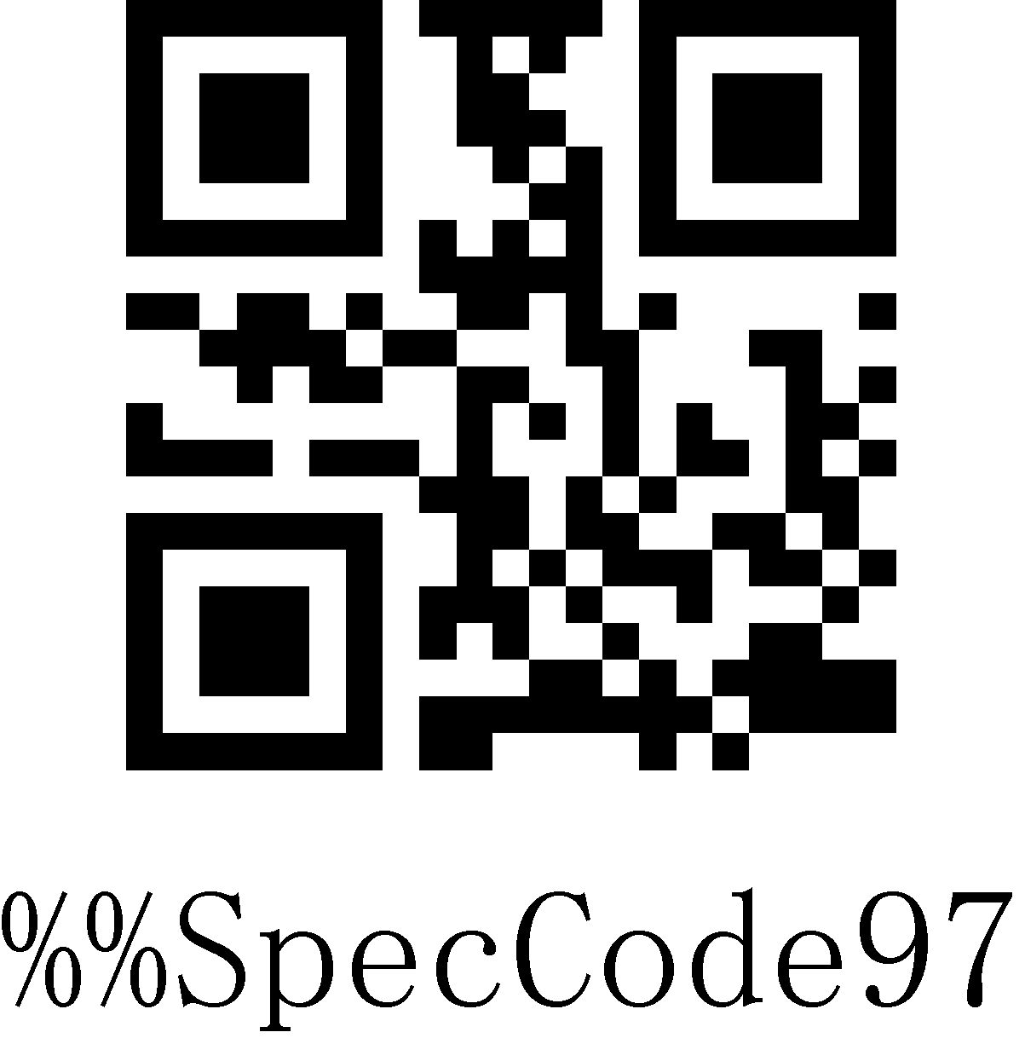
High*
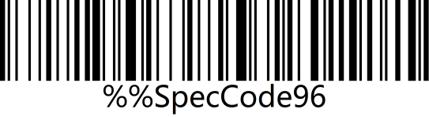 | 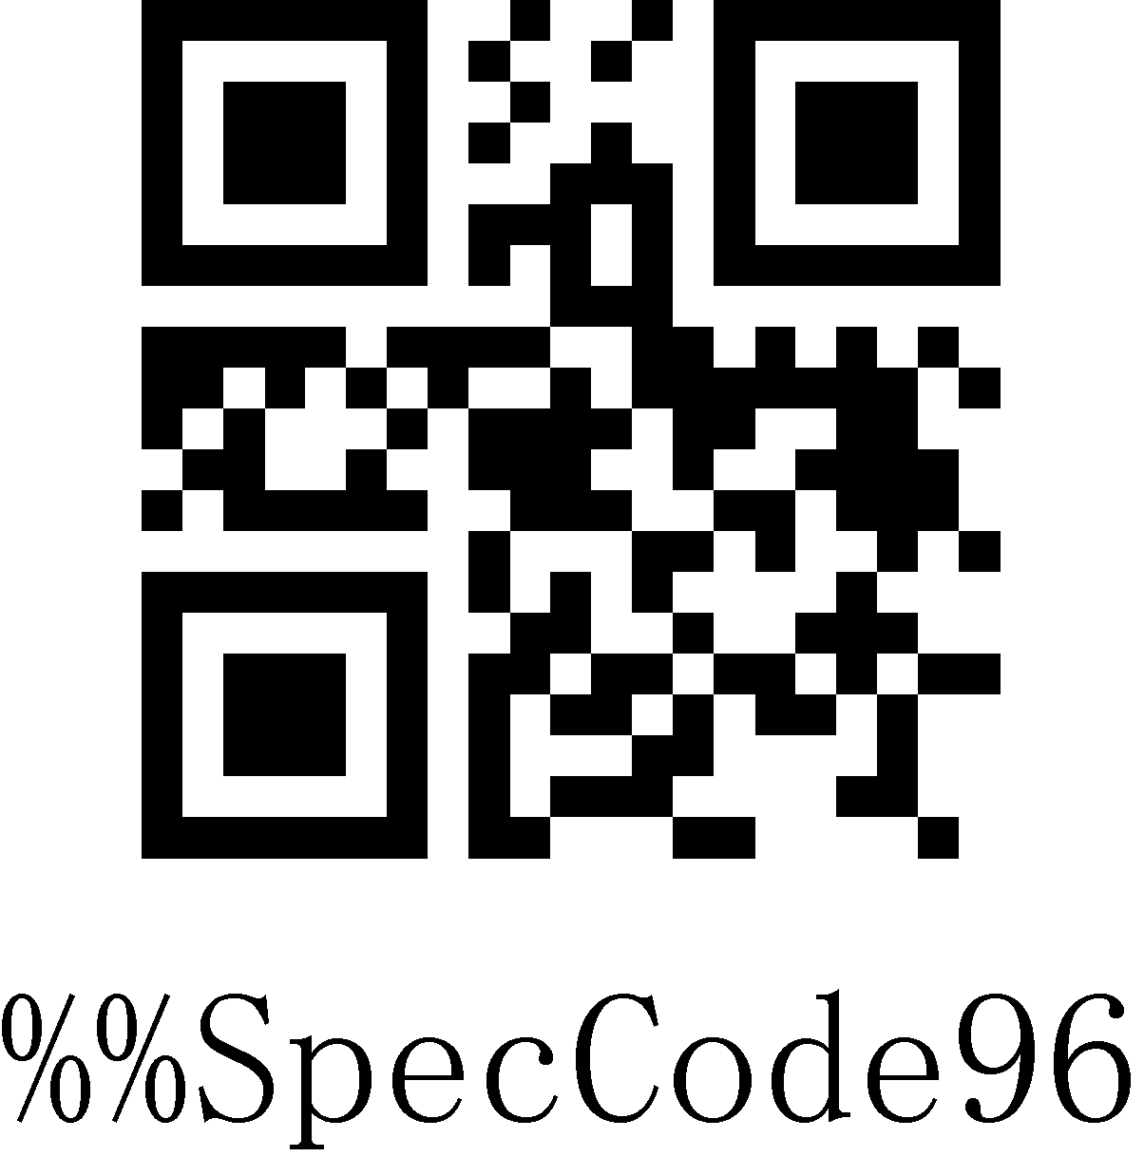
Medium
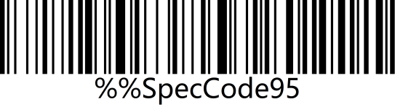 | 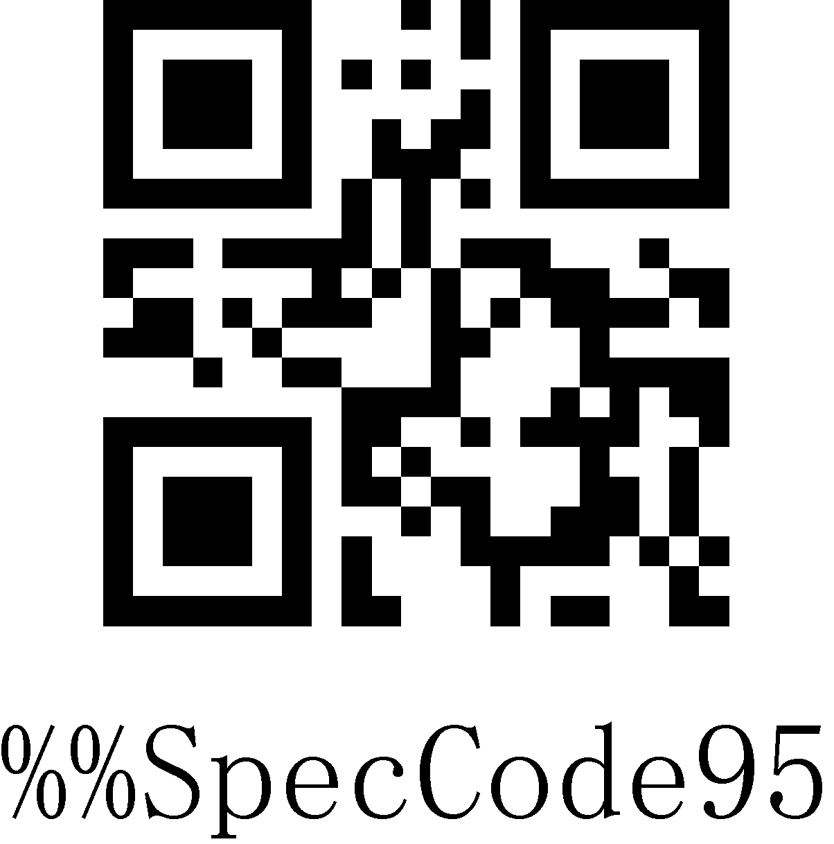
Low
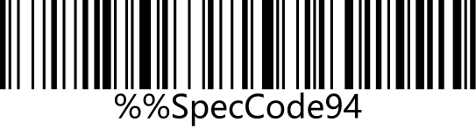 | 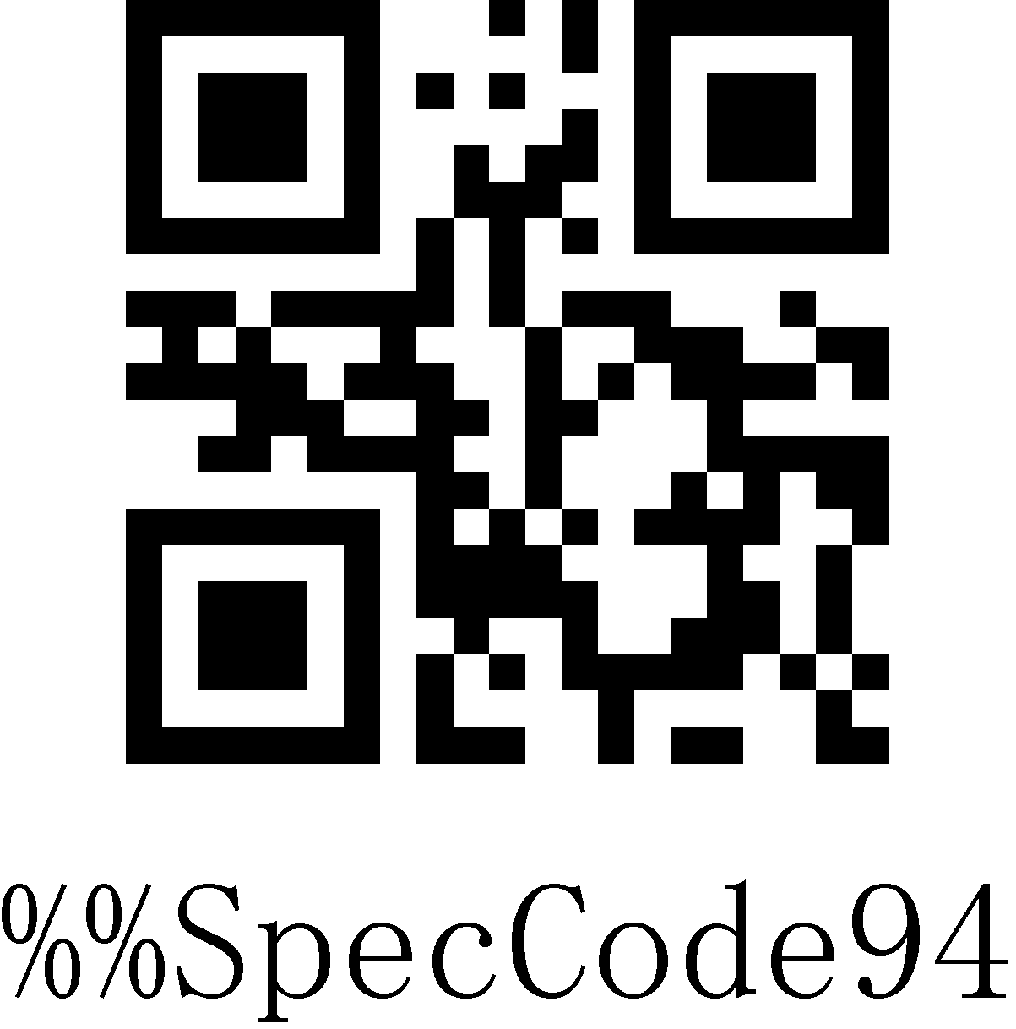
Mute

Frequency
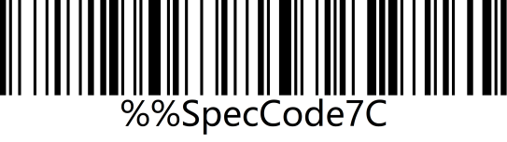 | 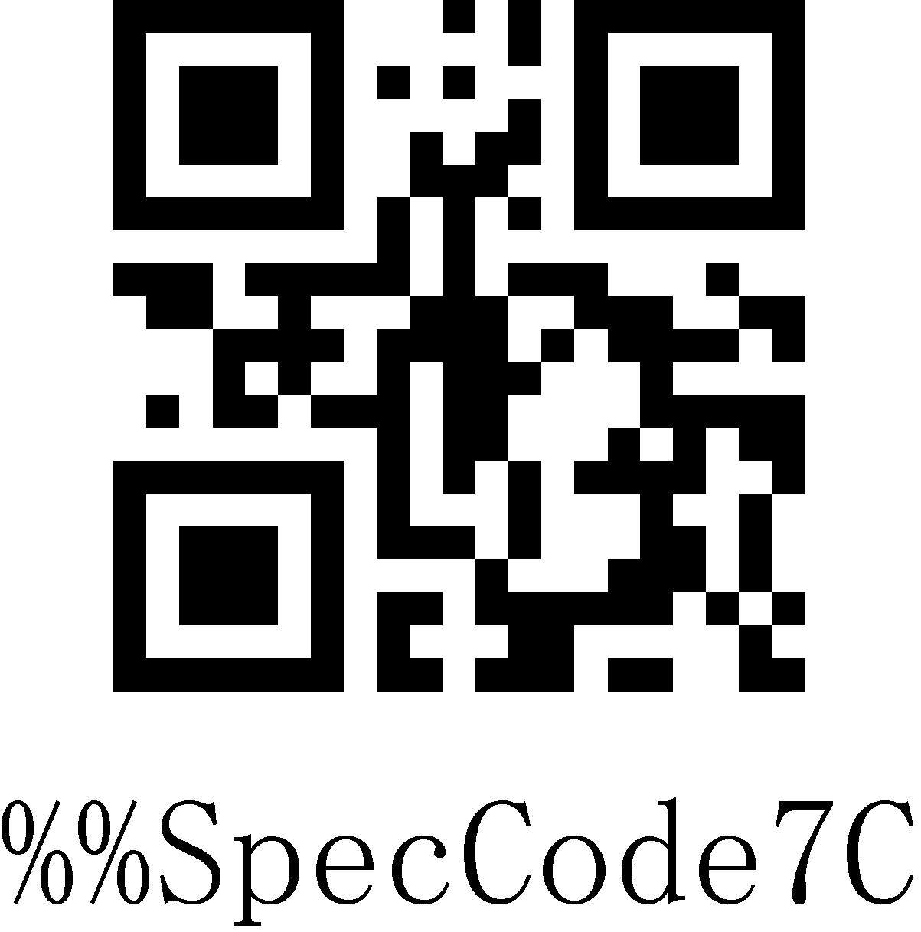
2048MHz
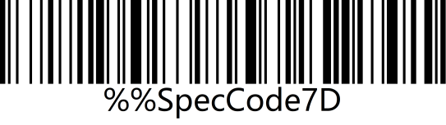 | 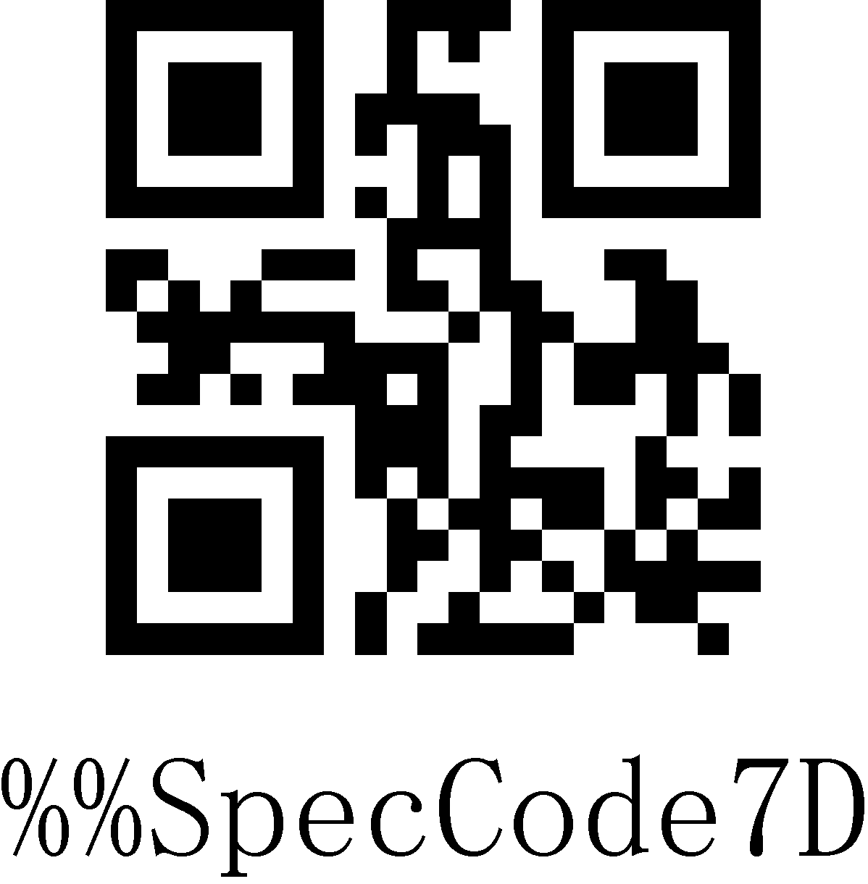
2730MHz

Vibration (Optional)
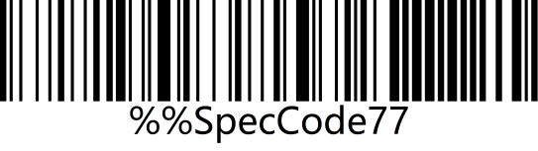 | 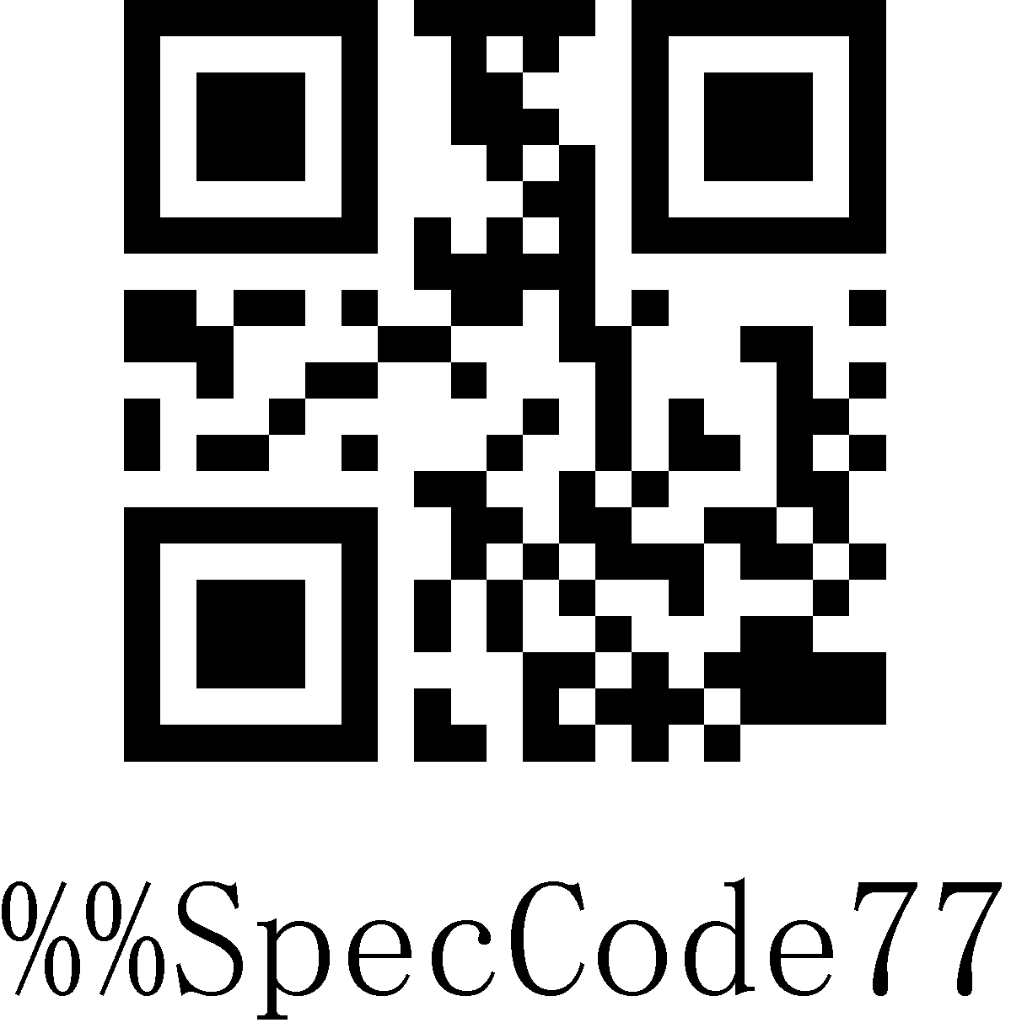
On
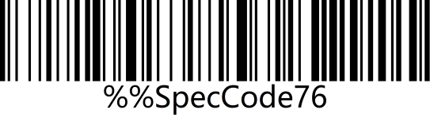 | 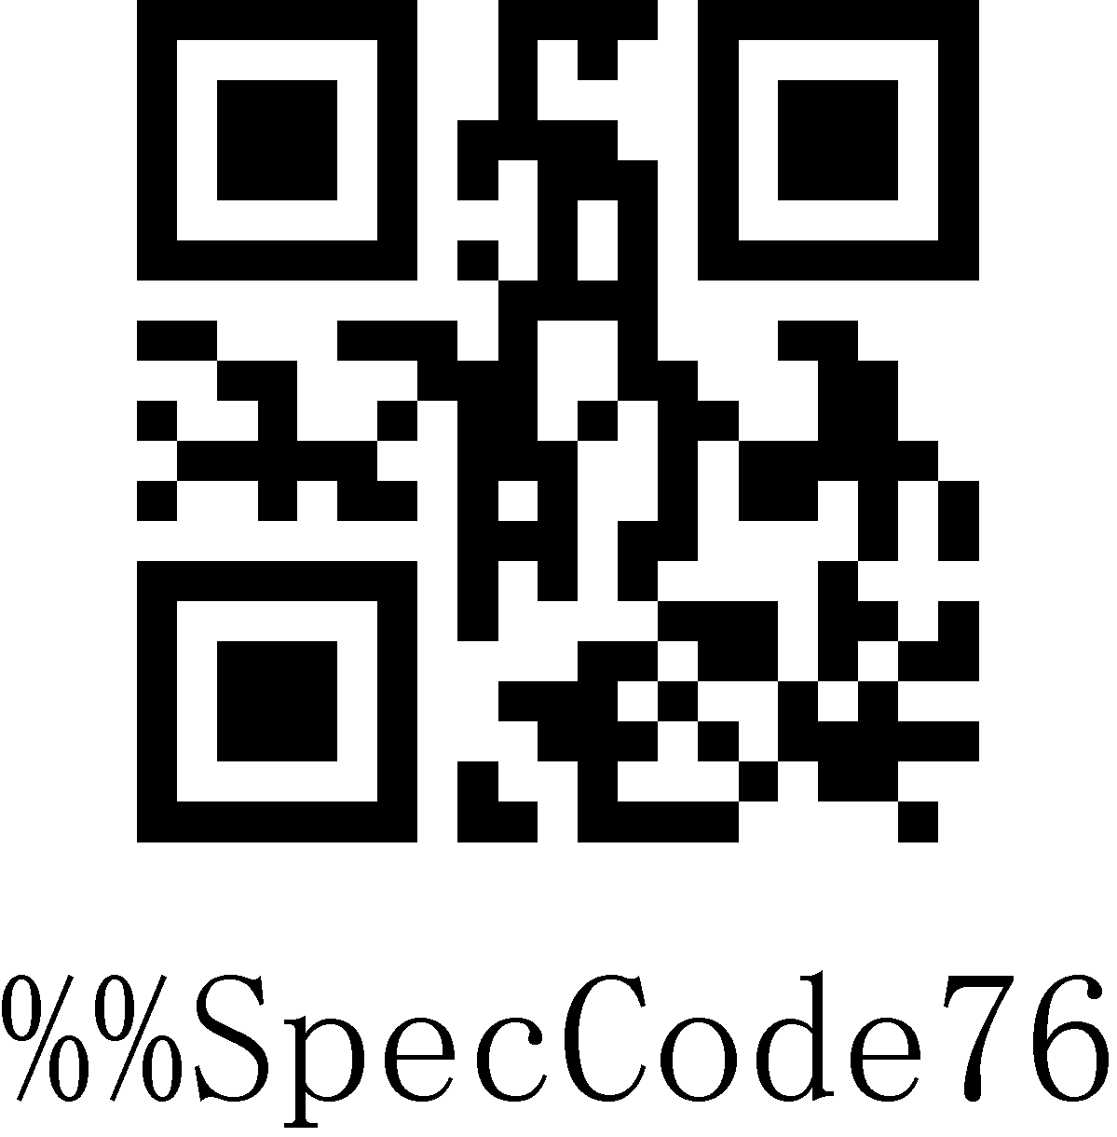
Off
Note: The vibration function is optional for some products.

Battery Level
Scan the “Battery Level” setting code to check out the current battery status.
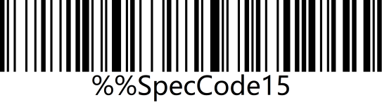 | 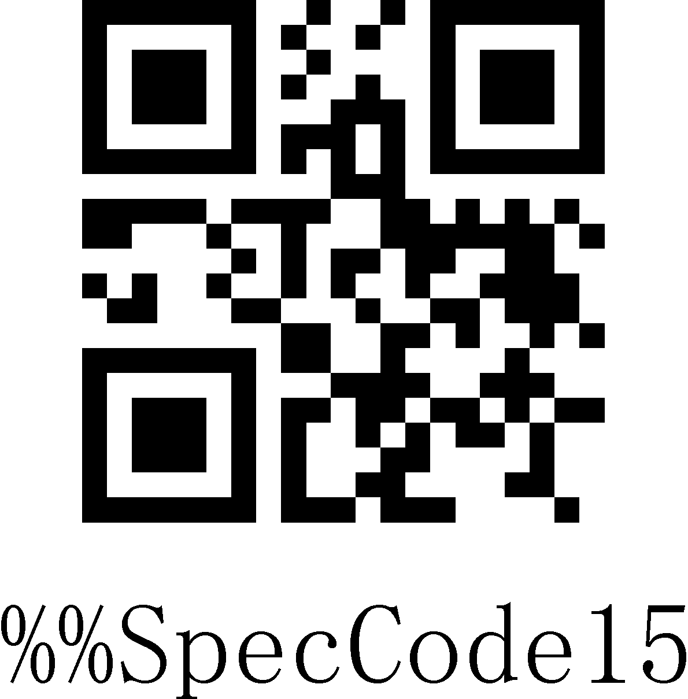
Battery Level

Sleeping Time
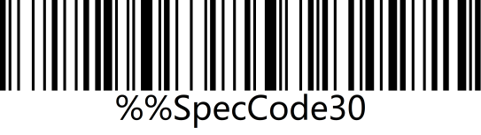 | 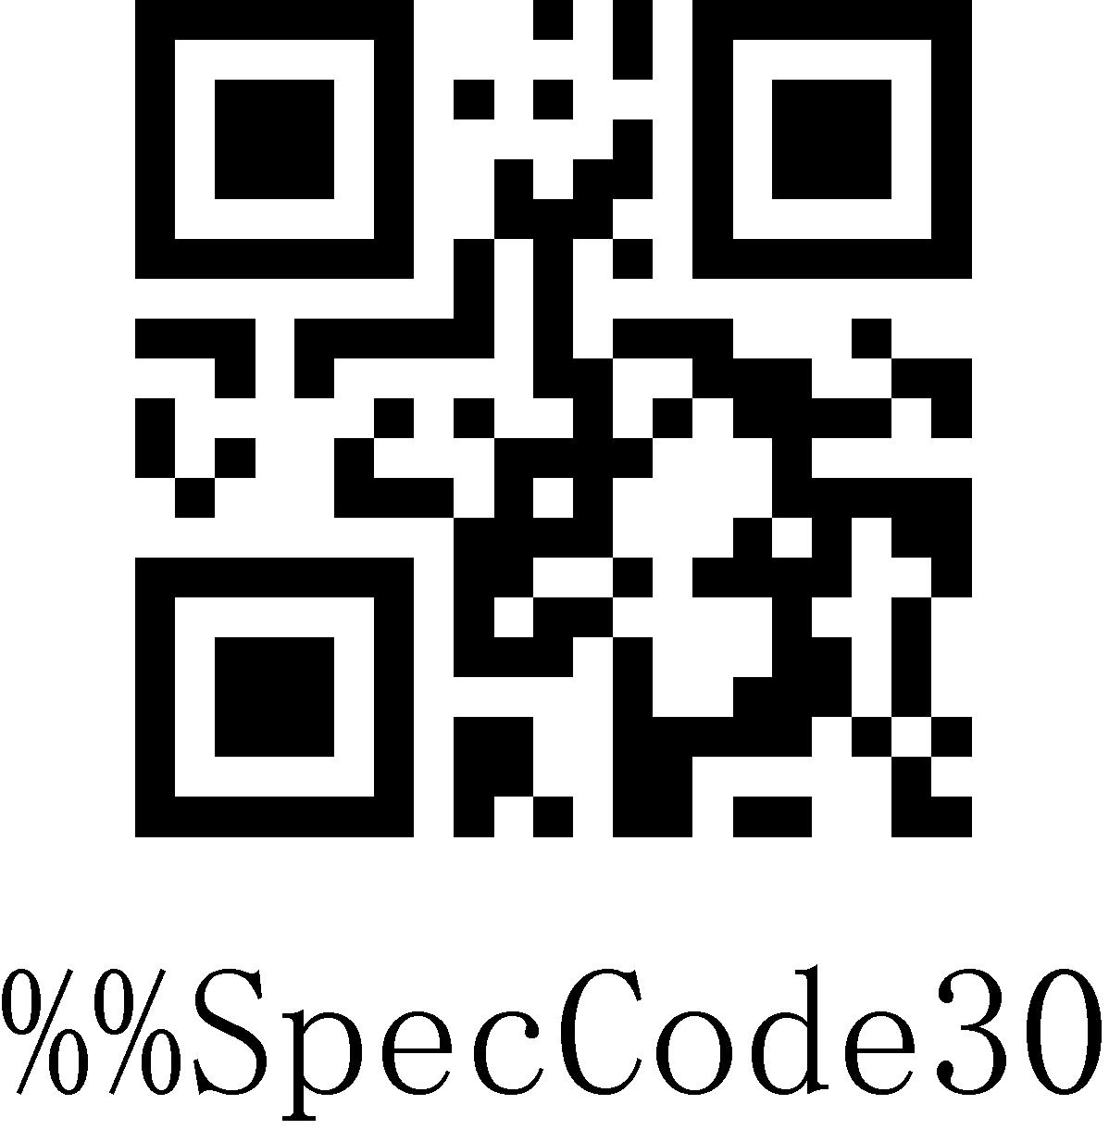
30s
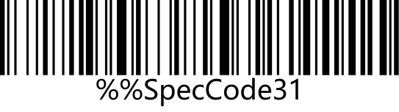 | 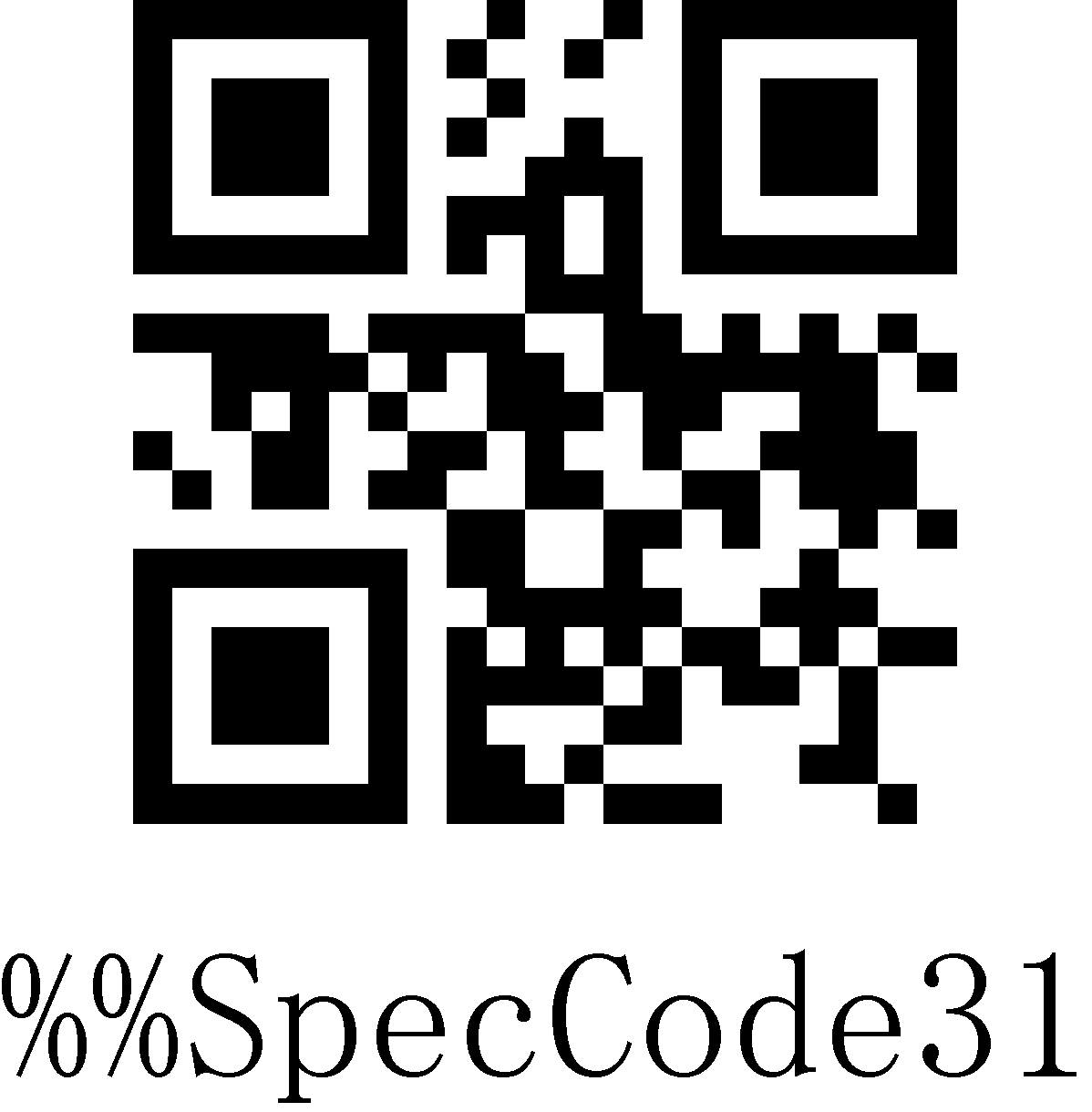
1min
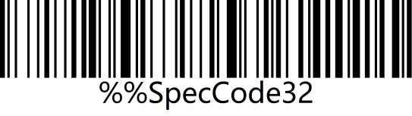 | 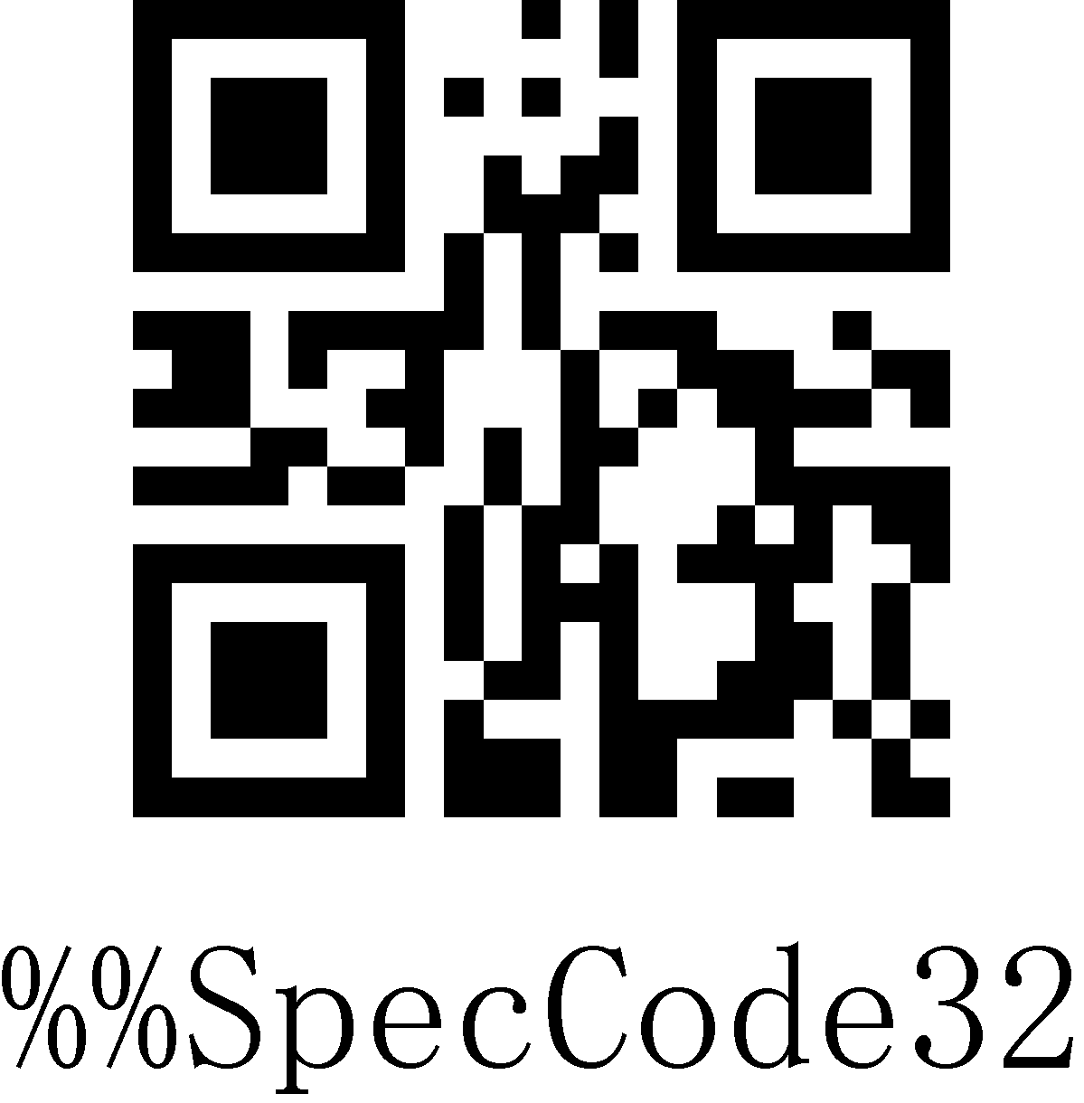
2min
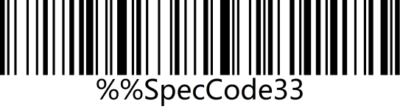 | 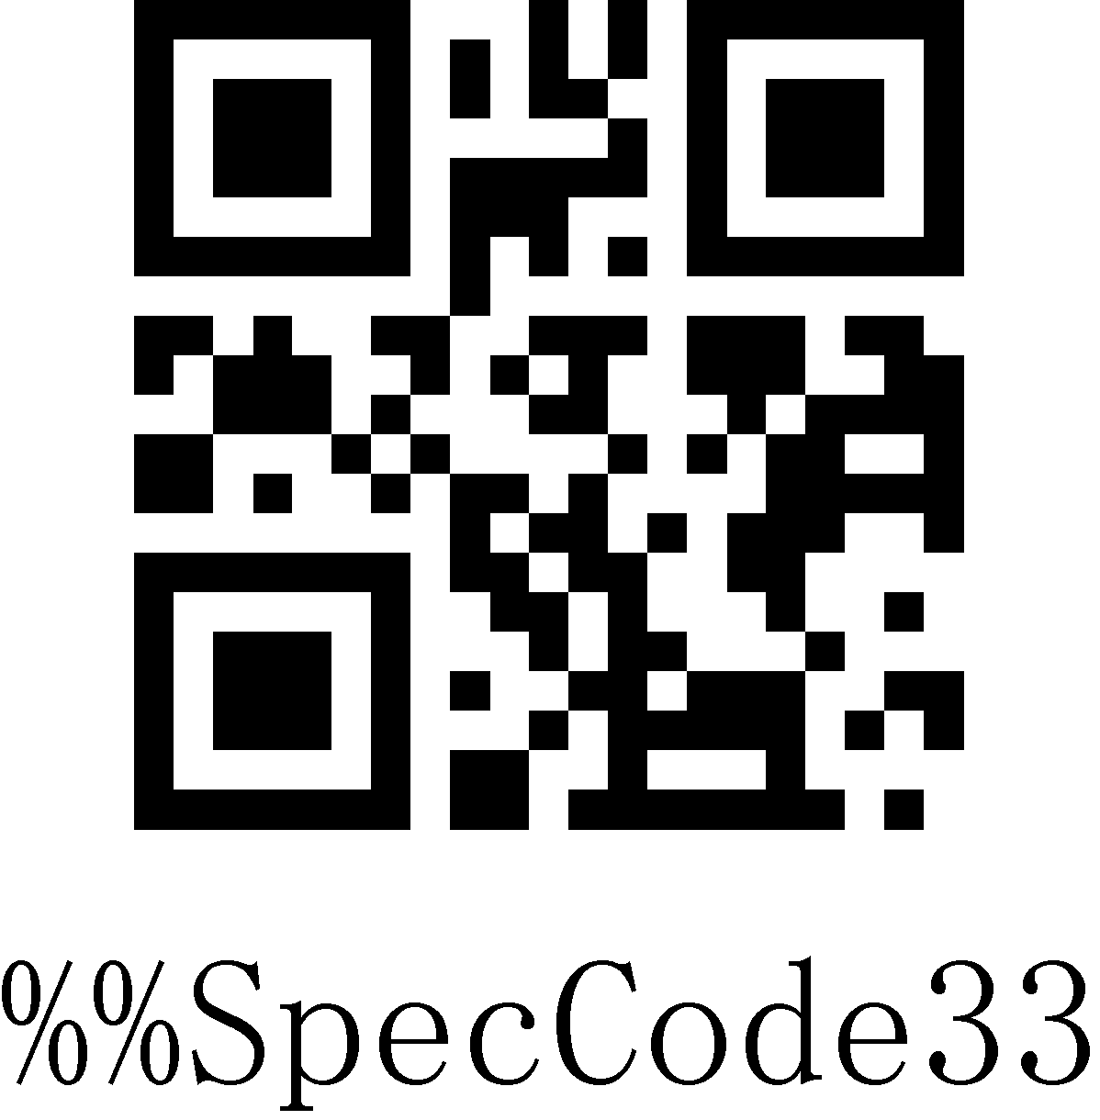
5min*
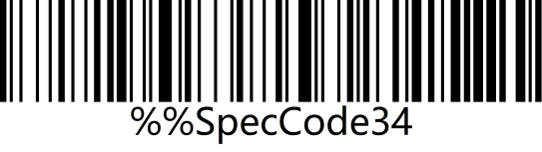 | 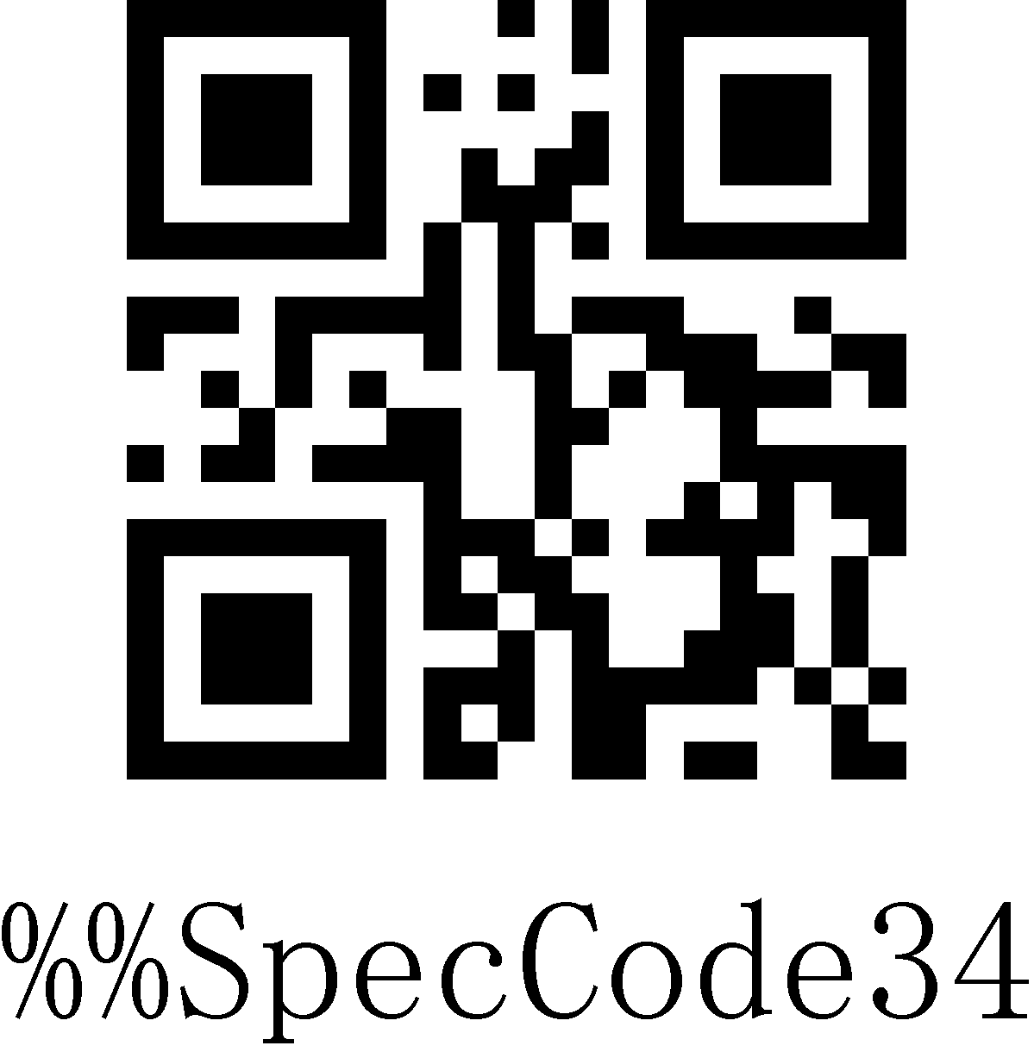
10min
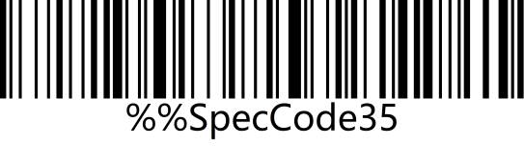 | 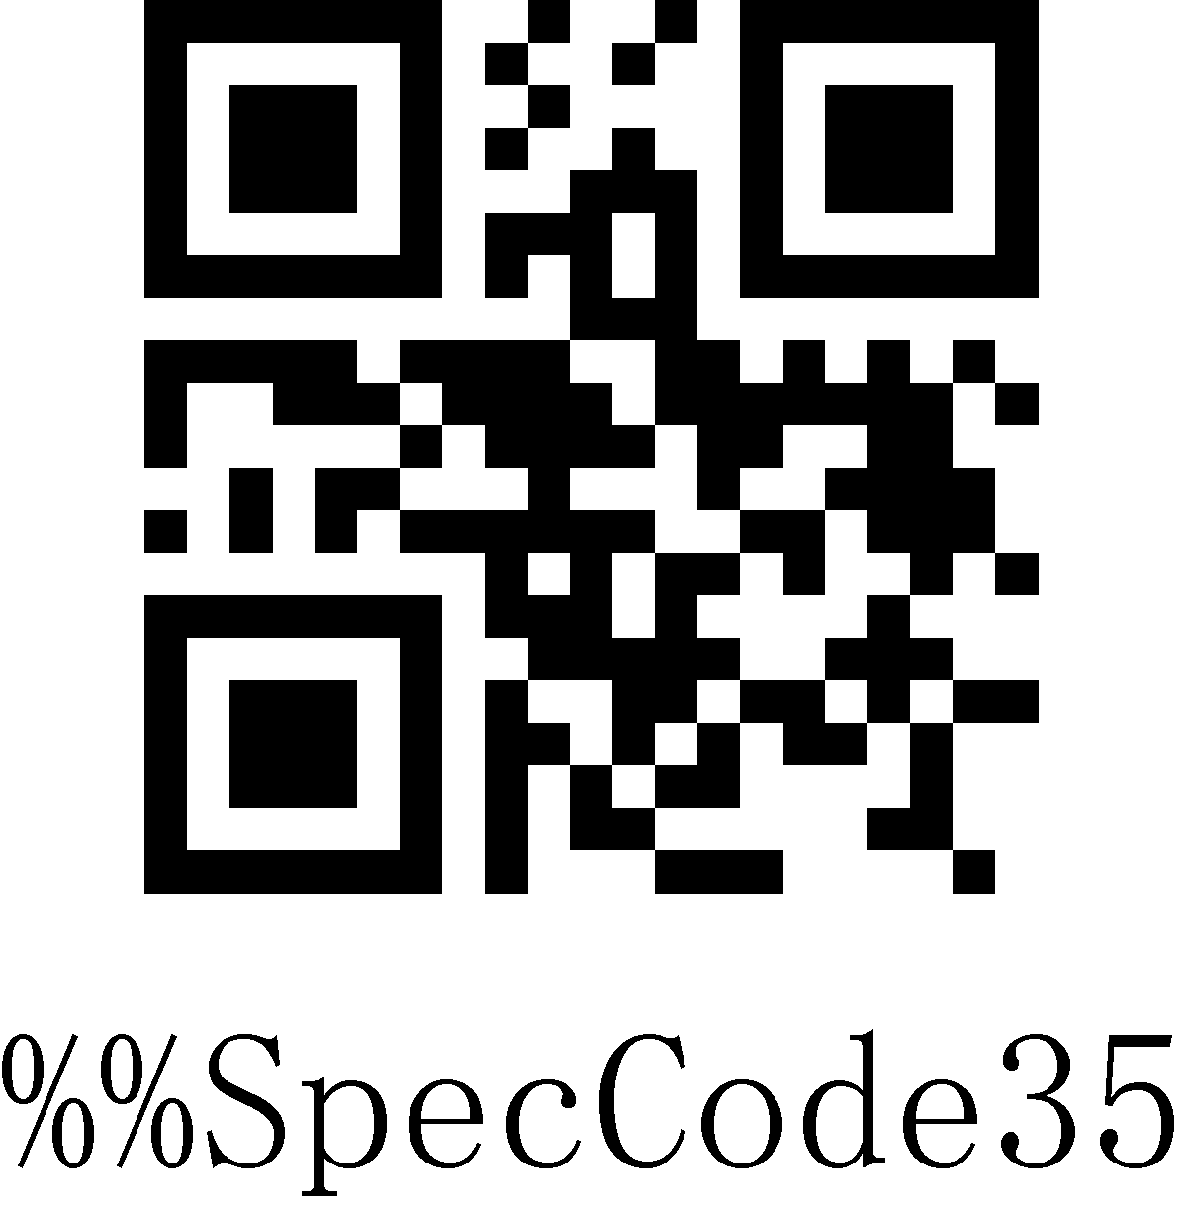
30min
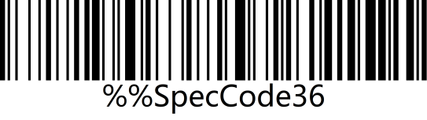 | 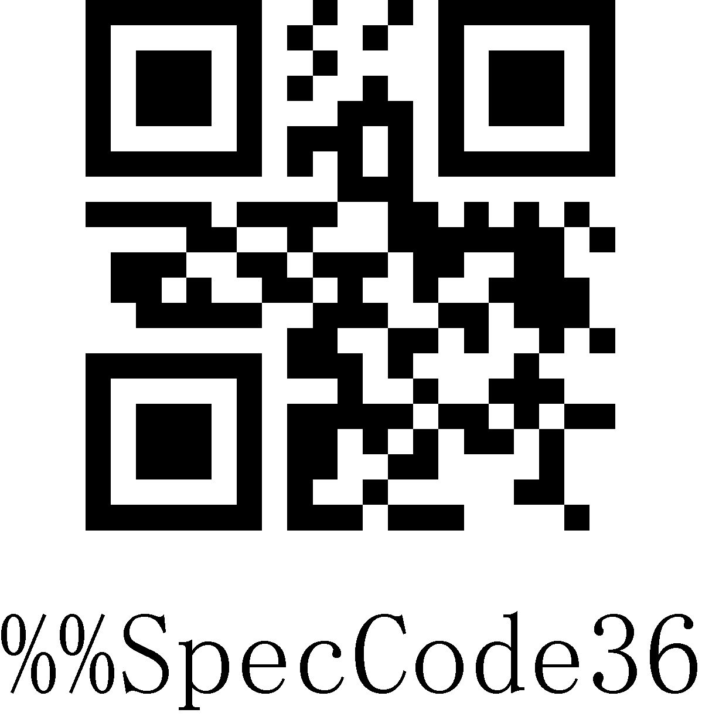
Never
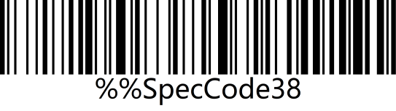 | 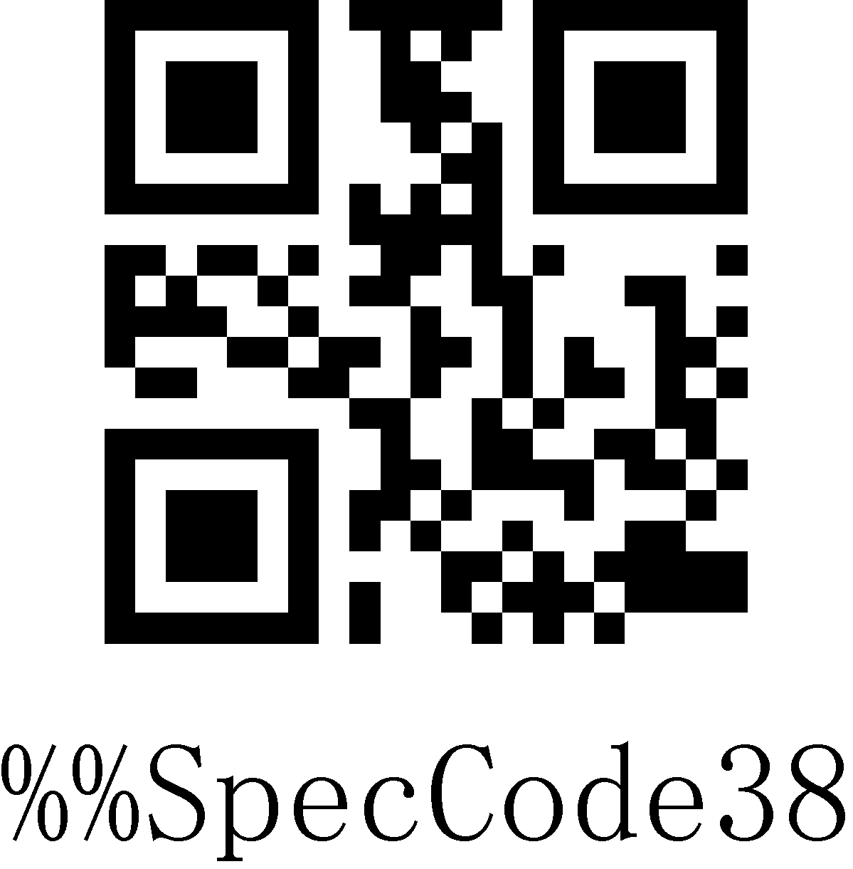
Sleep Immediately

Data Format
Use the scanner wireless 2.4G or wired USB interface to set the data input format, you can directly output Chinese or other format languages.
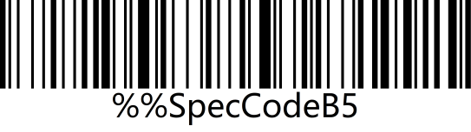 | 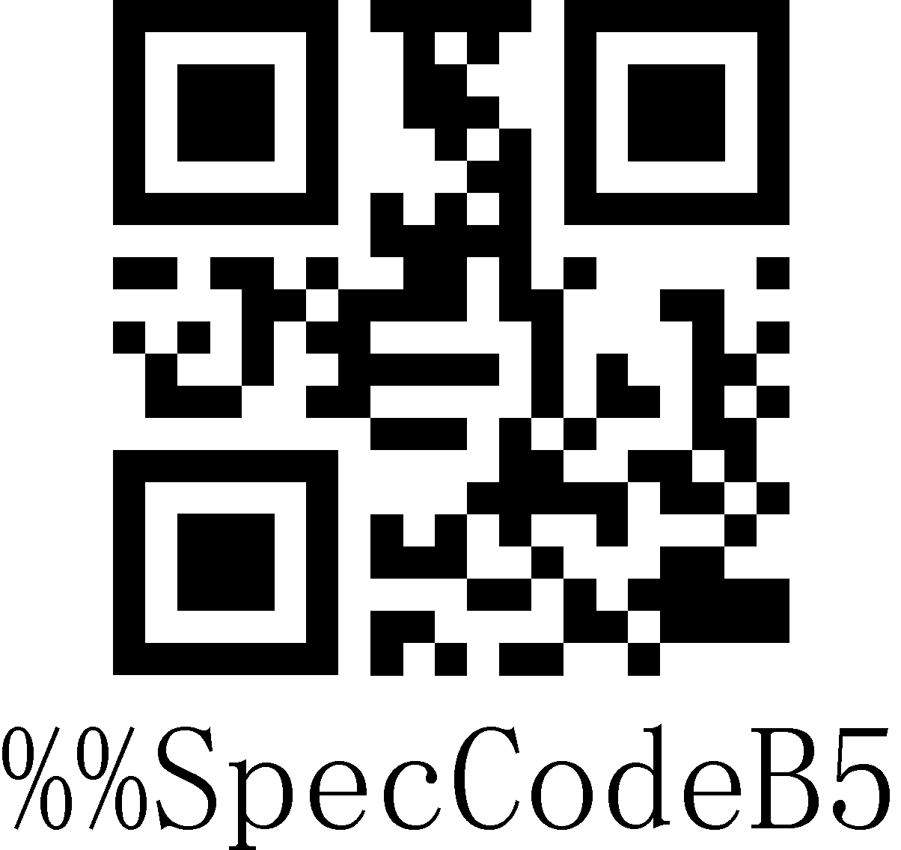
GBK（Notepad，Excel, etc）*
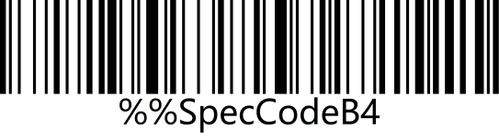 | 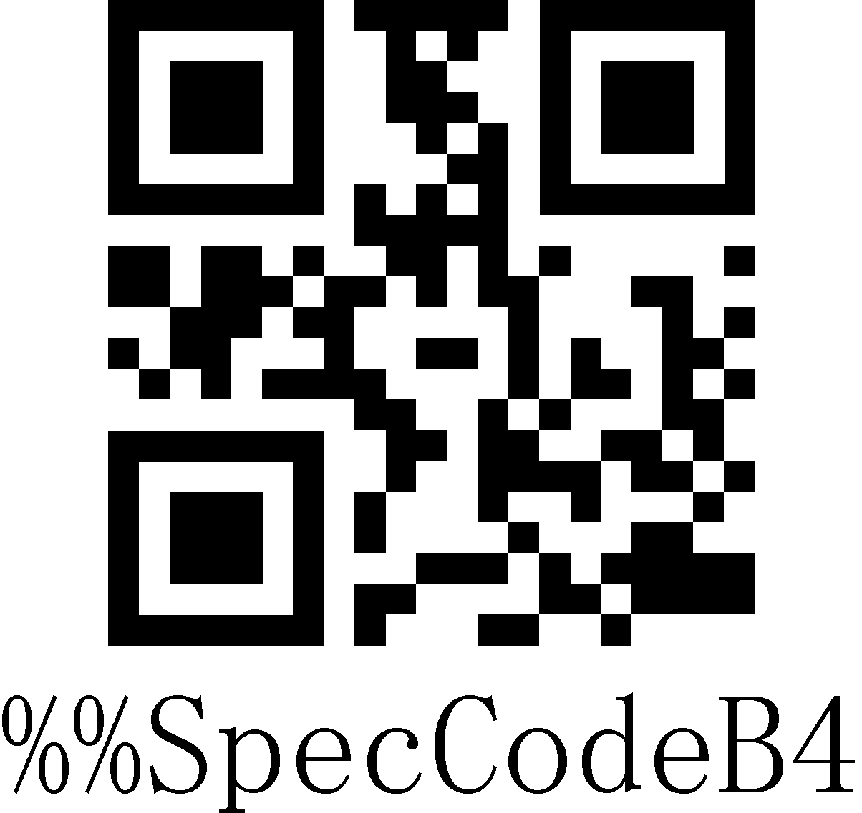
Unicode（WORD，QQ, etc）

Wireless Working Mode
The wireless scanner has two different working modes: instant upload mode and storage mode. The operation mode is switched by different setup codes.

Instant Upload Mode
Instant upload Mode is also called normal mode. In this mode, the barcodes that are scanned will be transmitted to the host device immediately.
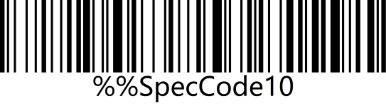 | 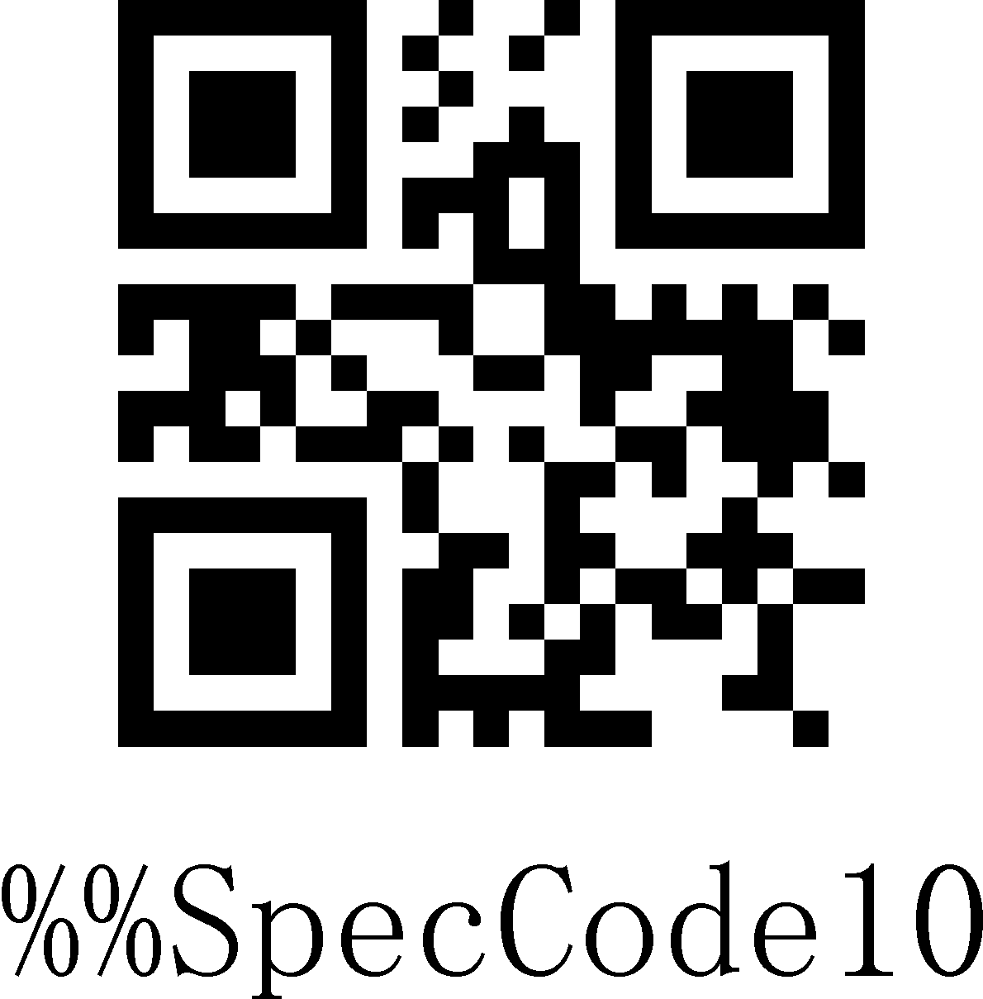
Instant Upload Mode*

Storage Mode
Storage Mode is also called inventory mode or warehouse mode. In storage mode, the scanner will not transmit scanned barcodes directly to the host device, but store them in the storage memory. If you need to check or clear the stored barcodes, refer to data control section. When the scanner is powered off, the barcodes stored will not get lost unless the “Clear All Barcodes Stored” setup code is scanned.
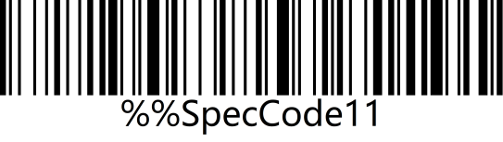 | 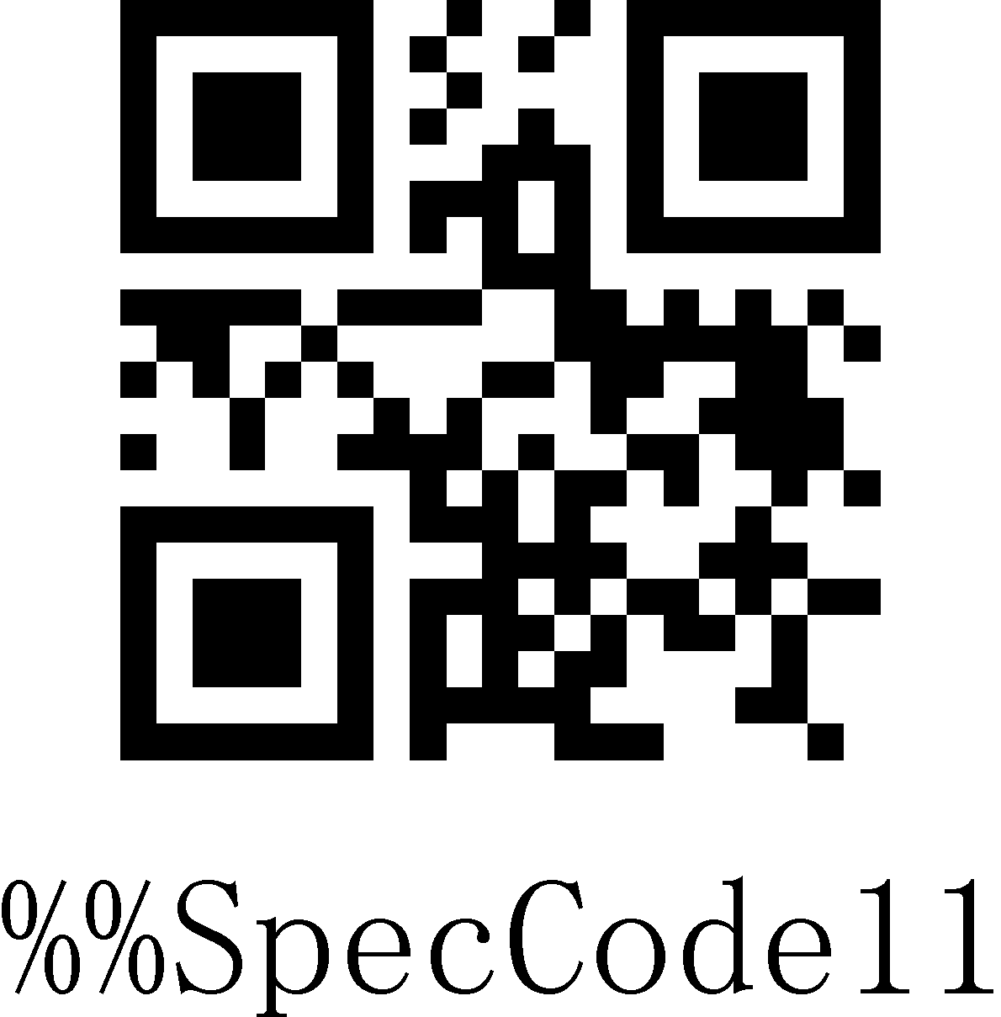
Storage Mode

Data Control
Data control is used for processing stored data.

Upload All Code
To upload the data stored in the memory, scan the “Upload All Codes” barcode to transmit data to computers or mobile devices. In whatever mode, the data stored in the memory will not be deleted when data upload succeeds unless the “Clear All Codes” is scanned.
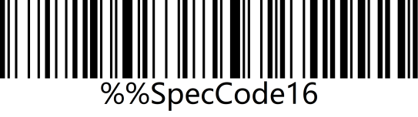 | 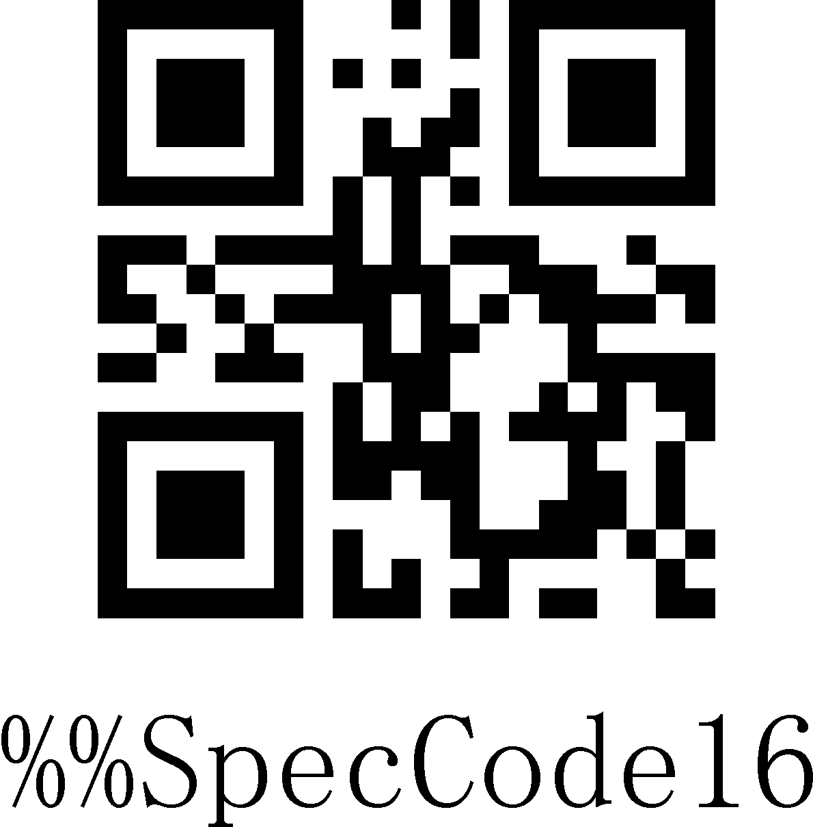
Upload All Codes

Upload Total Count
If you wish to output the total number of barcodes scanned, scan the barcode below.
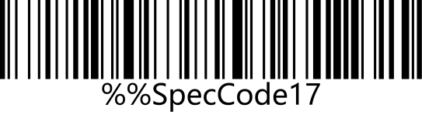 | 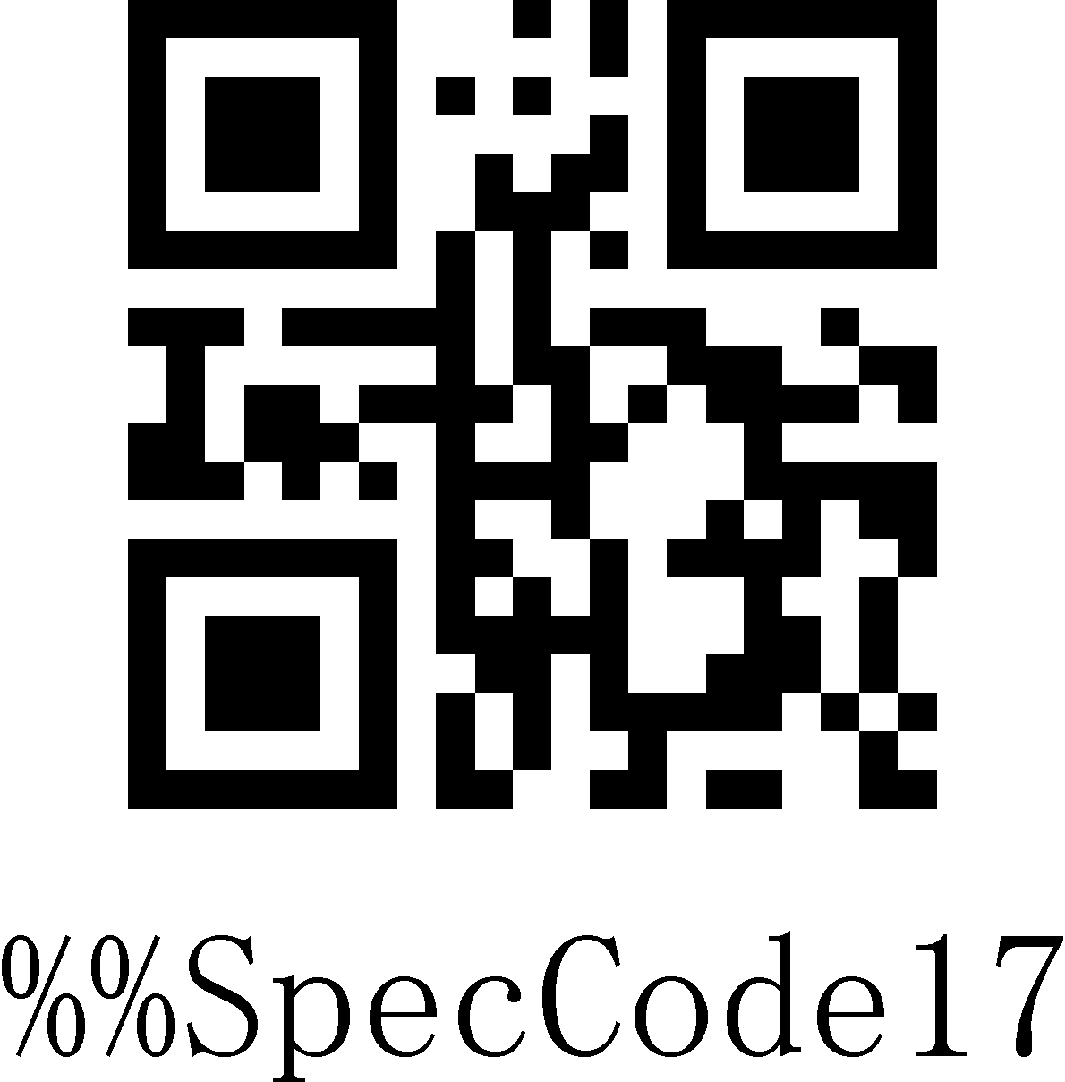
Upload Total Count

Clear All Codes
Scan the “Clear All Codes” to clear the data stored in the scanner memory.
Note: this operation will clear all stored data.
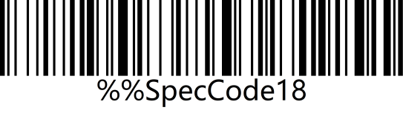 | 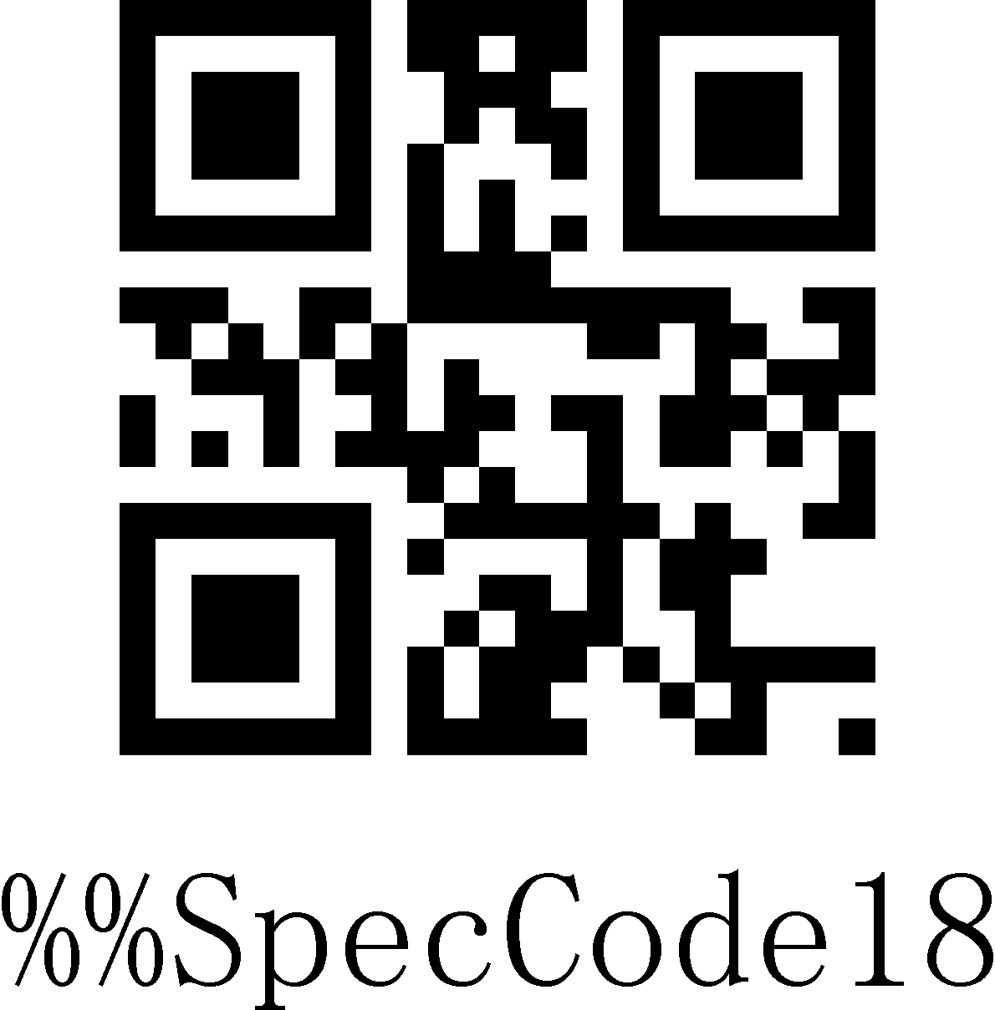
Clear All Codes

Communication Setting
This scanner can not only support wireless communication, but also supports wired communication. When the scanner is wired to the scanner, the scanner will automatically switch to wired transmission.

USB-COM
USB virtual serial port supports the use of 2.4G mode wireless virtual serial port and wired USB virtual serial port, whether you use wired or wireless virtual serial port, you need to install the virtual serial port driver.
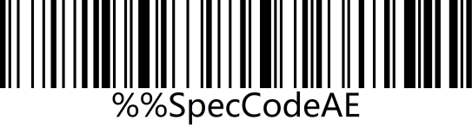 | 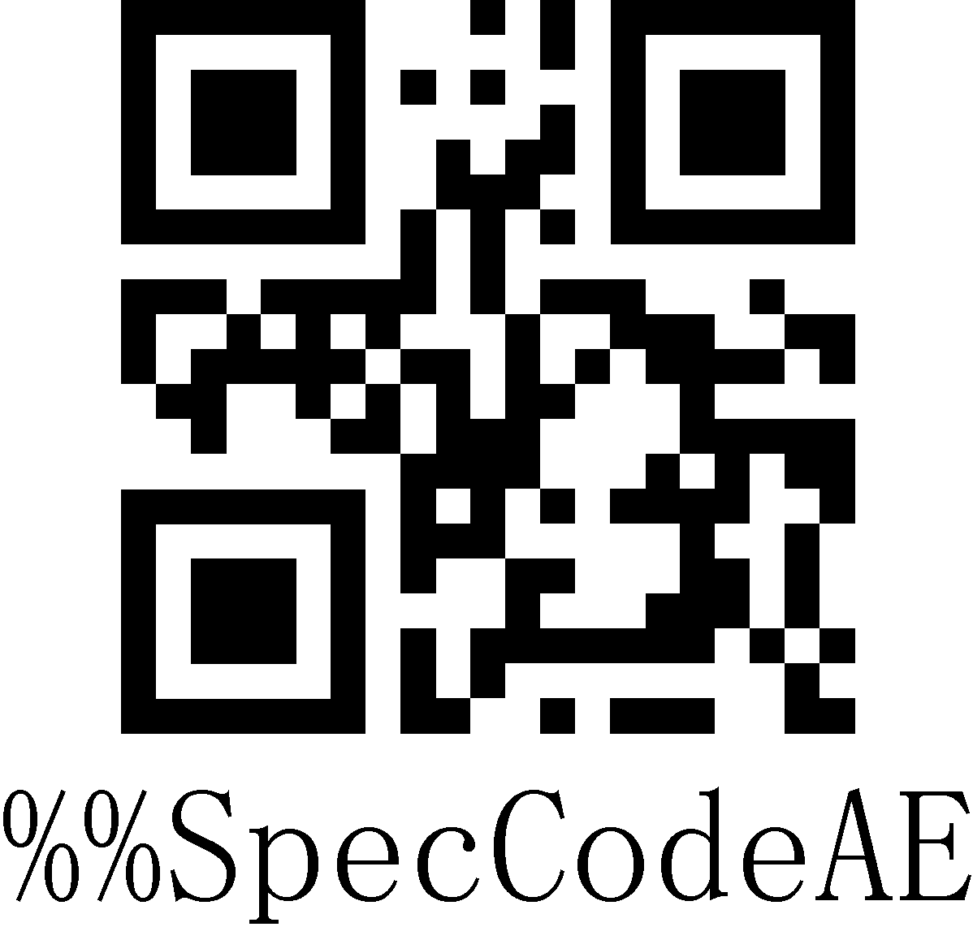
USB-COM

Wireless 2.4G Mode
It is suitable for devices that can be plugged into a 2.4G receiver, and can directly use text output, which is equivalent to USB keyboard input.
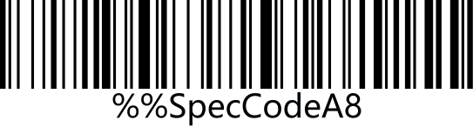 | 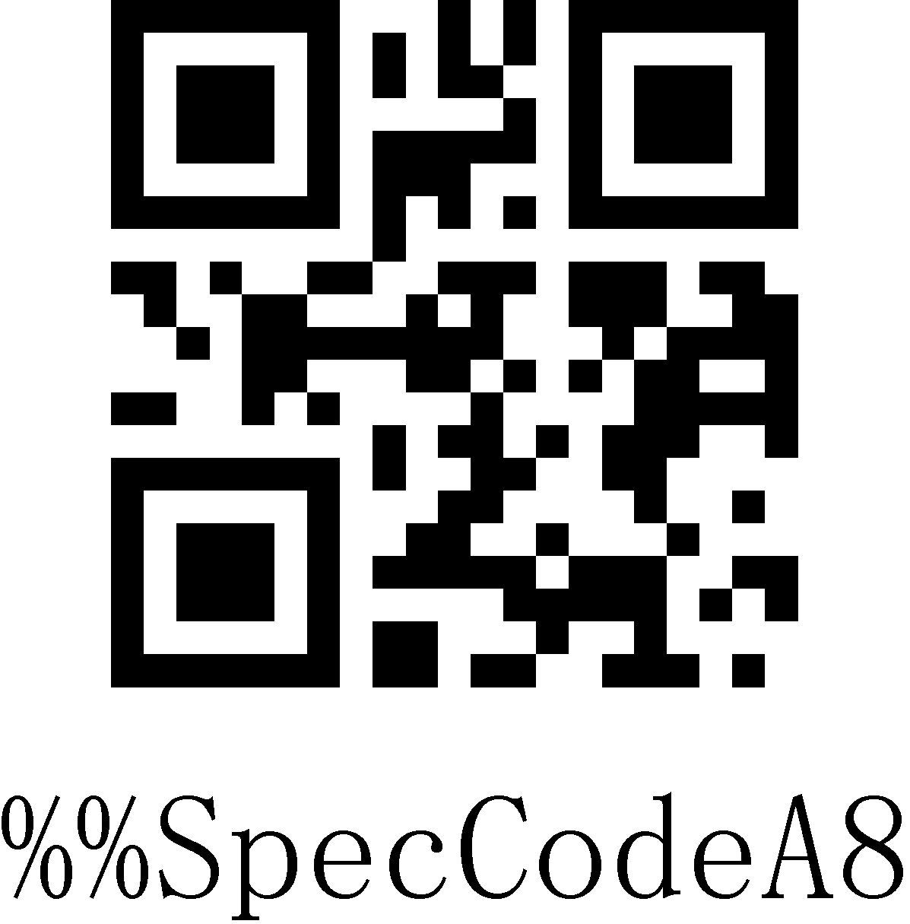
Wireless 2.4G Mode

Virtual Bluetooth Mode
Virtual Bluetooth is suitable for connecting to a host without Bluetooth and does not need to install a Bluetooth driver. When using virtual Bluetooth mode, you need to use a dedicated virtual Bluetooth receiver.
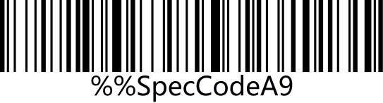 | 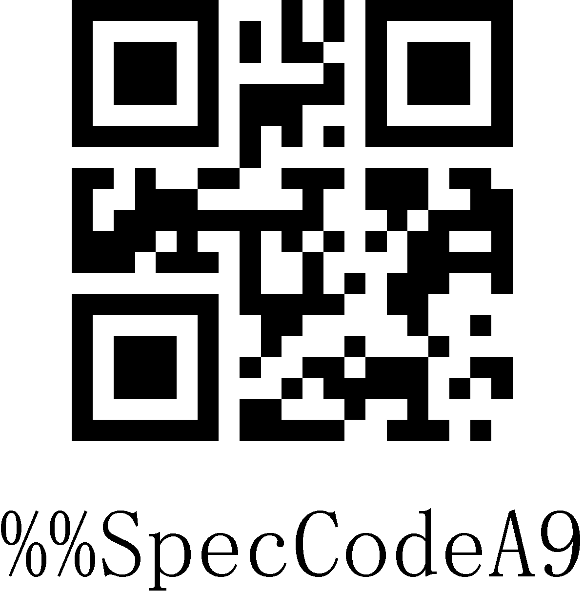
Virtual Bluetooth Mode

Bluetooth HID Mode
It is suitable for using in devices that support Bluetooth, such as mobile phones, pads, laptops with Bluetooth, etc. After the connection is successful, you can use direct text input, which is equivalent to the virtual keyboard input method of this type of device.
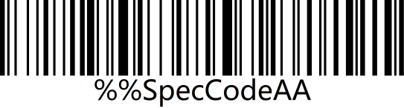 | 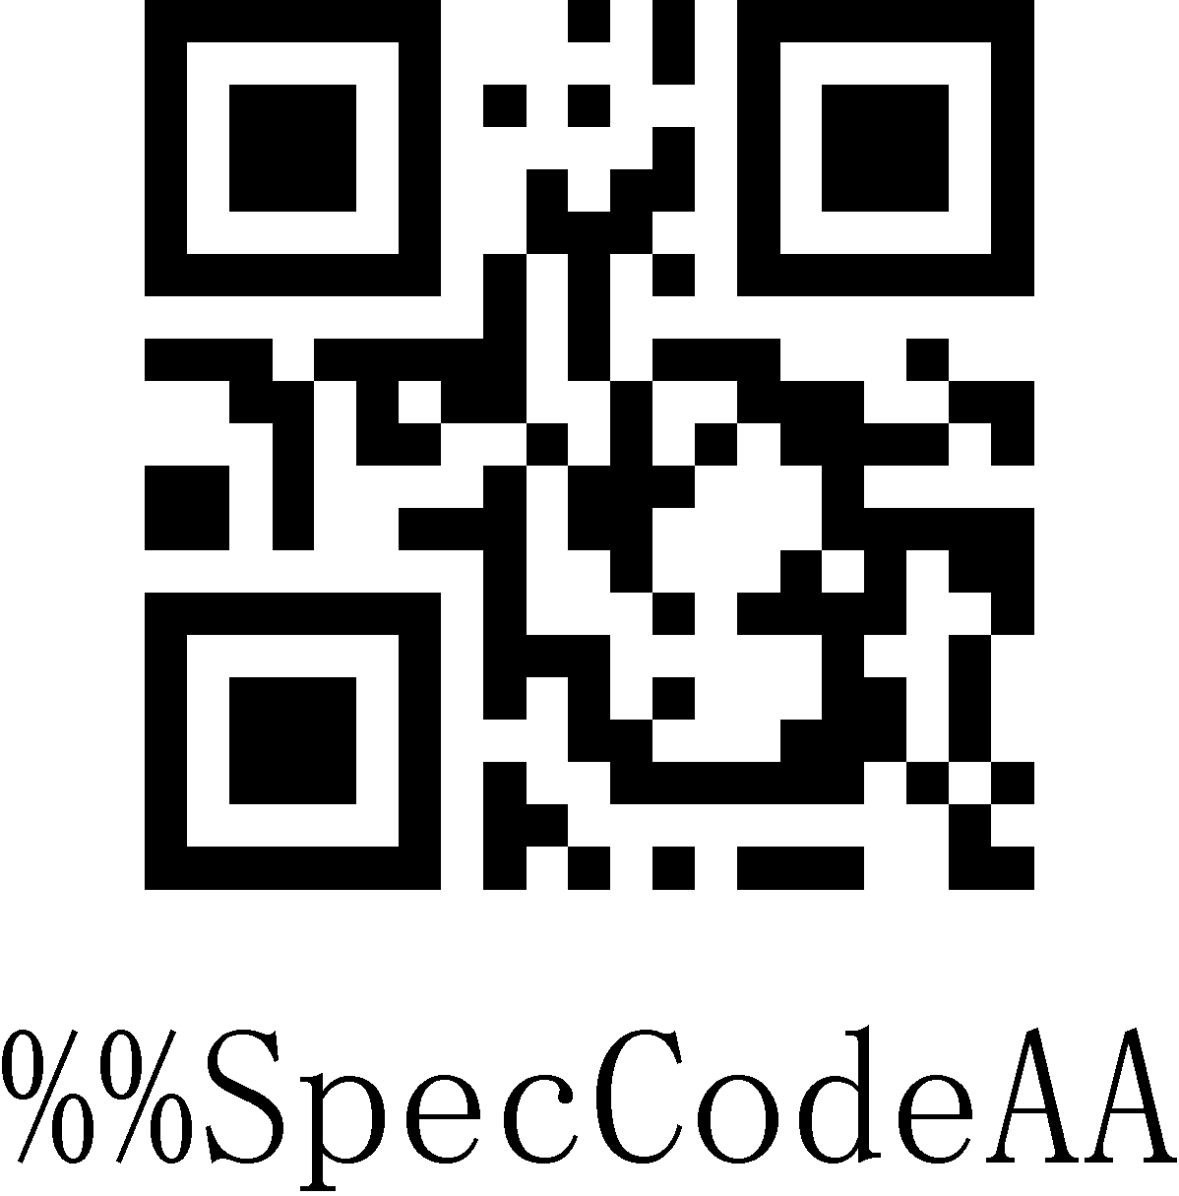
Bluetooth HID Mode

Bluetooth SPP Mode
It is suitable for use in devices that support Bluetooth, such as mobile phones, pads, laptops with Bluetooth, etc. When using SPP to transparently transmit data, you need to download or develop classic Bluetooth SPP transparent transmission software before it can be used. SPP mode is suitable for mass data transmission.
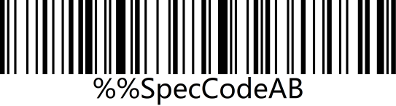 | 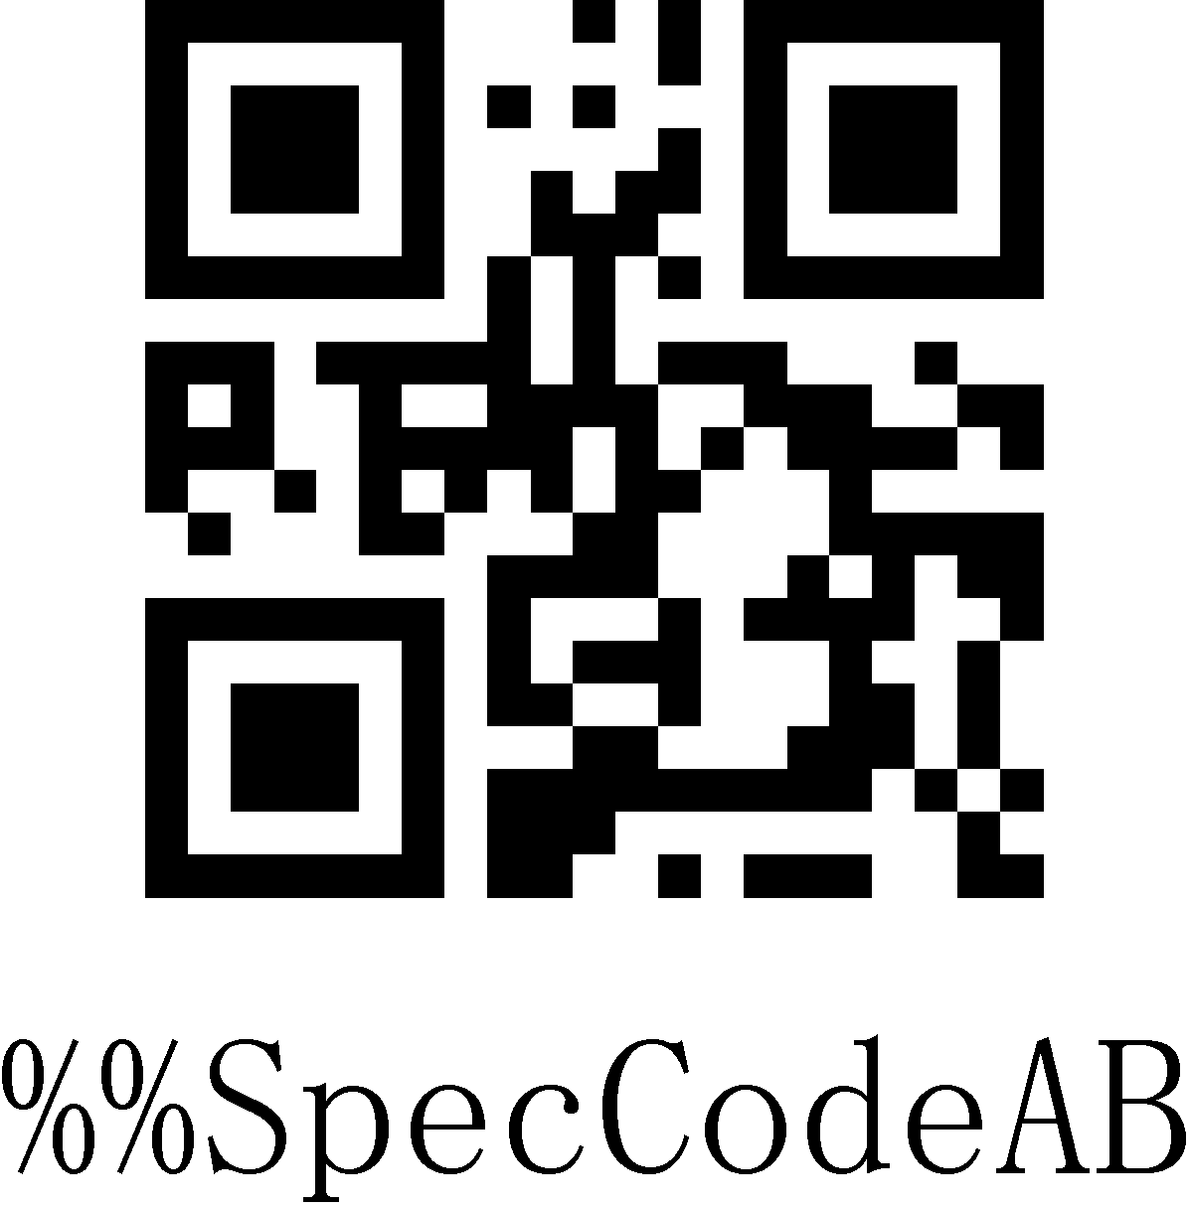
Bluetooth SPP Mode

Bluetooth BLE Mode
It is suitable for use in devices that support Bluetooth, such as mobile phones, pads, laptops with Bluetooth, etc. When using BLE to transparently transmit data, you need to download or develop low-power Bluetooth BLE transparent transmission software before it can be used. BLE mode is suitable for small amount of data transmission.
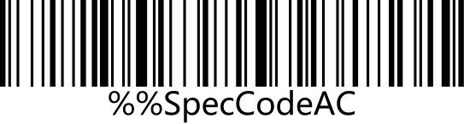 | 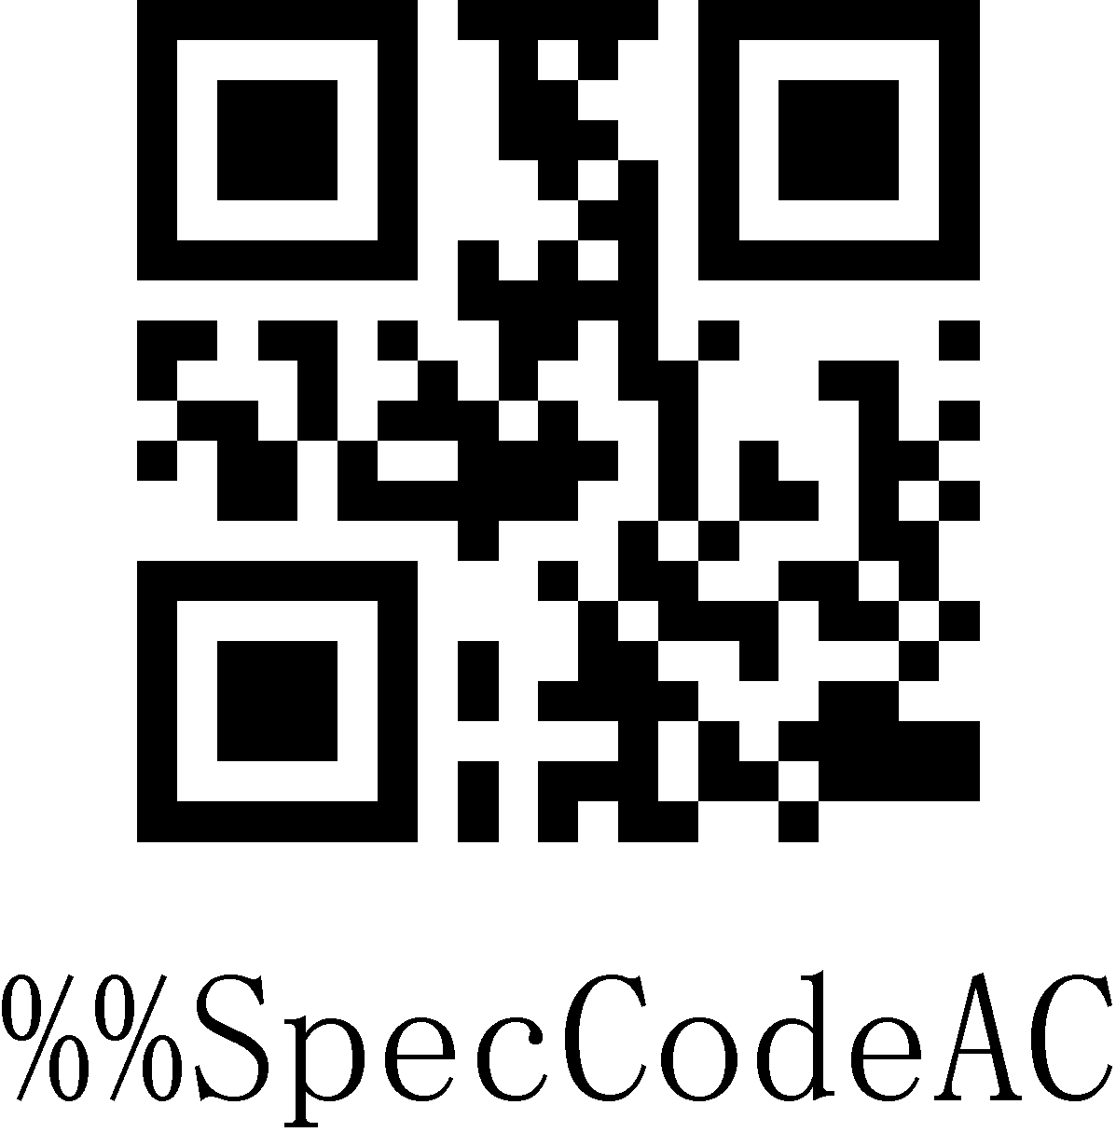
Bluetooth BLE Mode

Wireless Pairing

2.4 Wireless Pairing Steps (Dongle Pairing)
Compatible with XP、Win7、Win8、Win10，MAC OS and so on.
Step 1: Scan the "Wireless 2.4G Mode" setup code
When setting the wireless 2.4G mode, it will give priority to connect to the last paired receiver by default.
 | 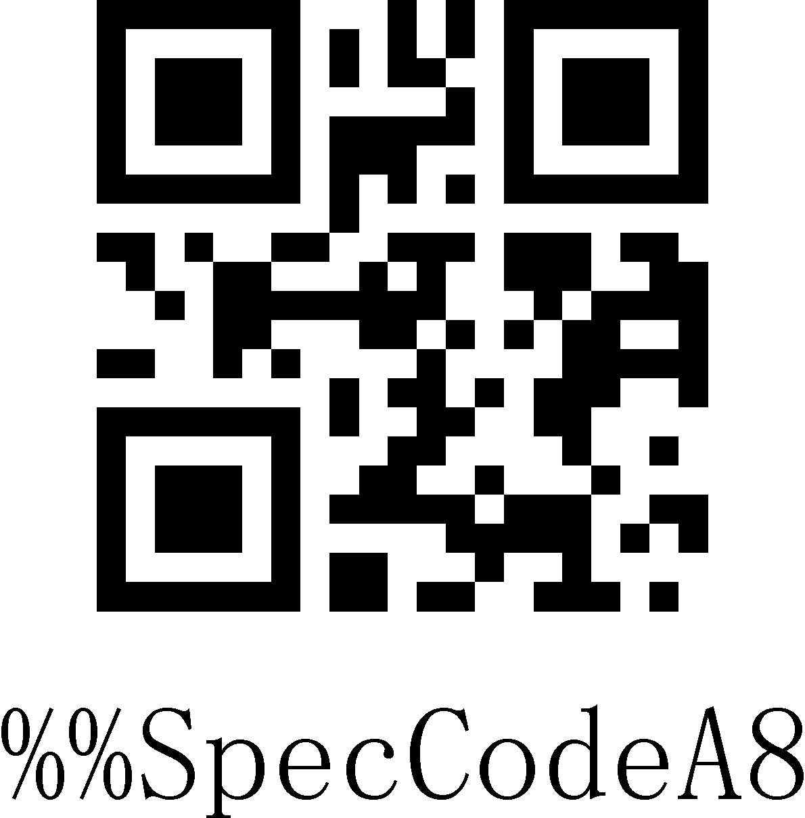
Wireless 2.4G Mode
Step 2: Scan the "Forced Pairing" setup code to enter the pairing state, and the blue LED1 flashes quickly.
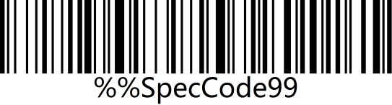 | 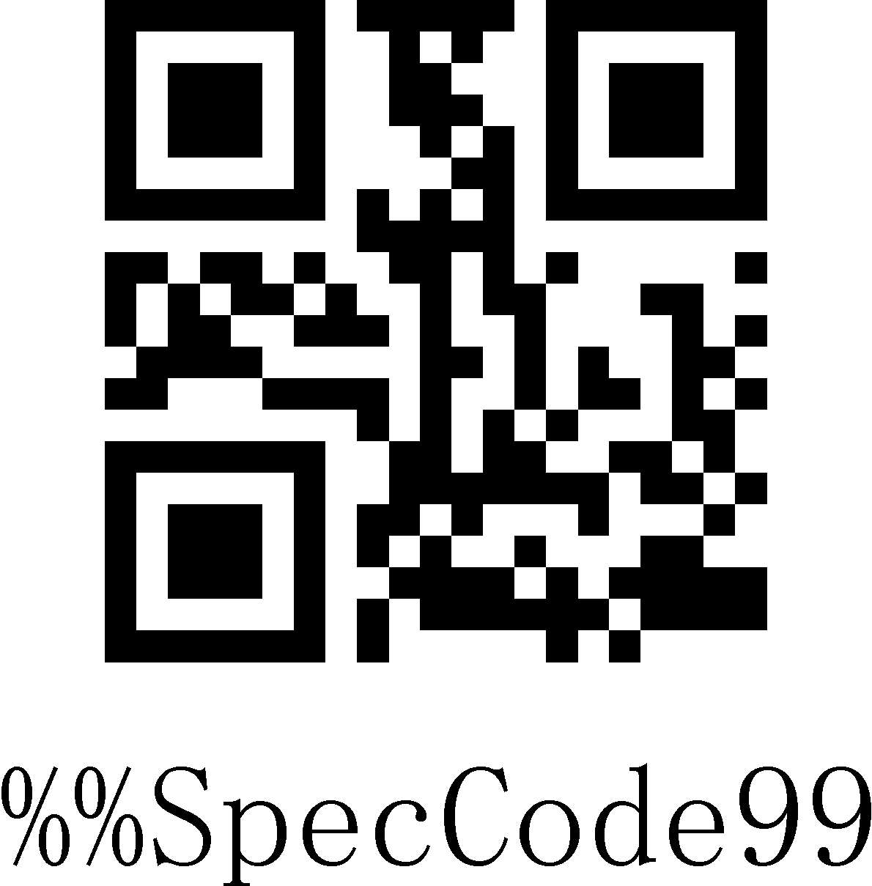
Forced Pairing
Step 3: Plug in Dongle (receiver) and hear a beep, indicating that the connection and pairing is successful. Blue LED2 is always on.

Note:
When the scanner is in the pairing state, you can exit the pairing state by double-clicking the button or the pairing timeout for 1 minute.

Virtual Bluetooth Pairing Steps
Compatible with XP、Win7、Win8、Win10，MAC OS and so on.
Step 1: Scan the "Virtual Bluetooth Mode" setup code
When setting the virtual bluetooth mode, the virtual bluetooth receiver paired last time will be connected first by default。
Virtual Bluetooth mode
Step 2: Scan the "Forced Pairing" setup code to enter the pairing state, and the blue LED1 flashes quickly.
Frced Pairing
Step 3: Plug in Dongle (receiver) and hear a beep, indicating that the connection and pairing is successful. The blue LED2 is always on.

Note:
When the scanner is in the pairing state, you can exit the pairing state by double-clicking the button or the pairing timeout for 1 minute.

Bluetooth HID Pairing Steps
Step 1: Scan the "Bluetooth HID Mode" setup code
When setting the wireless bluetooth HID mode, it will give priority to connect to the last paired bluetooth by default.
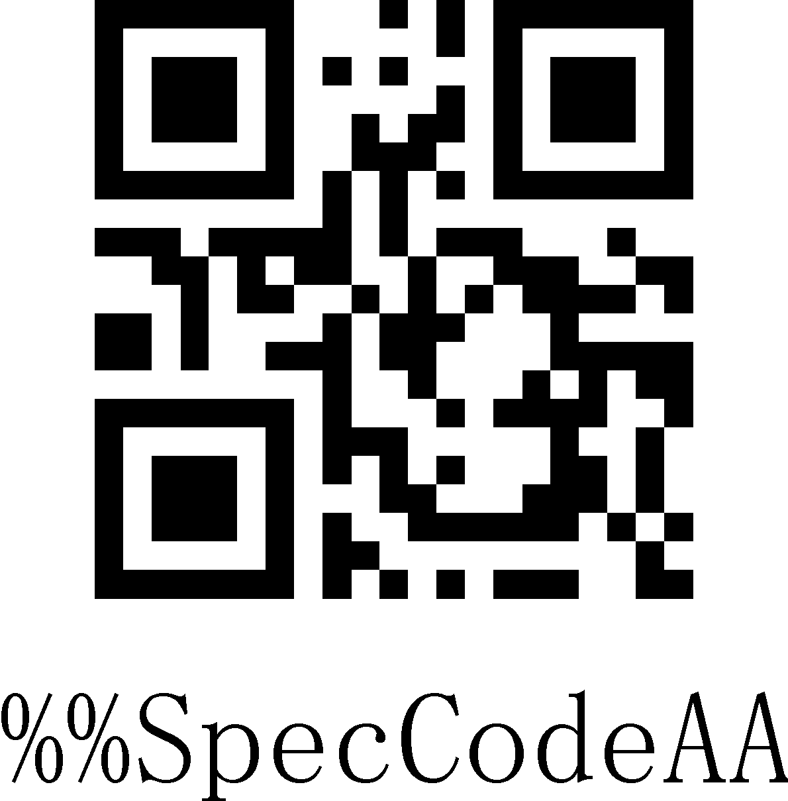
Bluetooth HID Mode
Step 2: Scan the "Forced Pairing" setup code to enter the pairing state, and the blue LED1 and blue LED2 flash alternately.
Forced Pairing
Note: Press and hold the button for 8 seconds without releasing it and you will hear a beep, and then release the button to enter the Bluetooth HID pairing state (this function needs to be turned on).
Step 3: Turn on Bluetooth in the device and search for "BarCode Bluetooth HID".
Step 4: Click "BarCode Bluetooth HID" Bluetooth device to enter the pairing state.
Step 5: When you hear a beep, it means the connection and pairing is successful, and the blue LED2 is always on.

Note:
When the scanner is in the pairing state, you can exit the pairing state by double-clicking the button or the pairing timeout for 1 minute.

Bluetooth SPP Pairing Steps
Step 1: Scan the "Bluetooth SPP Mode" setup code
When setting the wireless Bluetooth SPP mode, it will automatically enter the SPP mode and enter the broadcast state by default. You can directly click the BarCode Bluetooth SPP device in the SPP software to pair。
Bluetooth SPP Mode

Step 2: Search for "BarCode Bluetooth SPP" in the SPP transparent transmission software.
Step 3: Click the "BarCode Bluetooth SPP" Bluetooth device to enter the pairing state.
Step 4: When you hear a beep, it means the connection and pairing is successful, and the blue LED2 is on.

Bluetooth BLE Pairing Steps
Step 1: Scan the "Bluetooth SPP Mode" setup code
When setting the wireless Bluetooth BLE mode, it will automatically enter the BLE mode and enter the broadcast state by default. You can directly click the BarCode Bluetooth BLE device in the BLE software to pair.
Bluetooth BLE Mode

Step 2: Search for "BarCode Bluetooth BLE" in the SPP transparent transmission software.
Step 3: Click the "BarCode Bluetooth BLE" Bluetooth device to enter the pairing state.
Step 4: When you hear a beep, it means the connection and pairing is successful, and the blue LED2 is on.

Bluetooth Mode Function Setting

Press and hold for 8s to enter HID Mode
When using a Bluetooth barcode, turn on and hold for 8 seconds to enter the Bluetooth HID search.

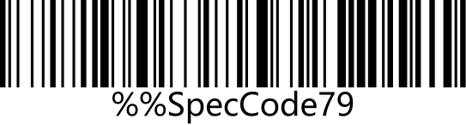 | 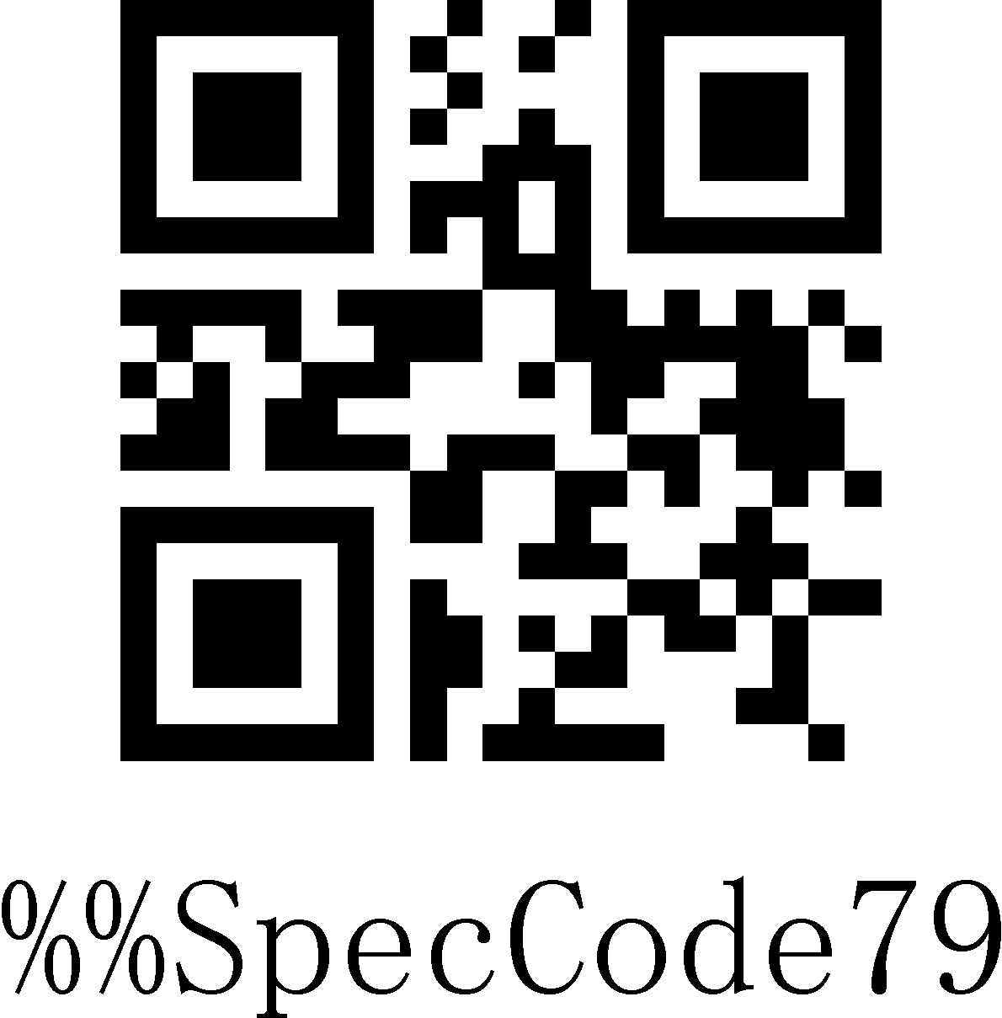
On
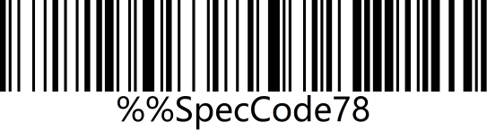 | 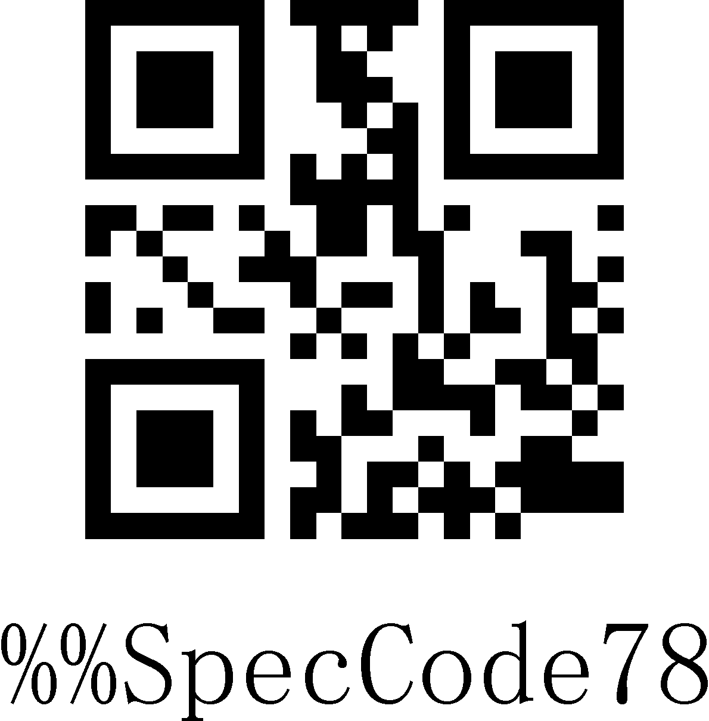
Off

IOS System HID Virtual Keyboard Setting
When using Bluetooth HID mode to connect to IOS system, scan "Show or hide IOS keyboard" to show or hide IOS keyboard
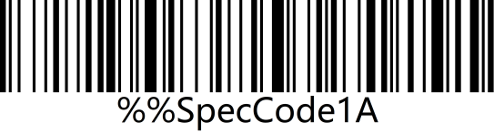 | 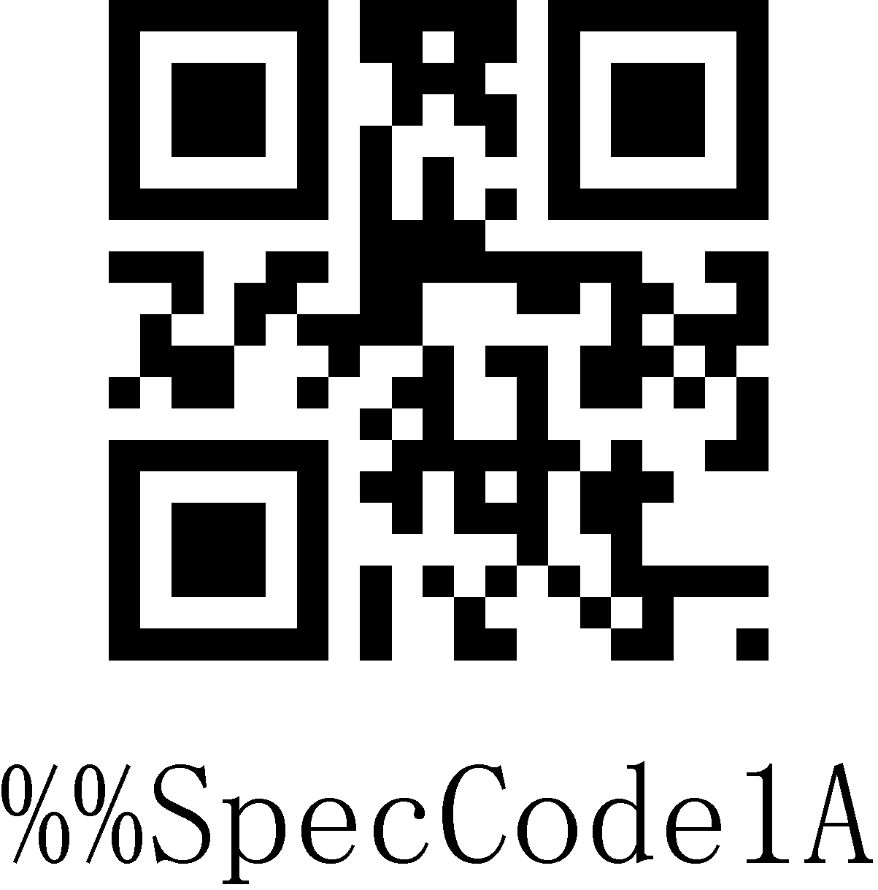
Show/Hide IOS Keyboard

Users can also set to quickly show or hide the IOS keyboard. When double-click to display the IOS keyboard function is enabled, the IOS virtual keyboard can be called up by quickly clicking the scanner button.
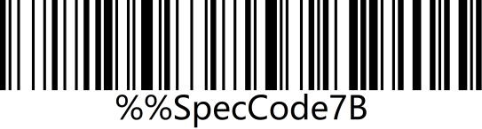 | 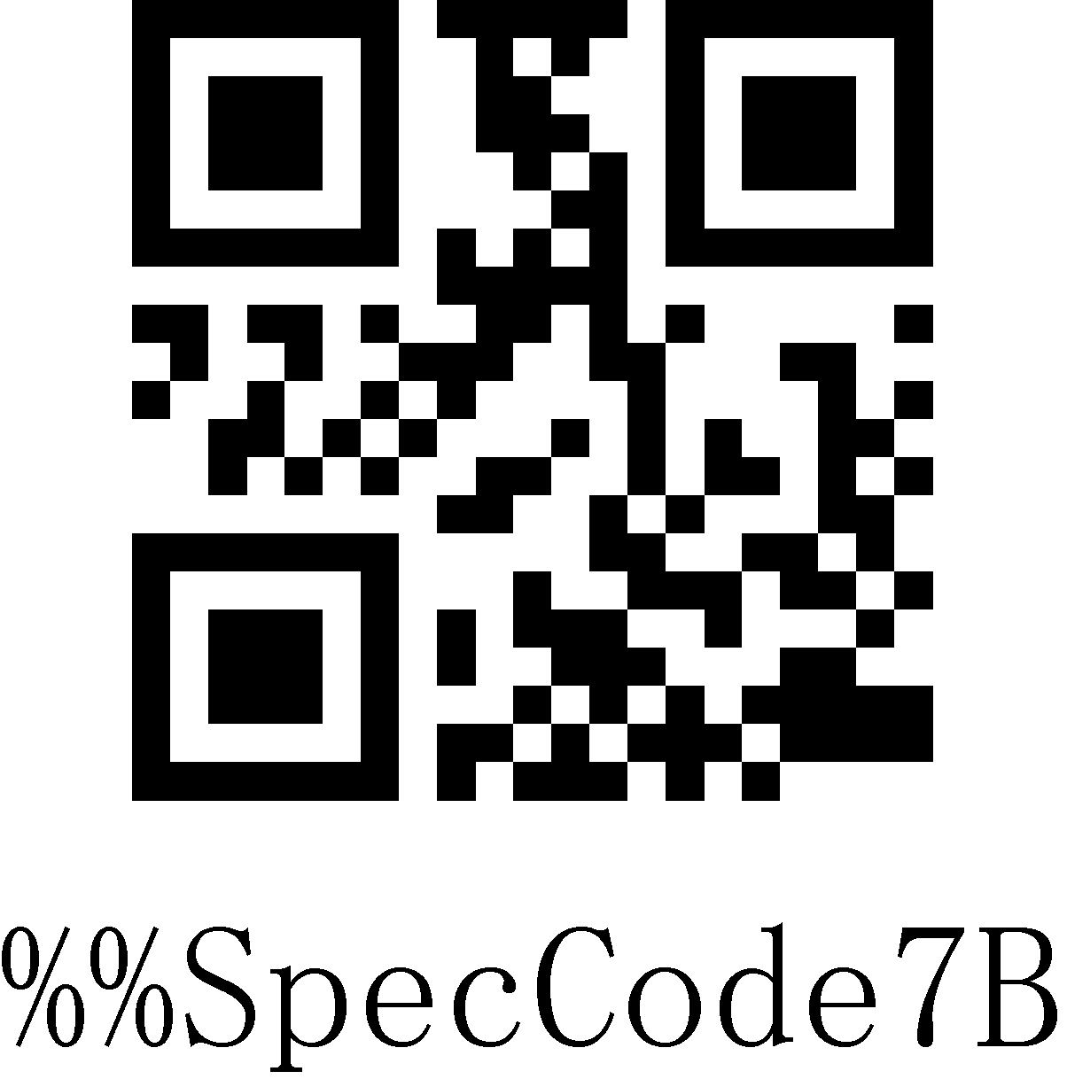
Turn on the double-click to display the IOS keyboard function (HID mode)
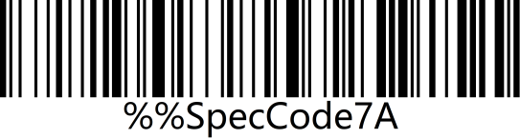 | 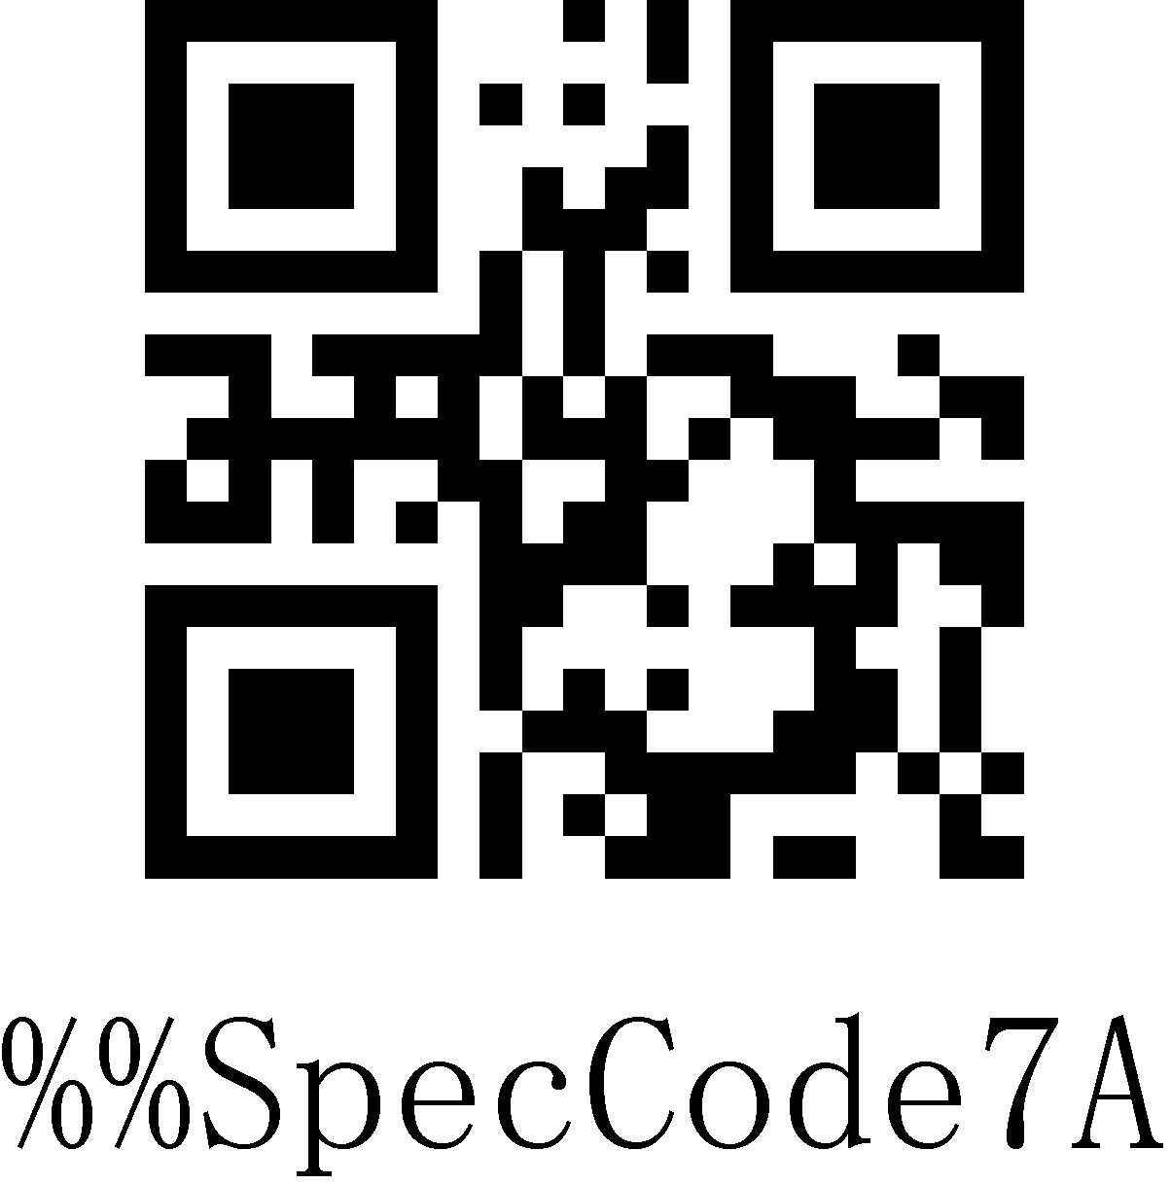
Turn off the double-click to display the IOS keyboard function (HID mode)

Note: For the Android system keyboard display, please contact the supplier to obtain the Bluetooth input method APP (due to the Android system, some mobile phone manufacturers support the virtual keyboard when connected to the Bluetooth scanner)

Bluetooth HID Upload Speed
When using Bluetooth HID to connect to a Bluetooth host, the upload speed of the Bluetooth scanner can be adjusted according to the response capability of the Bluetooth host. If the uploaded content is messy or missing, please lower the speed.
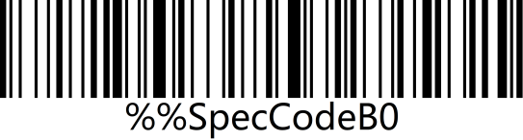 | 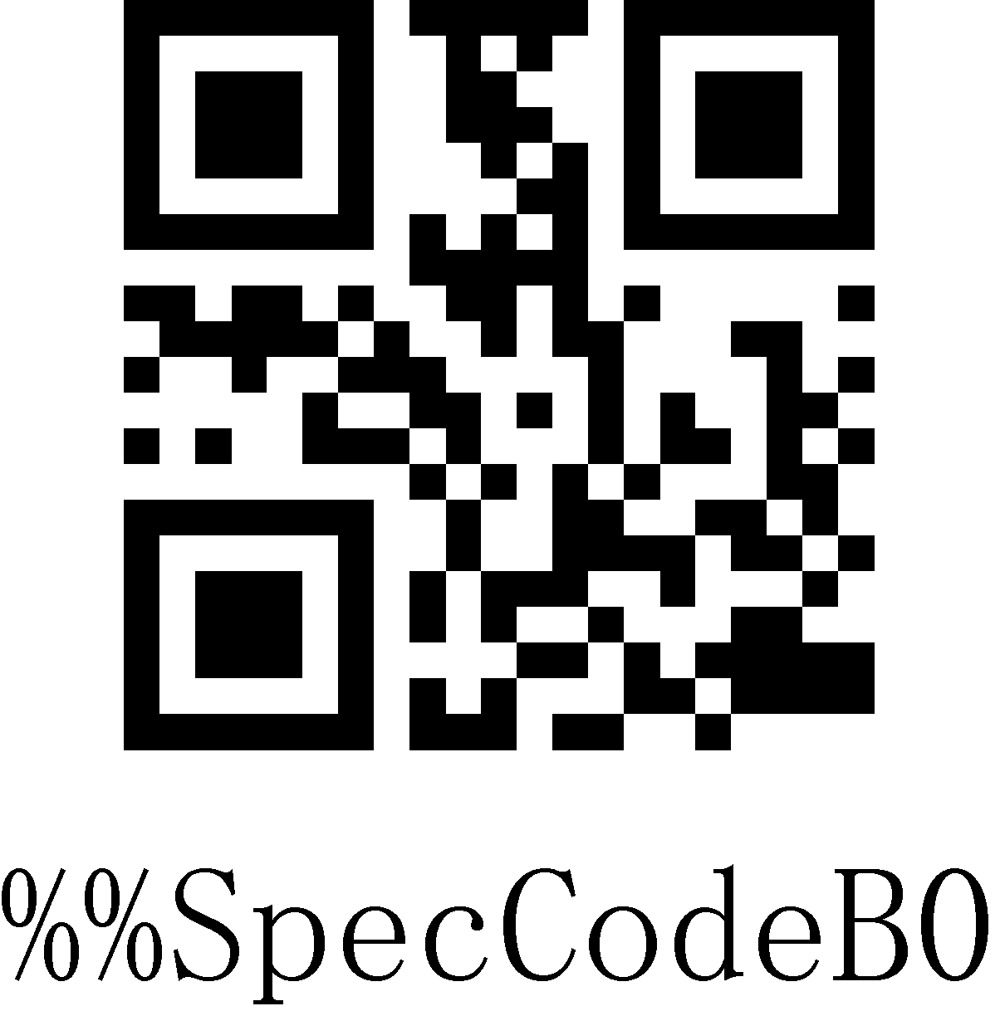
Fast
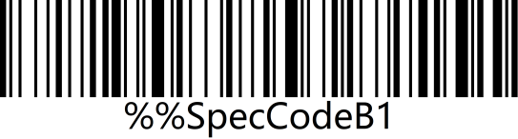 | 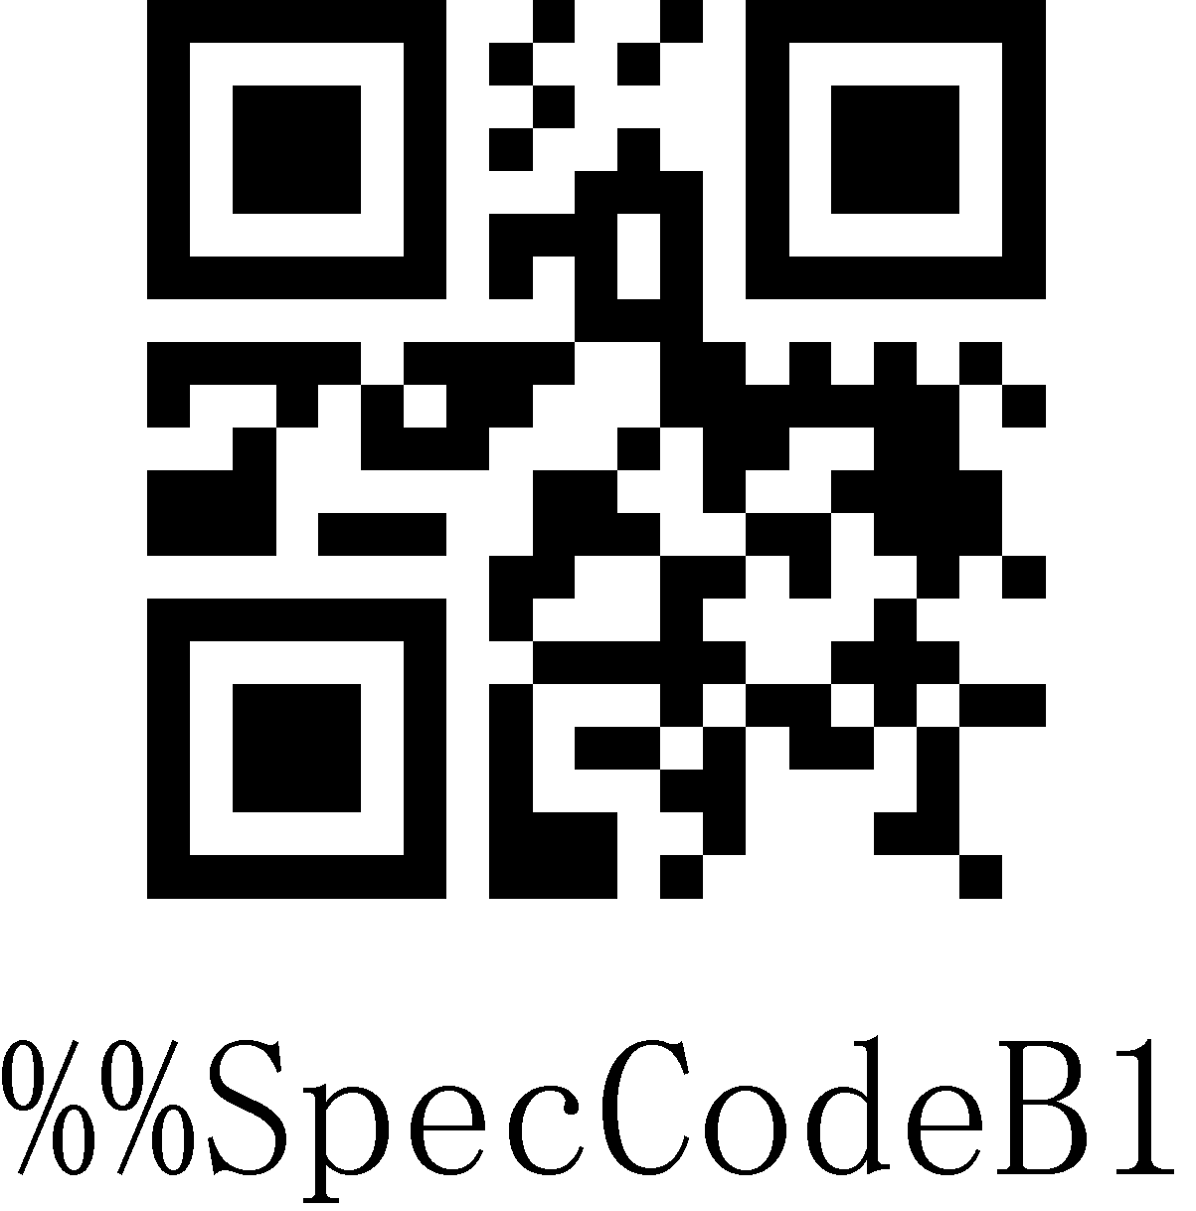
Medium*
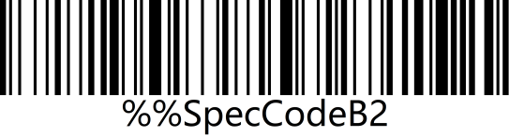 | 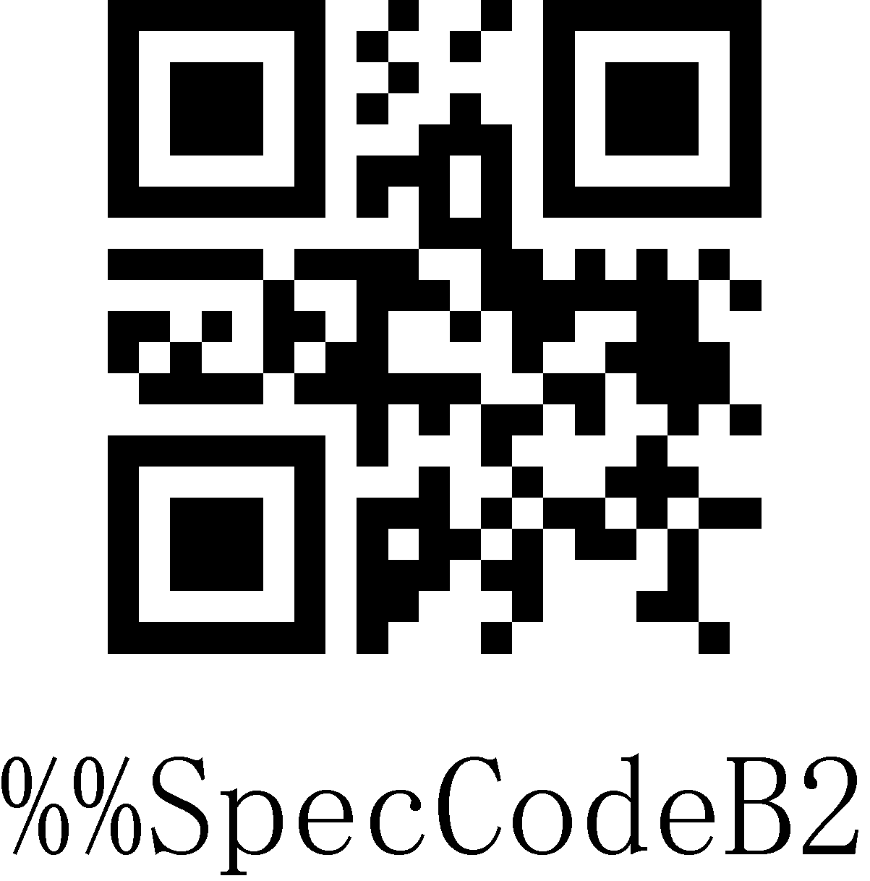
Slow
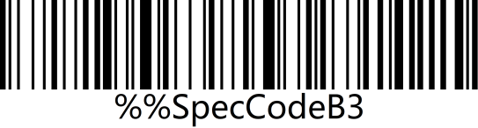 | 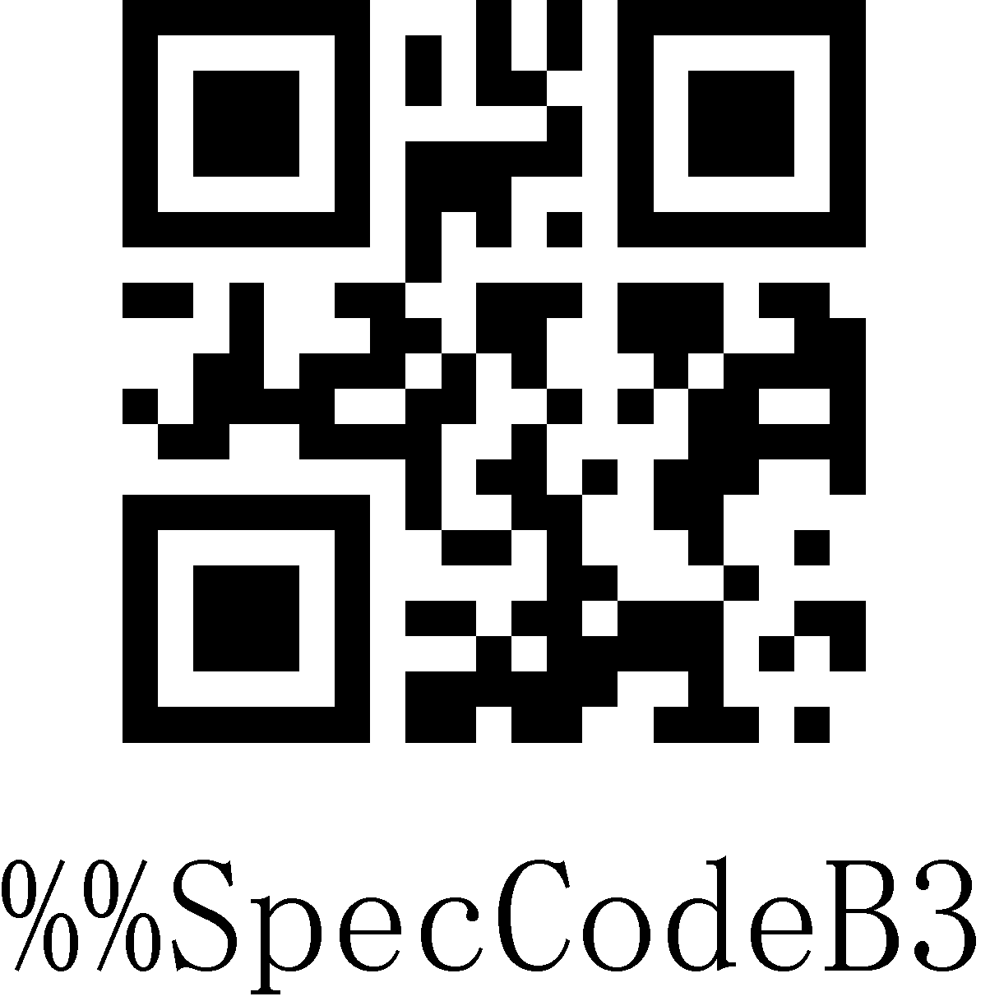
Very slow

Bluetooth Name
Use the following steps to customize the Bluetooth name of Bluetooth HID, SPP and BLE.

Steps
Step 1: Scan the "Custom Bluetooth Name" setup code
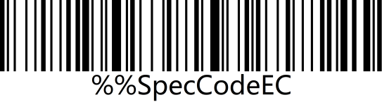 | 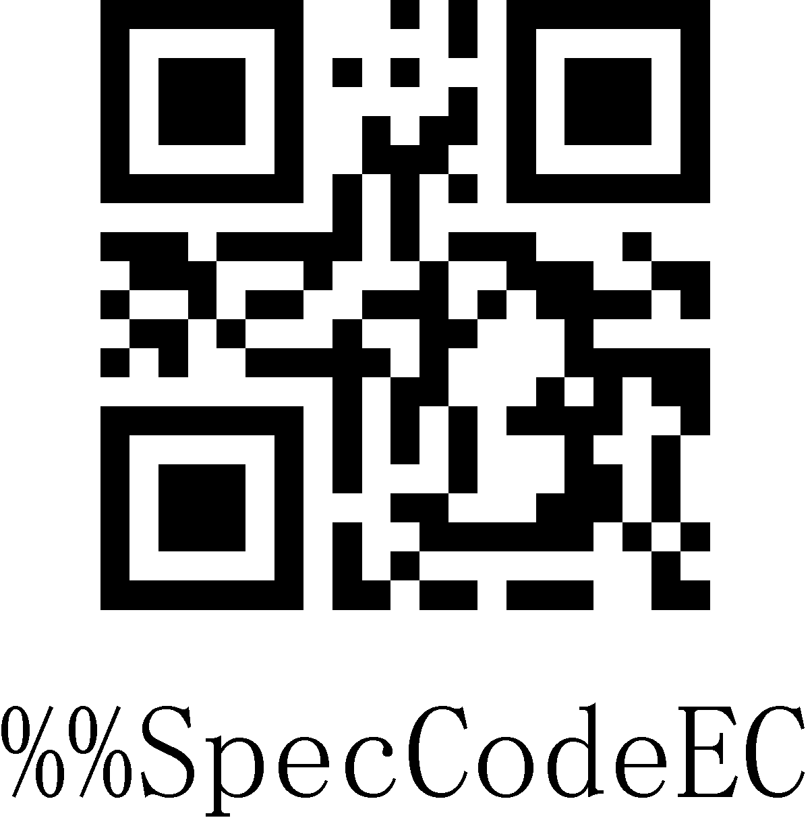
Custom Bluetooth Name
Step 2: Scan the Bluetooth name barcode.

Note: The default name of Bluetooth is "Barcode Scanner". After setting through this step, this barcode will be set to the name of Bluetooth.
a) The name can only be set up to 16 bytes. If the name of barcode exceeds 16 bytes, the scanner will only take the first 16 bytes as the Bluetooth name.
b) The complete Bluetooth name includes: Bluetooth name + protocol type, and only supports to modify the Bluetooth name. After modifying the Bluetooth name, the names of all Bluetooth protocols have been changed.

Example: Set the Bluetooth name to: Scanner.
Step 1: Scan the "Custom Bluetooth Name" setup code
Custom Bluetooth Name
Step 2: Make and scan the Bluetooth name barcode
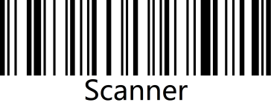 | 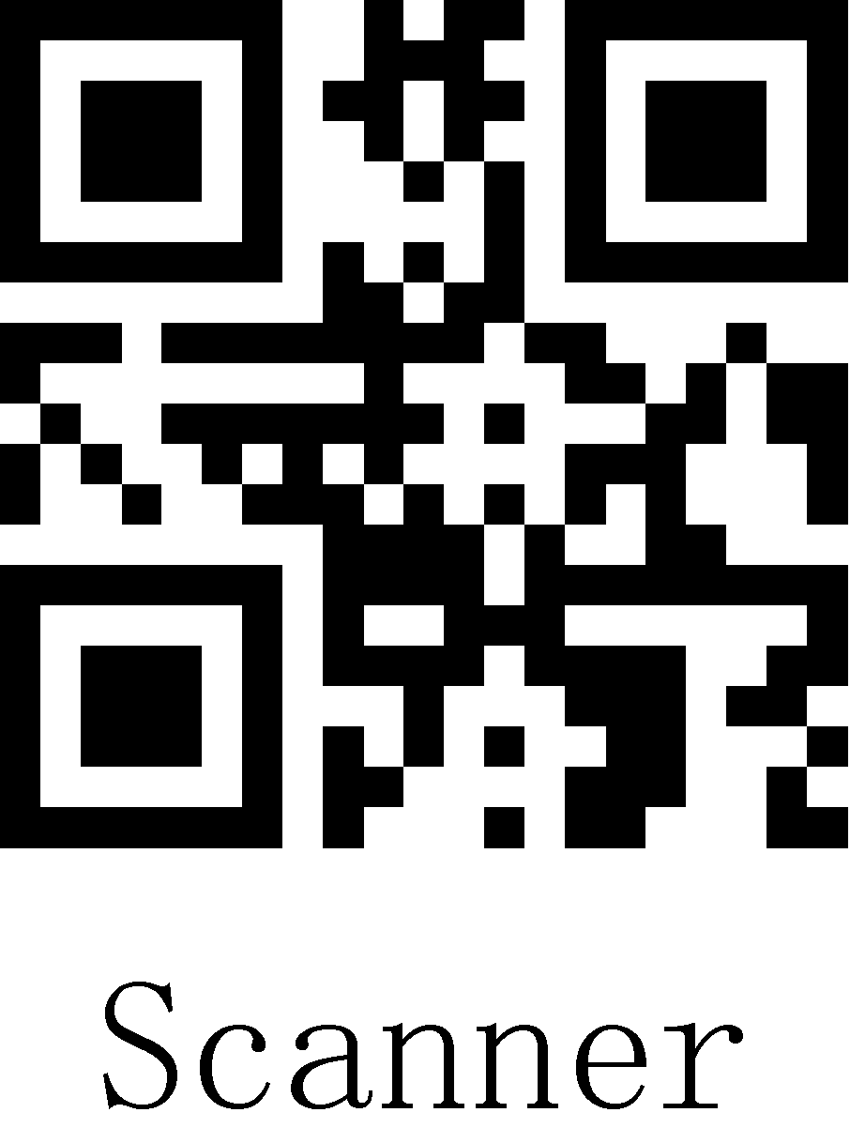
Bluetooth Name: Scanner

After setting:
The name of the Bluetooth HID is displayed as: Scanner HID;
The name of the Bluetooth SPP is displayed as: Scnaner SPP;
The name of Bluetooth BLE is displayed as Scanner BLE.

Get the Bluetooth Name
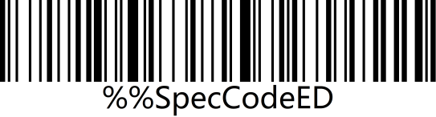 | 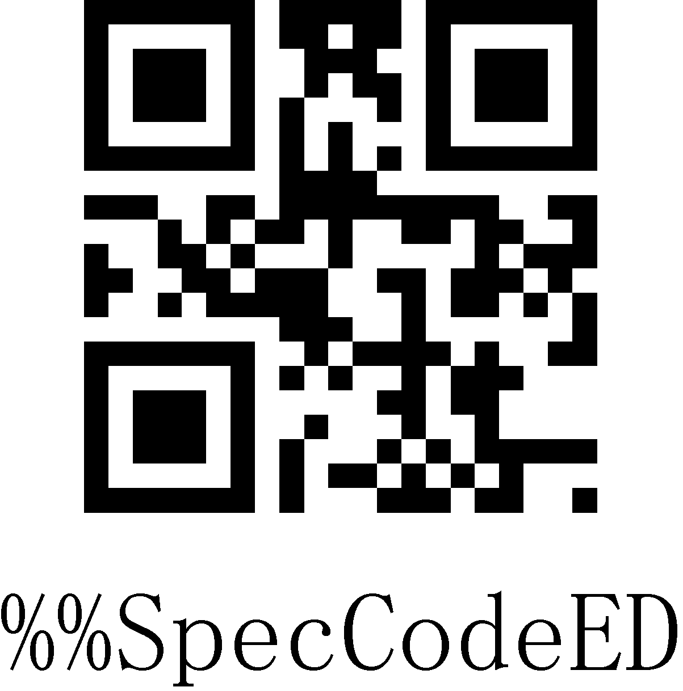
Get the Bluetooth Name
Note: Only in the Bluetooth HID, SPP, BLE mode can the Bluetooth name be obtained successfully, otherwise it will fail.

National Keyboard Layout
The keyboard key arrangement, symbols, etc. corresponding to different national languages are not same. The scanner can be virtualized into different national keyboard standards according to actual needs. The keyboard layout setting is applicable to the HID communication interface mode. The default is "American English keyboard".
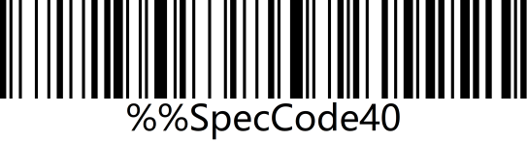 | 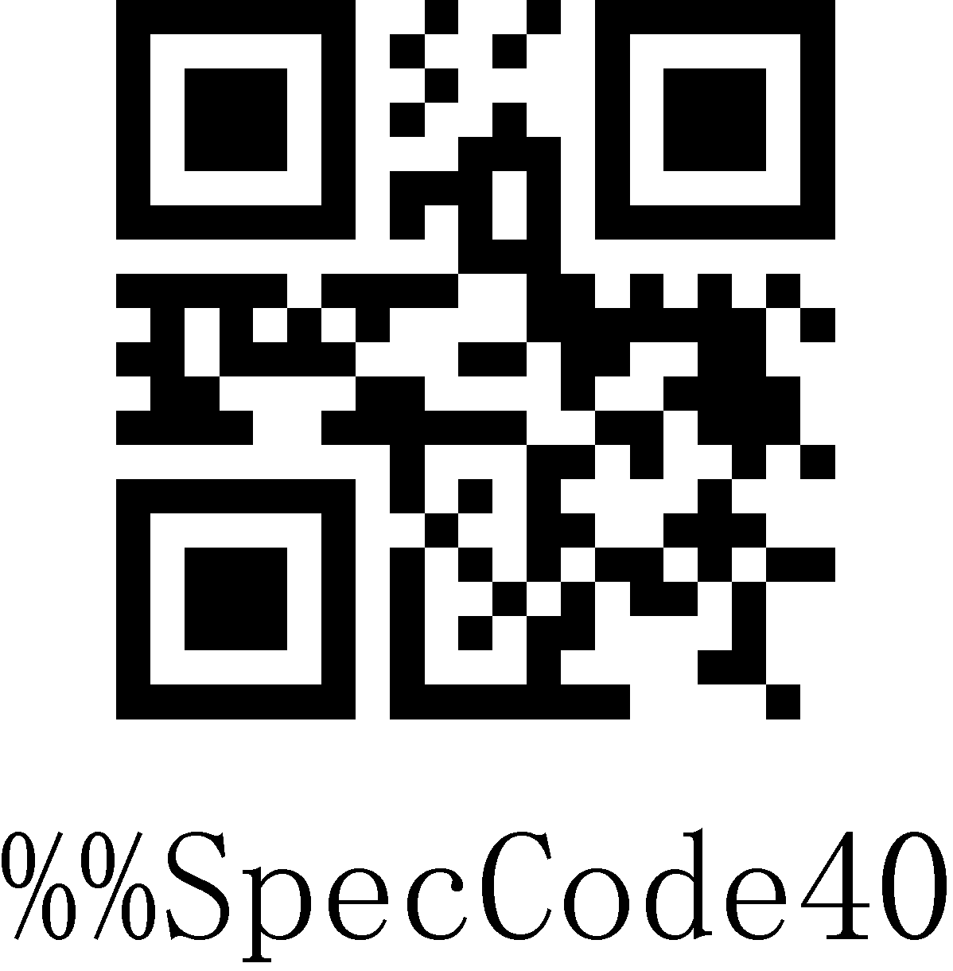
English
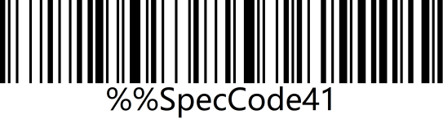 | 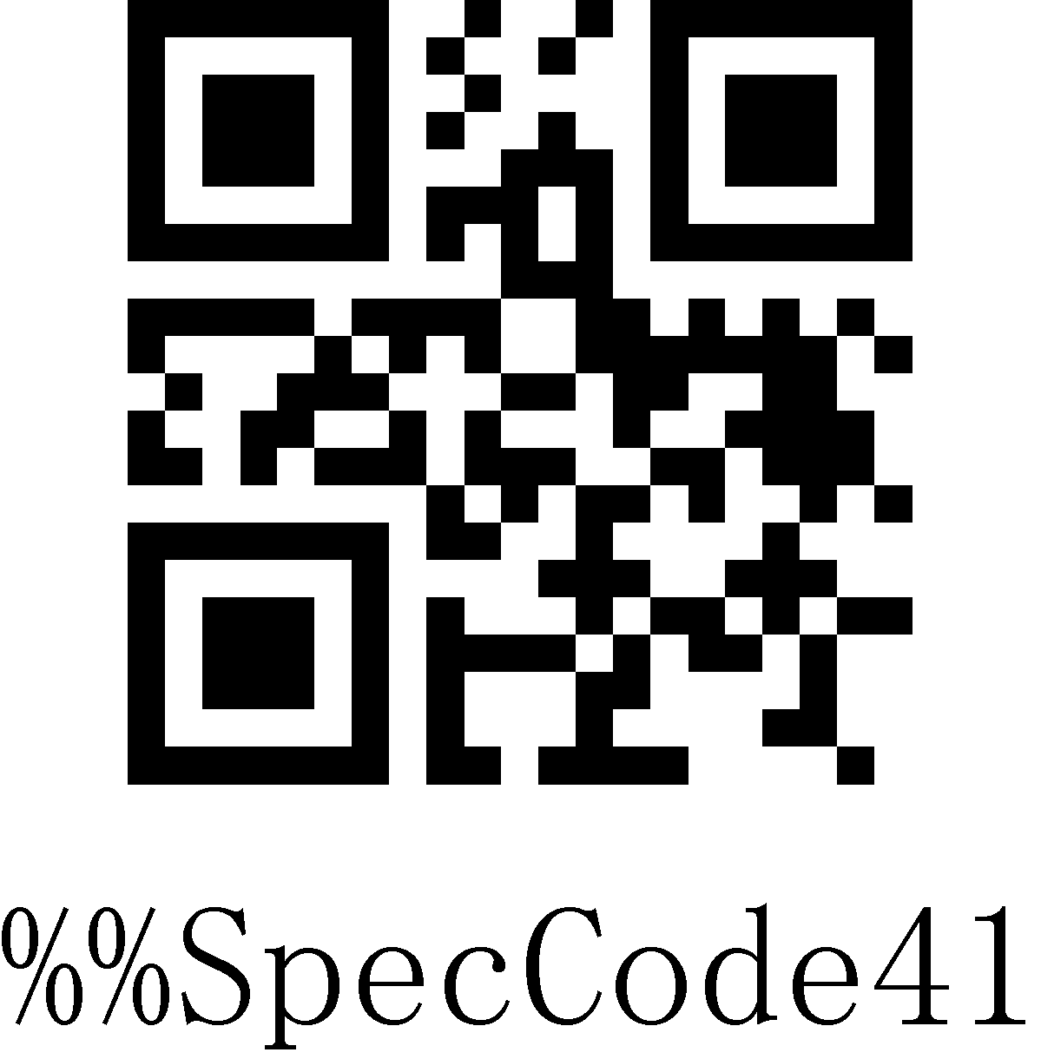
German
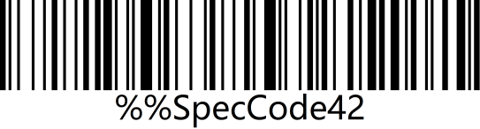 | 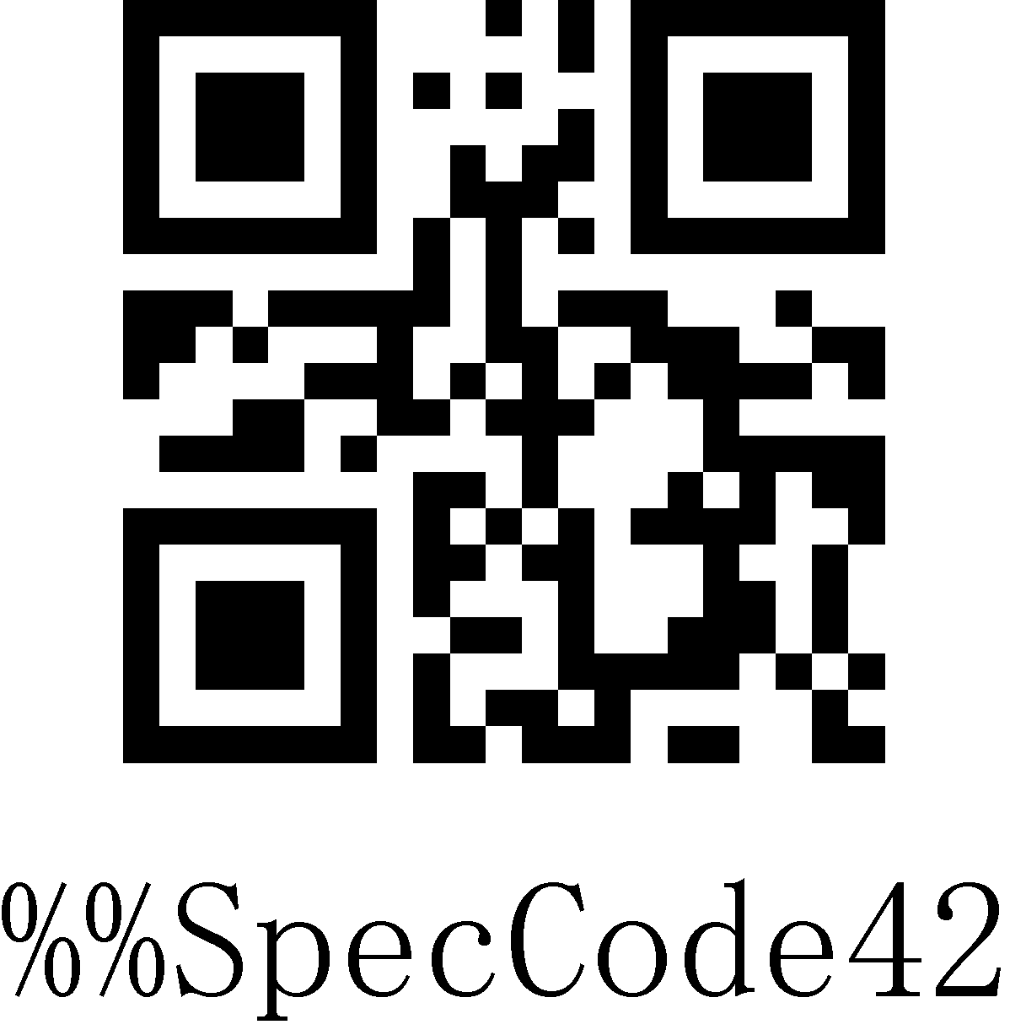
French
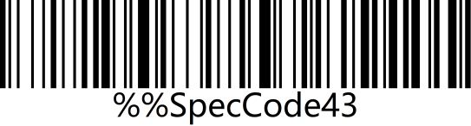 | 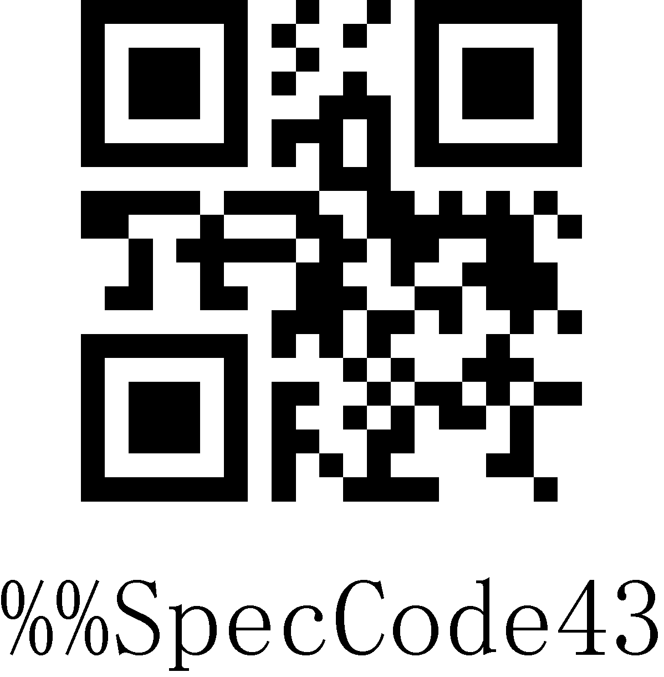
Spanish
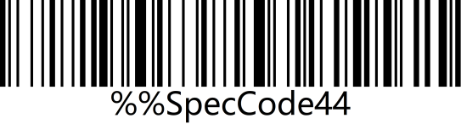 | 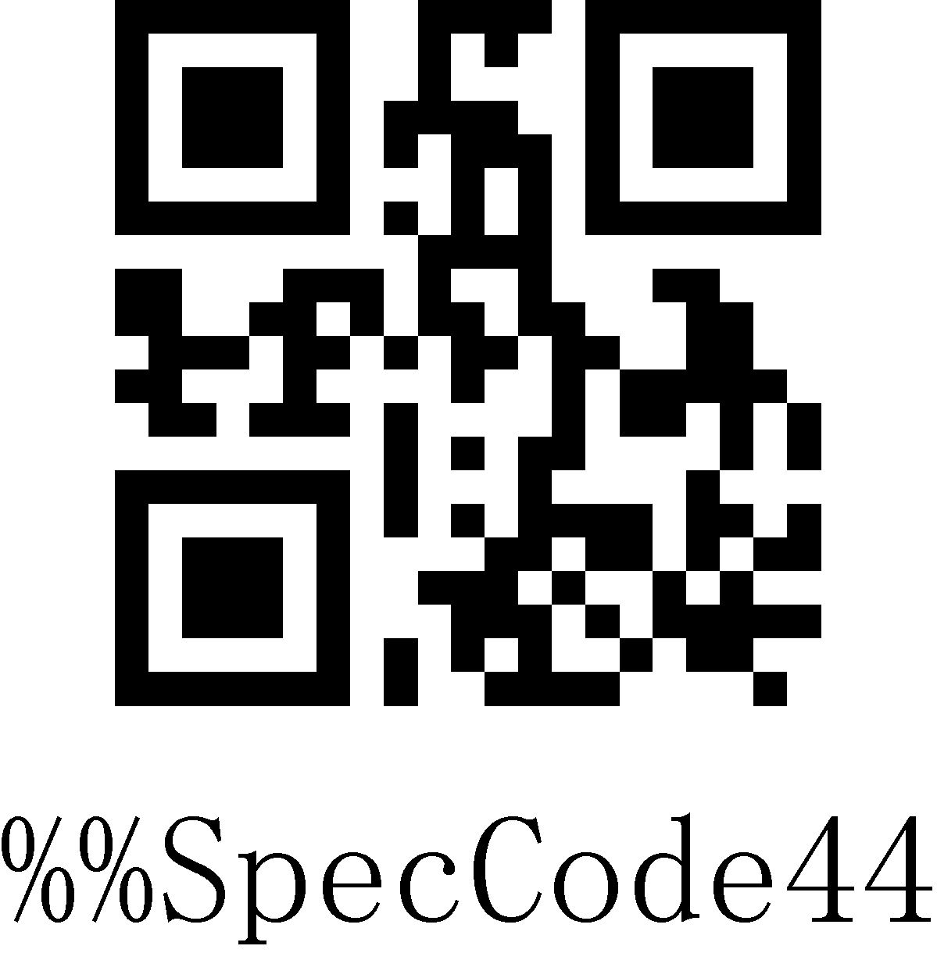
Italian
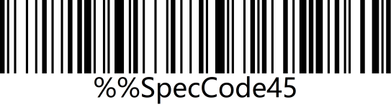 | 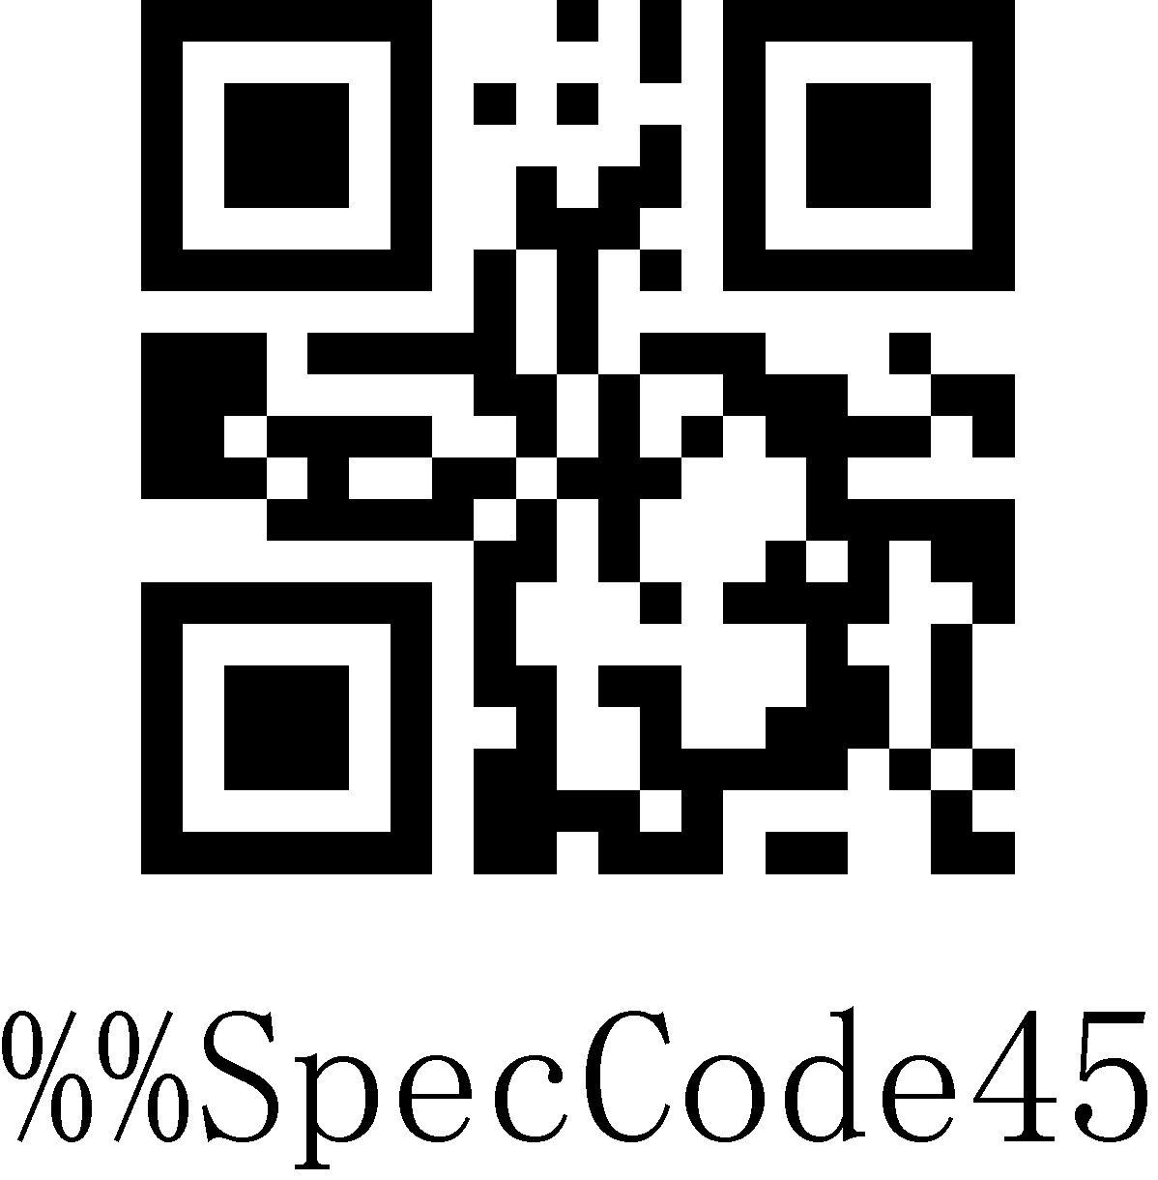
Japanese
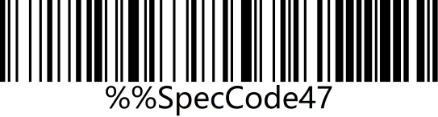 | 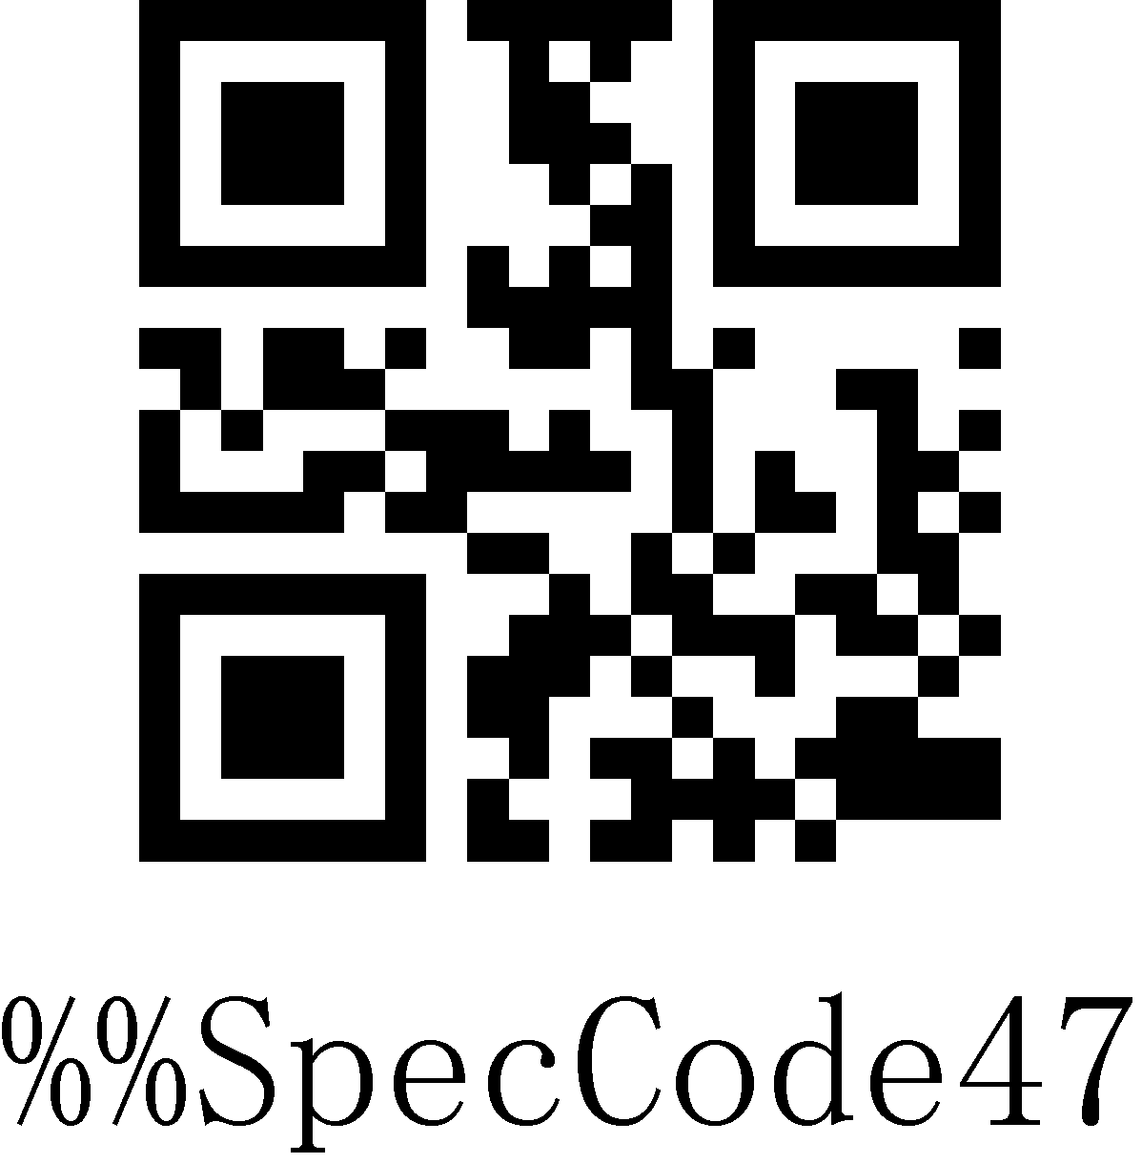
BF - Belgian French
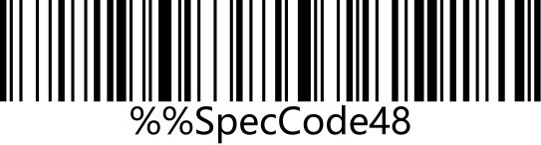 | 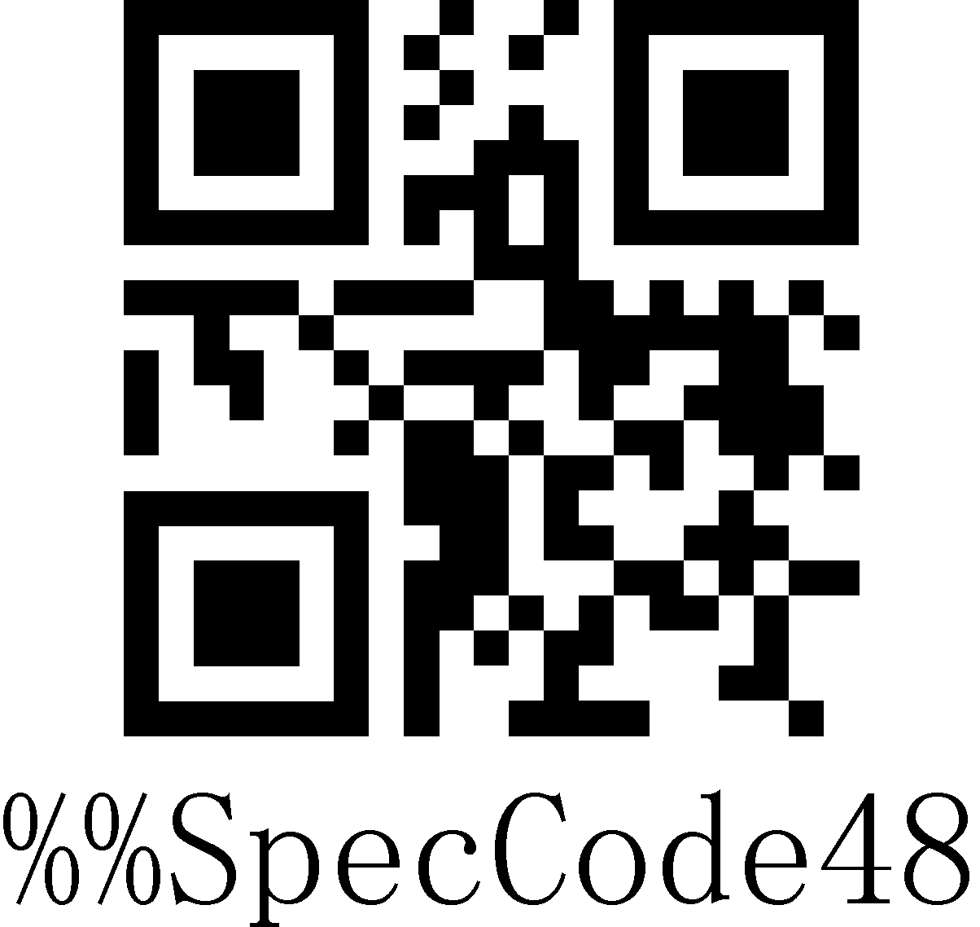
Portuguese
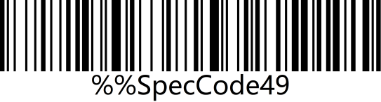 | 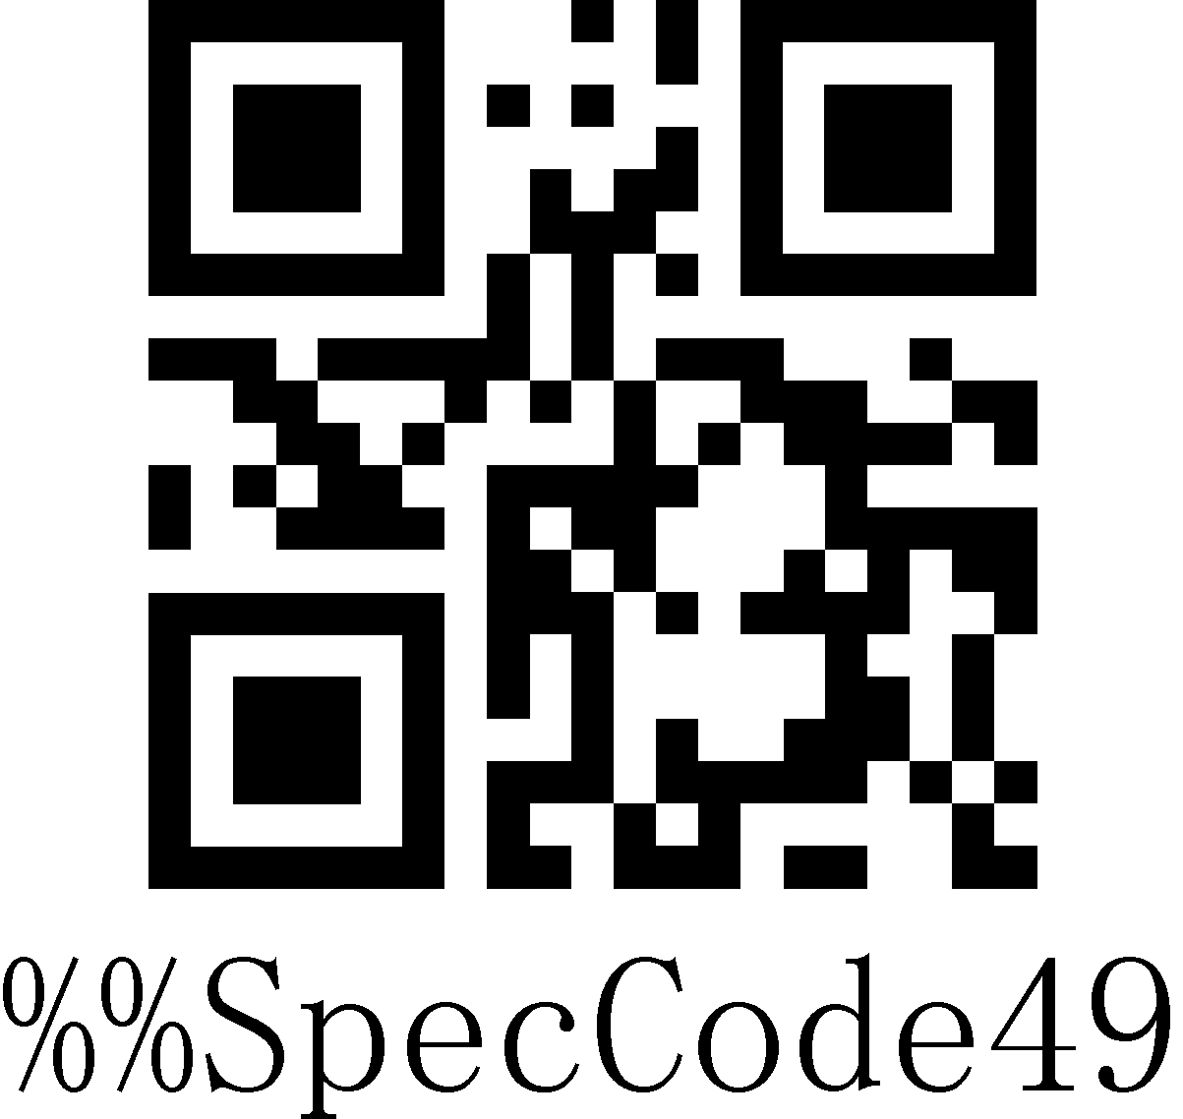
British English
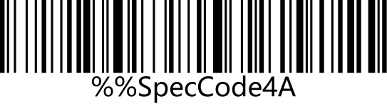 | 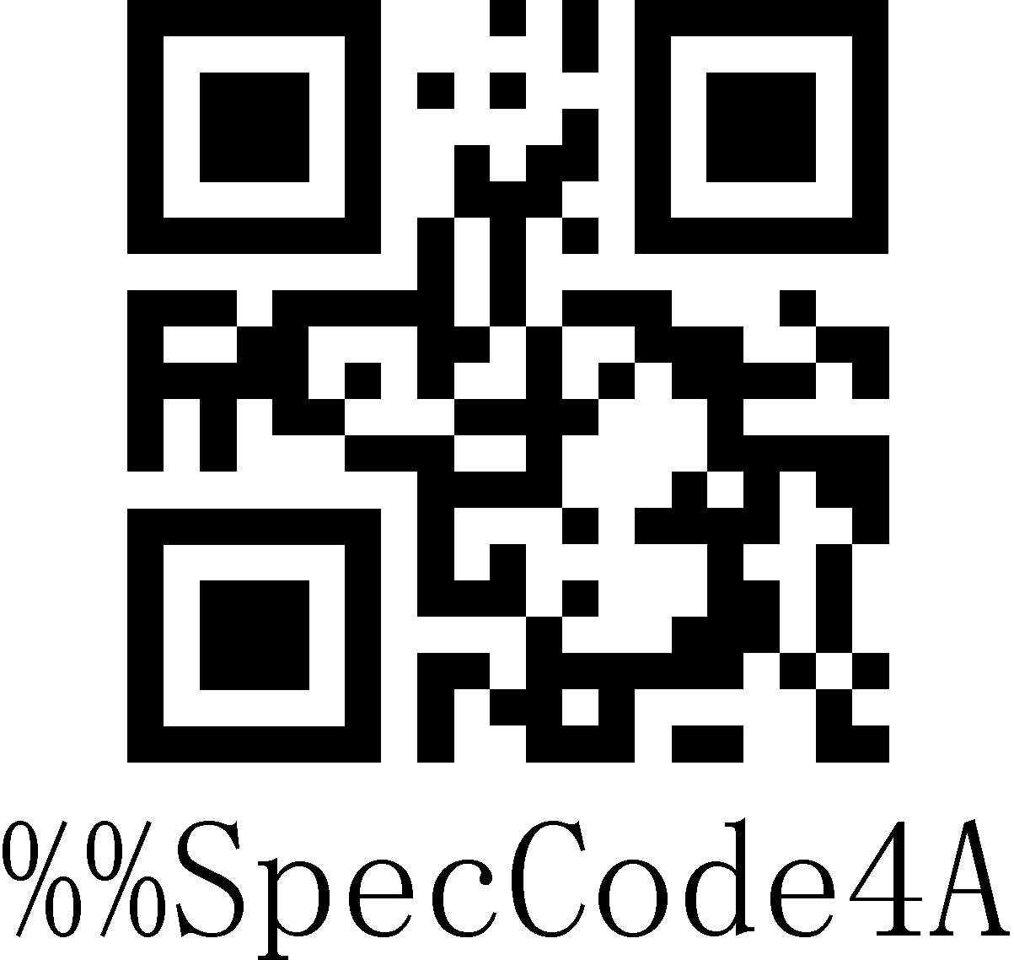
German IOS keyboard
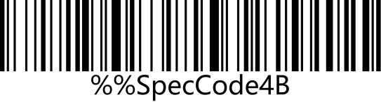 | 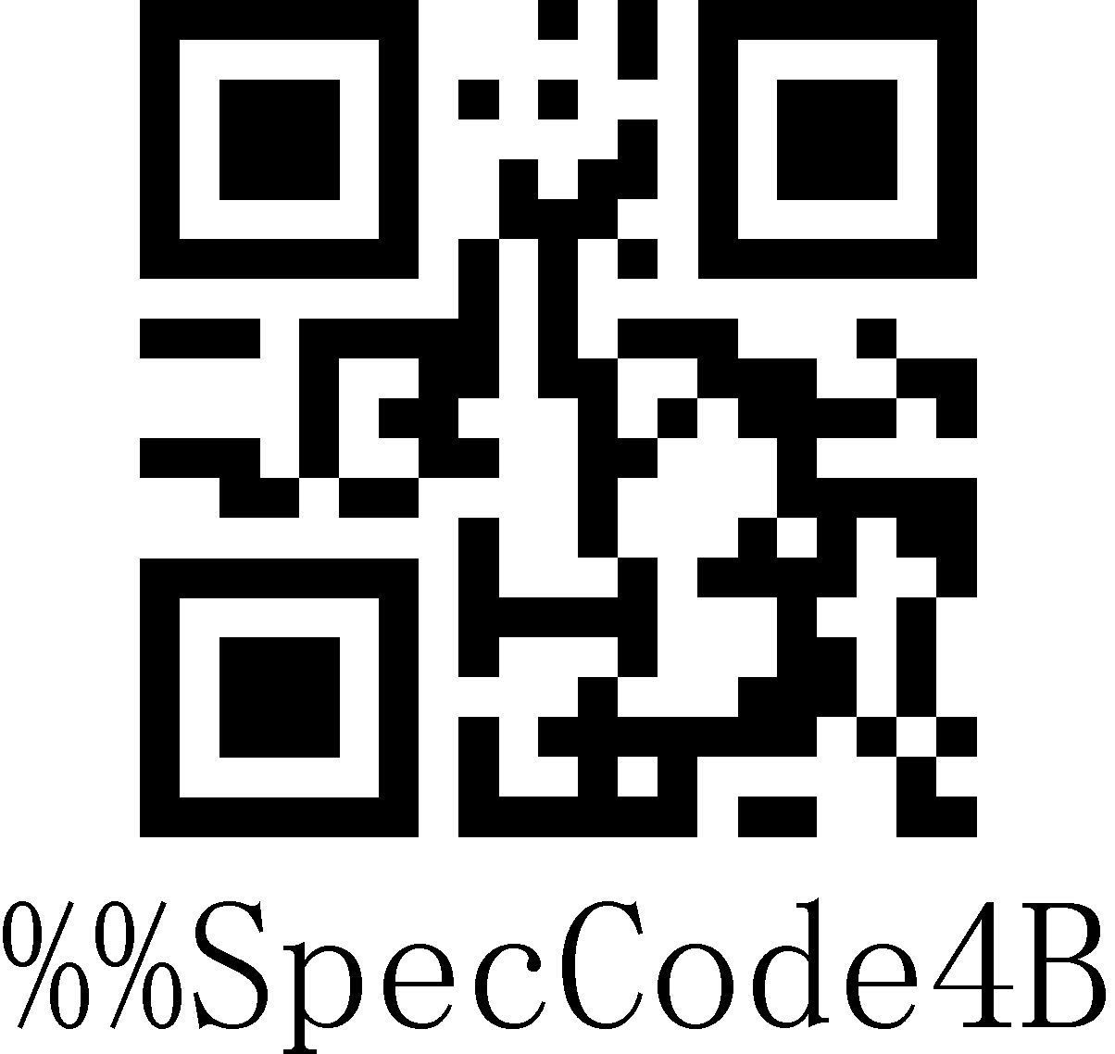
Brazilian Portuguese
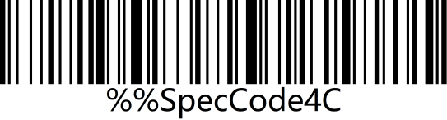 | 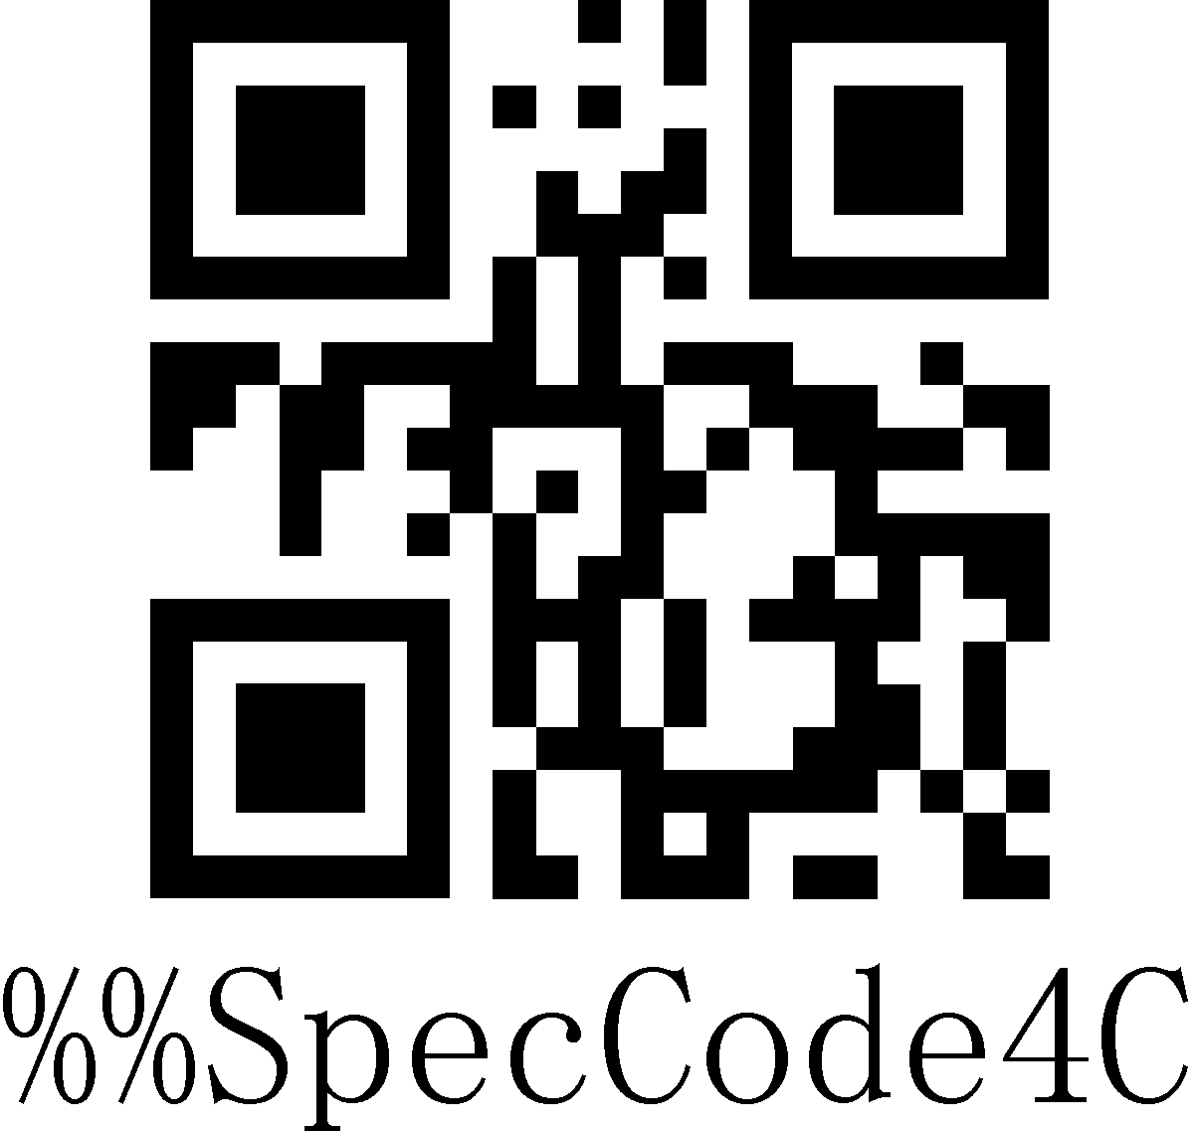
Russian
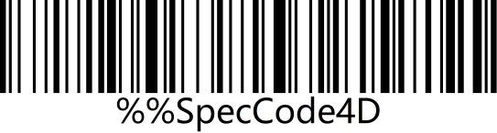 | 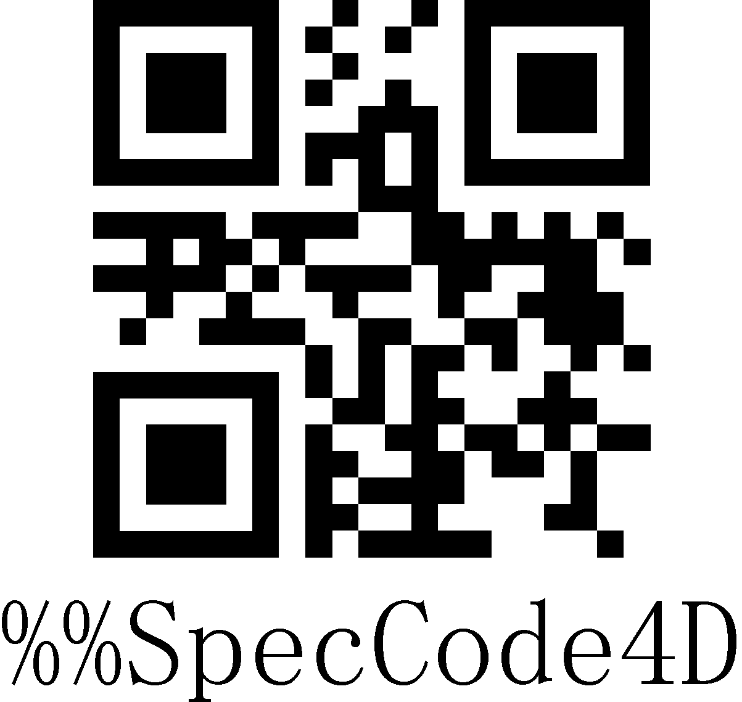
Czech
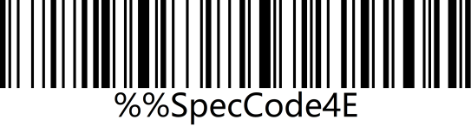 | 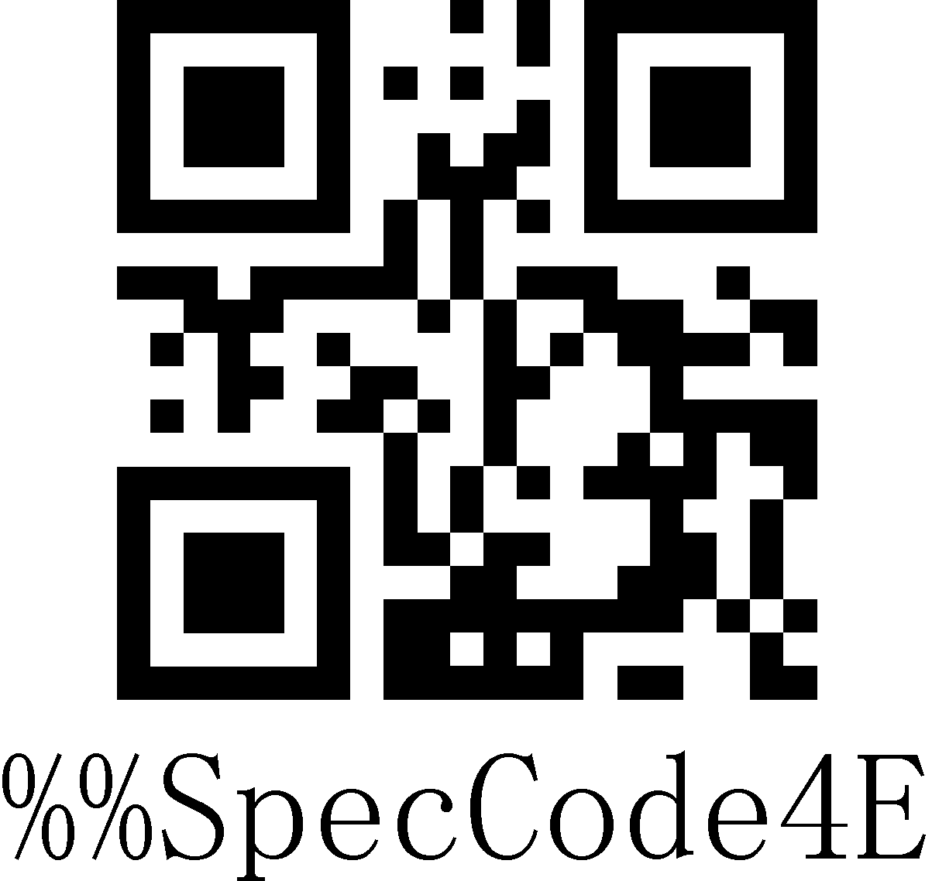
Italy 142
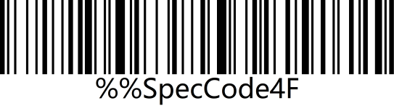 | 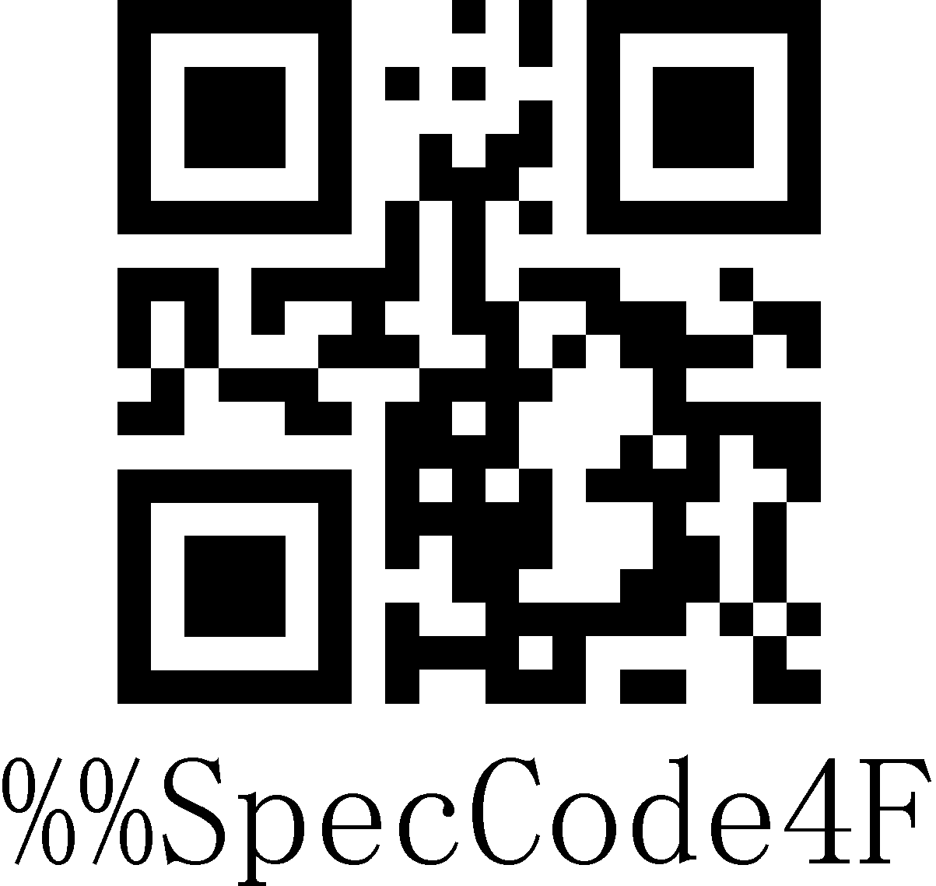
(Turkey Q)
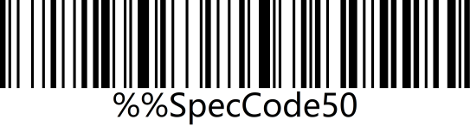 | 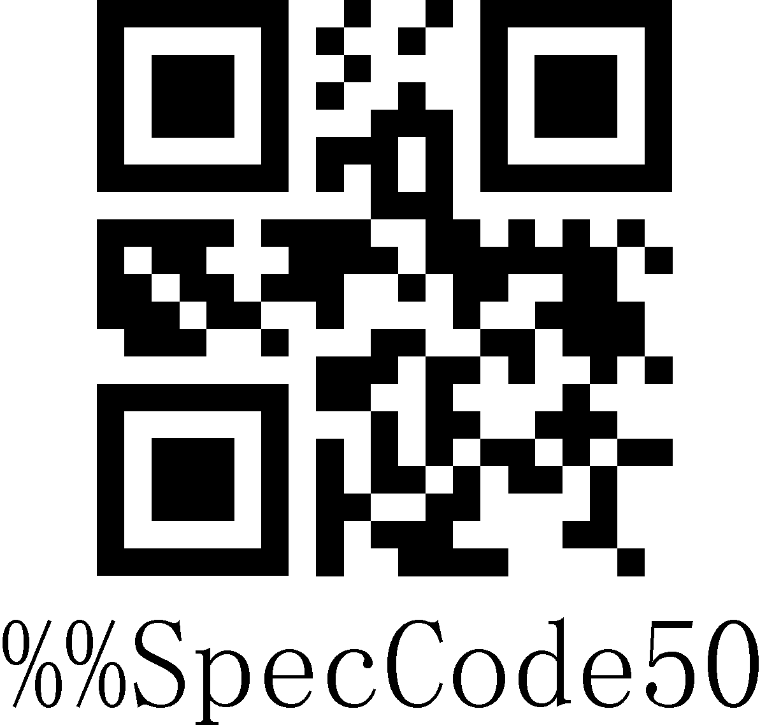
(Turkey F)
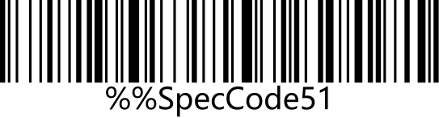 | 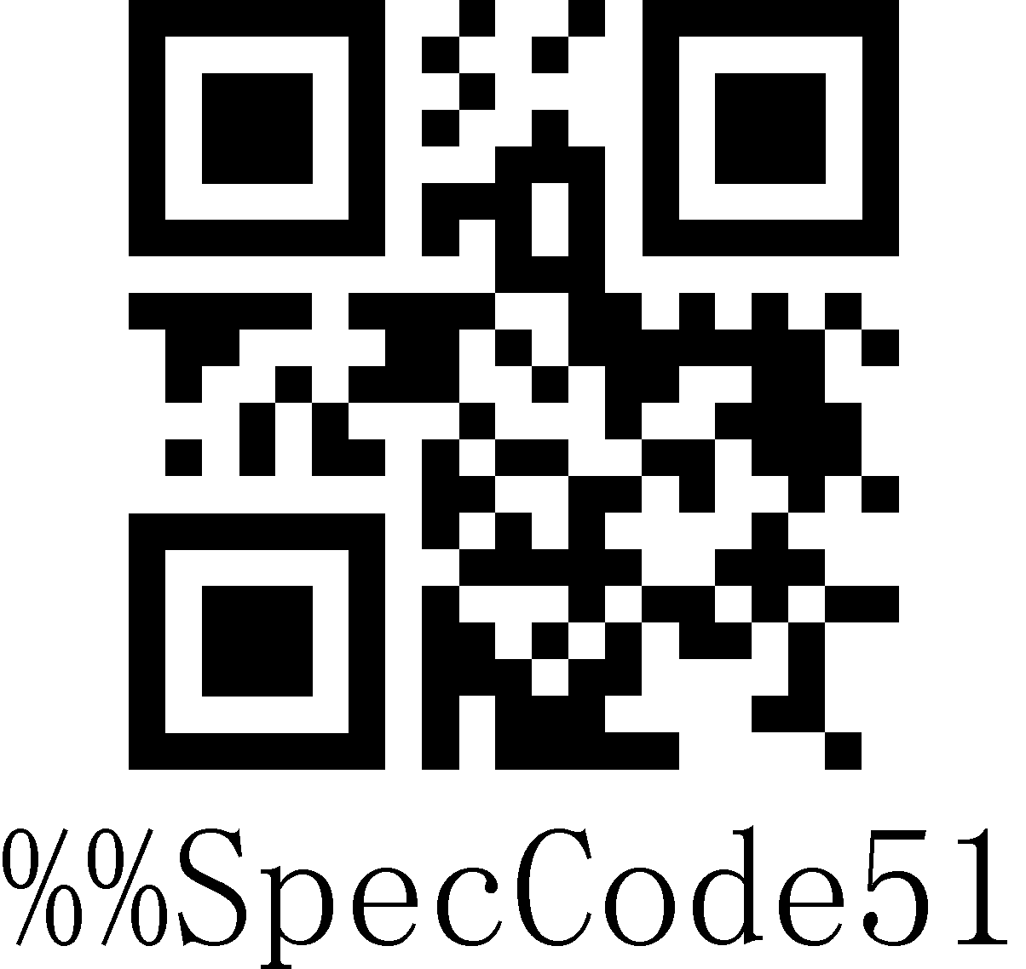
Sweden / Finland
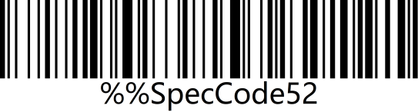 | 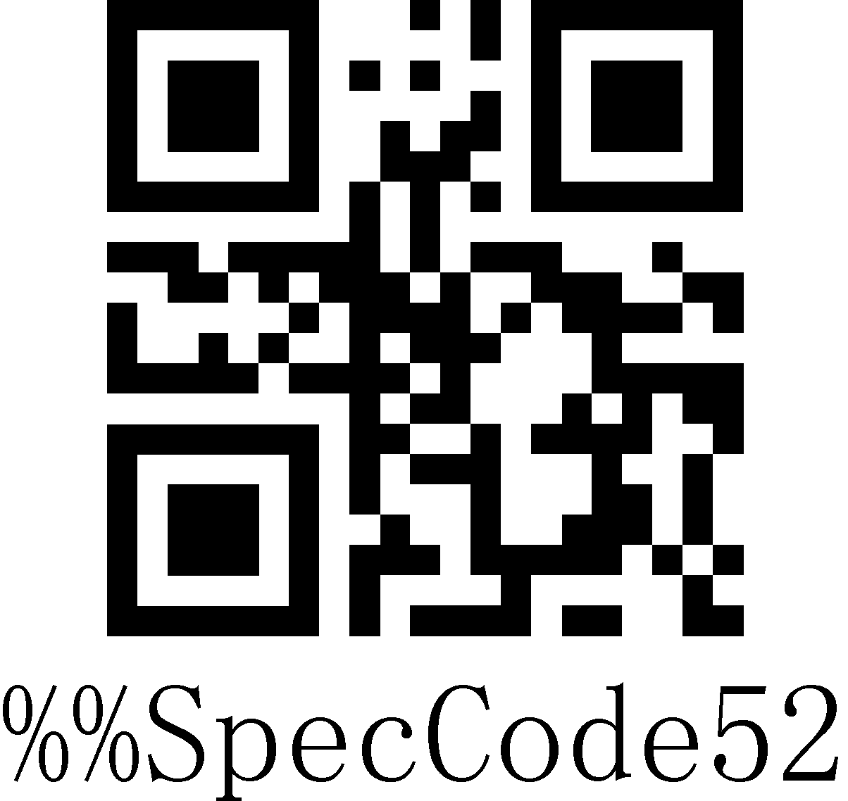
Mexican Spanish
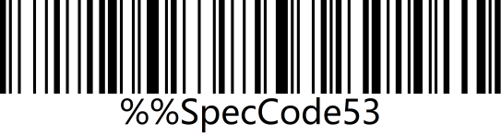 | 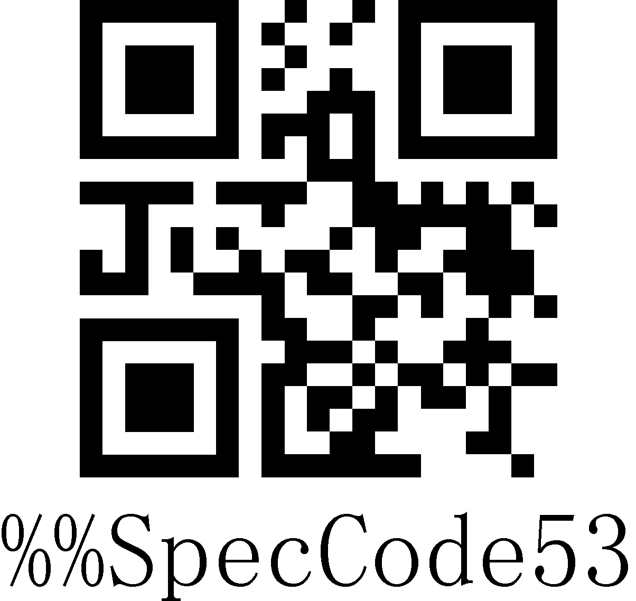
Denmark
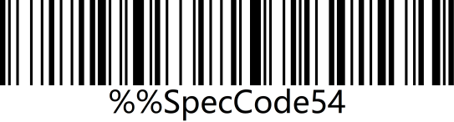 | 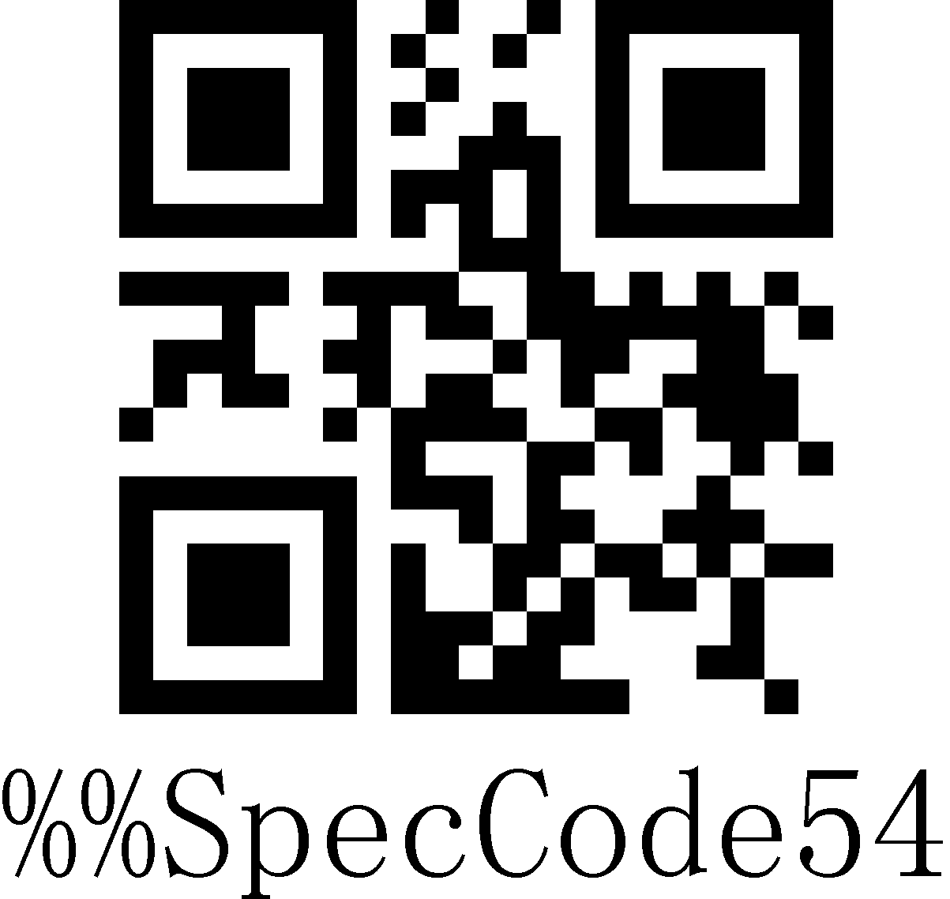
Written Norwegian
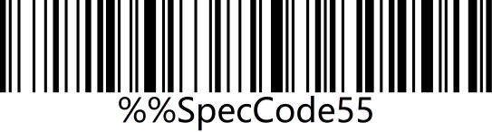 | 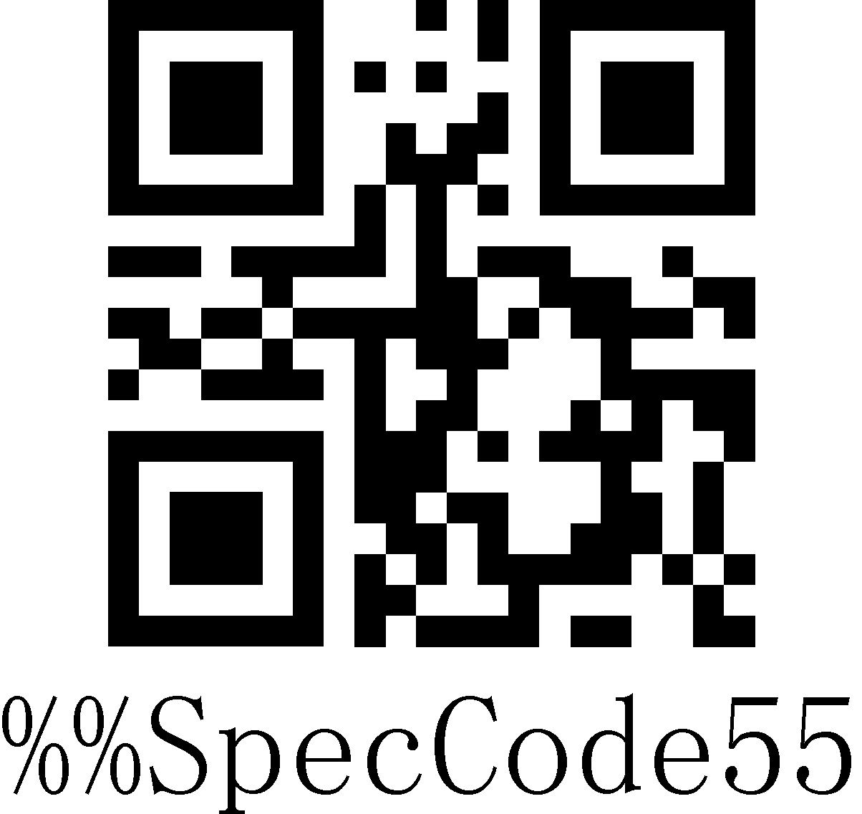
Croatian/Serbian
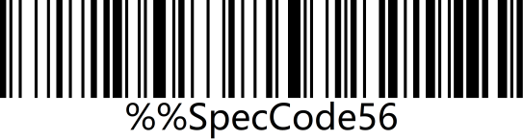 | 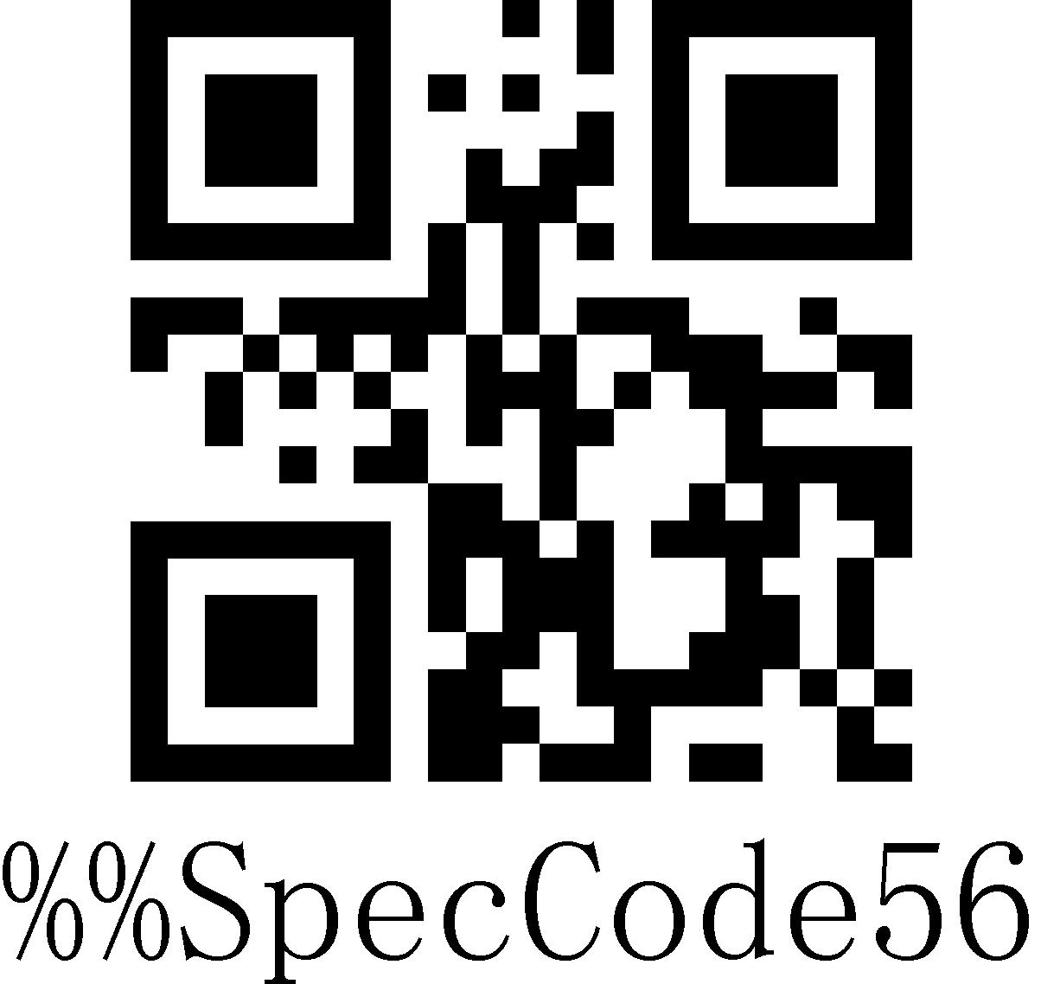
Swiss German
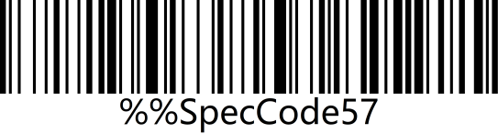 | 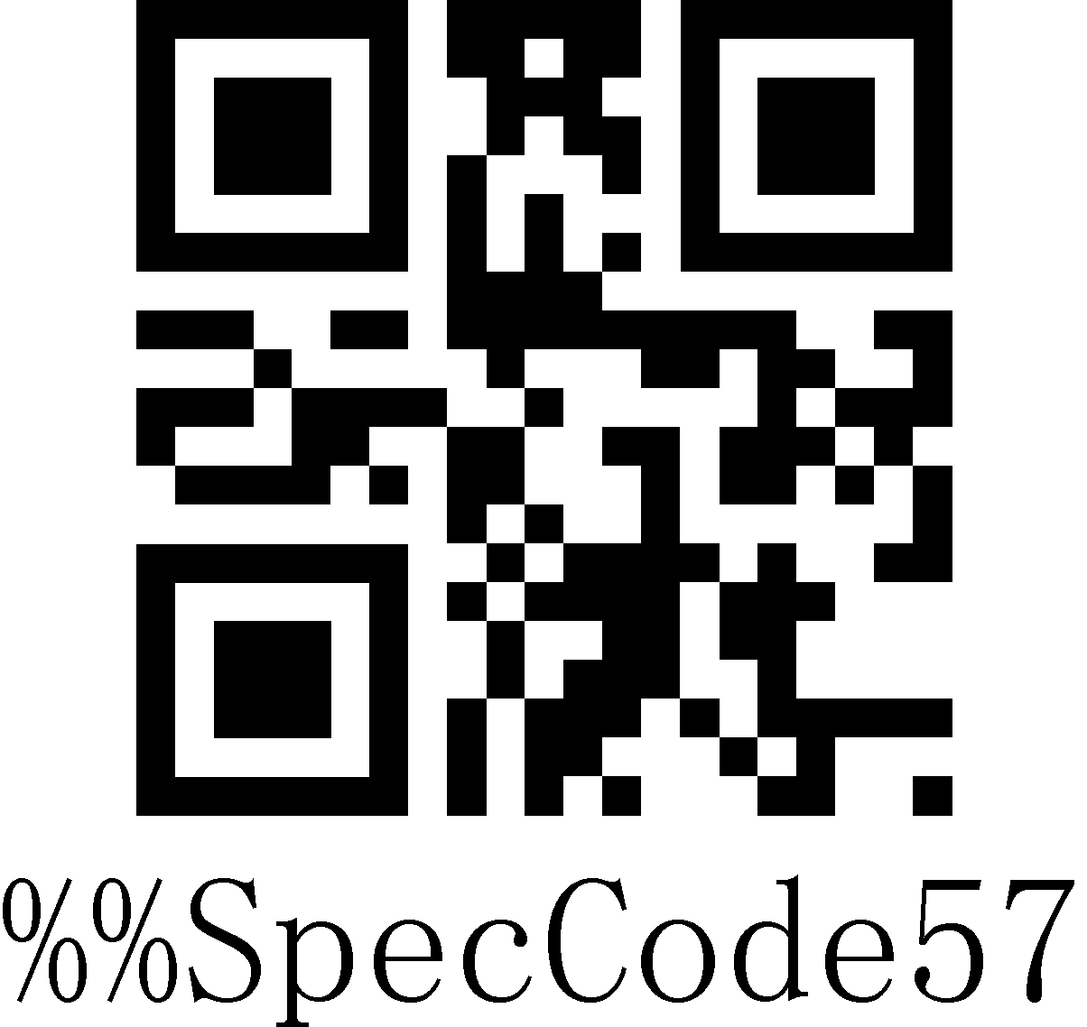
Swiss French
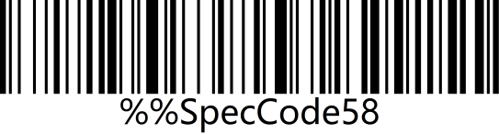 | 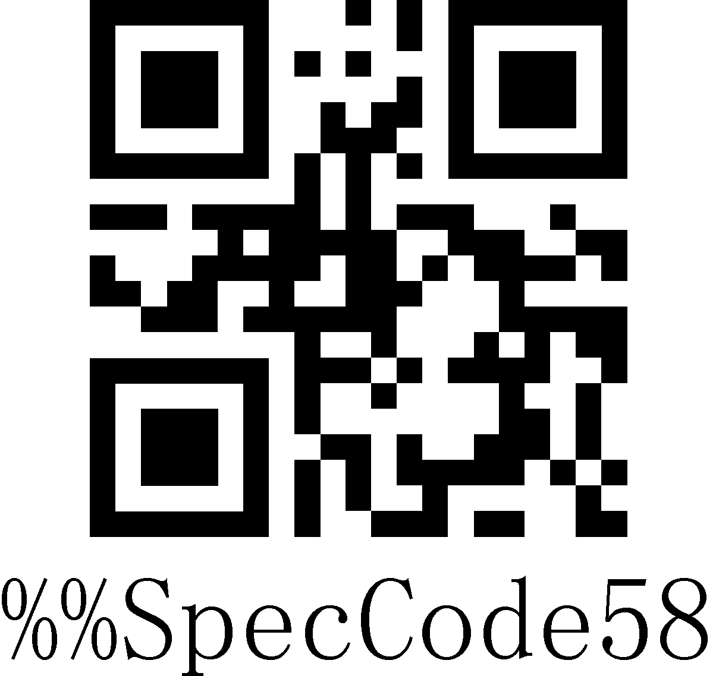
Dutch
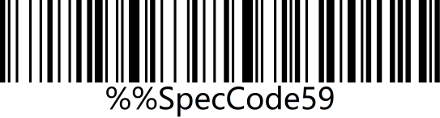 | 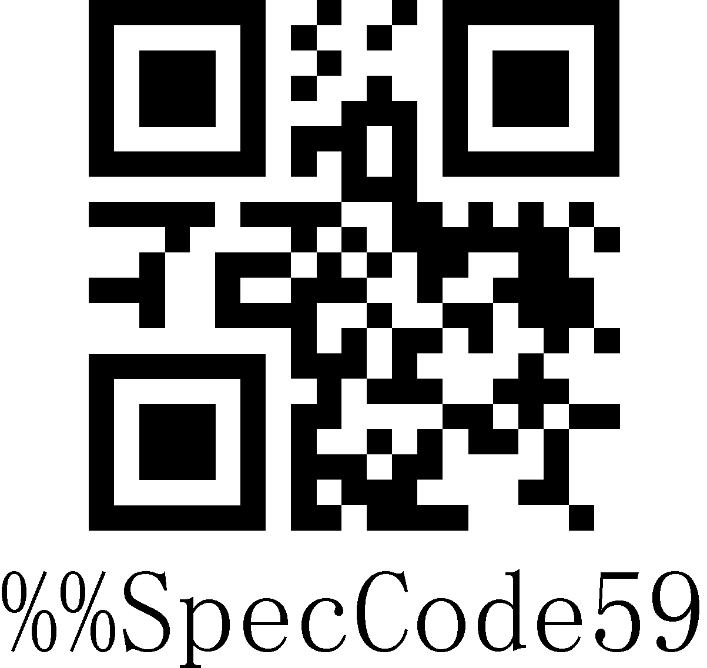
Hungarian
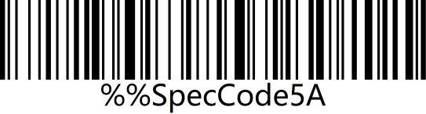 | 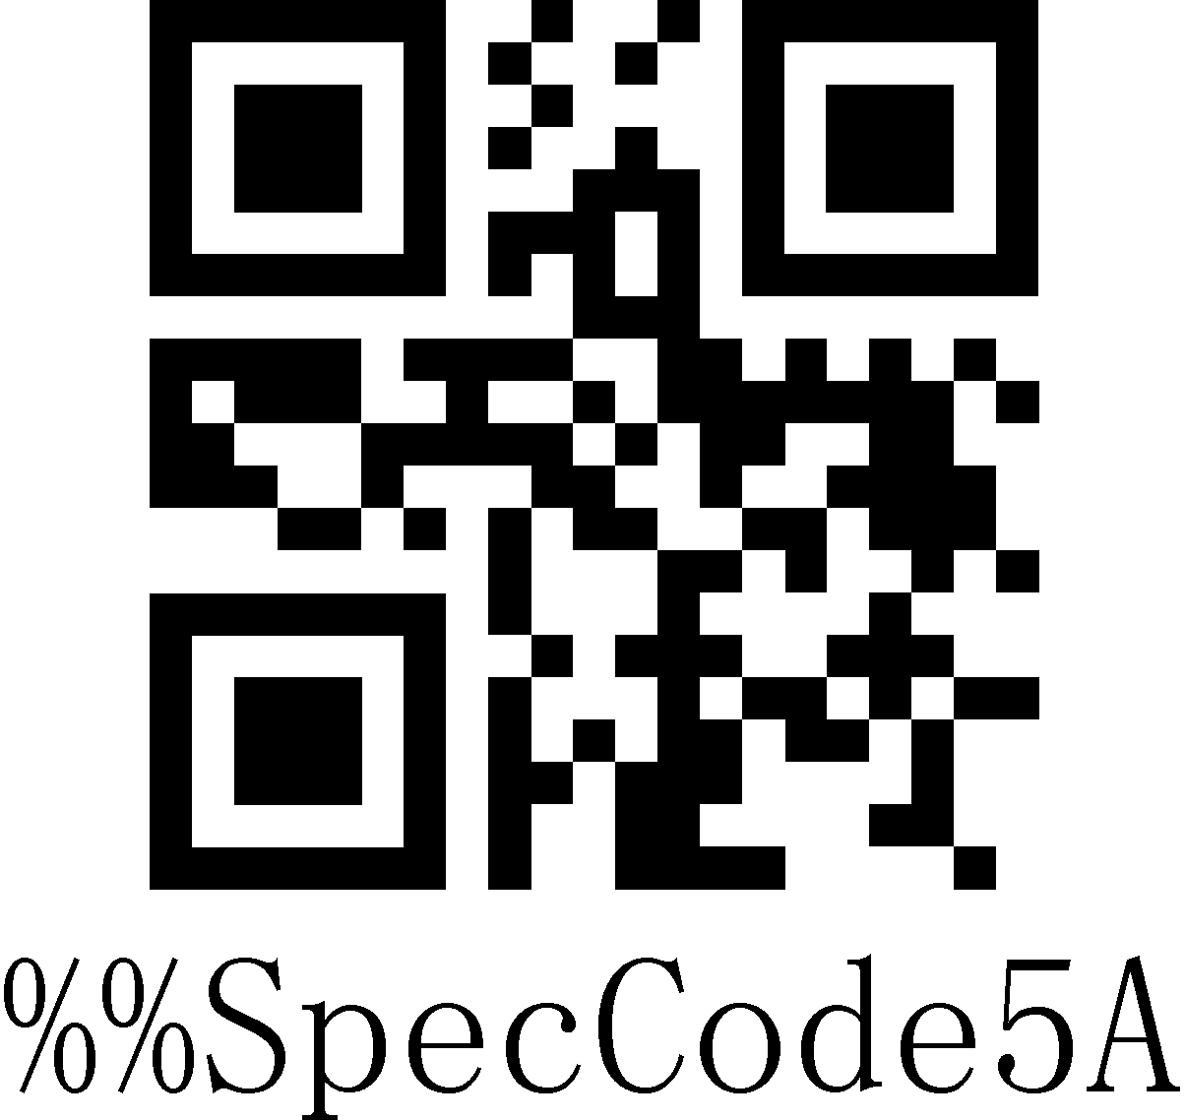
Polish
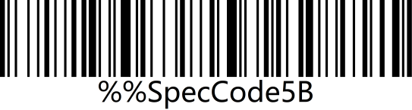 | 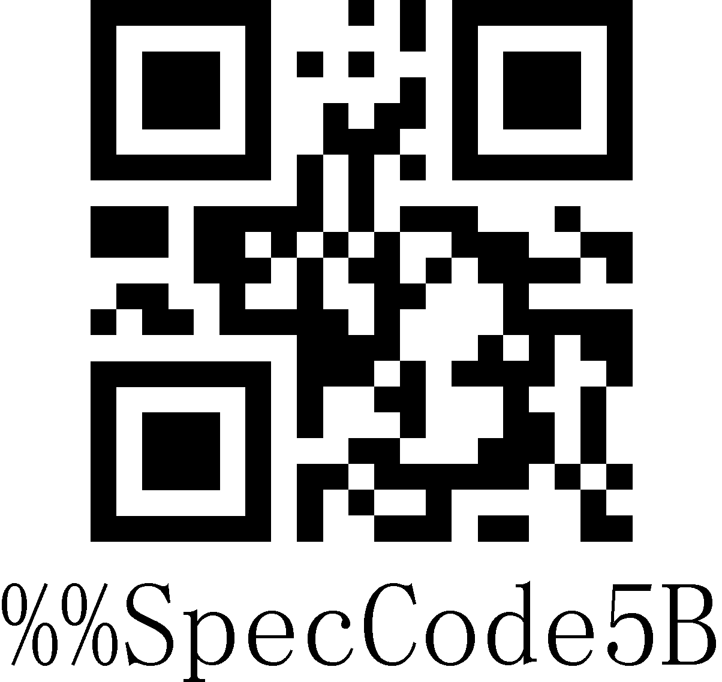
Canadian French
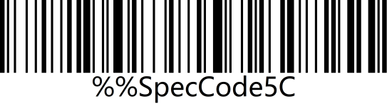 | 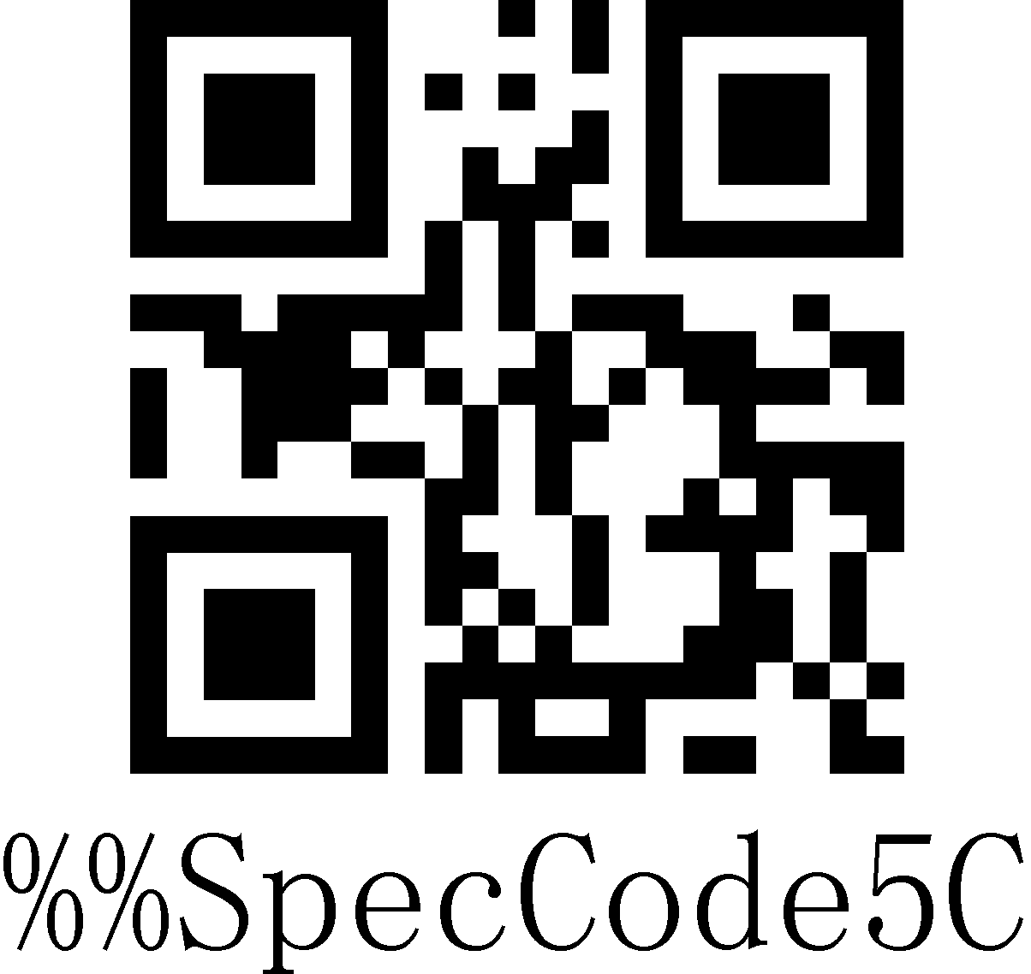
Argentina (Latin American)
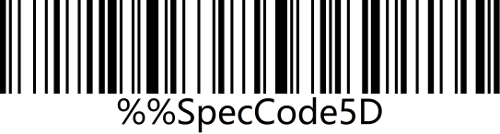 | 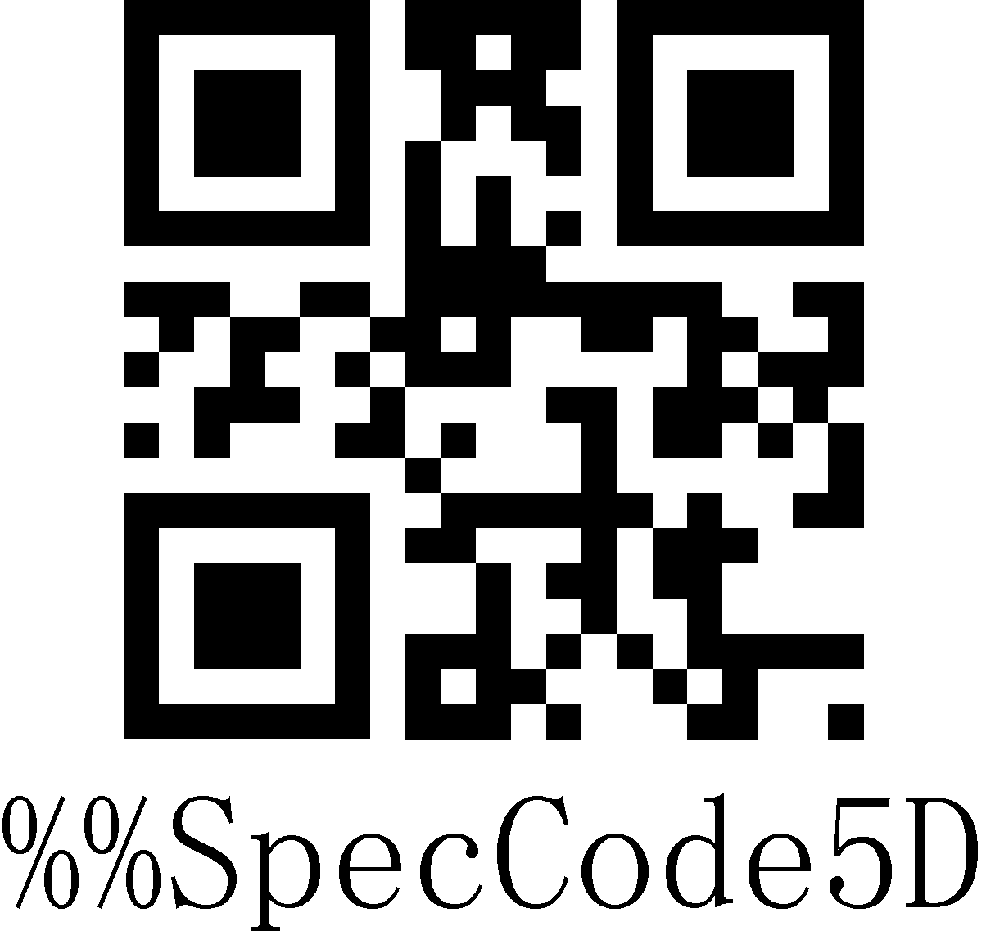
Slovak
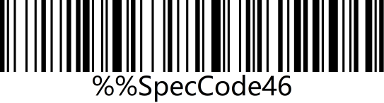 | 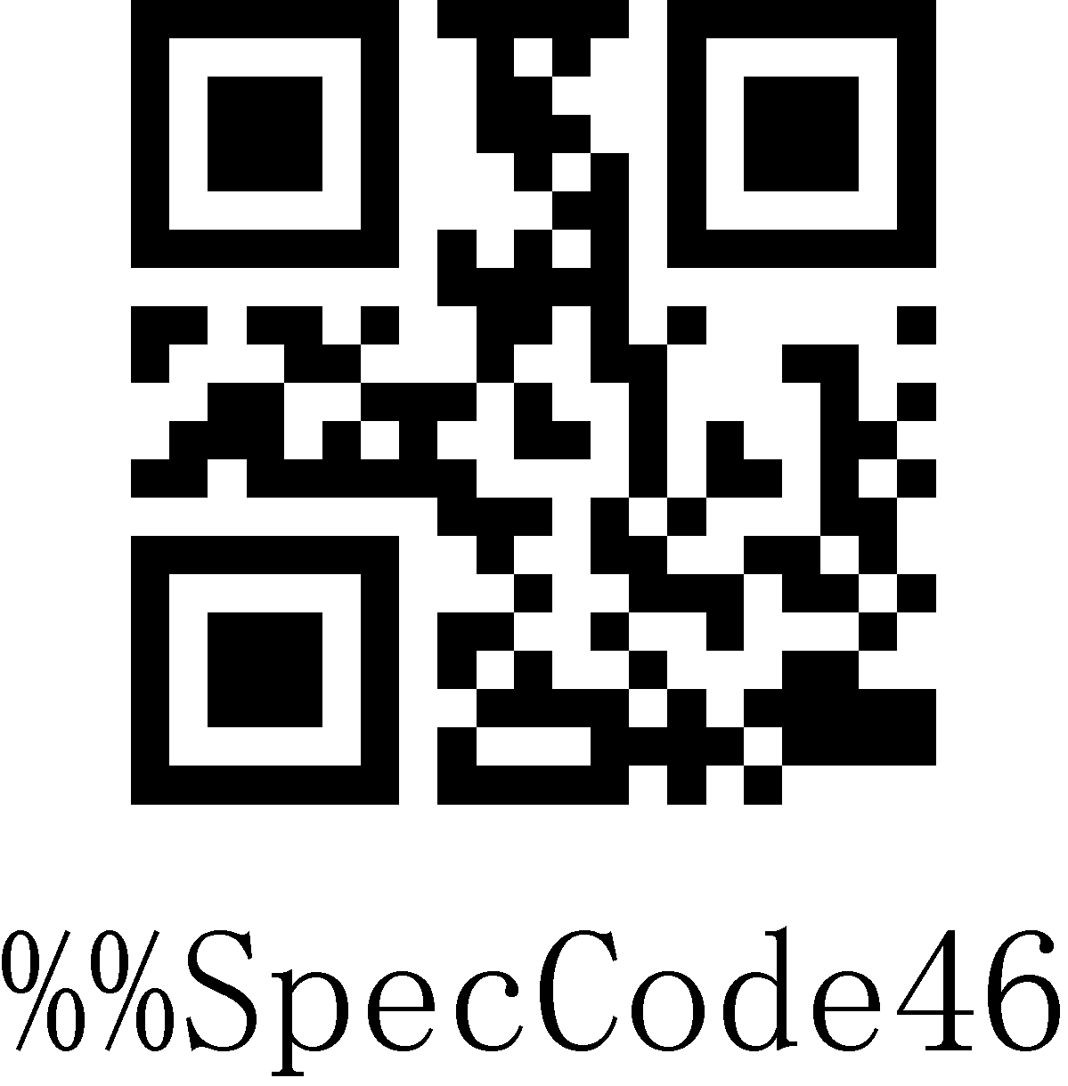
International keyboard
Note: The international keyboard supports all minority languages on the PC side。

Case Conversion
By setting the character case conversion function of the scanner, the English letters of the scanner output data can be case-converted.
For example: The content of the barcode is aBC123, scan "Lower", the data obtained by the host will be "abc123". The default is Normal.
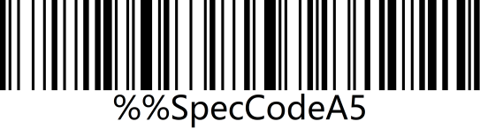 | 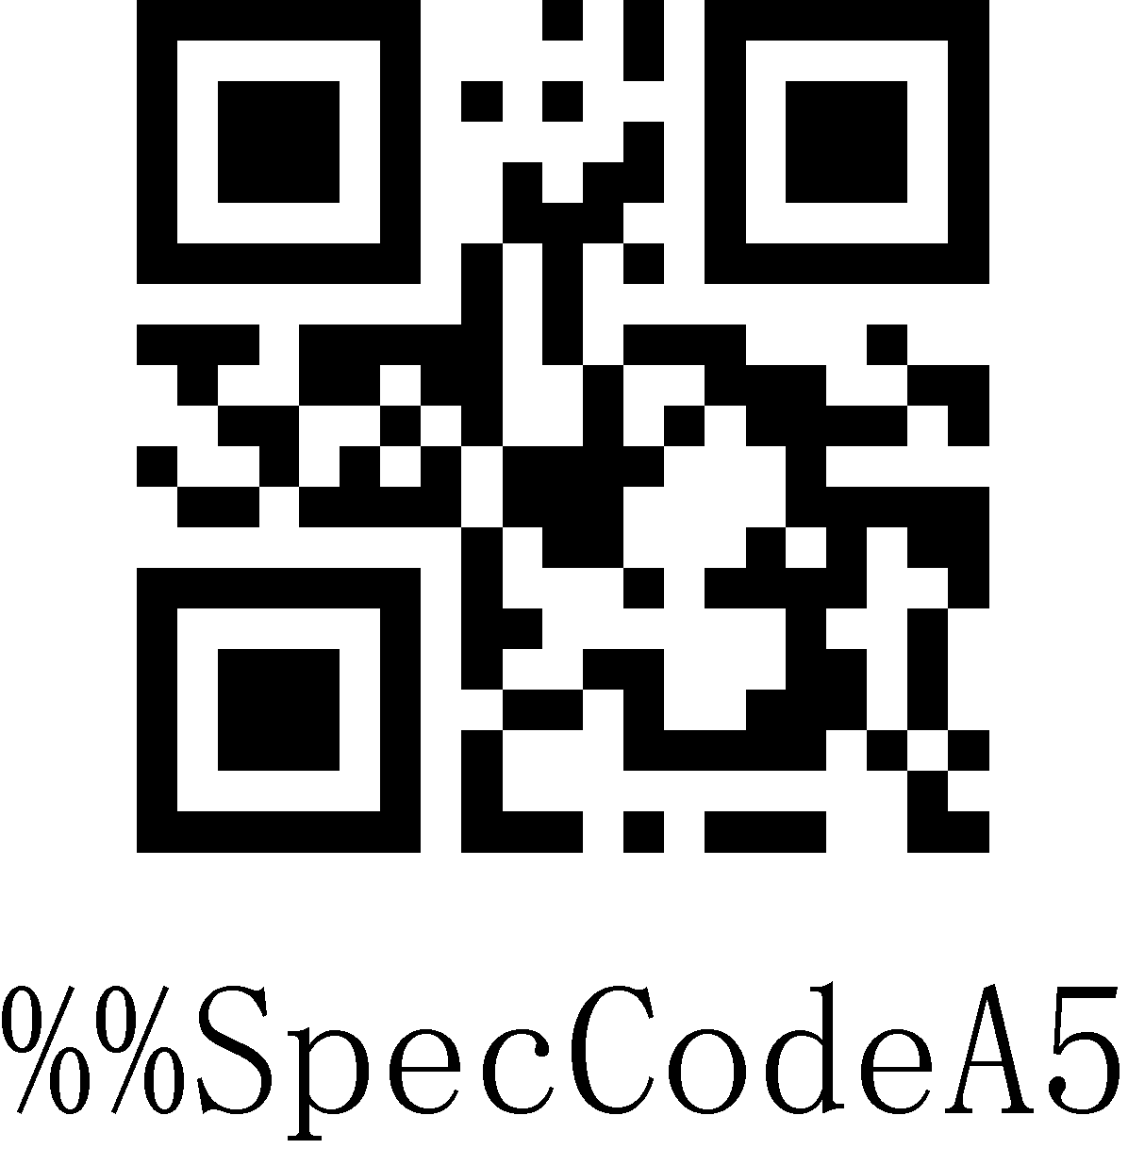
Normal*
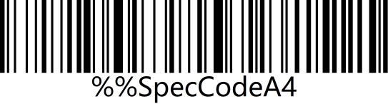 | 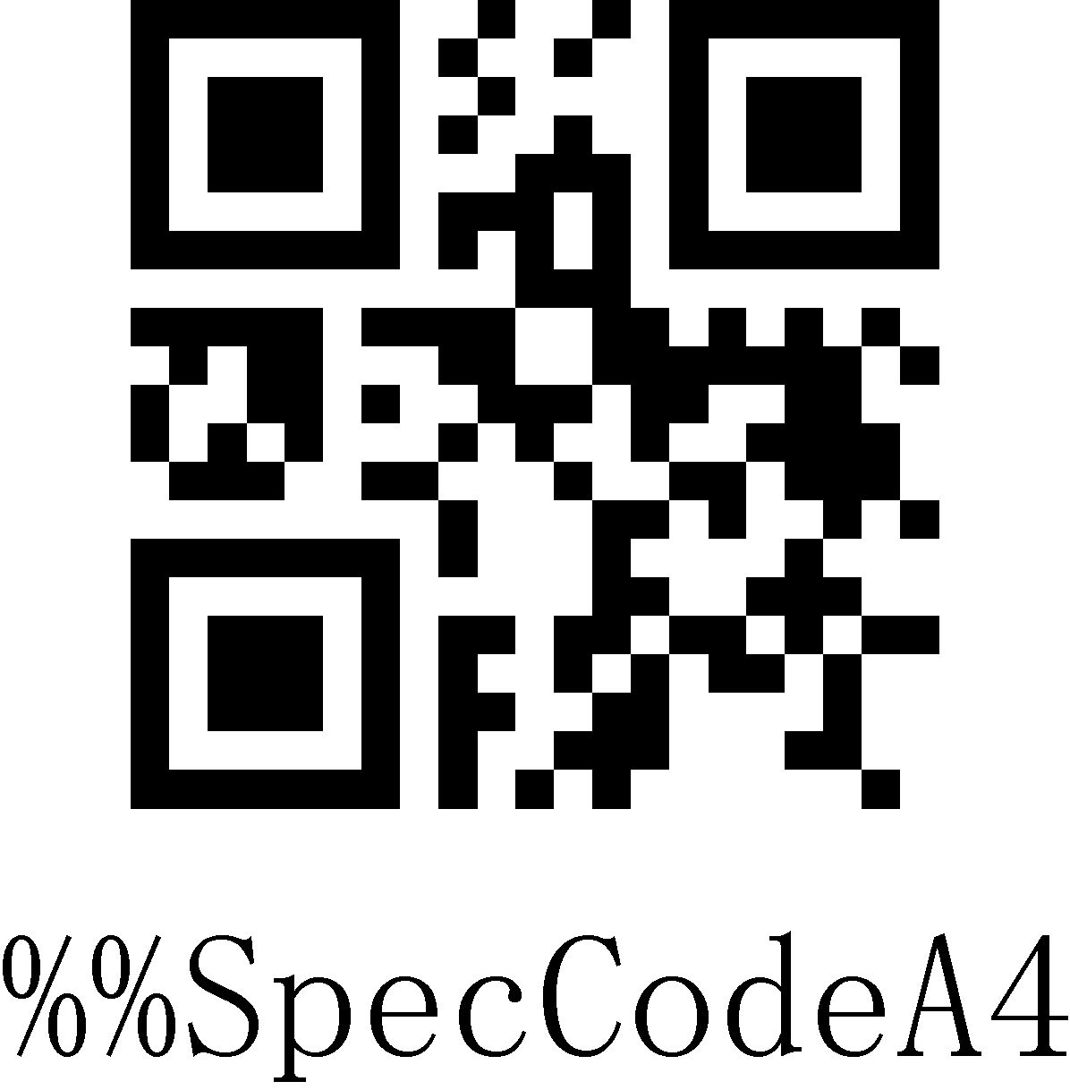
Upper
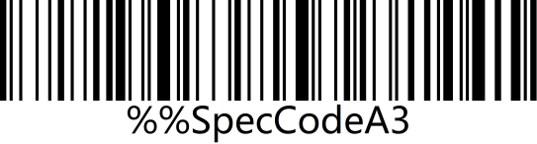 | 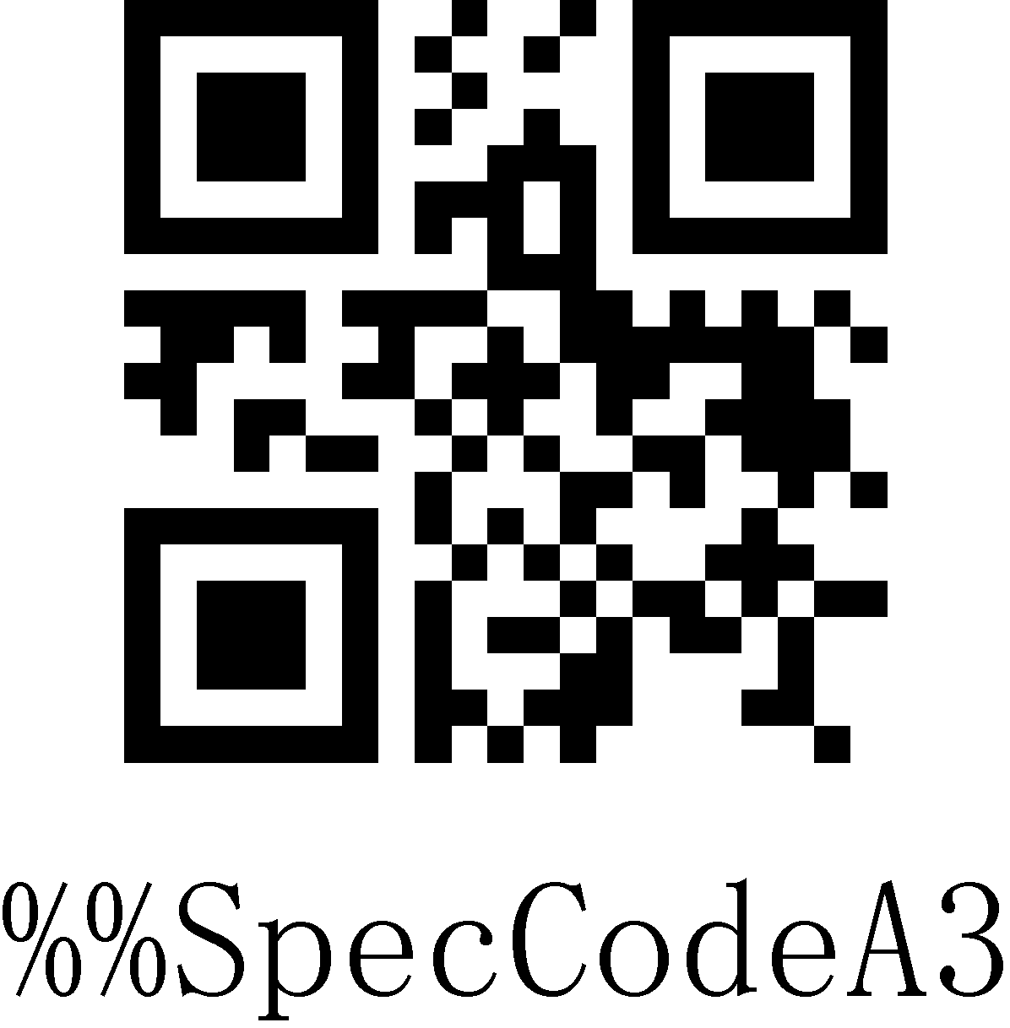
Lower
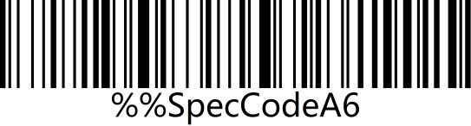 | 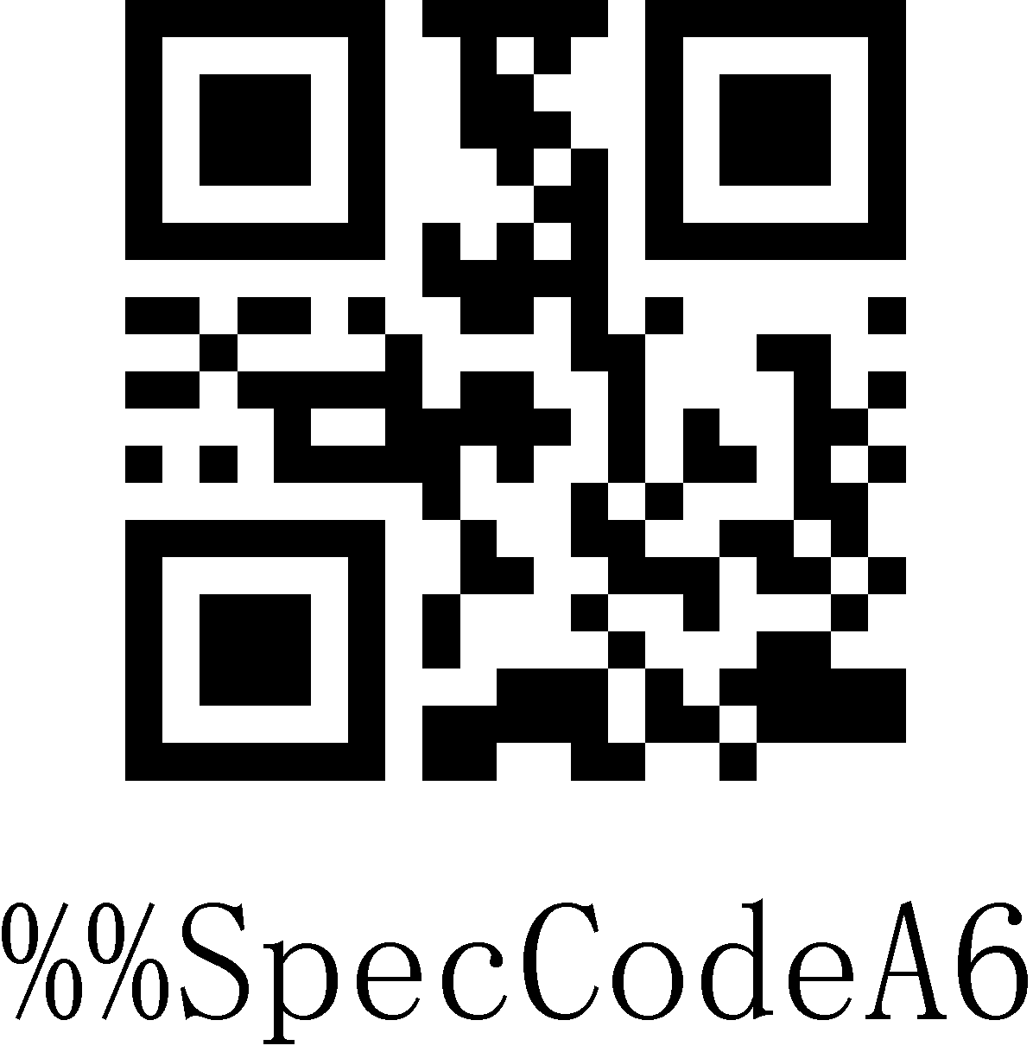
Inverse
Note: This parameter is only valid in standard keyboard input mode and keyboard emulation input control character mode.

GS Replacement function
After using the GS replacement function, the GS can be replaced with other characters, which is convenient for the host device to display. When you need to display GS characters, you can set GS to be replaced with 1D of the ASCII code character table.

Custom GS Replacement
Step 1: Scan the "Custom GS Replacement" setup code
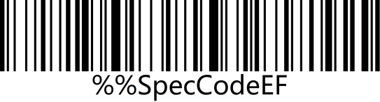 | 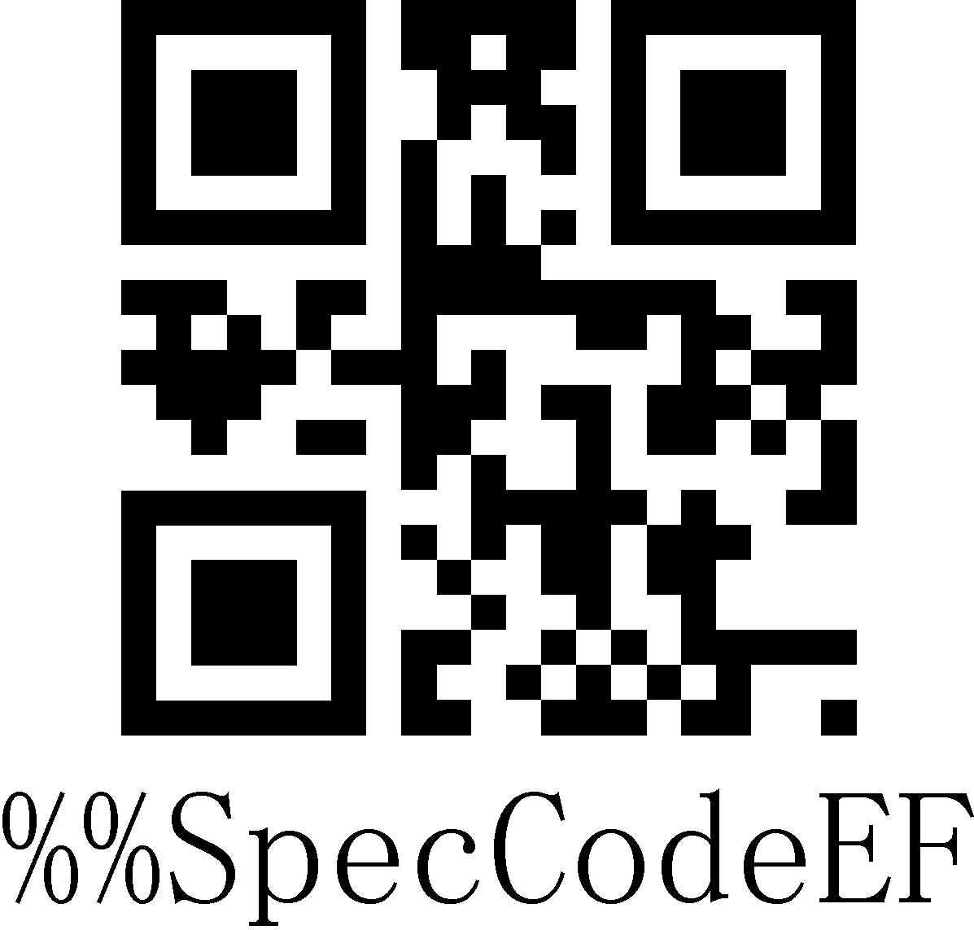
Custom GS Replacement
Step 2: Query "Appendix-ASCII code character table" to find the barcode corresponding to the character to be replaced and scan it.
Example:
Replace GS characters with characters that can be displayed”|”
Step 1: Scan the "Custom GS Replacement" setup code.
Step 2: Query the "Appendix-ASCII code character table" to find the barcode corresponding to the "|" character and scan it.

Cancel GS Replacement
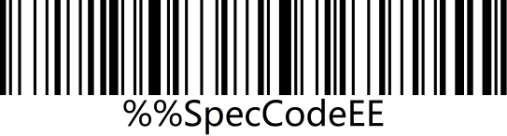 | 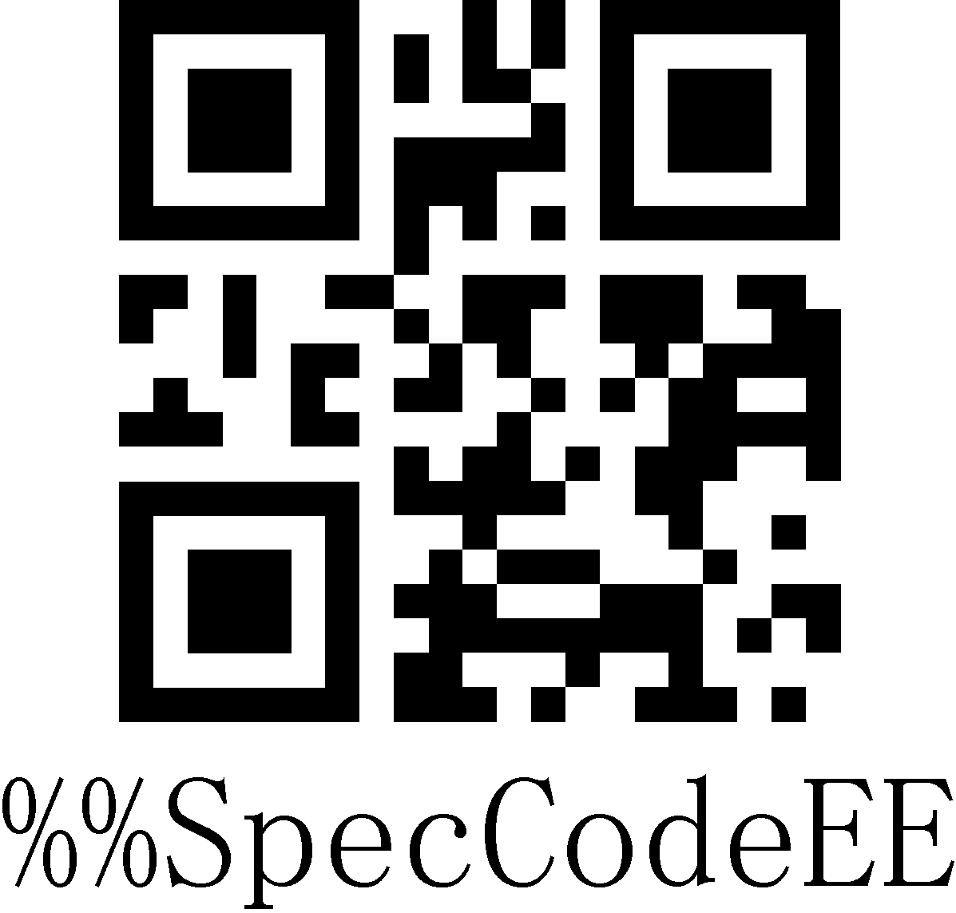
Cancel GS Replacement

Custom Prefix/Suffix
This product supports up to 32-byte prefix and 32-byte suffix setting.

Add Custom Prefix
Step 1: Scan “Add Custom Prefix” Setup Code
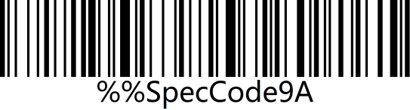 | 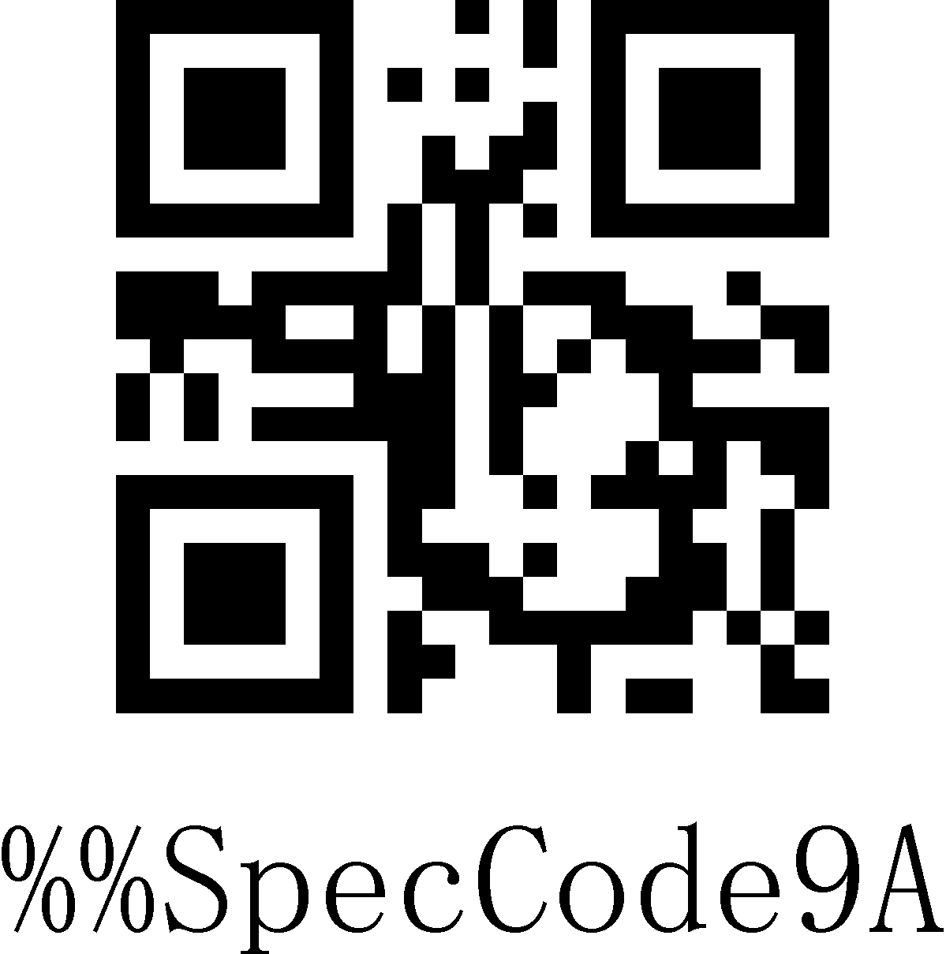
Add Custom Prefix
Step 2: According to the content that needs to be added, query the "ASCII code character table" and scan the setup code corresponding to the custom prefix.

Example:
Original barcode is "ABC123", add custom "789", and output "789ABC123"
Step 1: Scan the "Add custom prefix" setting code;

Step 2: According to the content that needs to be added, query the "ASCII code character table" and scan the setup codes corresponding to "7", "8", and "9".

Clear Custom Prefix
Refer to Adding Custom Prefix Setting and follow the steps below to clear the custom prefix.
Step 1: Scan the "Add custom prefix" setup code;

Step 2: Scan the setup code of "Exit Setting Mode" in "Appendix-Enter/Exit Setting";

Or you can directly scan and restore factory values to clear custom prefixes.

Add Custom Suffix
Step 1: Scan “Add Custom Suffix”Setup Code
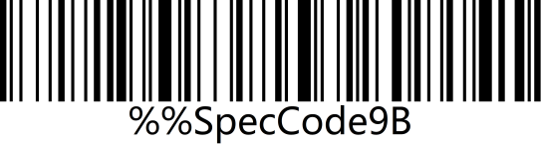 | 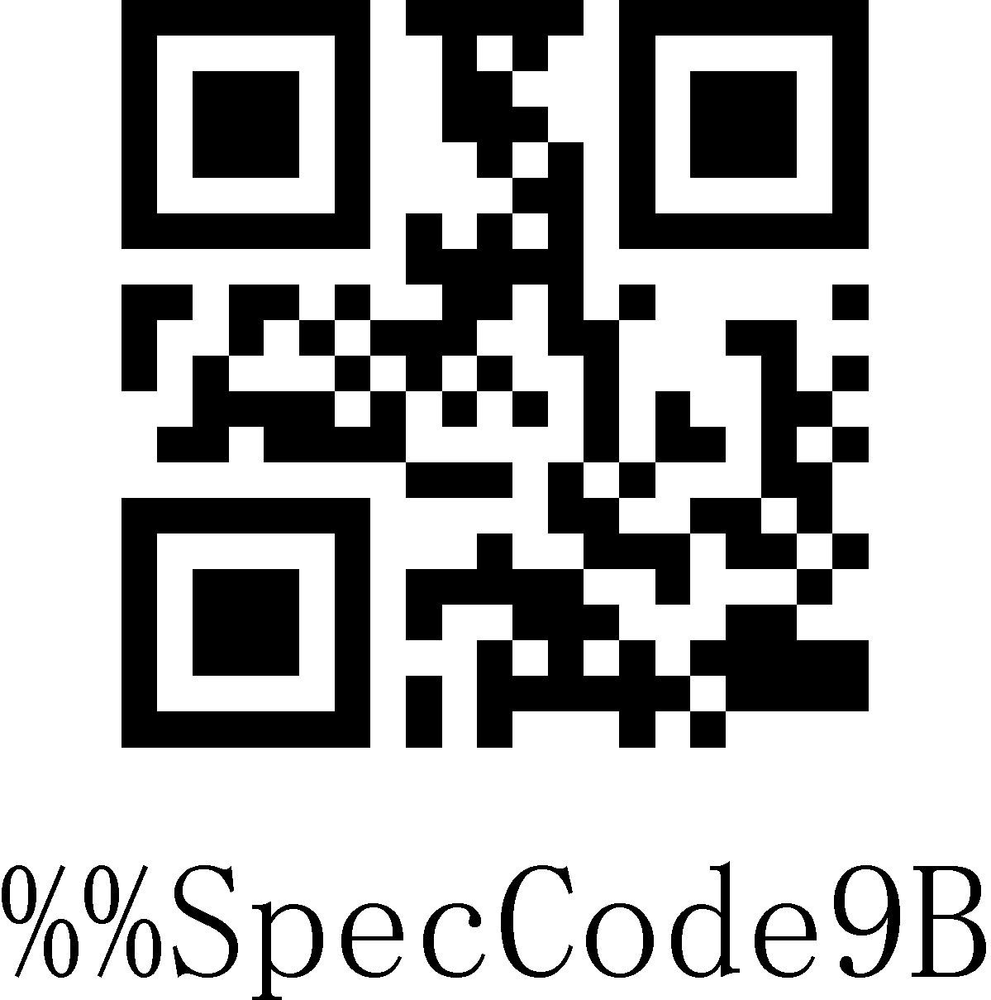
Add Custom Suffix
Step 2: According to the content that needs to be added, query the "ASCII code character table" and scan the setup code corresponding to the custom suffix.

Example:
Original barcode is "ABC123", add custom "XYZ", and output "ABC123XYZ"
Step 1: Scan the "Add custom suffix" setup code;

Step 2: According to the content that needs to be added, query the "ASCII code character table" and scan the setup codes corresponding to "X", "Y", and "Z";

Clear Custom Suffix
Refer to the setting of adding custom suffix and follow the steps below to clear the custom suffix.
Step 1: Scan the "Add custom suffix" setup code.
Step 2: Scan the setup code of "Exit Setting Mode" in "Appendix-Enter/Exit Setting".

Or you can directly scan and restore factory default to clear custom suffixes.

Hide First/Last Characters
Follow the steps below to set the number of digits for the characters before and after hiding, up to 16 digits.
Step 1: Scan the setup code of "Hide first characters" or "Hide last characters"
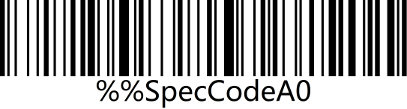 | 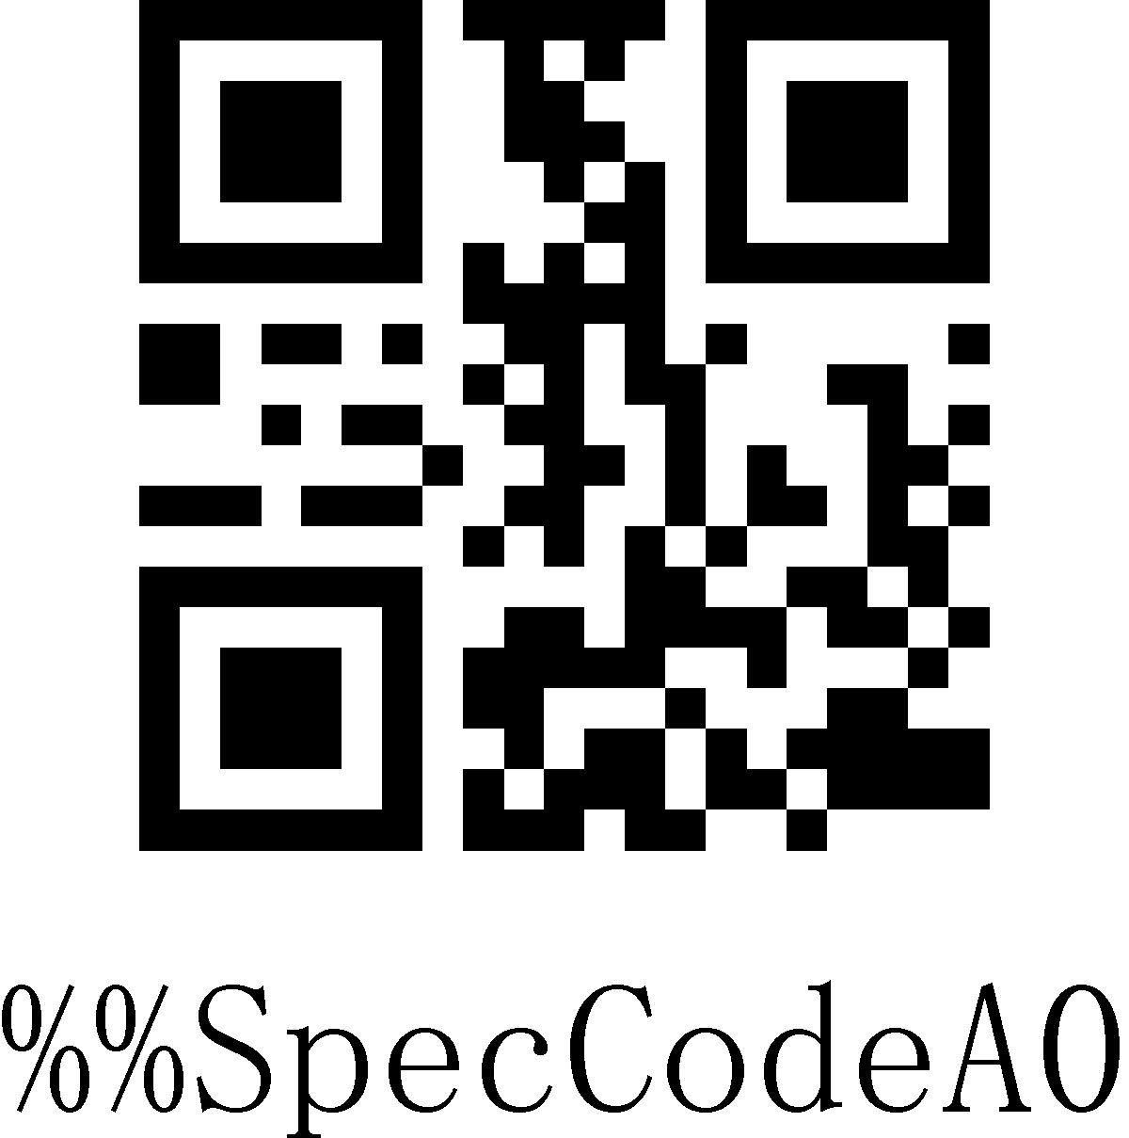
Hide first characters
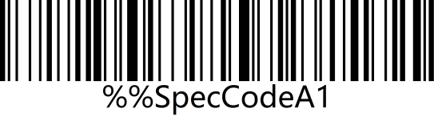 | 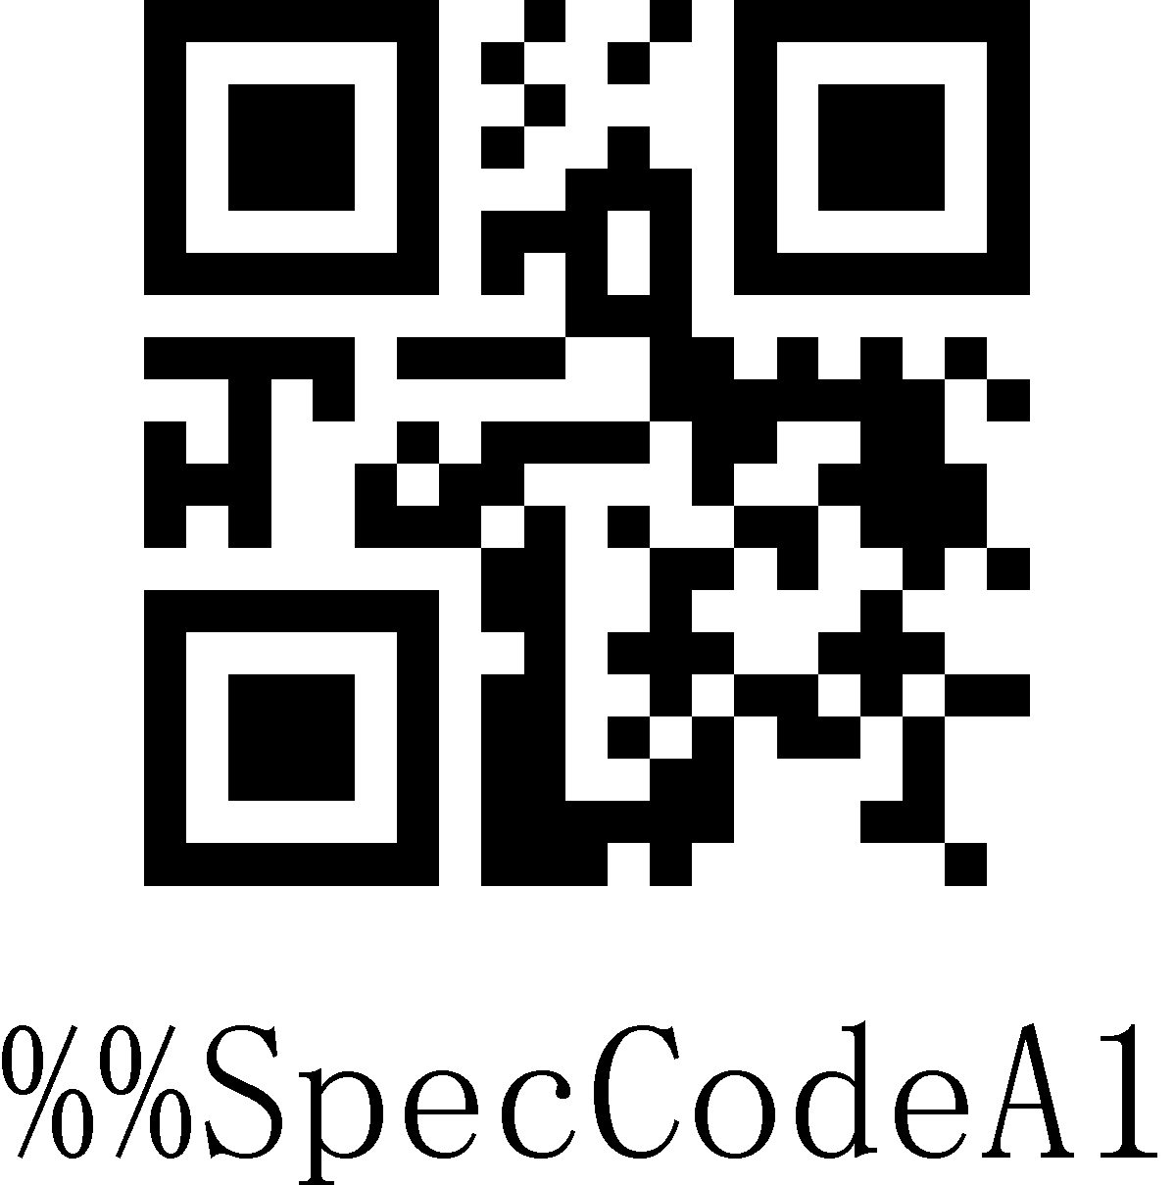
Hide last characters

Step 2: Scan the barcode corresponding to 01-16 in "Appendix-ASCII code character table" according to the number of prefix or suffix characters that need to be hidden.
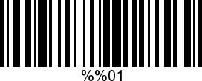 | 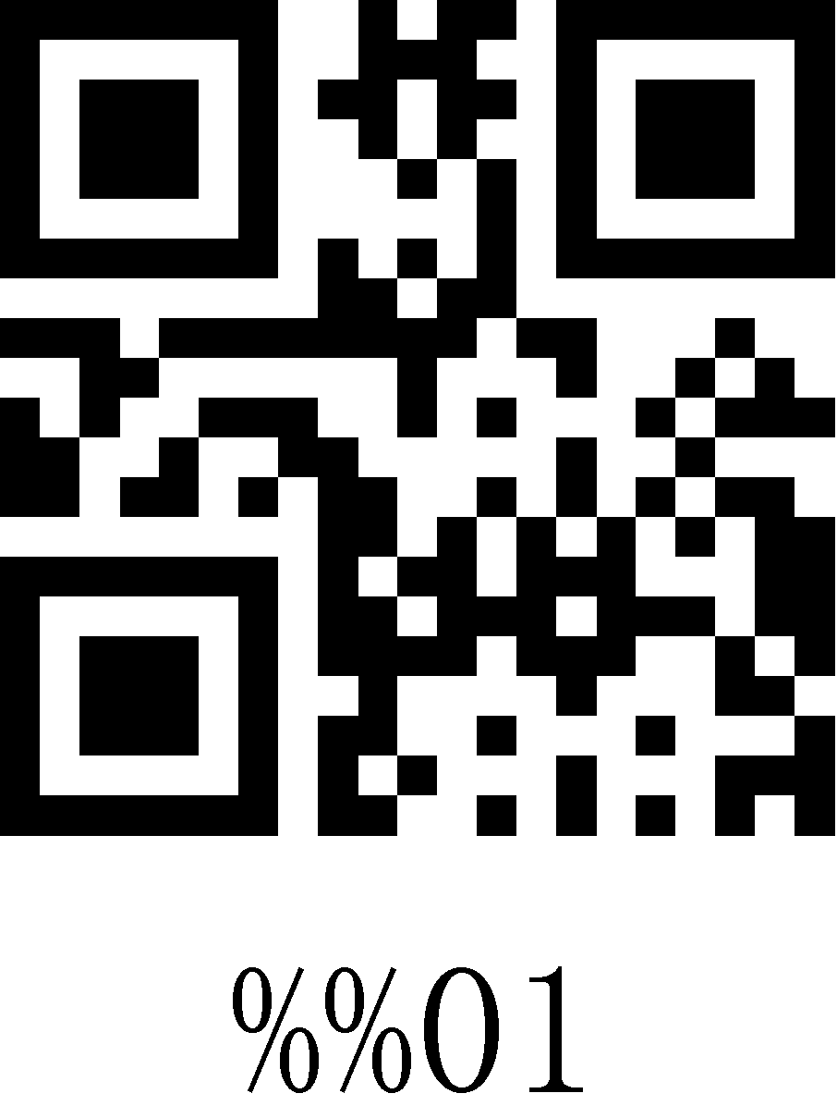
Hide 1 character
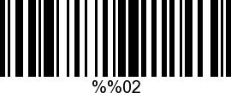 | 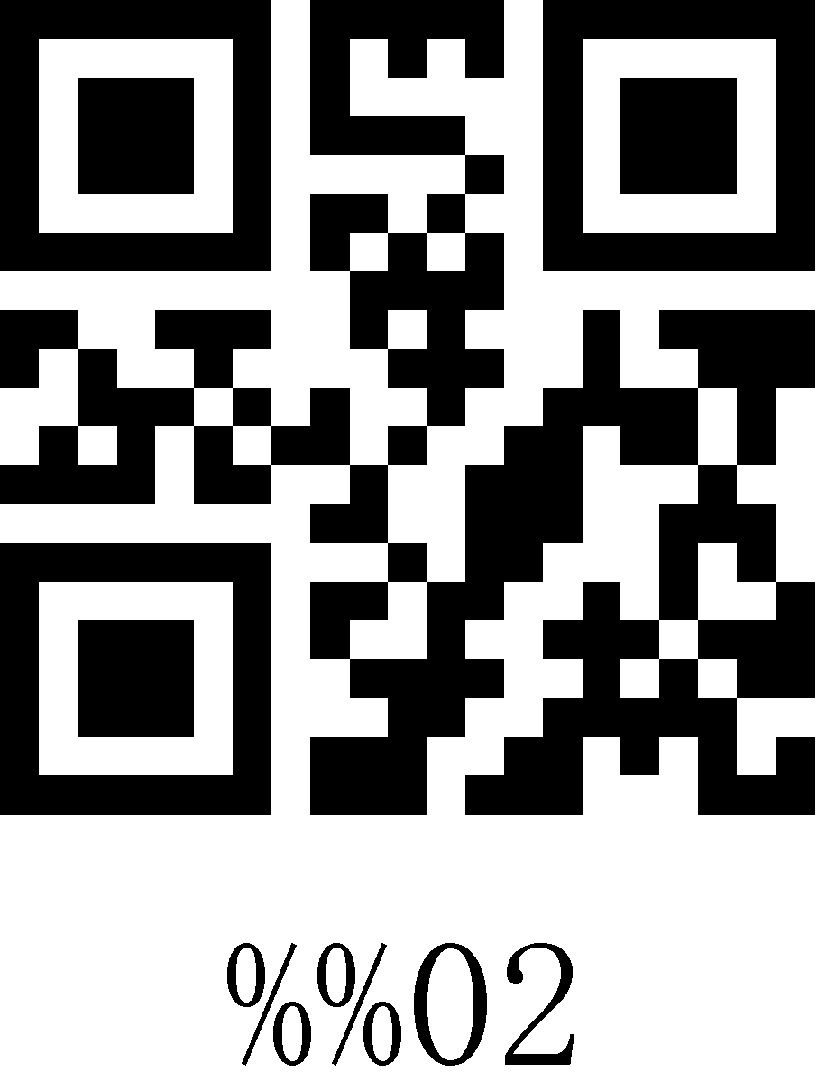
Hide 2 characters
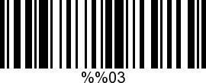 | 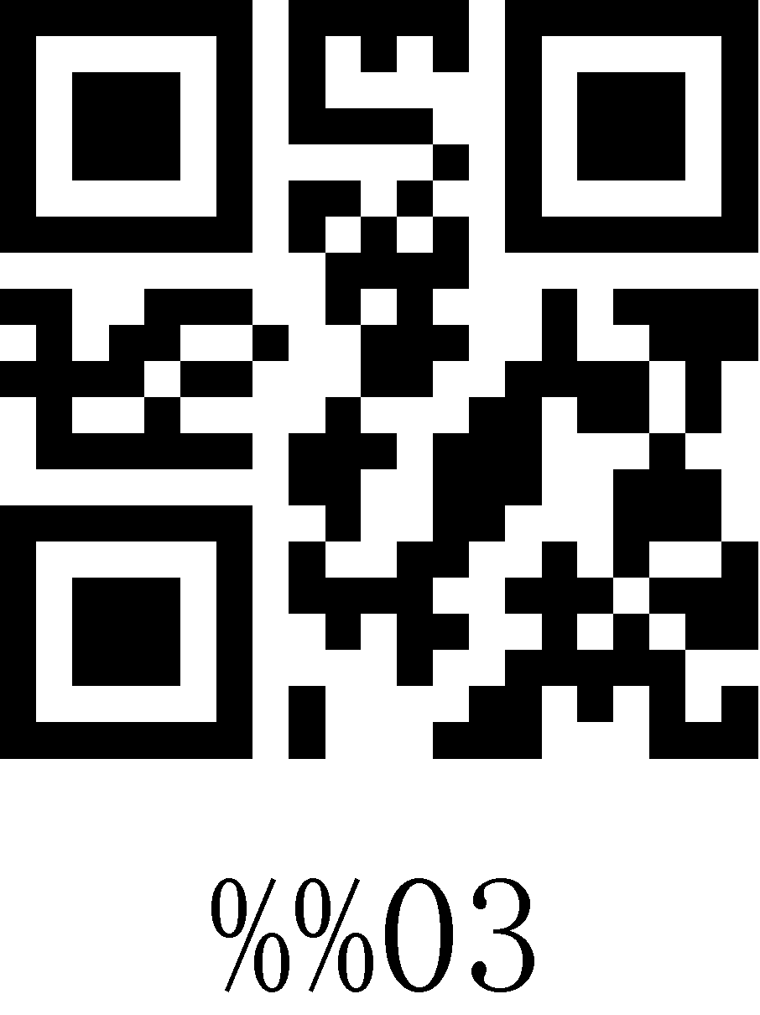
Hide 3 characters
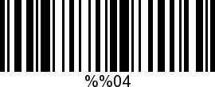 | 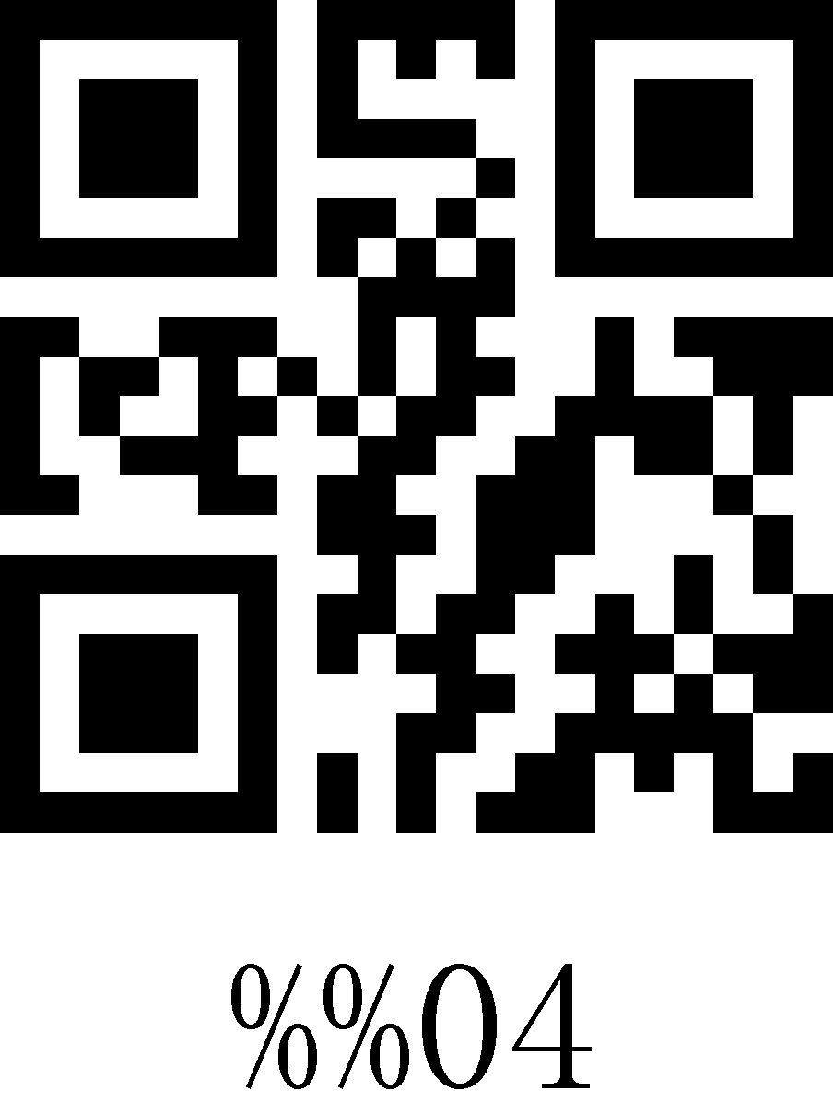
Hide 4 characters

Clear Hidden characters
Step 1: Scan the setup code of "Hide first characters" or "Hide last characters";
Step 2: Scan the setup code of "Exit Setting Mode" in "Appendix-Enter/Exit Setting";

Or you can directly scan and restore factory ddefault to clear custom prefixes.

Terminator
The terminator is used to mark the end of a complete data message. The terminator must be the last content when a piece of data is sent, and there will be no additional data after that. Choose to scan the appropriate end character to set the barcode according to your needs, the default is Enter.
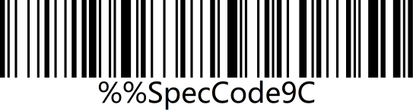 | 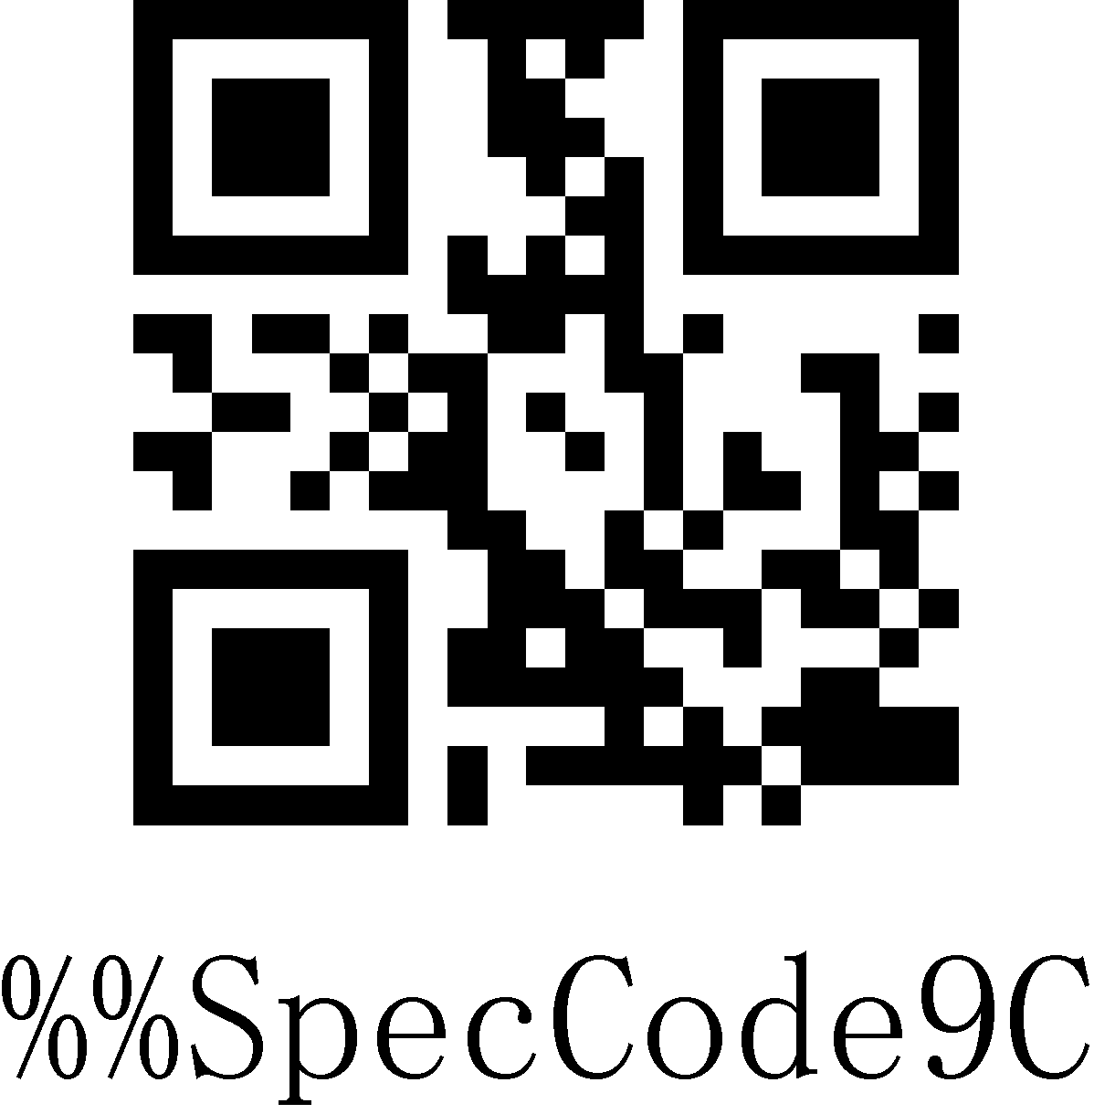
<CR>(0x0D)*
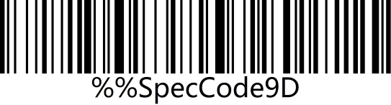 | 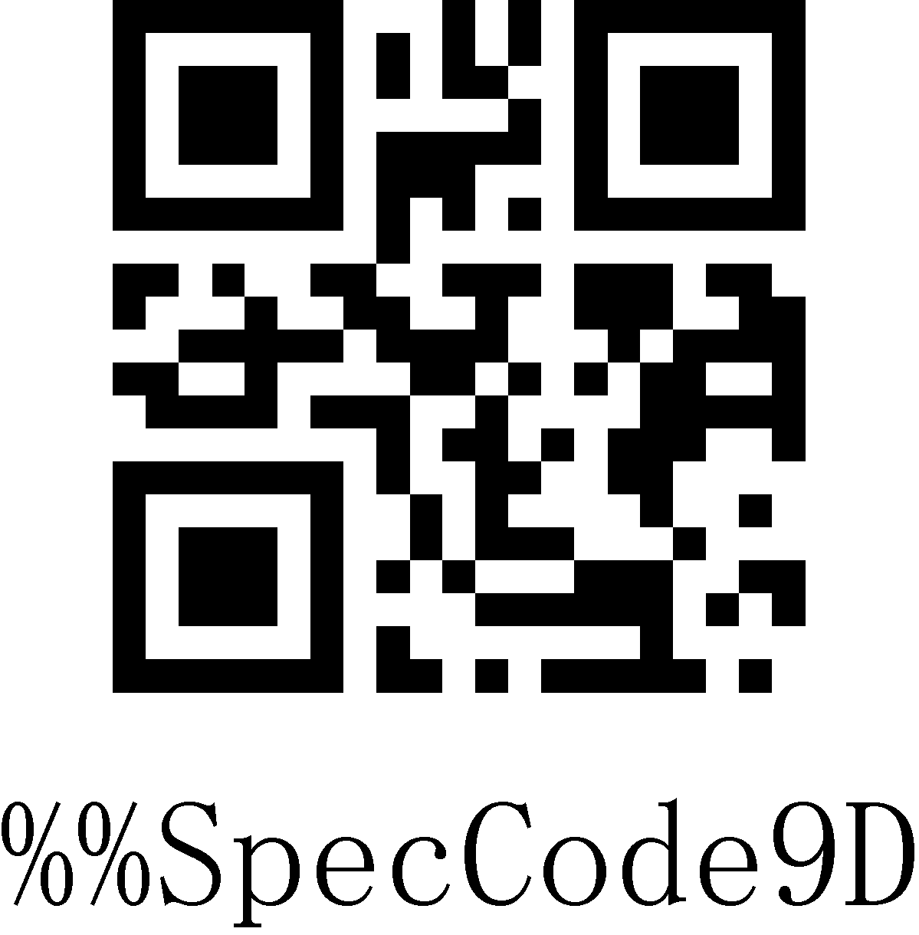
<LF>(0x0A)
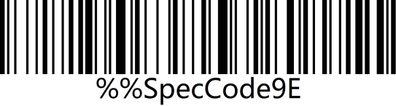 | 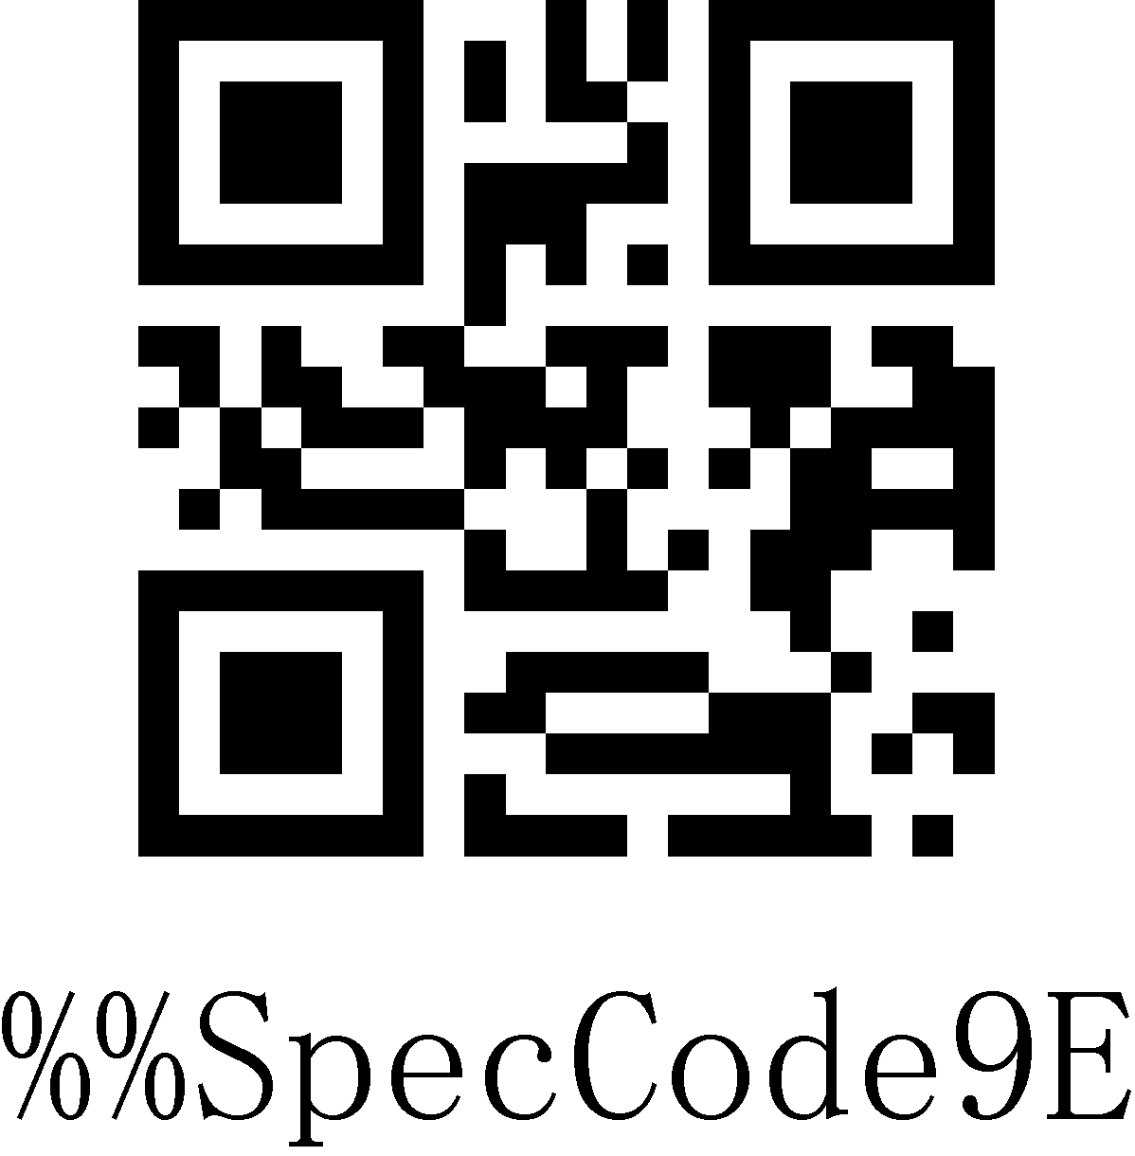
<CR><LF>(0x0D,0x0A)
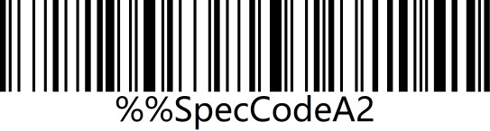 | 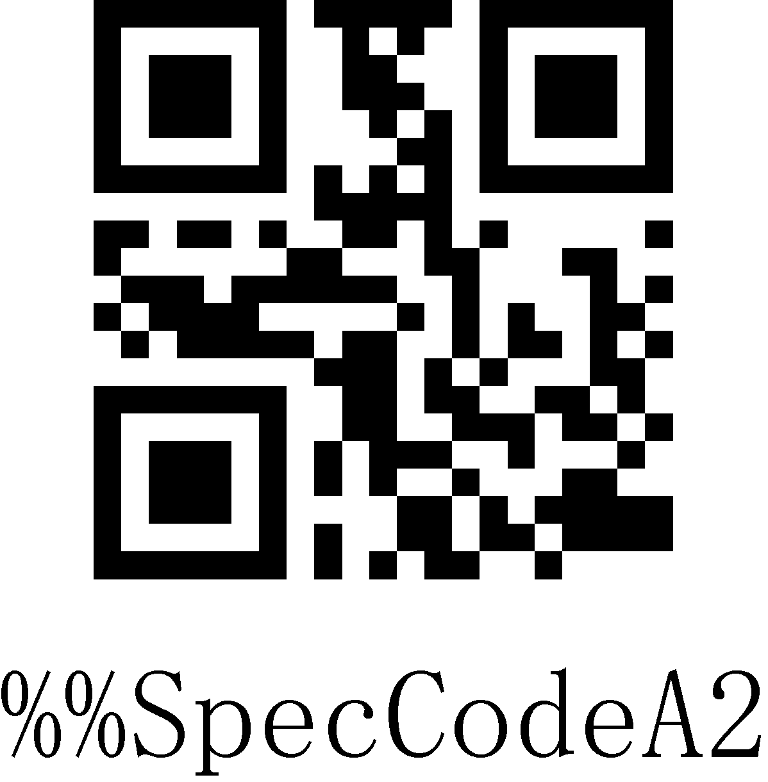
<HT>(0x09)
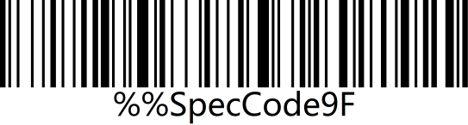 | 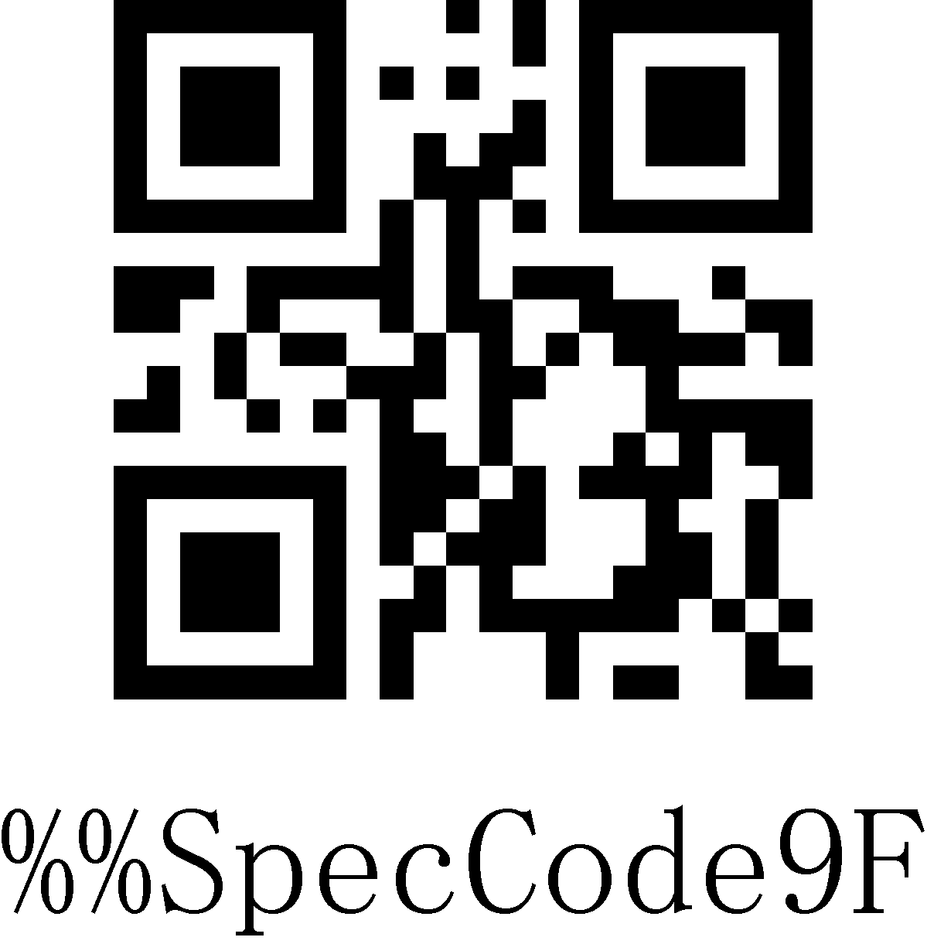
NONE

Clock Function
The clock function is supported by wireless version 3.0 and above. You can set the current time and send it to the output device together with the barcode by setting the clock function.
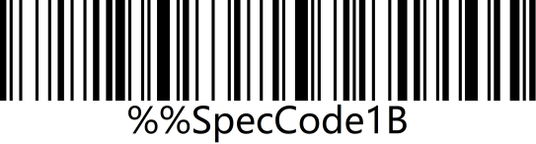 | 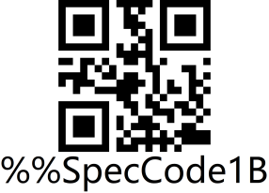
Show current time
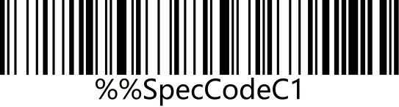 | 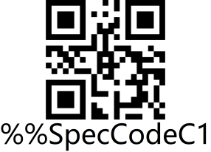
Add time before barcode
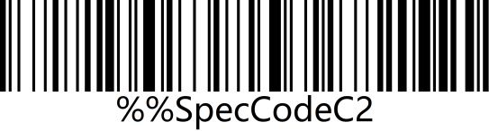 | 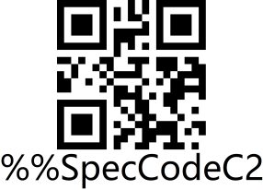
Add time after barcode
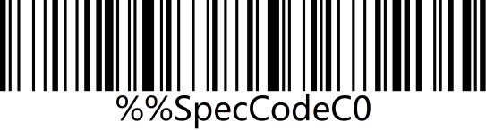 | 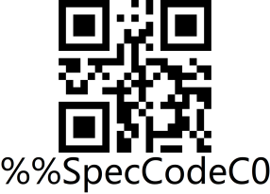
Close time before or after barcode

Note: The clock function needs to be customized and needs to be supported by a software version above 3.0. The clock function will re-time after the barcoder is shut down. You need to use a tool to synchronize the current time of the computer.

Control character set escape settings
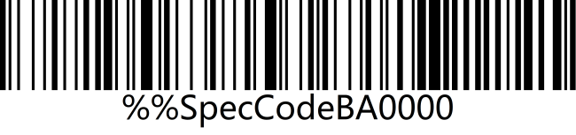 | 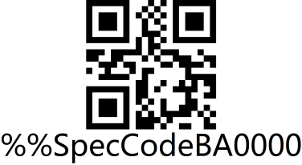
Escape character set 0*
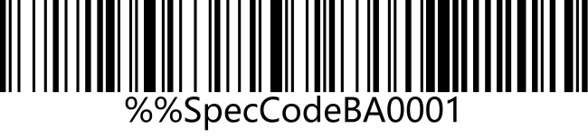 | 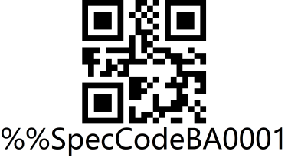
Escape character set 1
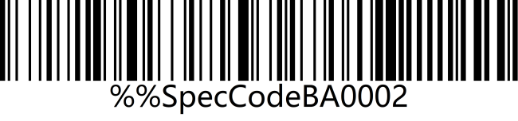 | 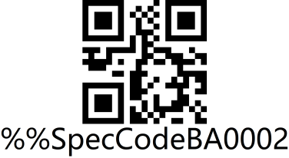
Escape character set 2
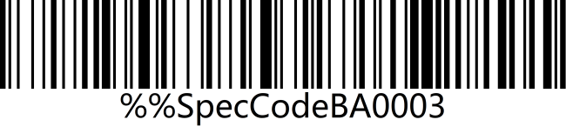 | 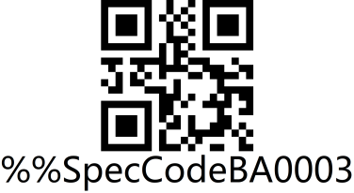
Escape character set 3
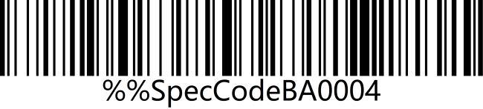 | 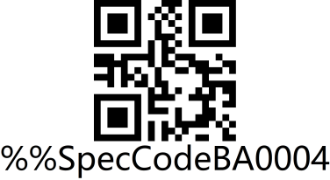
Escape character set 4
Note: The character escape function is supported by wireless version 3.0 and above

Appendix-Enter/Exit Settings
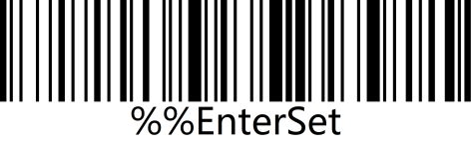 | 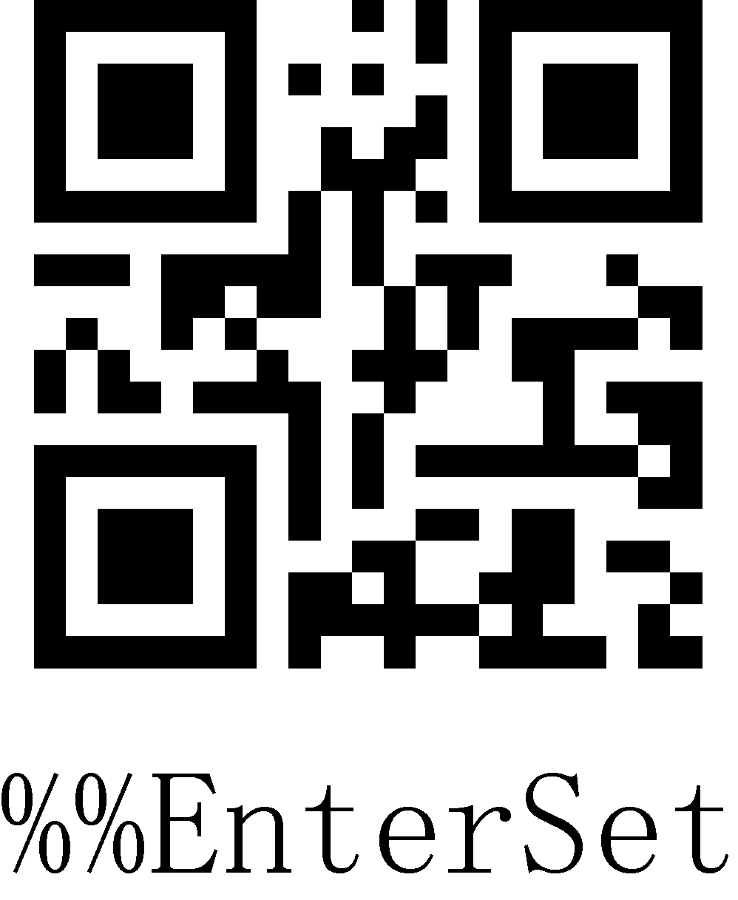
Enter setting mode
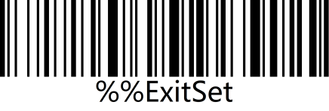 | 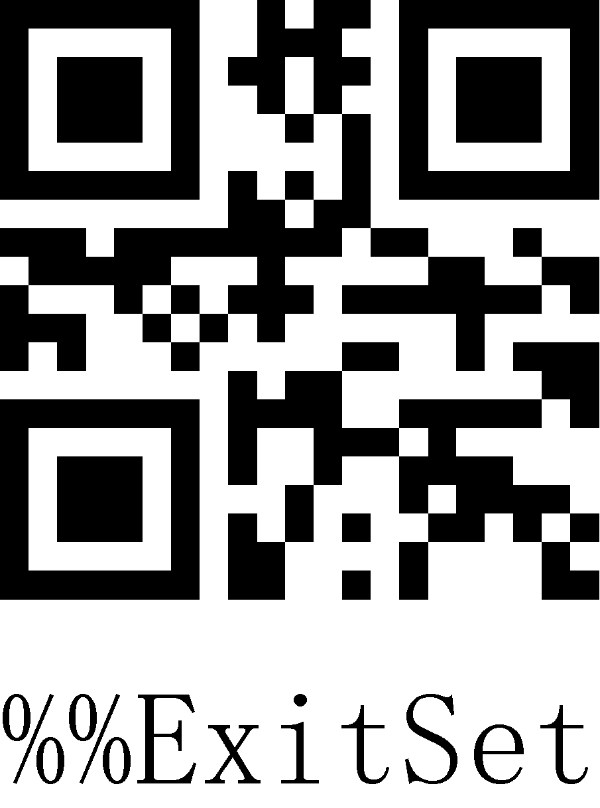
Exit setting mode

Appendix-LED indicator description
Basic function description of indicator light：
Blue LED2 | Used to indicate whether the wireless is connected or not, if it is connected, it is always on, if the connection is disconnected, it will be off.
Blue LED1 | The scan code indicator light flashes briefly when the barcode is successfully scan.
Red LED3 | The red light is always on to indicate that it is charging, and the red light is off to indicate that it is fully charged or not connected to charge
Blue light 2 is off, blue light 1 flashes quickly | 2.4G/Virtual Bluetooth mode pairing status
Blue light 1 is off, blue light 2 flashes quickly | Pairing status in SPP mode
Blue light 1 and blue light 2 flash alternately and quickly | Pairing status in HID mode
Blue light 1 and blue light 2 flash synchronously and quickly | Pairing status in BLE mode
Blue light 1 and blue light 2 flash synchronously and slowly | The module is in an upgrade state
Note: This part of the lighting description is slightly different according to different product configurations. If you need more information, please contact the supplier.

Appendix-description of buzzer sound
One long tone (low first and then high) | Indicates that the power is on
One long tone (high first and then low) | Indicates that the power is off
One short tone (low frequency) | Indicates that the normal barcode is scanned, or the pairing is successful, or the wireless connection is successful.
One short tone (low first and then high) | Indicates that the scanned data is stored in the storage area
One short tone (high first and then low) | Indicates that the setup code was scanned
Three short tones (low frequency) | Indicates that the wireless transmission failed or the buffer is full
Five short tones (low frequency) | Indicates that it need to be charged
Two short tones (low frequency) | Indicates wireless disconnection
Two short tones (high frequency) | Indicates that the scanned setup code does not work

Appendix-Control Character List
Note: The setting code of the control character table refers to the corresponding setting code of 01-31 in the ASCII character table。
HEX | Decimal | ASCII | character set 0 | character set 1 | character set 2 | character set 3 | character set 4
01 | 01 | SOH | NULL | Home | Ctrl+A | Alt+001 | Enter on the keypad
02 | 02 | STX | Ctrl+B | End | Ctrl+B | Alt+002 | Cap Lock
03 | 03 | ETX | Ctrl+C | Up Arrow | Ctrl+C | Alt+003 | Right Arrow
04 | 04 | EOT | NULL | Down Arrow | Ctrl+D | Alt+004 | Up Arrow
05 | 05 | ENQ | NULL | Left Arrow | Ctrl+E | Alt+005 | NULL
06 | 06 | ACK | NULL | Right Arrow | Ctrl+F | Alt+006 | NULL
07 | 07 | BEL | NULL | Shift+Tab | Ctrl+G | Alt+007 | Enter
08 | 08 | BS | Back Space | Back Space | Back Space | Alt+008 | Left Arrow
09 | 09 | HT | Tab | Tab | Tab | Alt+009 | Tab
0A | 10 | LF | Enter | Enter | Ctrl+P | Alt+010 | Down Arrow
0B | 11 | VT | NULL | NULL | Ctrl+Q | Alt+011 | Tab
0C | 12 | FF | NULL | NULL | Ctrl+R | Alt+012 | delete
0D | 13 | CR | Enter | Enter | Enter | Alt+013 | Enter
0E | 14 | S0 | F1 | Page Up | Ctrl+N | Alt+014 | Insert
0F | 15 | S1 | F2 | Page Down | Ctrl+O | Alt+015 | Esc
10 | 16 | DLE | F3 | F11 | Ctrl+P | Alt+016 | F11
11 | 17 | DC1 | F4 | NULL | Ctrl+Q | Alt+017 | Home
12 | 18 | DC2 | F5 | NULL | Ctrl+R | Alt+018 | Print  Screen
13 | 19 | DC3 | F6 | NULL | Ctrl+S | Alt+019 | Back Space
14 | 20 | DC4 | F7 | NULL | Ctrl+T | Alt+020 | Shift tab
15 | 21 | NAK | F8 | F12 | Ctrl+U | Alt+021 | F12
16 | 22 | SYN | F9 | F1 | Ctrl+V | Alt+022 | F1
17 | 23 | TB | F10 | F2 | Ctrl+W | Alt+023 | F2
18 | 24 | CAN | F11 | F3 | Ctrl+X | Alt+024 | F3
19 | 25 | EM | F12 | F4 | Ctrl+Y | Alt+025 | F4
1A | 26 | SUB | NULL | F5 | Ctrl+Z | Alt+026 | F5
1B | 27 | Esc | Esc | F6 | Ctrl+[ | Alt+027 | F6
1C | 28 | FS | ALT+028 | F7 | Ctrl+\ | Alt+028 | F7
1D | 29 | GS | ALT+029 | F8 | Ctrl+] | Alt+029 | F8
1E | 30 | RS | NULL | F9 | Ctrl+^ | Alt+030 | F9
1F | 31 | US | NULL | F10 | Ctrl+_ | Alt+031 | F10

Appendix-ASCII code character table
Note: 01-31 are invisible characters. Please refer to "Appendix-Control Character List" to set the escape character set.
32-127 are visible characters. This part of the characters can generally be directly output through the HID keyboard without escaping.
Hexadecimal | ASCII | character | 1D setup code | 2D setup code
01 | 01 | SOH
02 | 02 | STX
03 | 03 | ETX
04 | 04 | EOT
05 | 05 | ENQ | 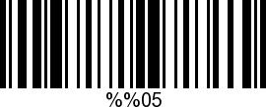 | 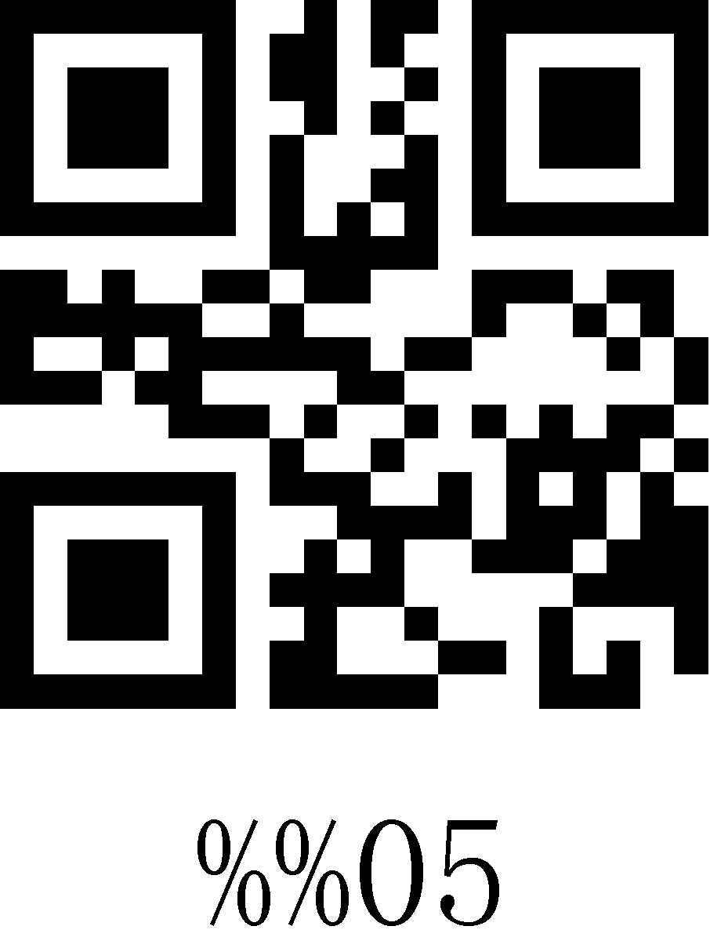
06 | 06 | ACK | 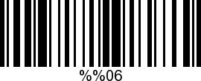 | 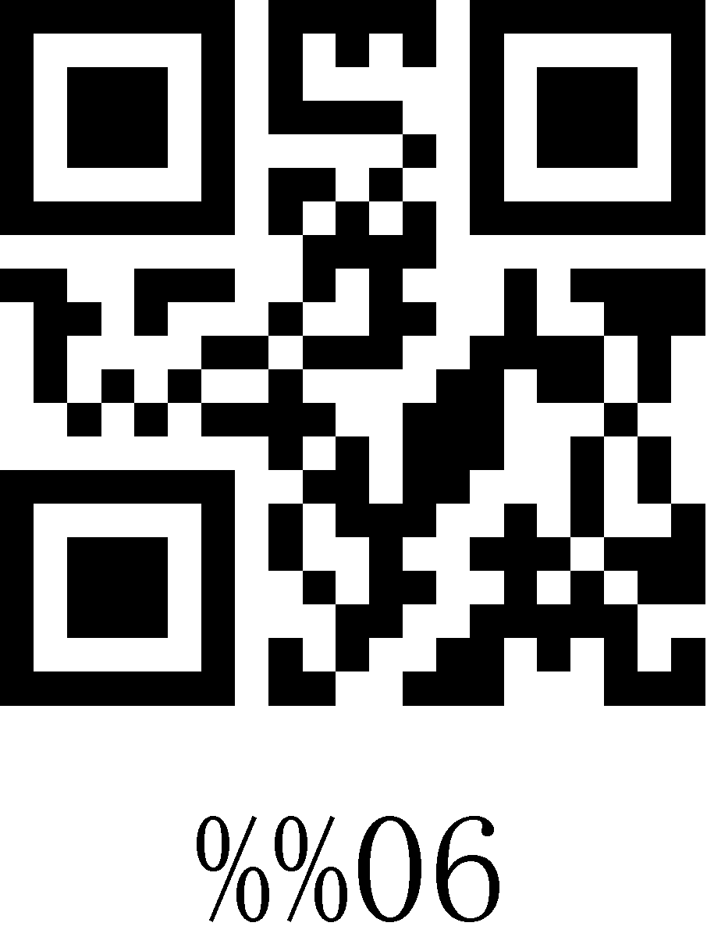
07 | 07 | BEL | 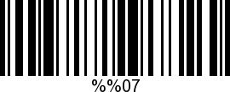 | 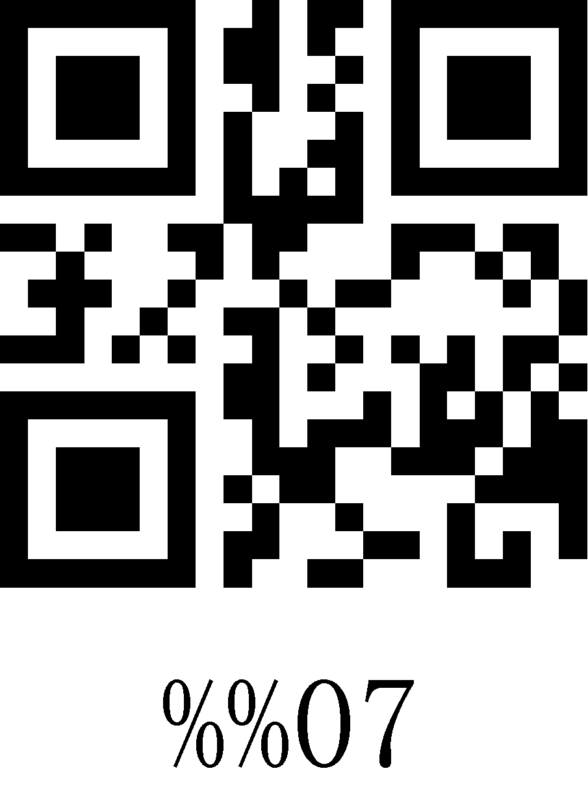
08 | 08 | BS | 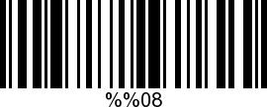 | 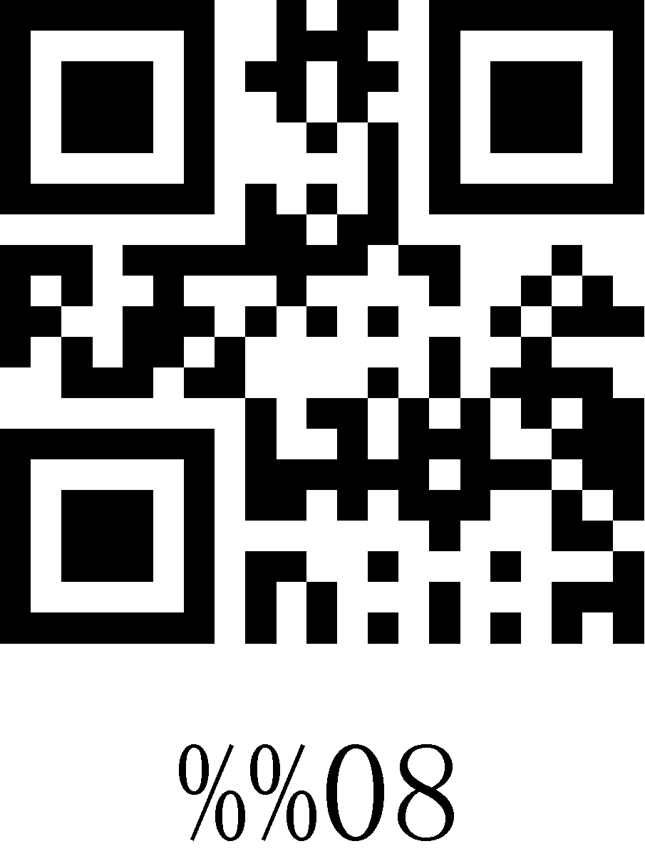
09 | 09 | HT | 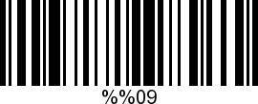 | 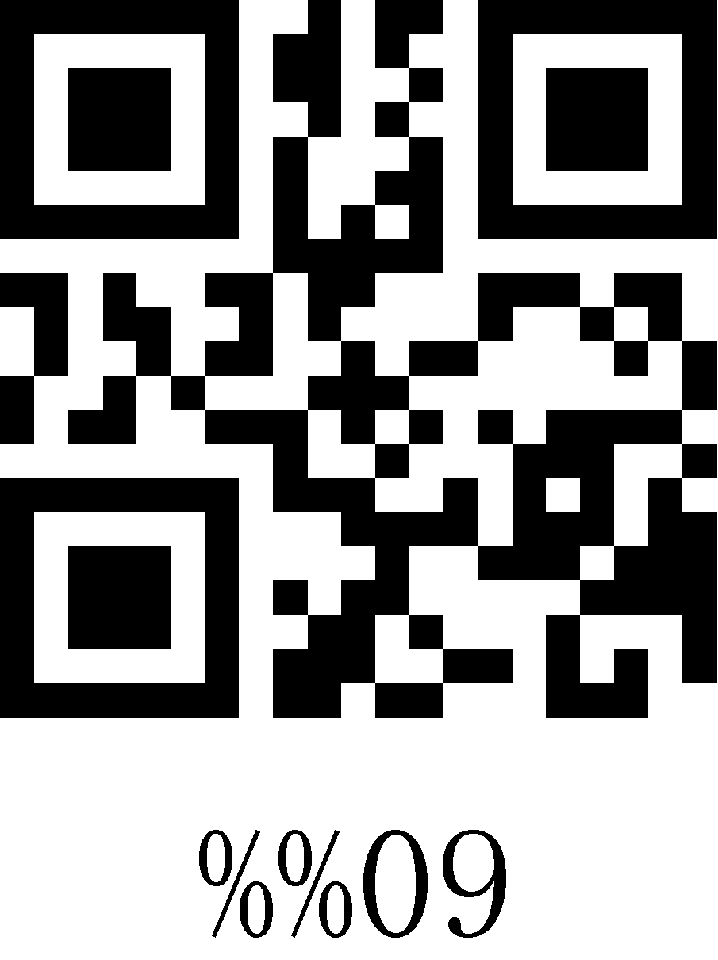
0A | 10 | LF | 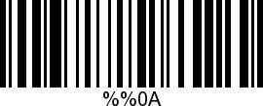 | 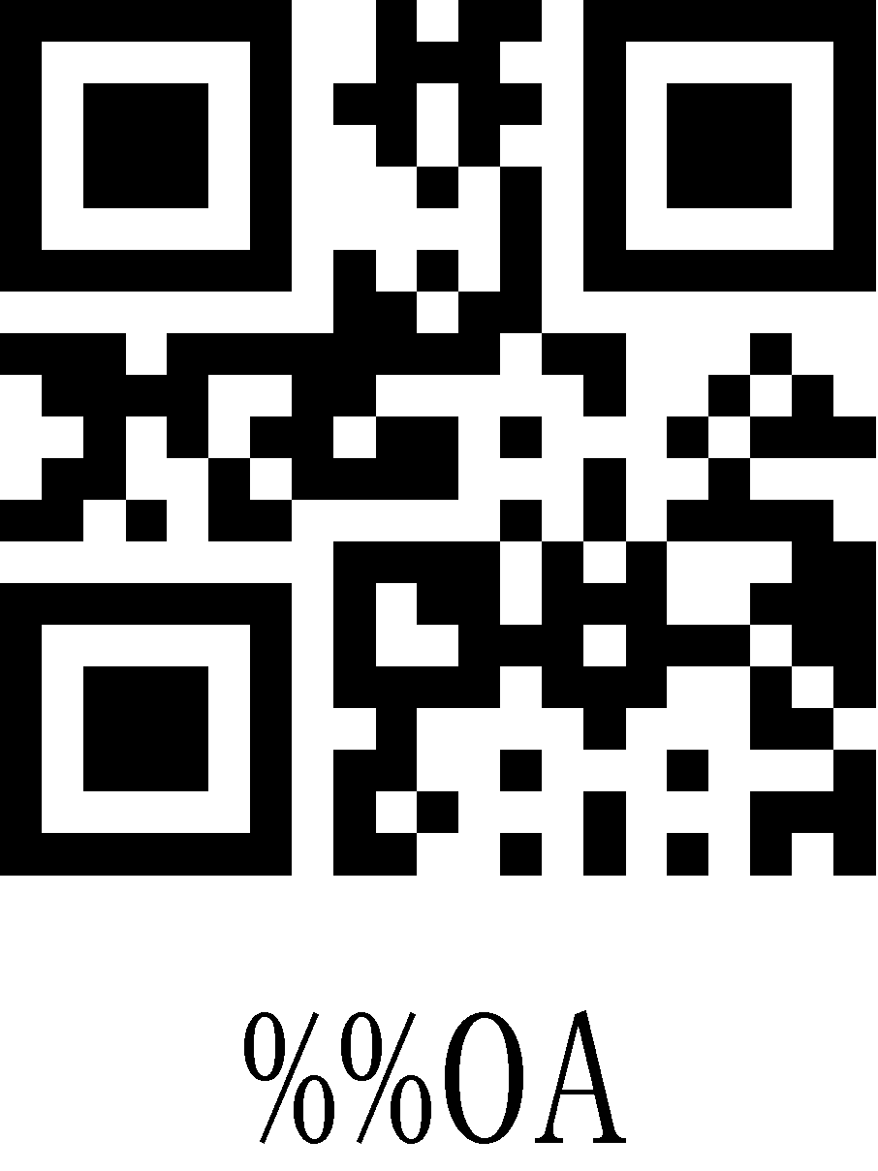
0B | 11 | VT | 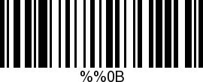 | 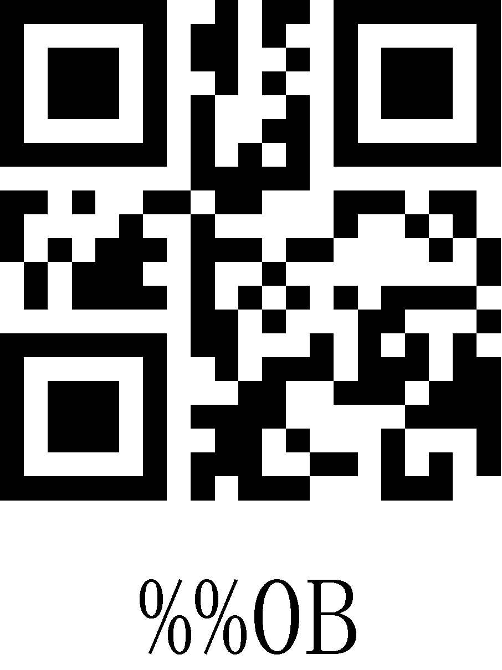
0C | 12 | FF | 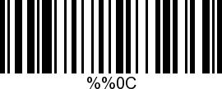 | 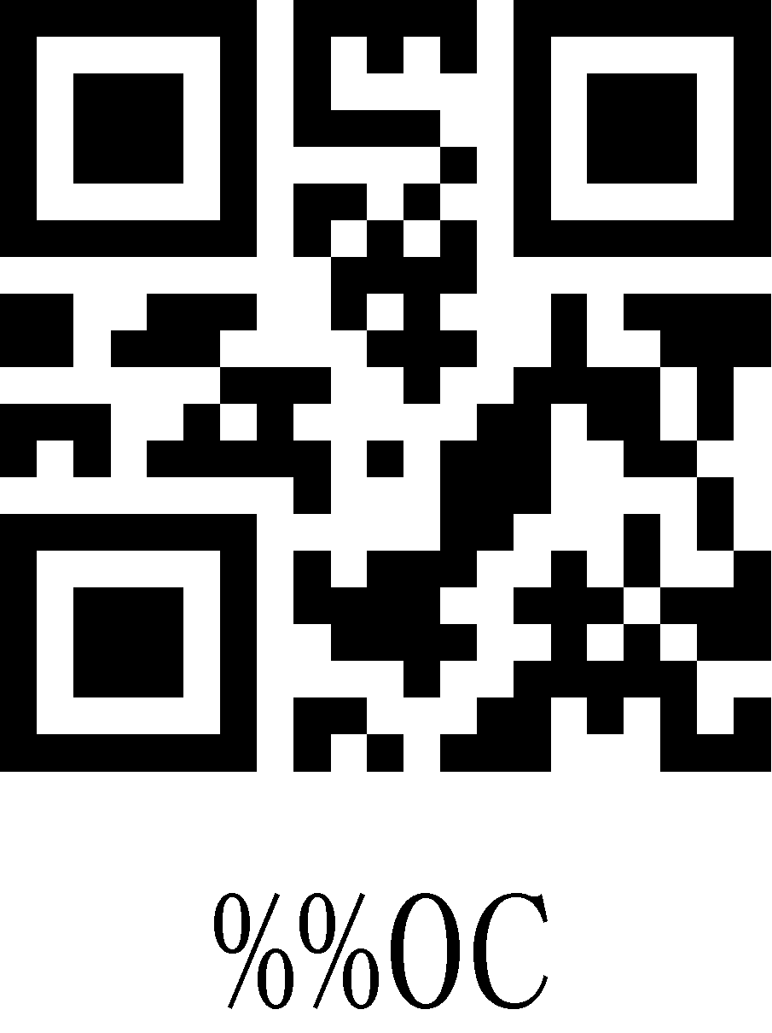
0D | 13 | CR | 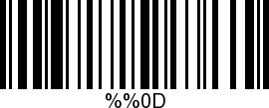 | 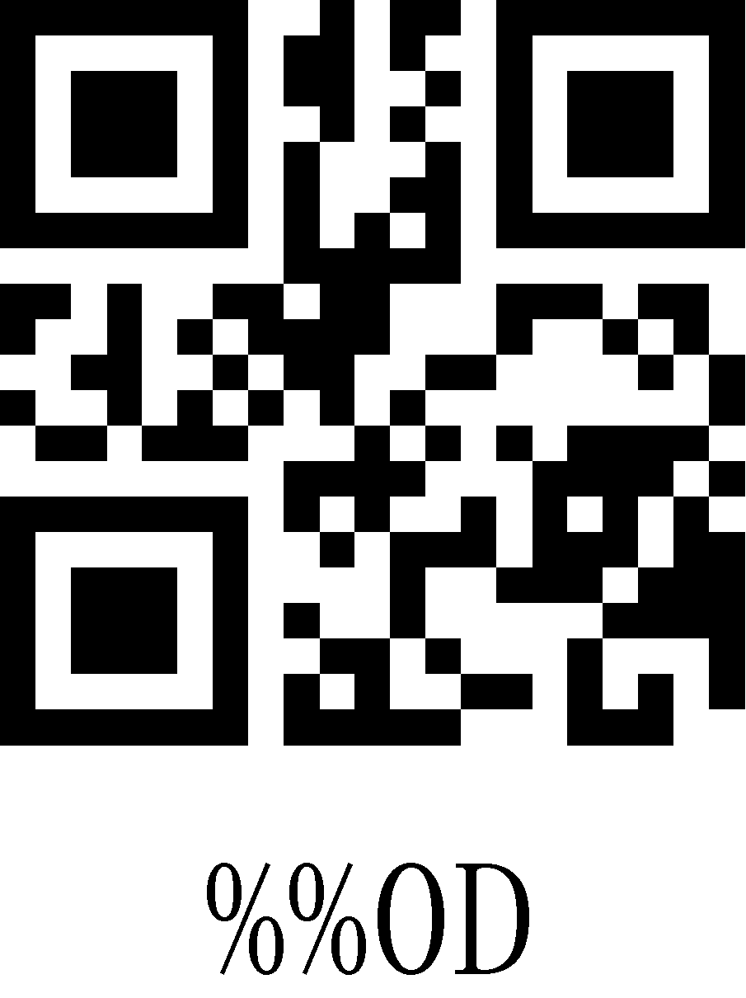
0E | 14 | S0 | 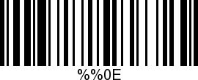 | 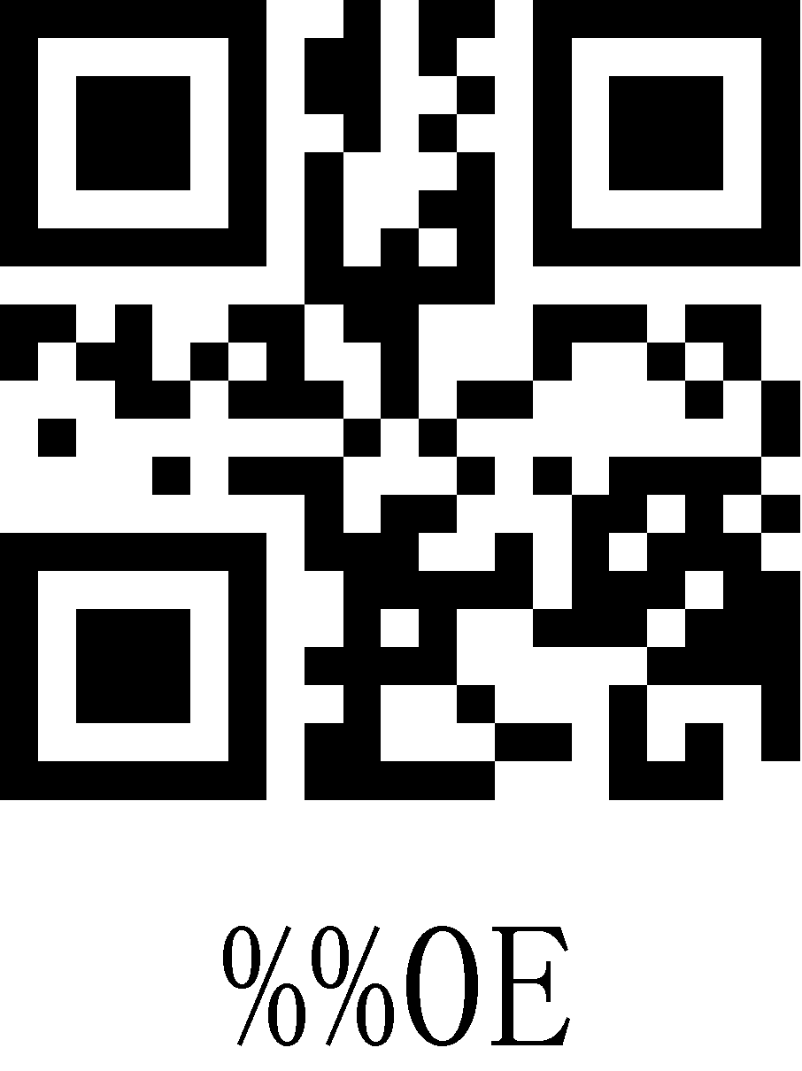
0F | 15 | S1 | 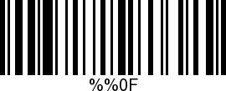 | 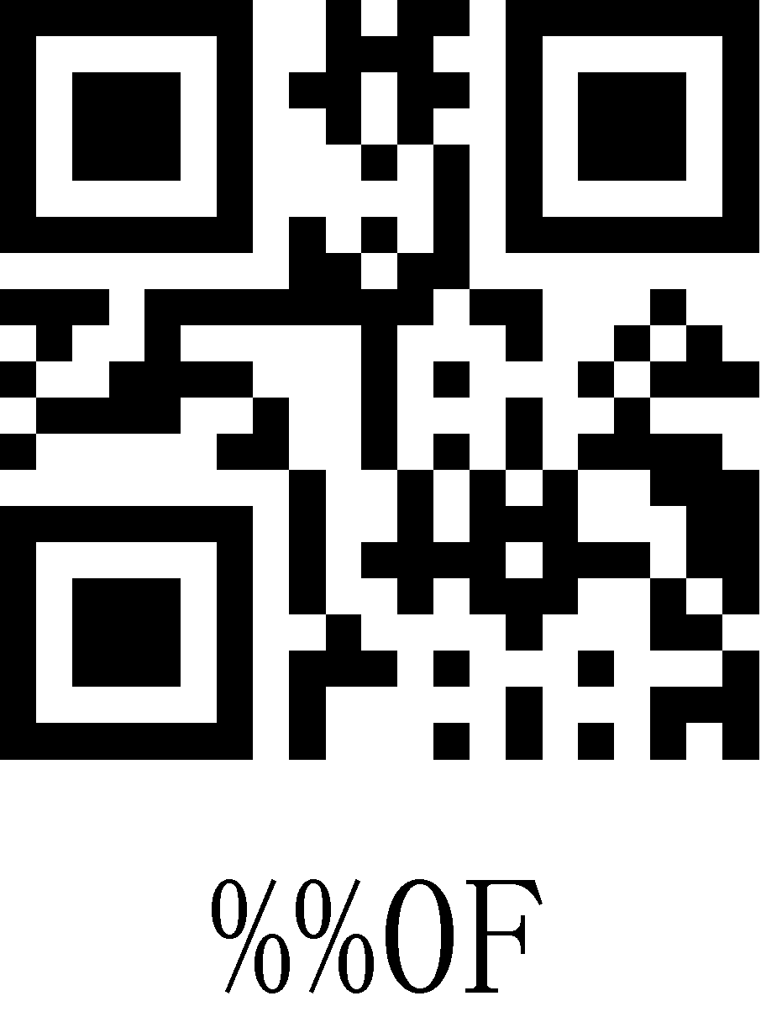
10 | 16 | DLE | 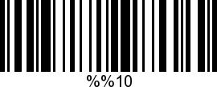 | 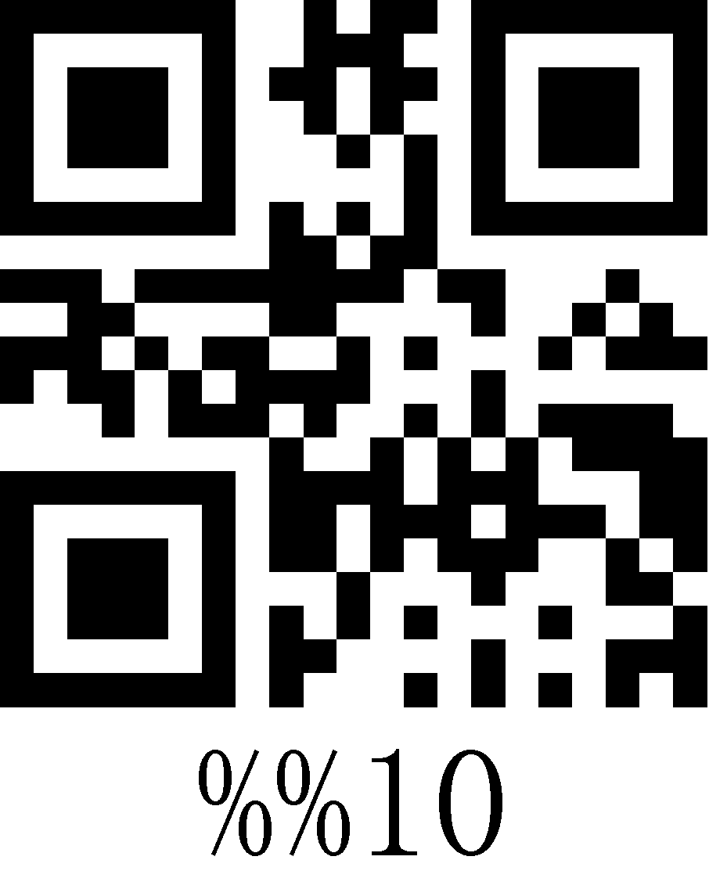
11 | 17 | DC1 | 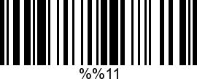 | 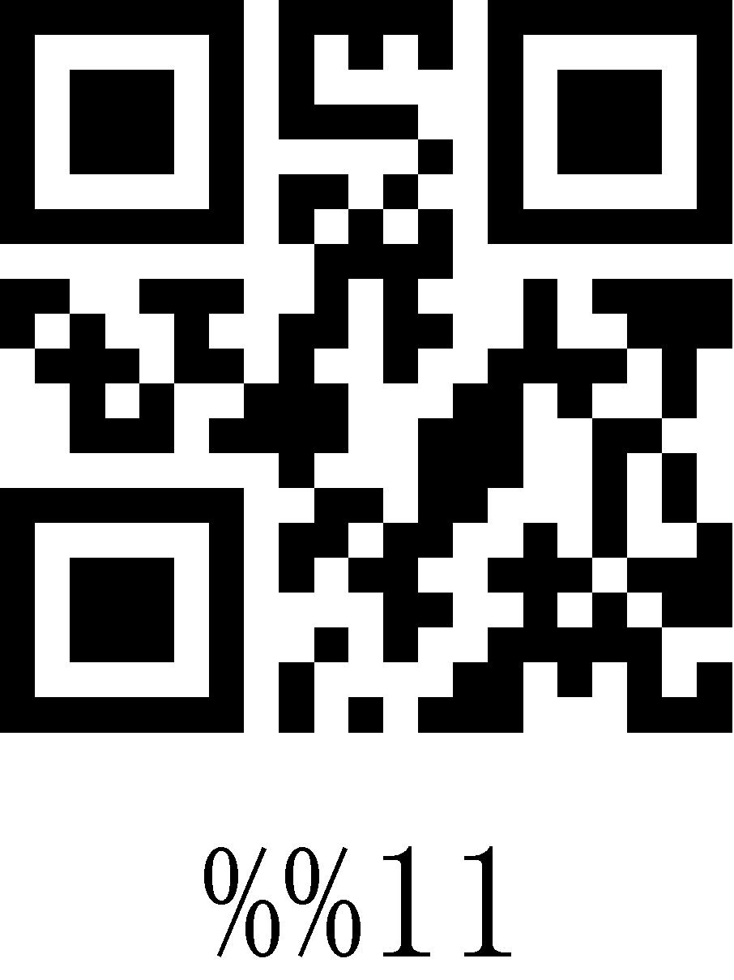
12 | 18 | DC2 | 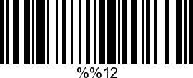 | 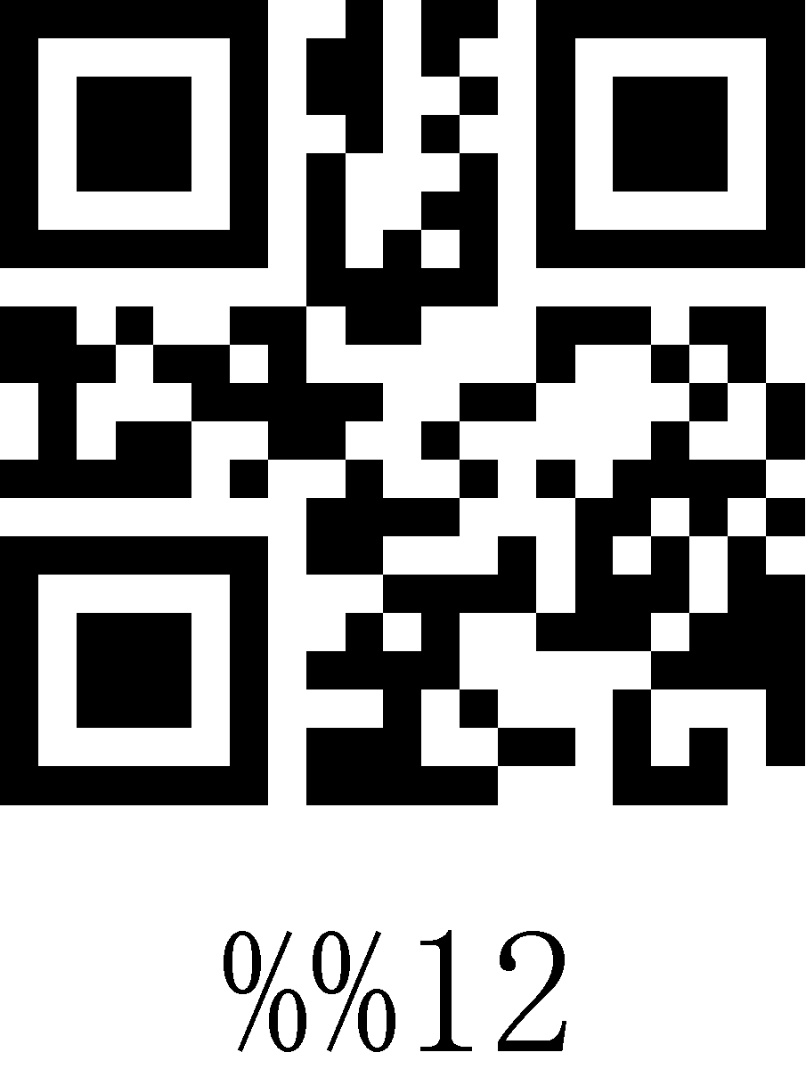
13 | 19 | DC3 | 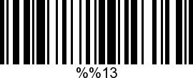 | 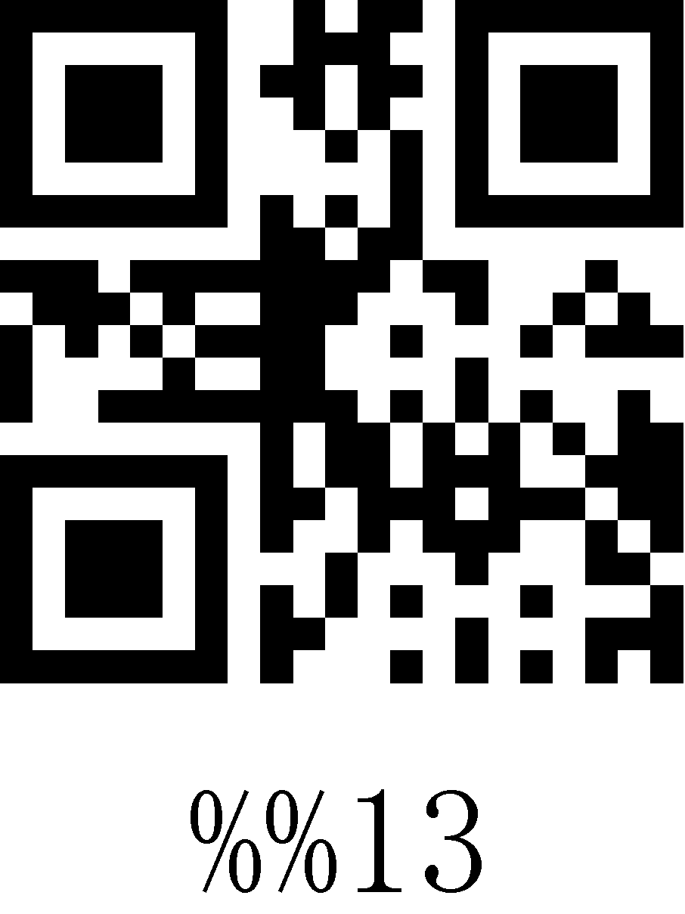
14 | 20 | DC4 | 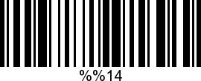 | 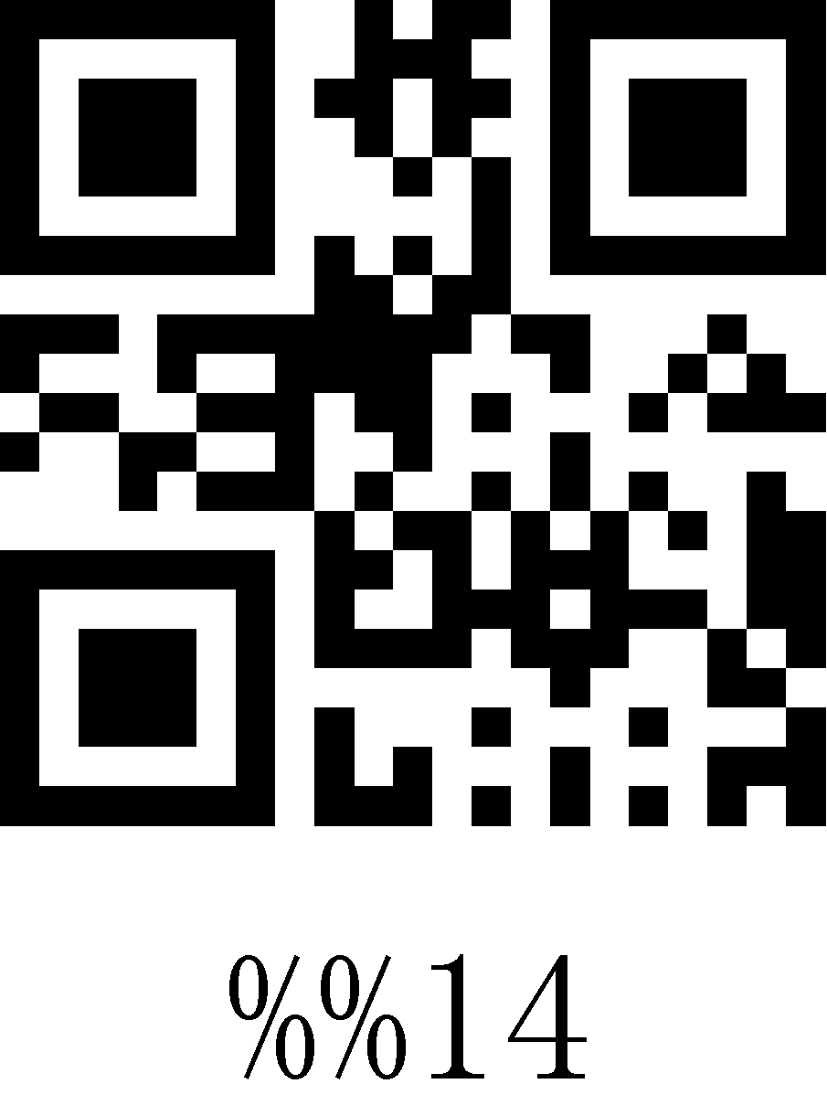
15 | 21 | NAK | 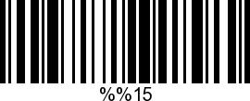 | 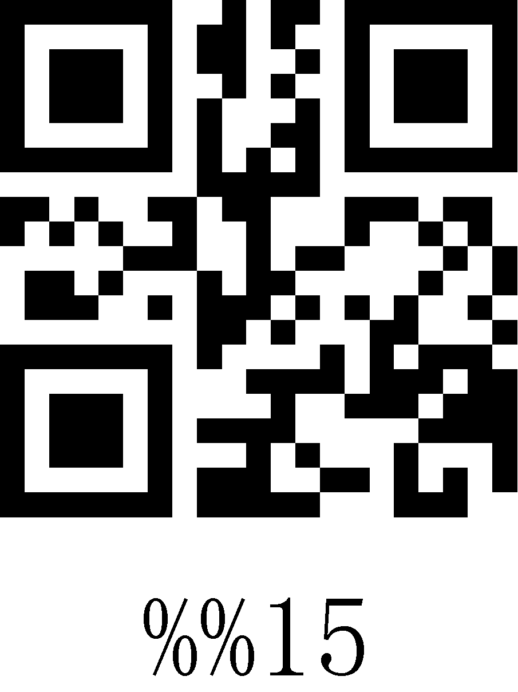
16 | 22 | SYN | 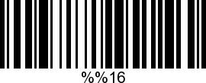 | 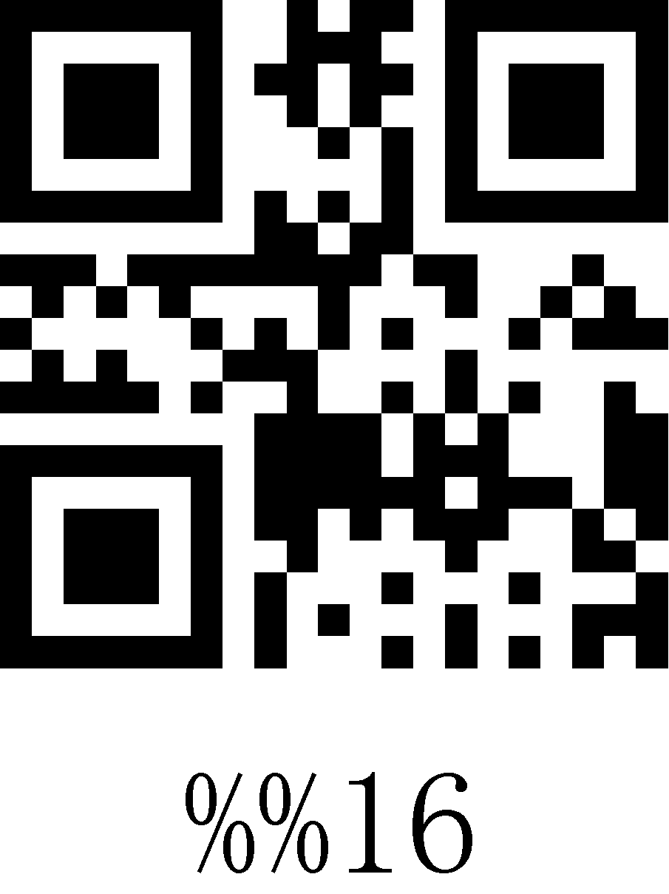
17 | 23 | TB | 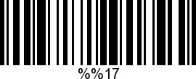 | 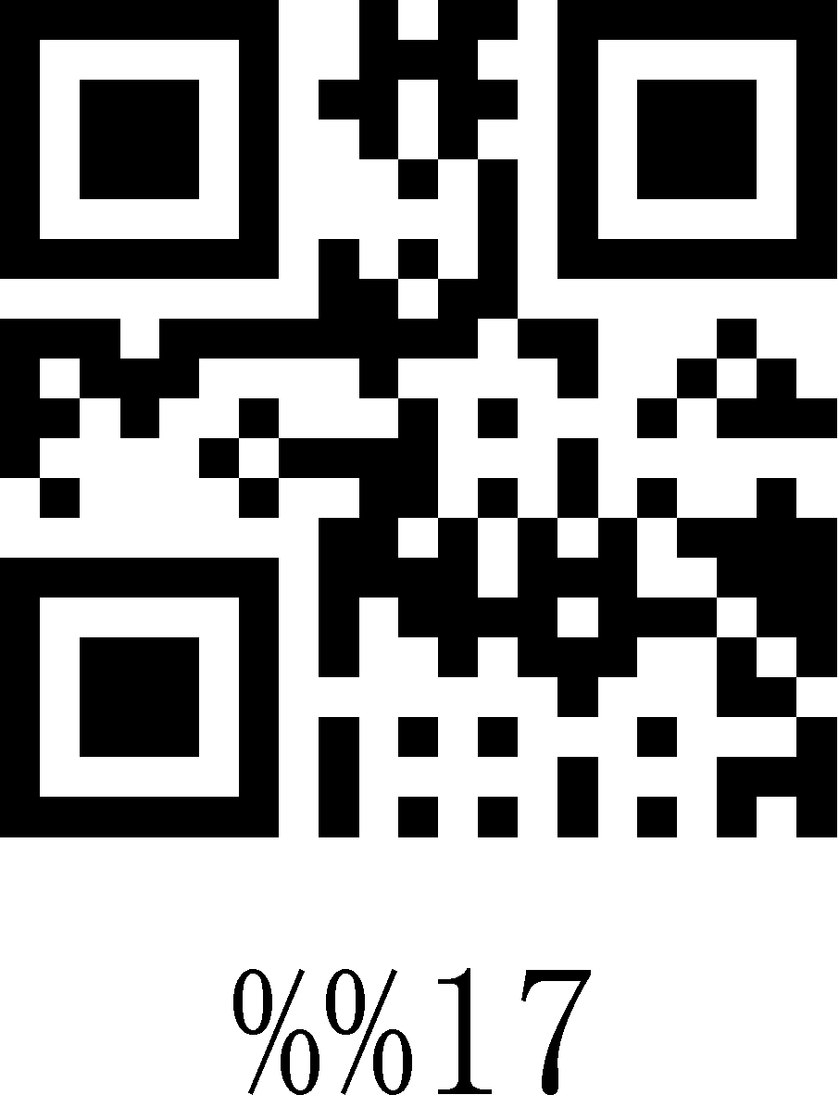
18 | 24 | CAN | 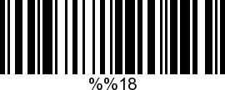 | 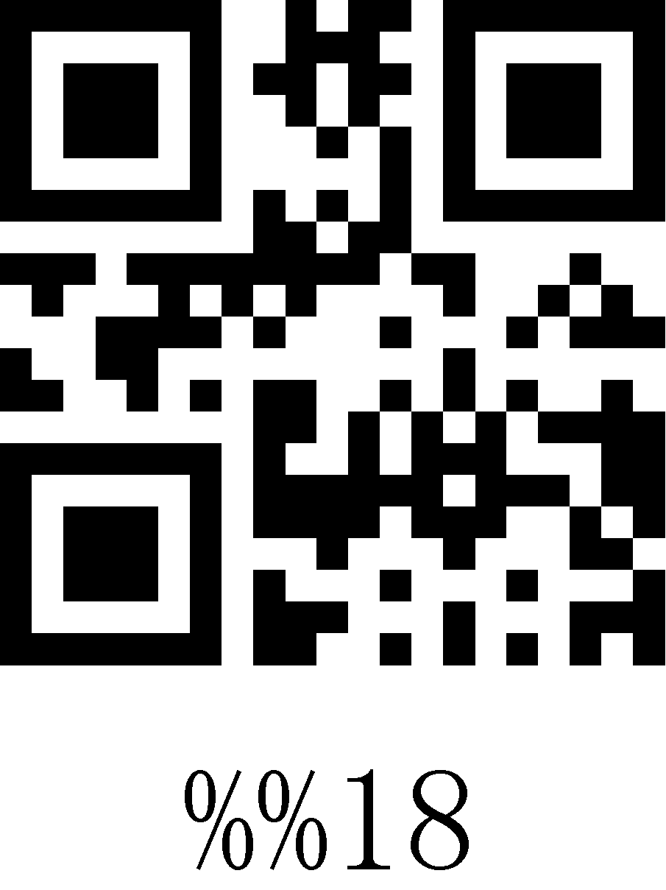
19 | 25 | EM | 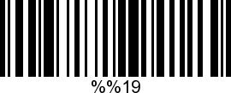 | 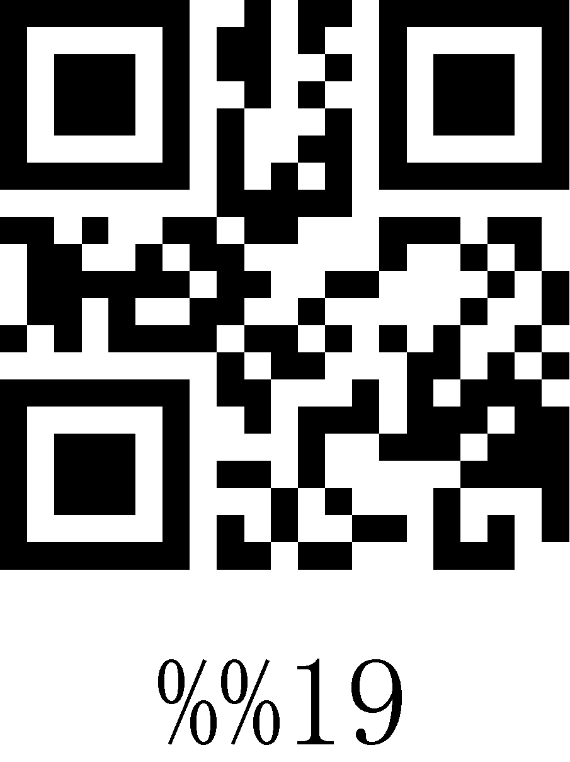
1A | 26 | SUB | 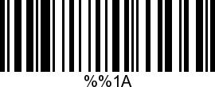 | 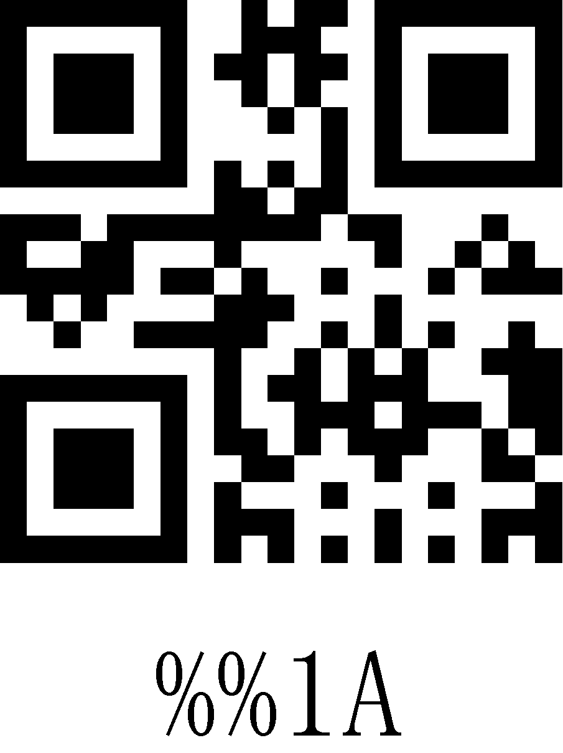
1B | 27 | Esc | 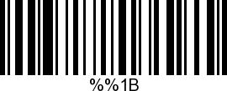 | 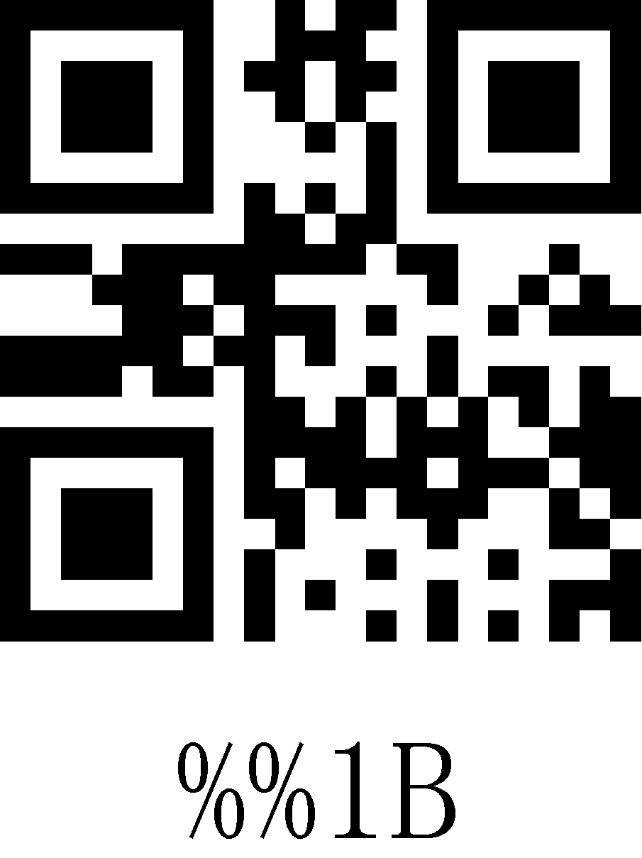
1C | 28 | FS | 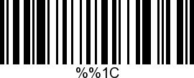 | 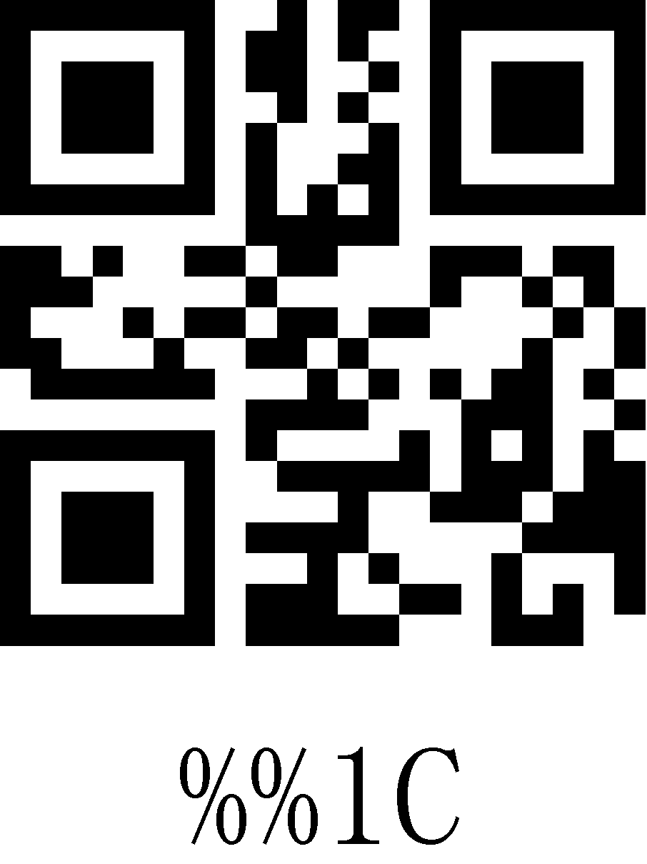
1D | 29 | GS | 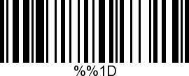 | 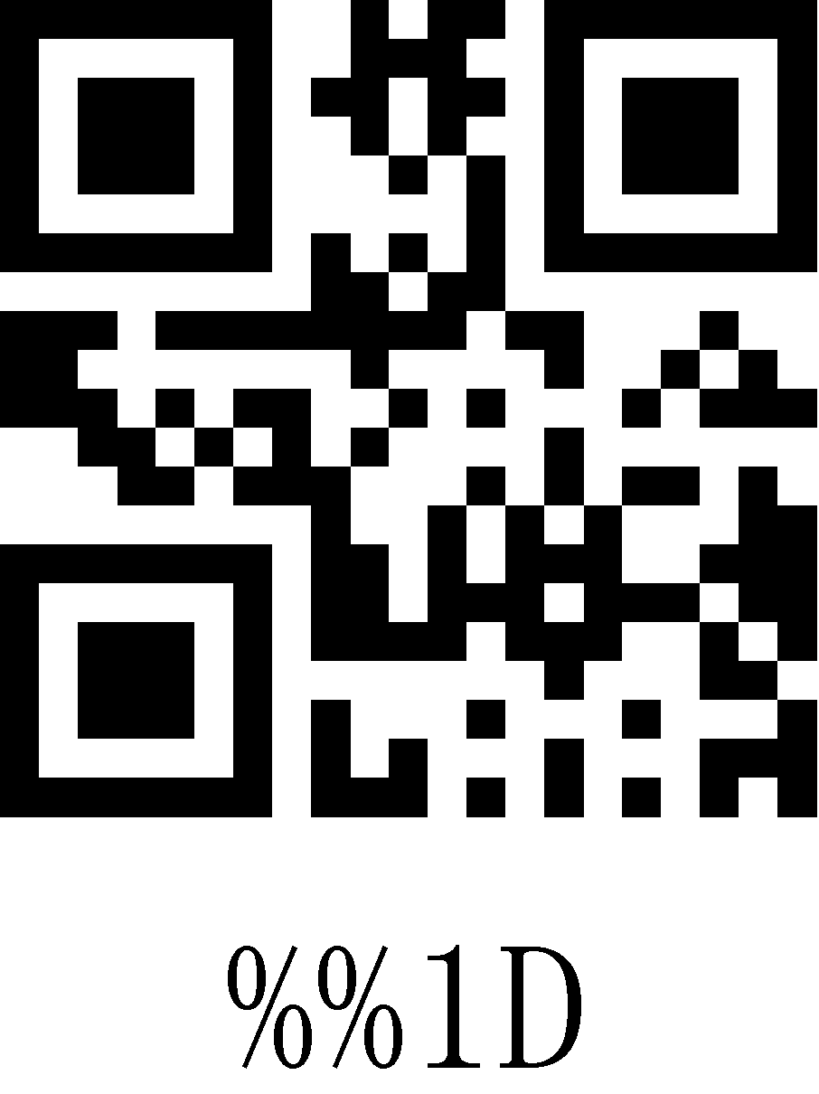
1E | 30 | RS | 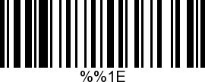 | 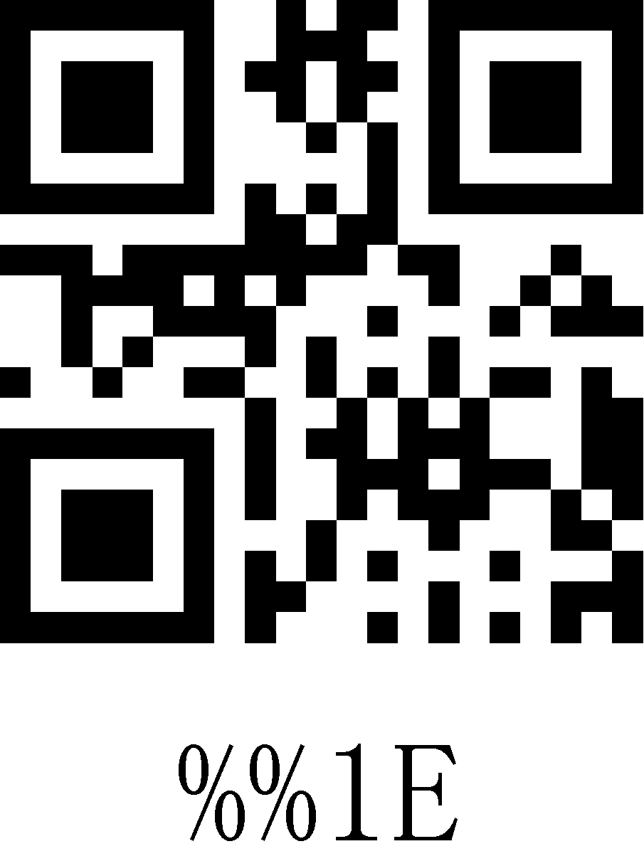
1F | 31 | US | 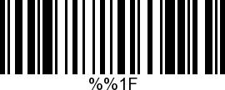 | 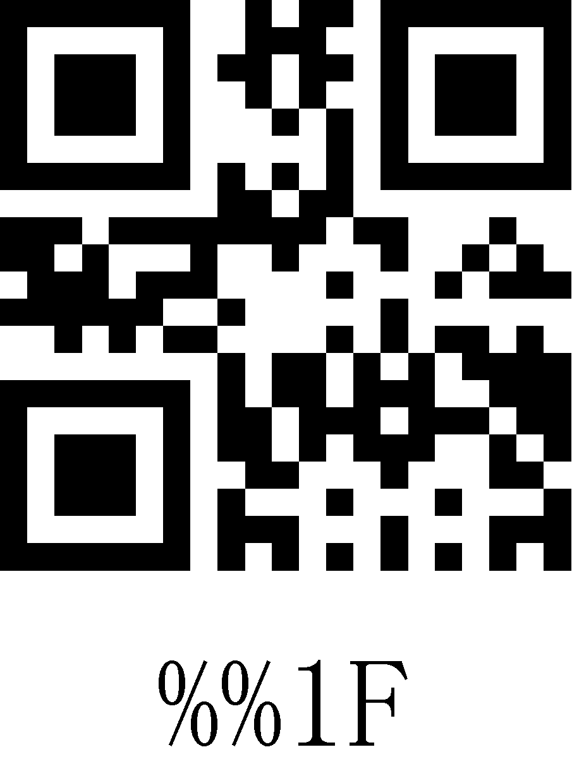
20 | 32 | SP | 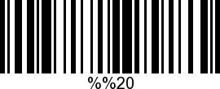 | 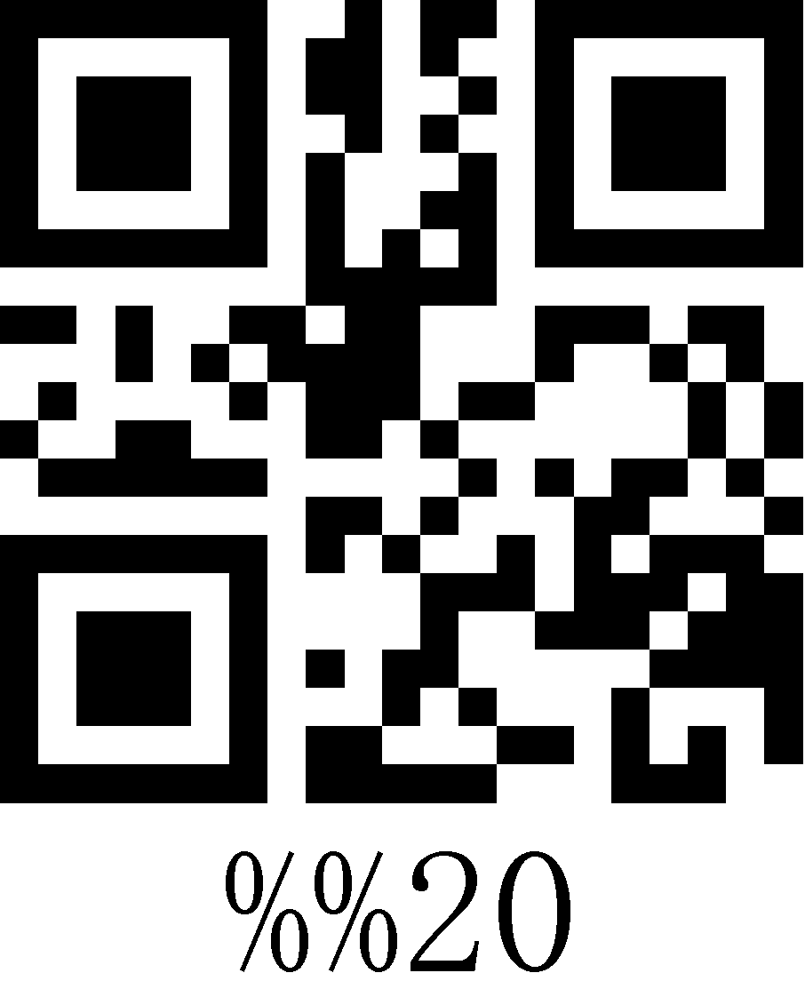
21 | 33 | ! | 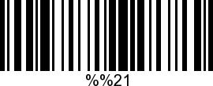 | 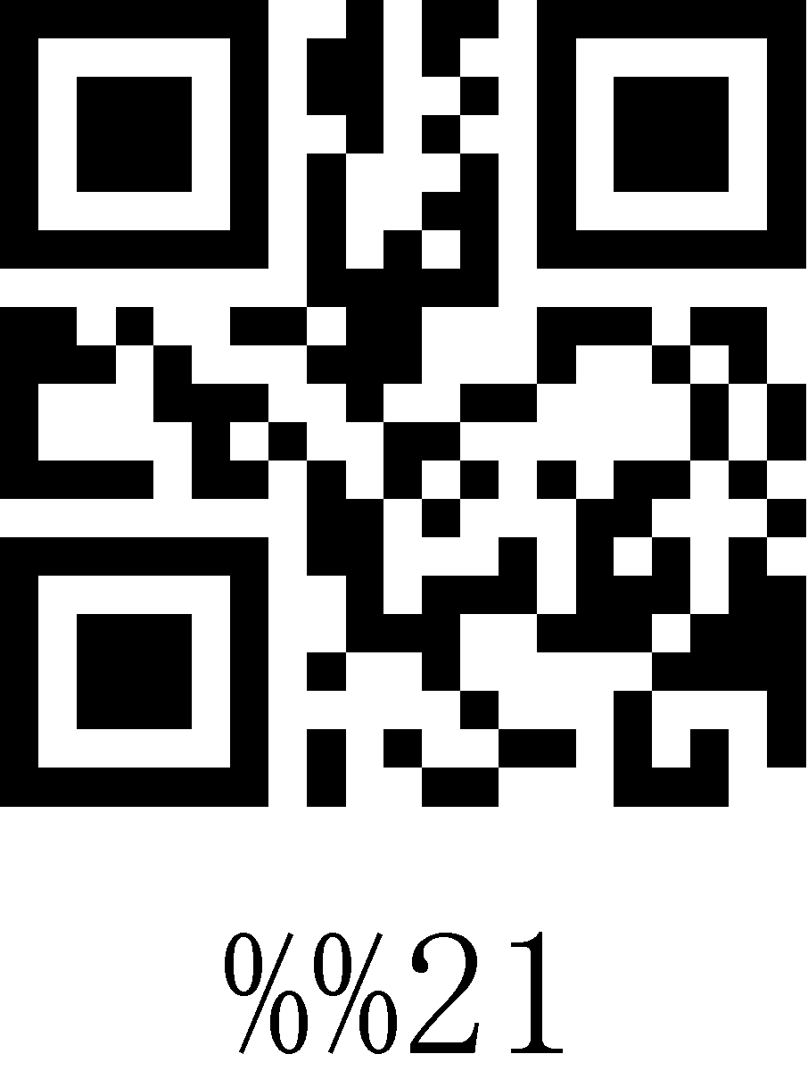
22 | 34 | " | 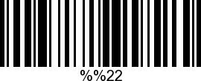 | 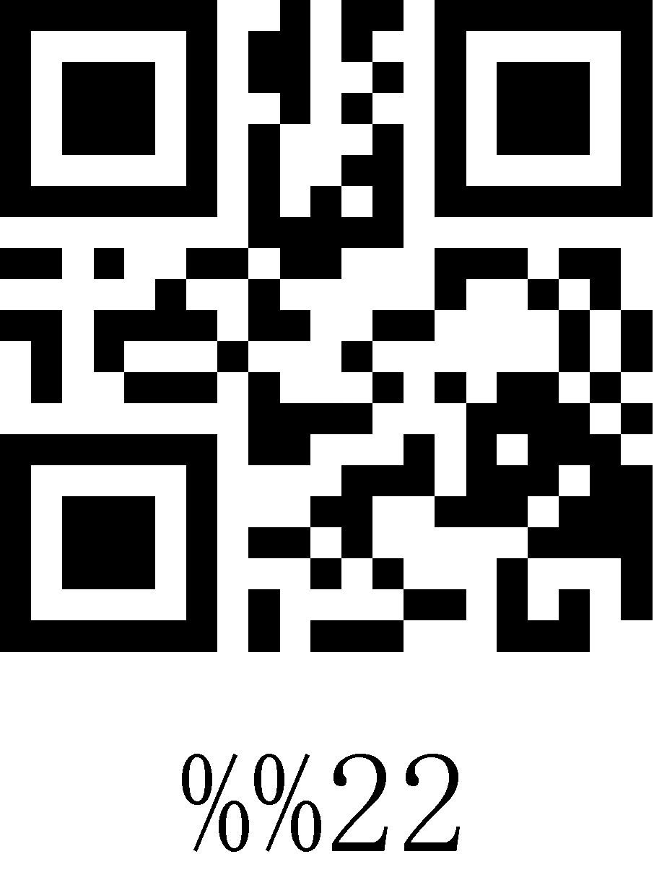
23 | 35 | # | 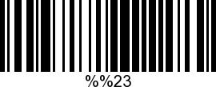 | 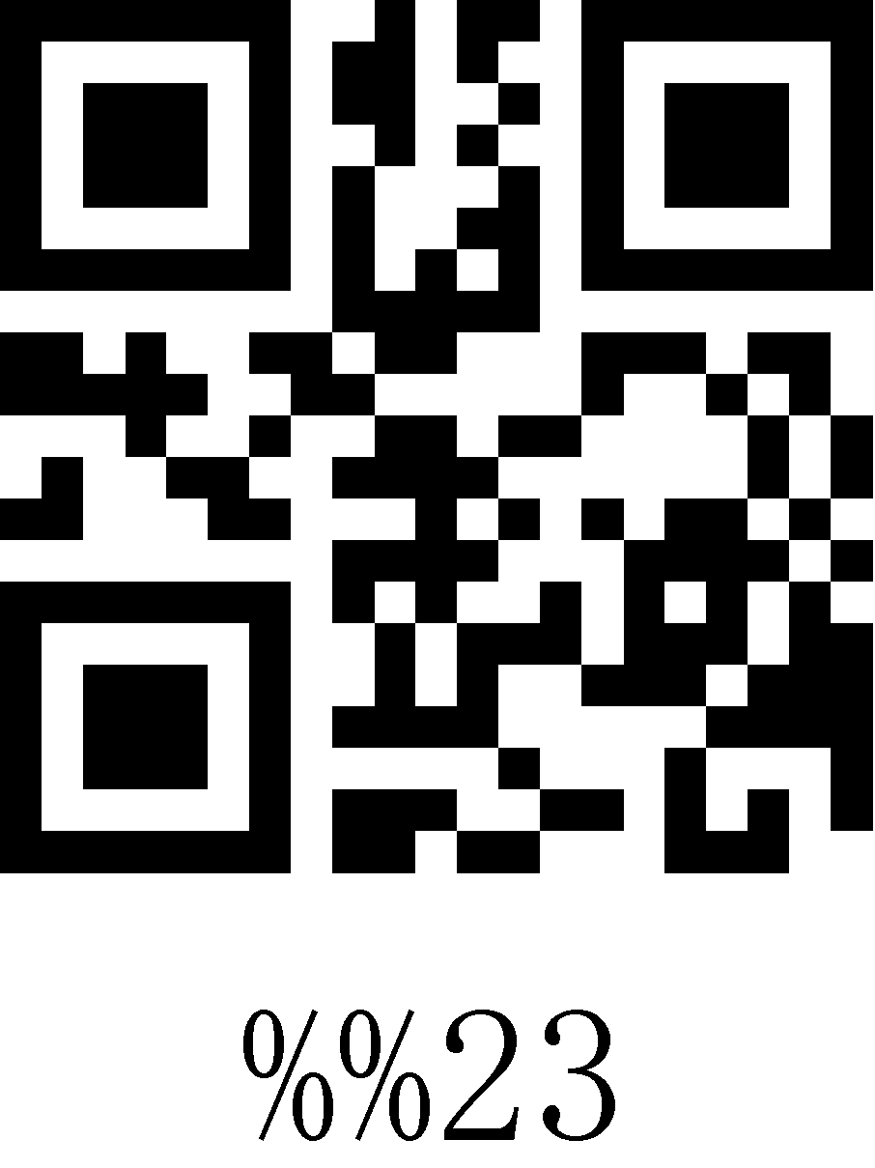
24 | 36 | $ | 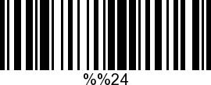 | 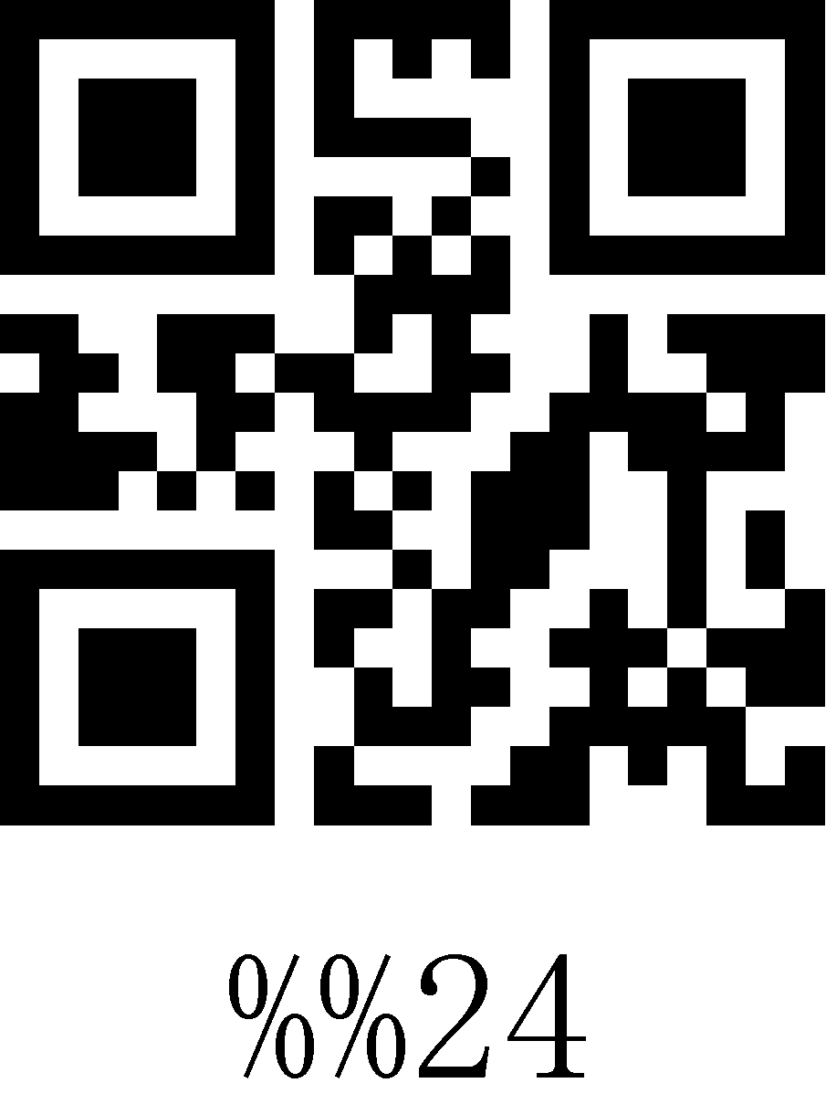
25 | 37 | % | 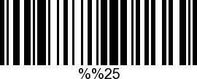 | 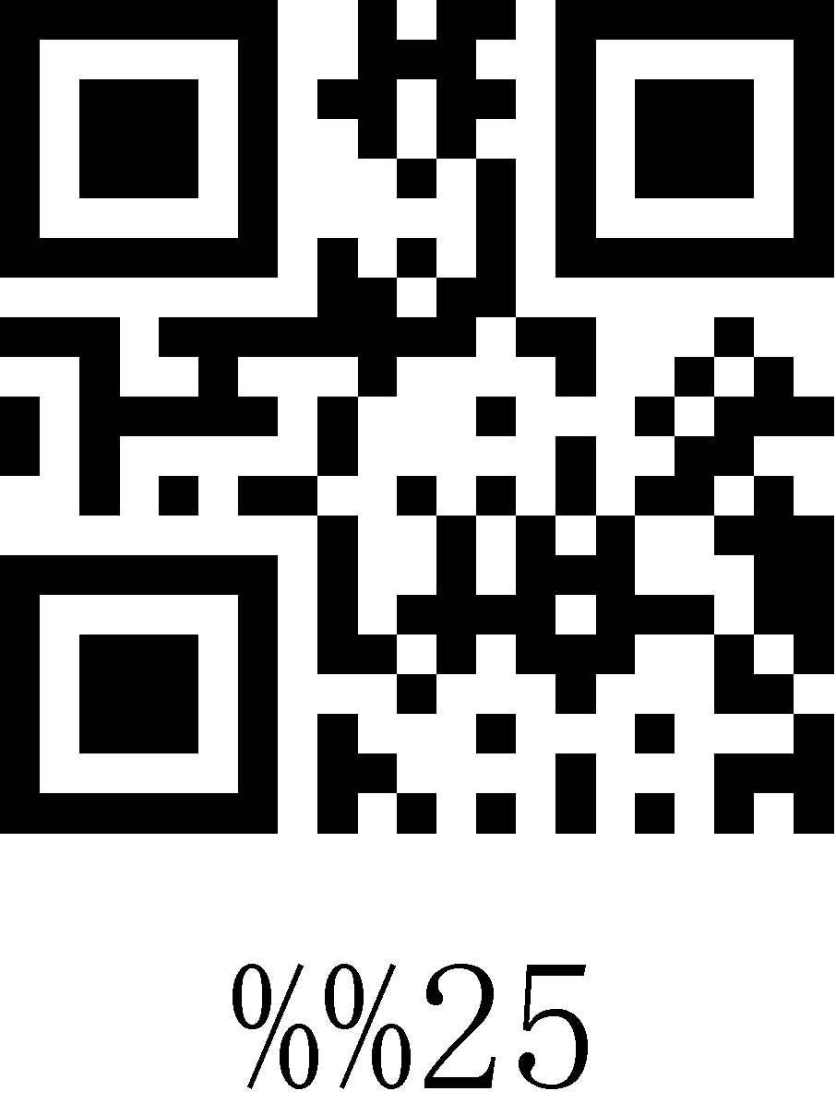
26 | 38 | & | 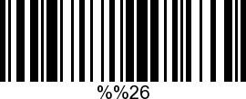 | 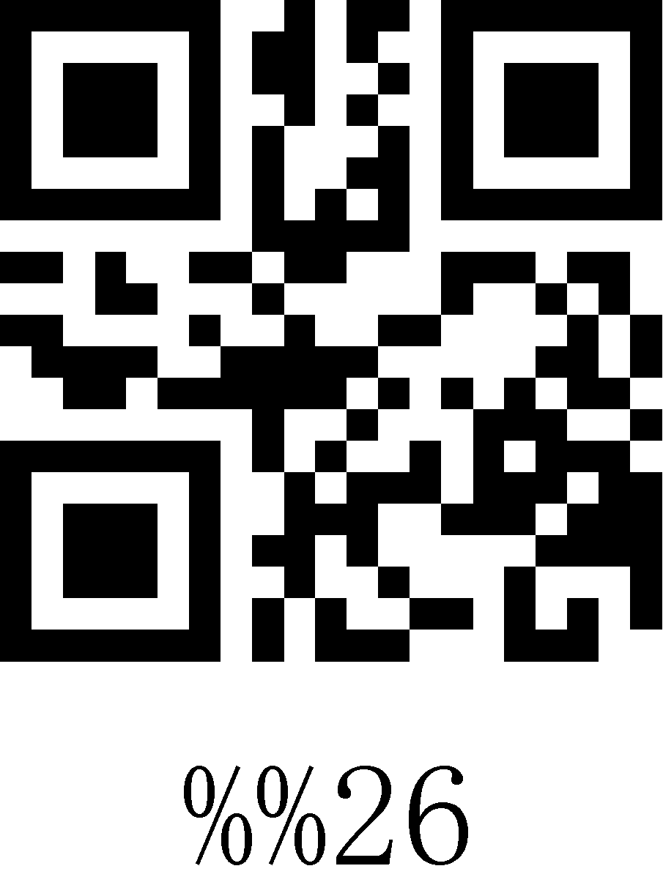
27 | 39 | ` | 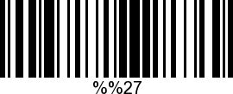 | 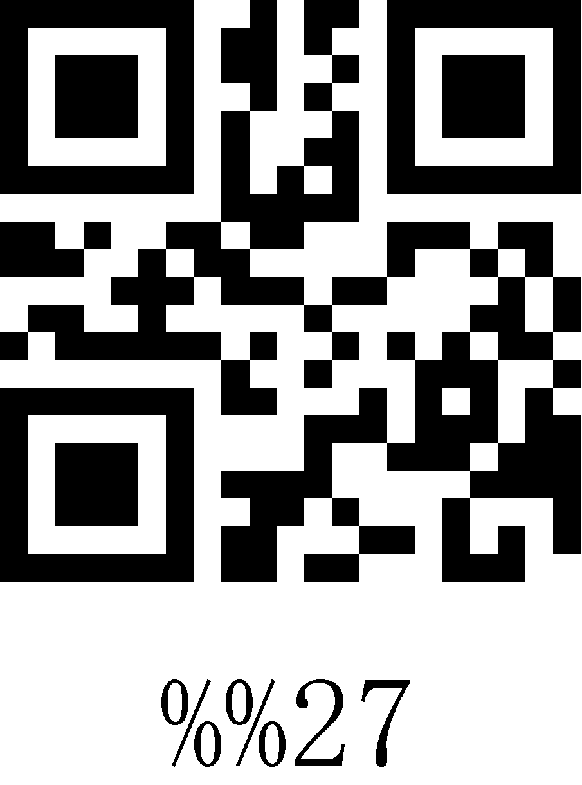
28 | 40 | ( | 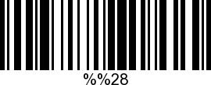 | 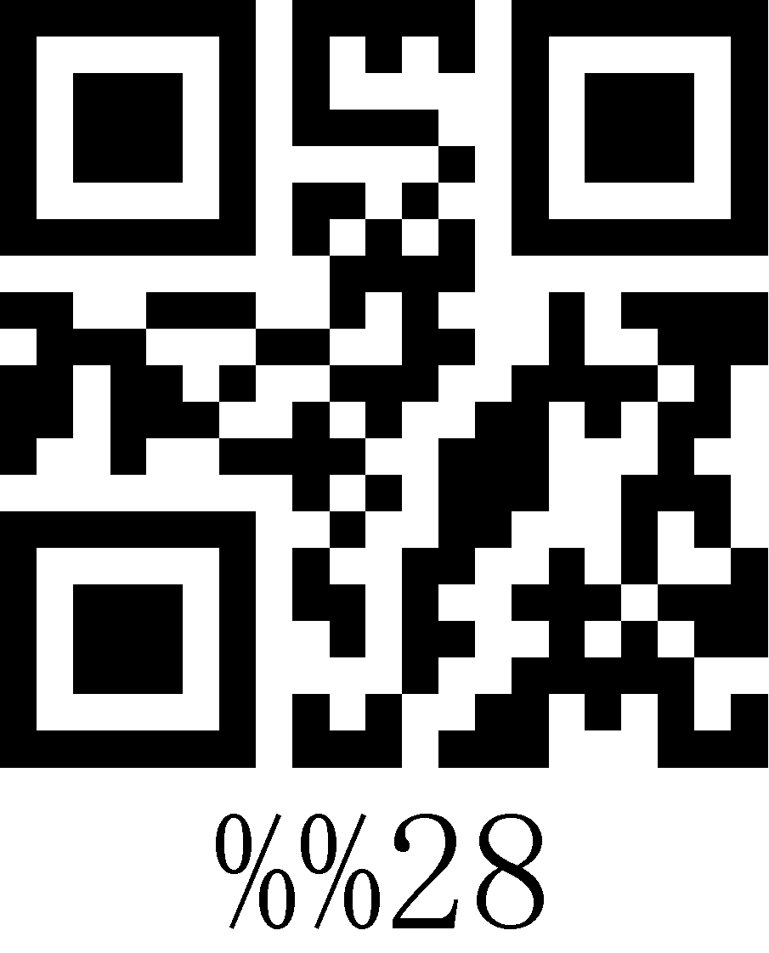
29 | 41 | ) | 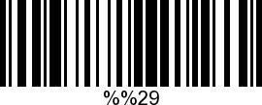 | 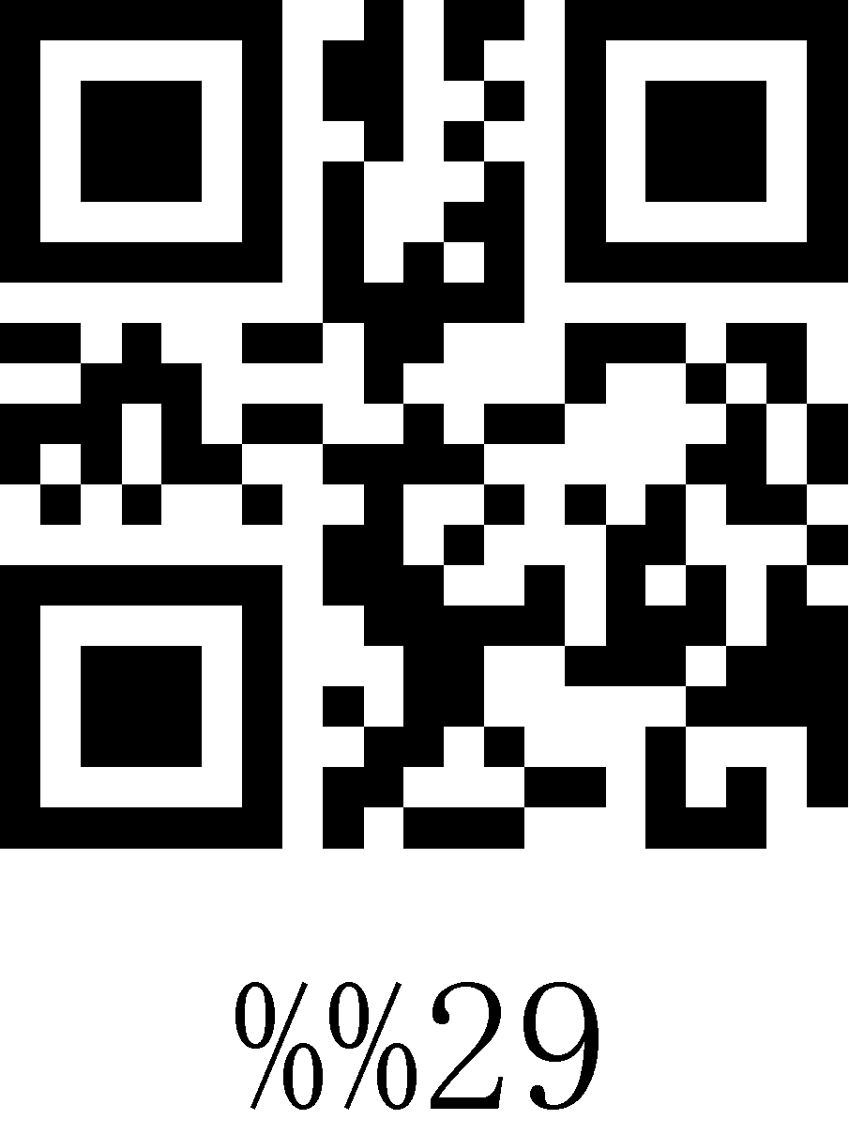
2A | 42 | * | 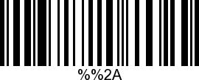 | 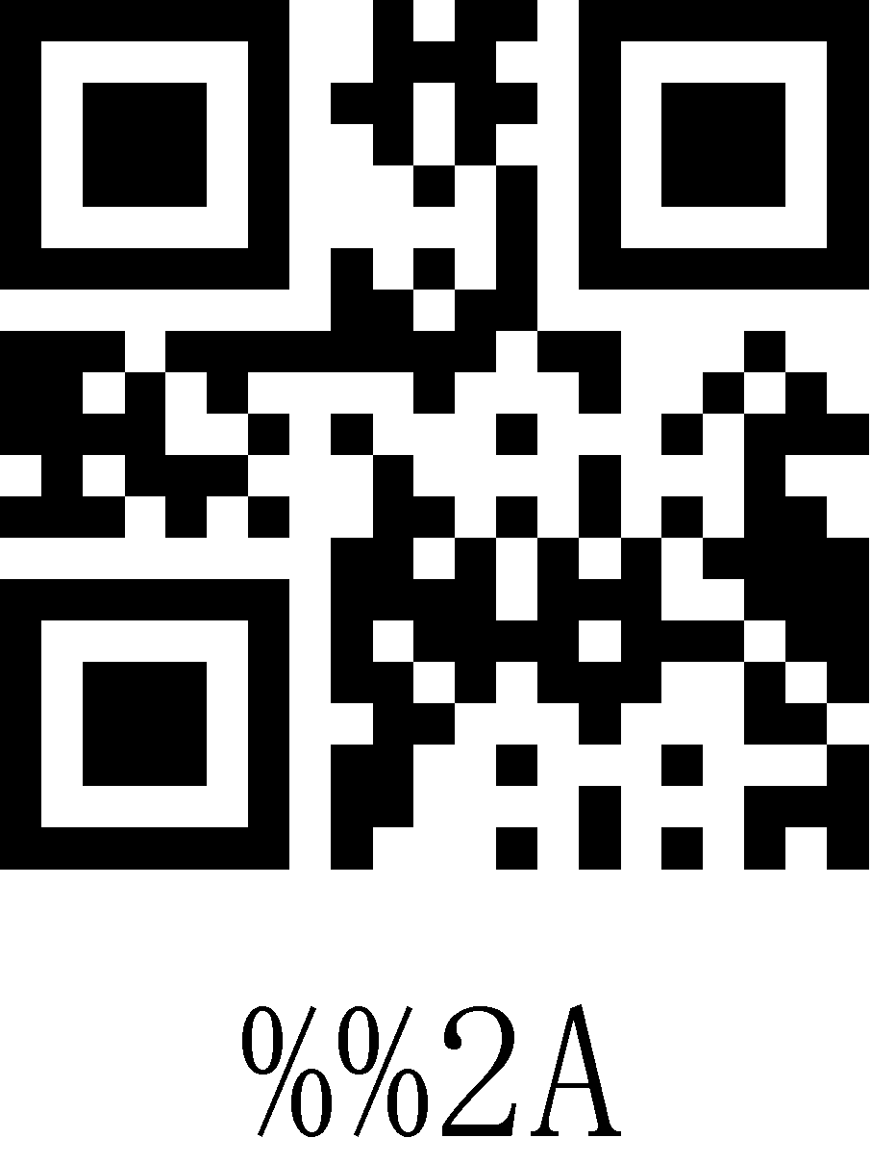
2B | 43 | + | 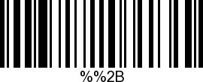 | 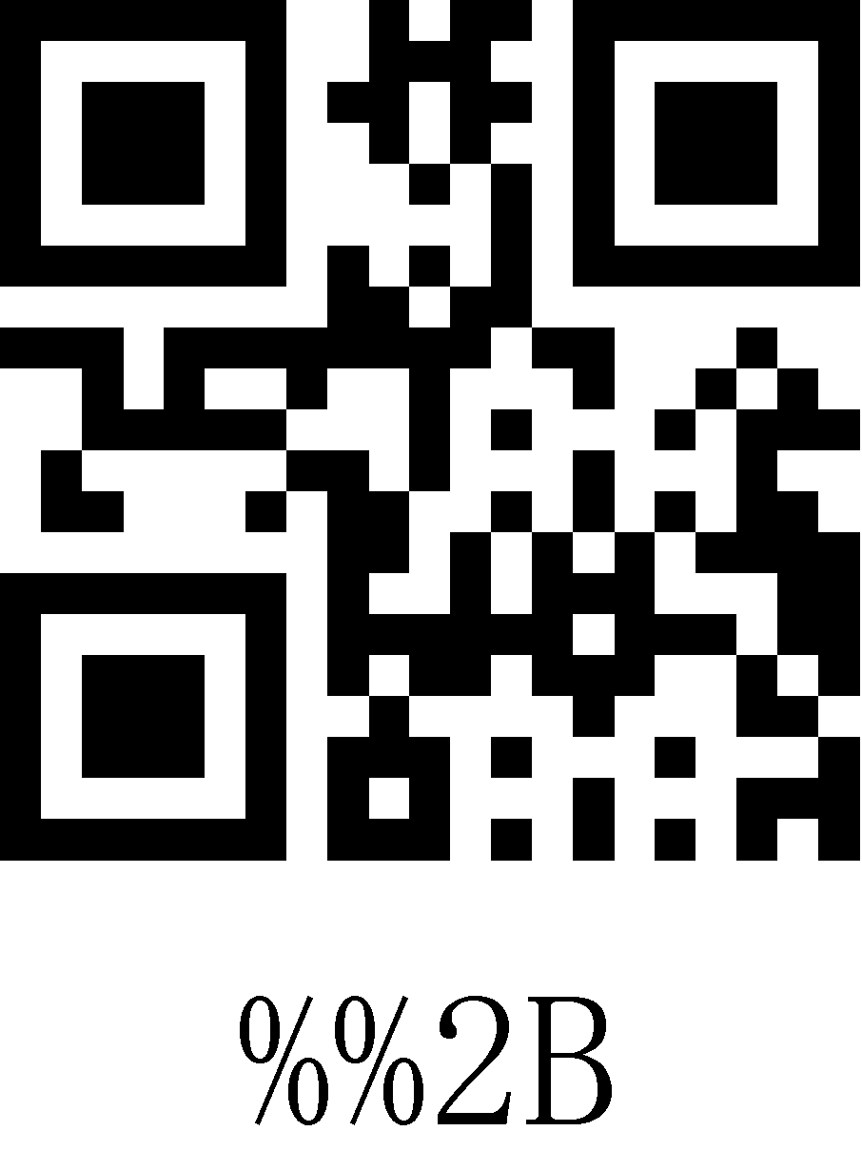
2C | 44 | , | 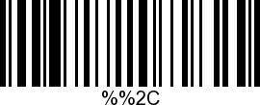 | 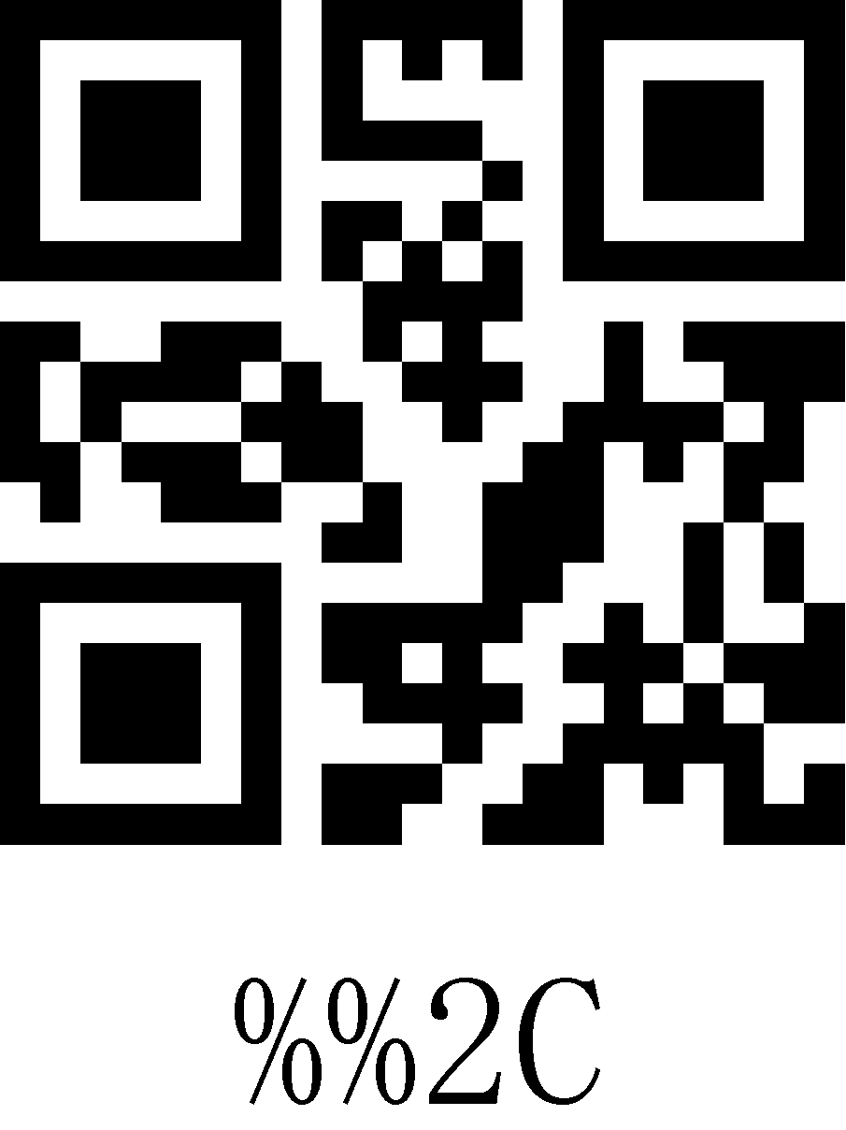
2D | 45 | - | 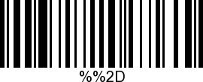 | 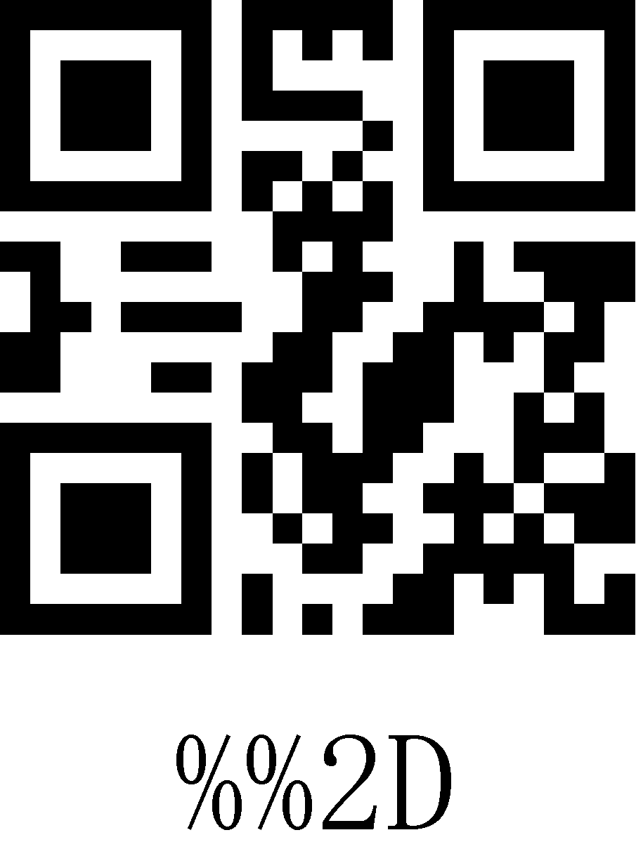
2E | 46 | . | 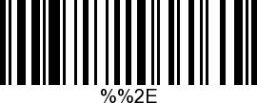 | 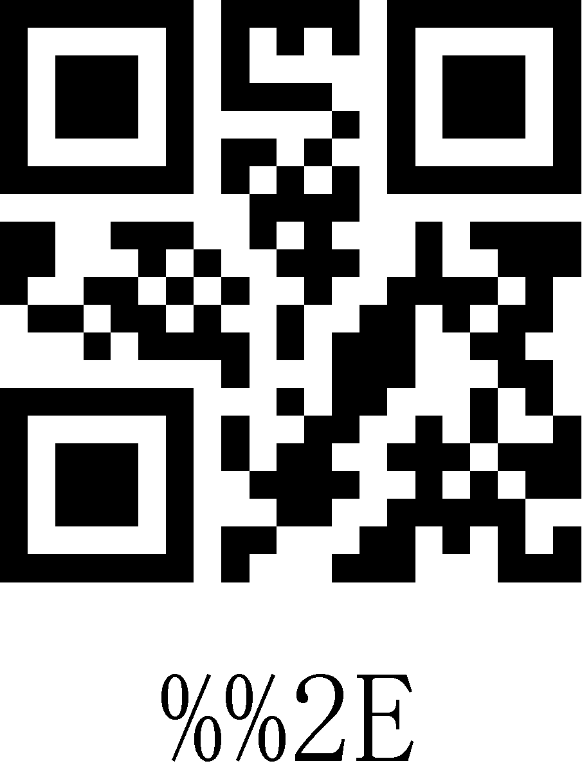
2F | 47 | / | 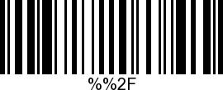 | 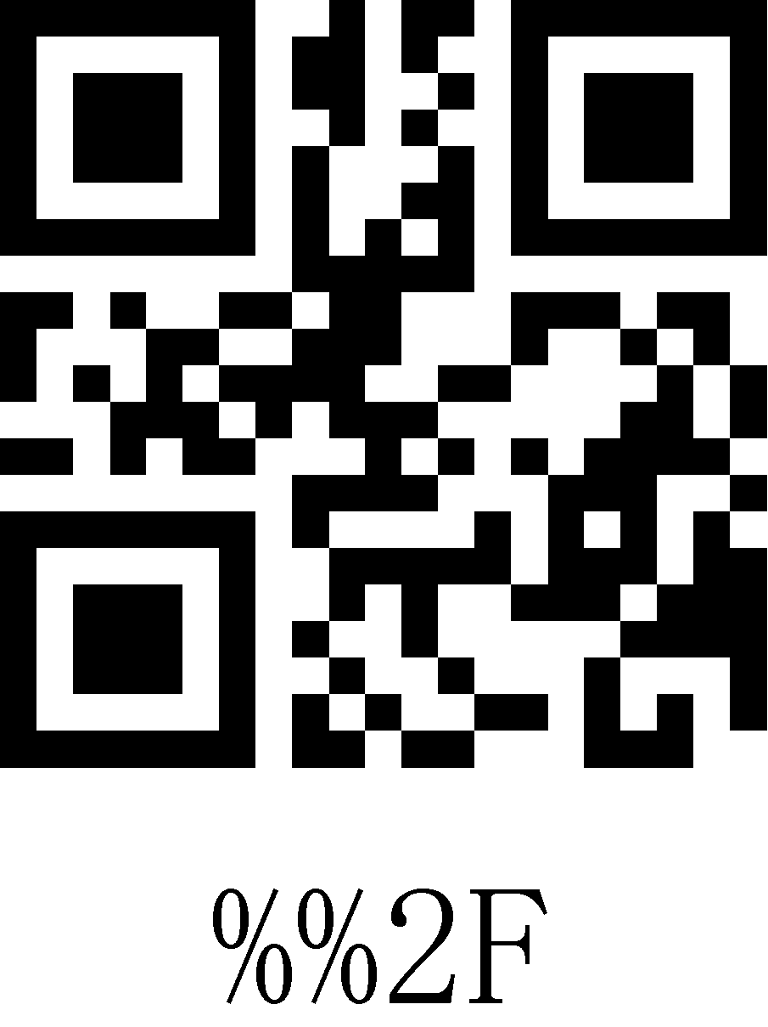
30 | 48 | 0 | 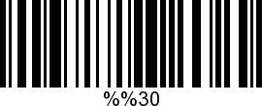 | 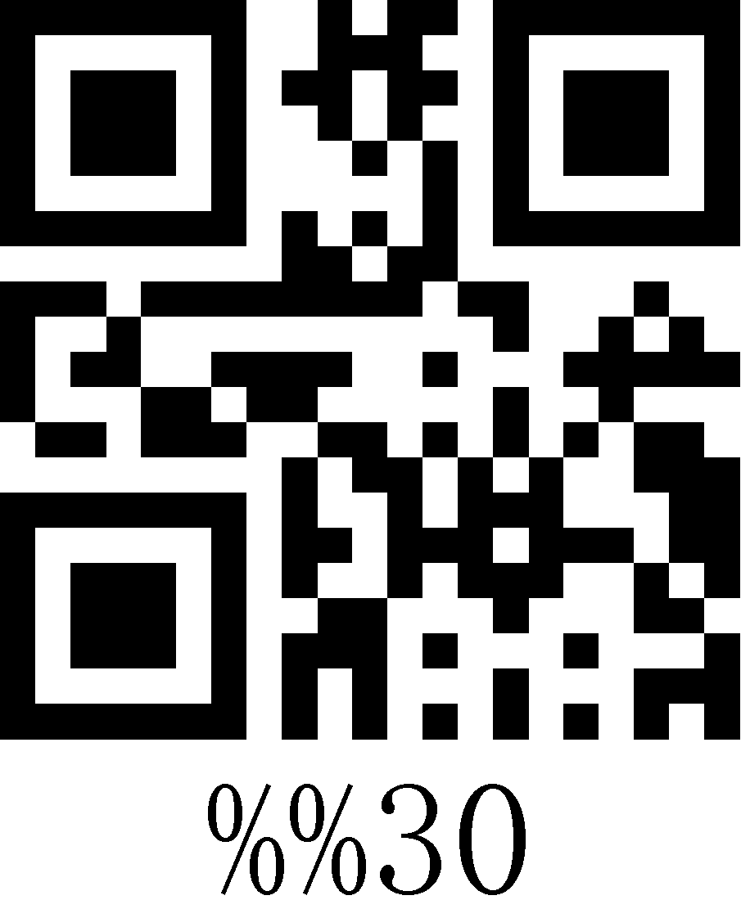
31 | 49 | 1 | 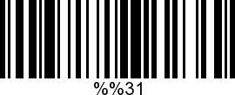 | 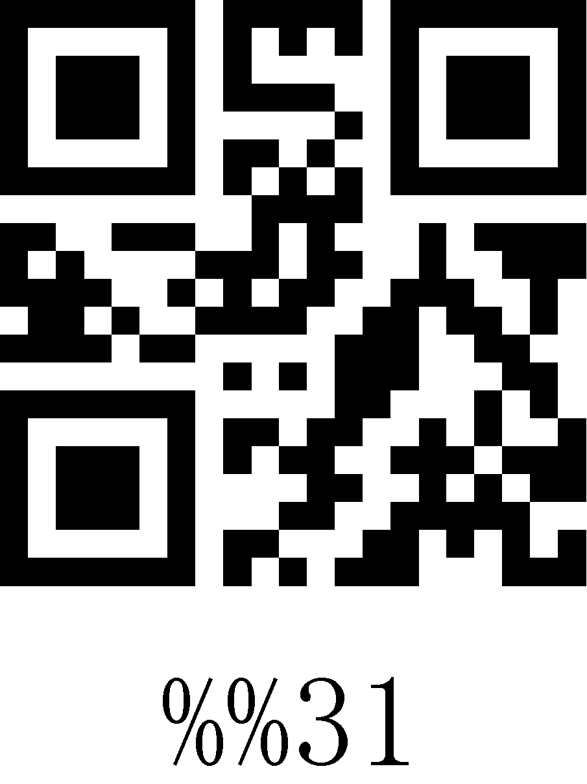
32 | 50 | 2 | 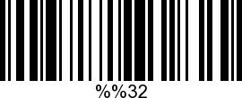 | 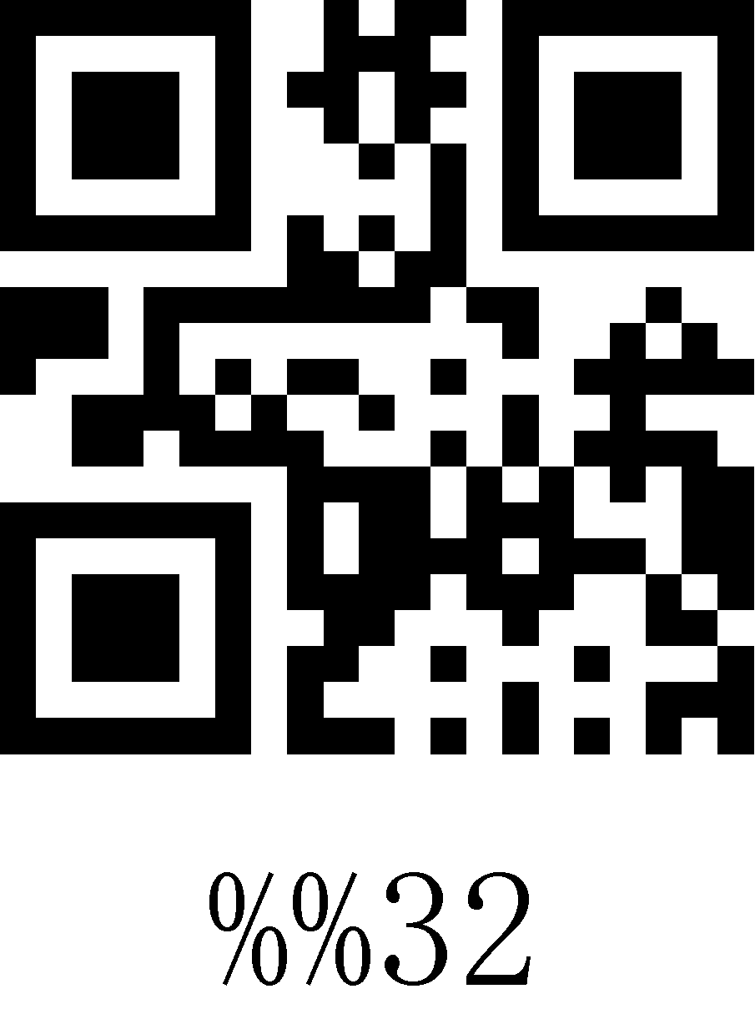
33 | 51 | 3 | 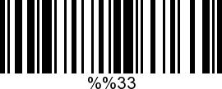 | 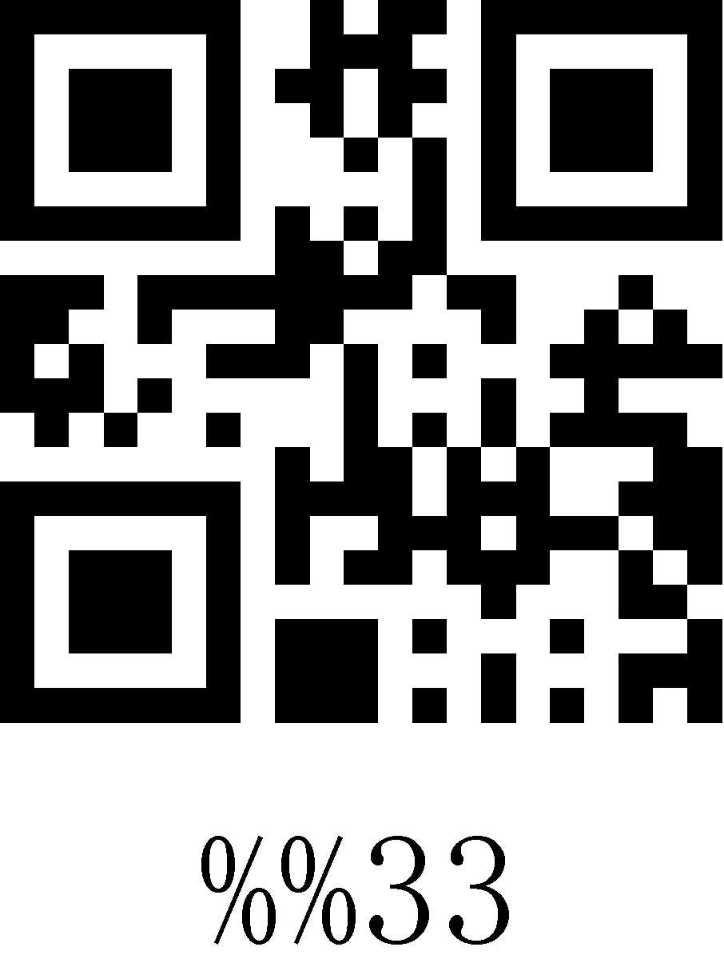
34 | 52 | 4 | 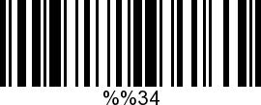 | 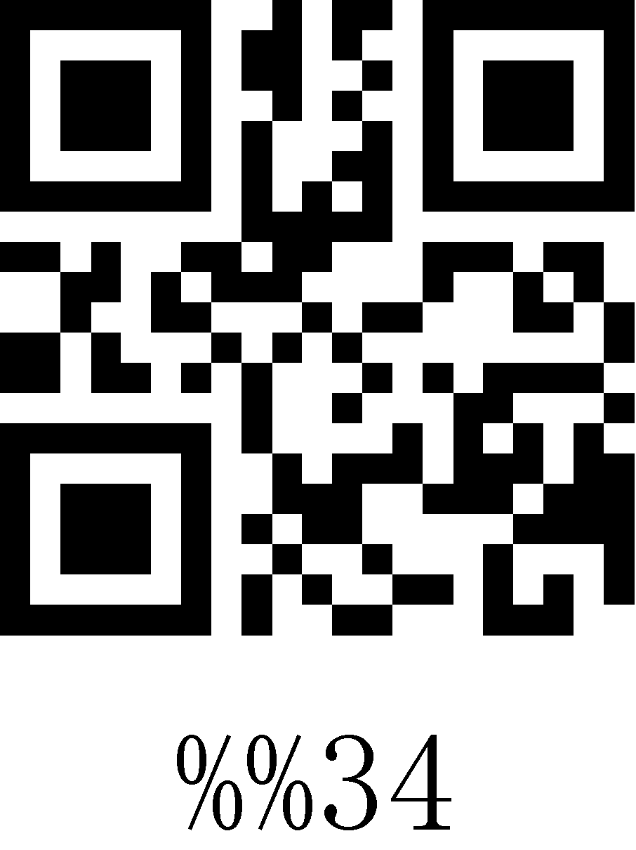
35 | 53 | 5 | 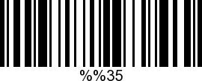 | 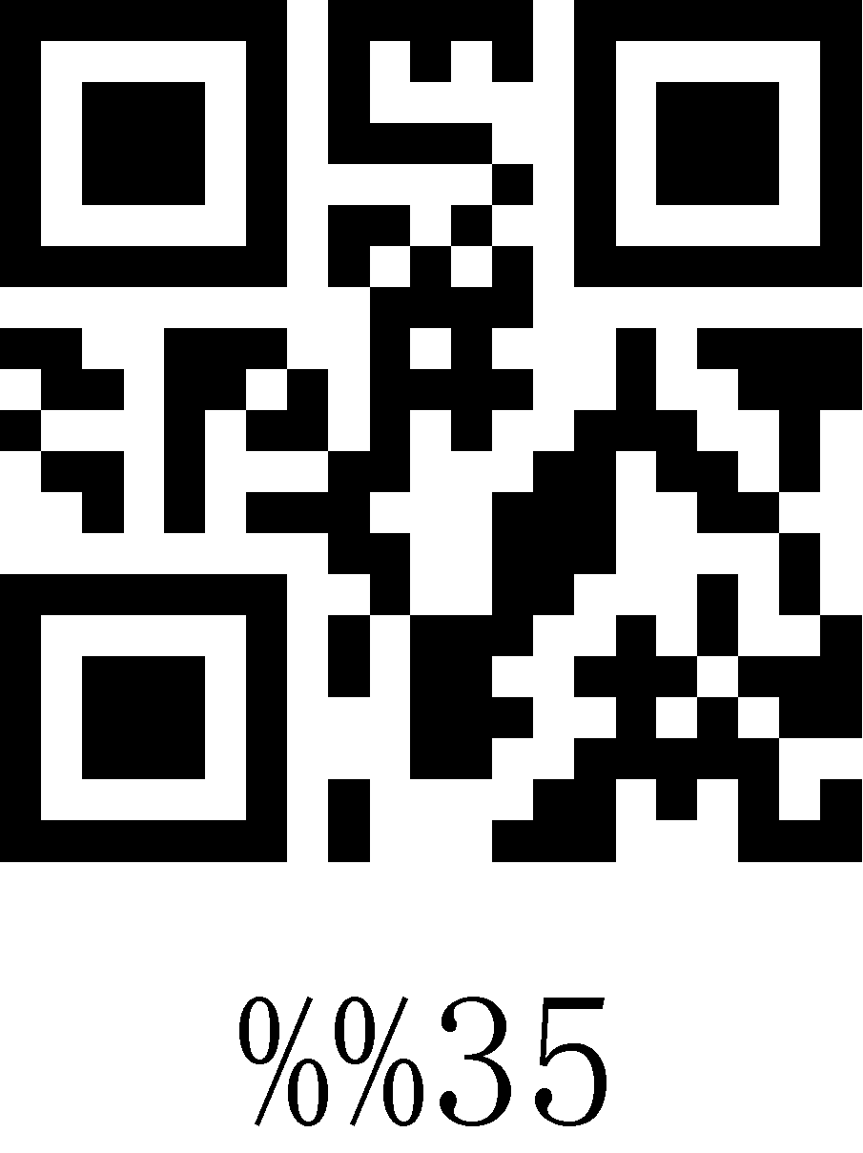
36 | 54 | 6 | 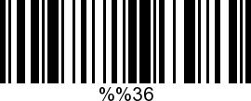 | 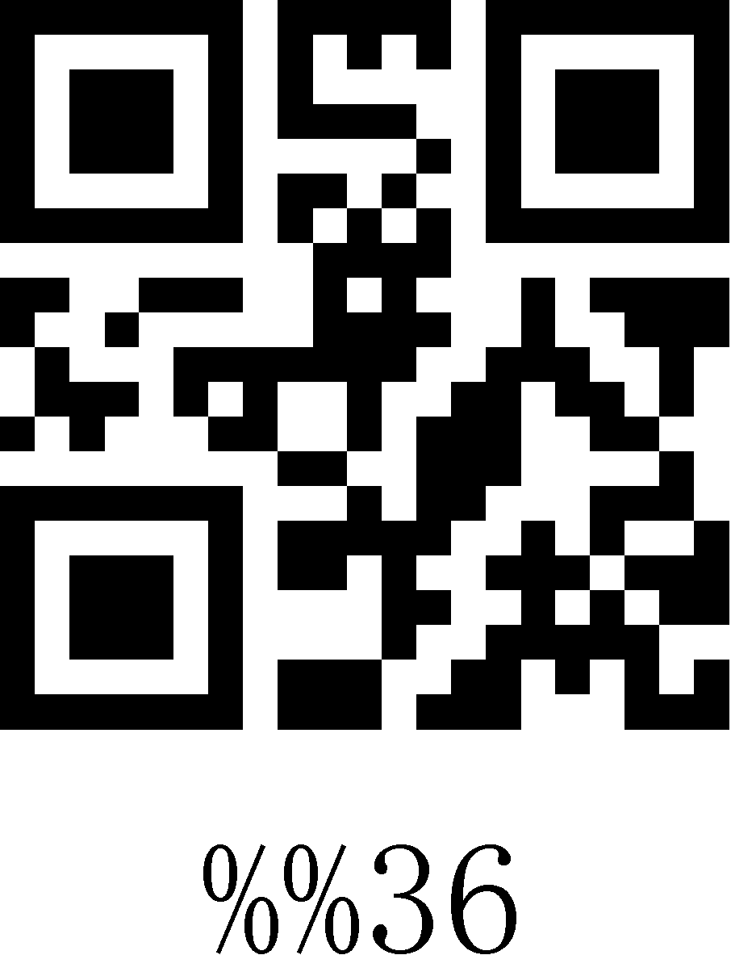
37 | 55 | 7 |  | 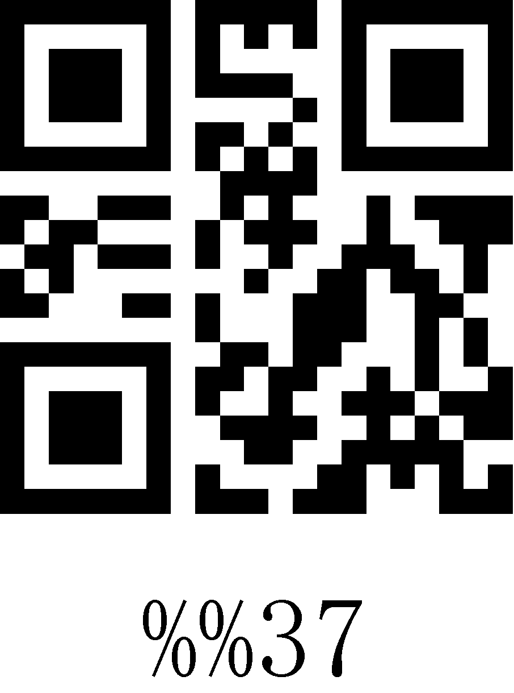
38 | 56 | 8 | 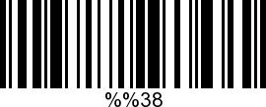 | 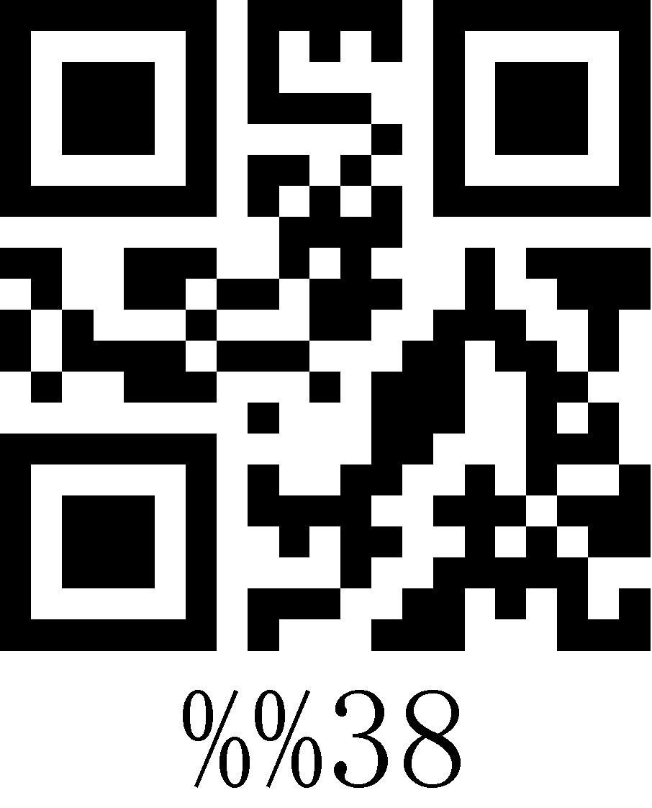
39 | 57 | 9 | 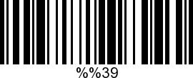 | 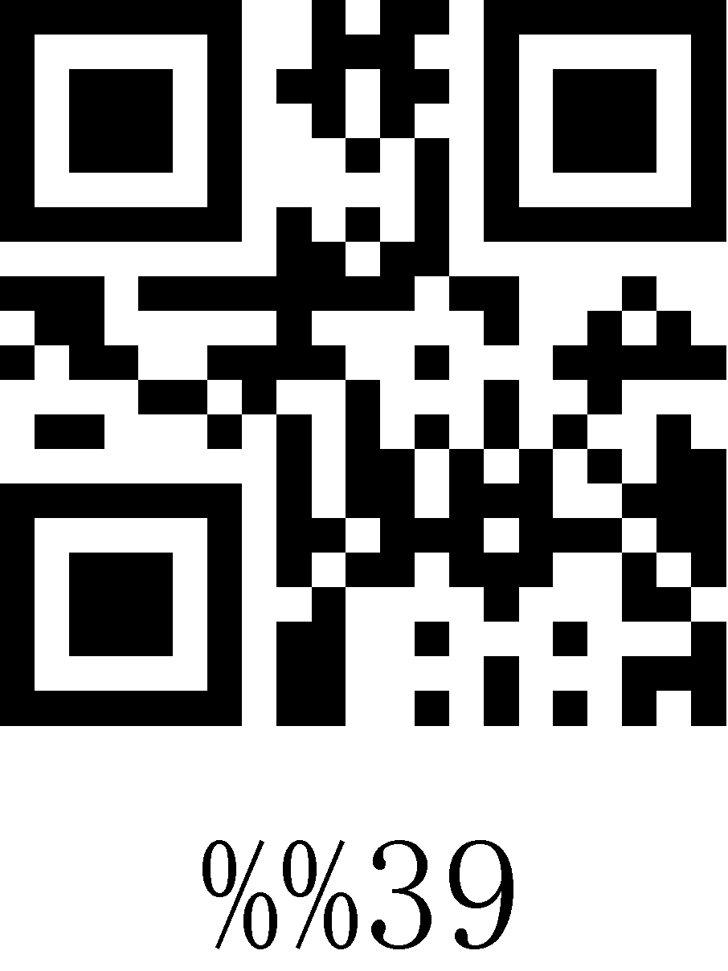
3A | 58 | : | 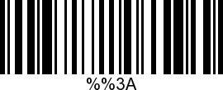 | 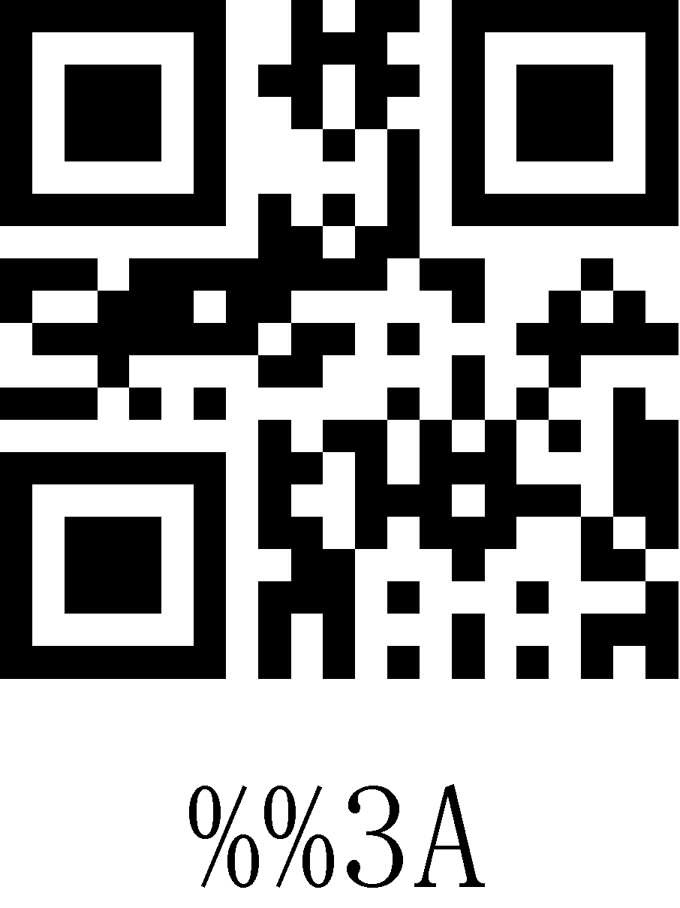
3B | 59 | ; | 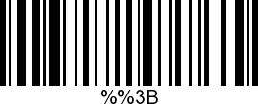 | 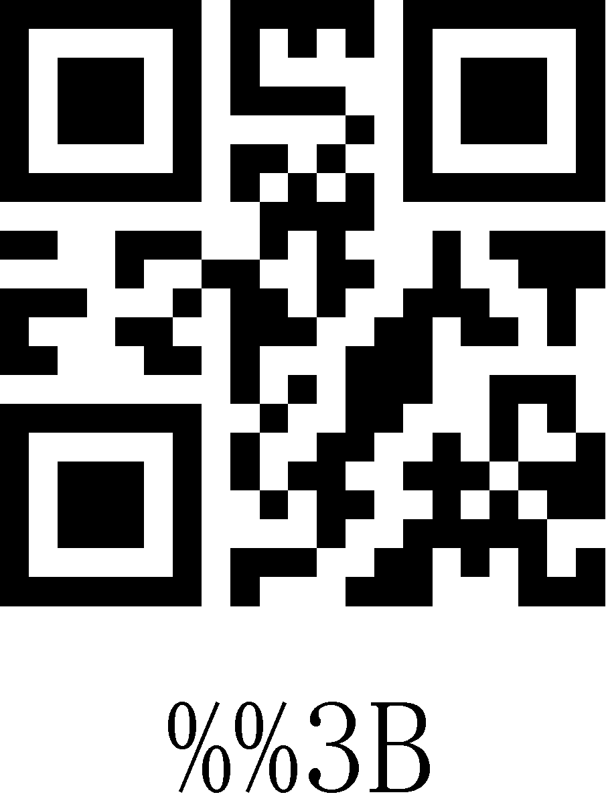
3C | 60 | < | 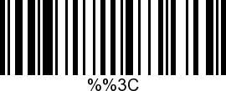 | 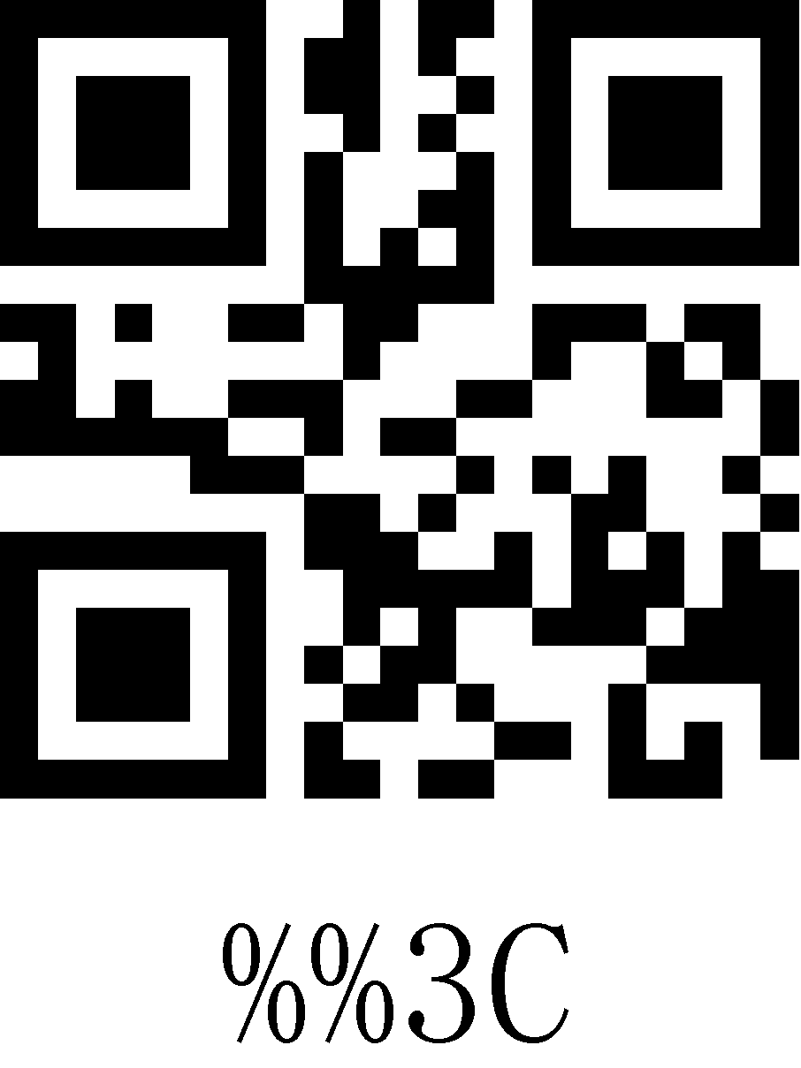
3D | 61 | = | 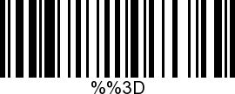 | 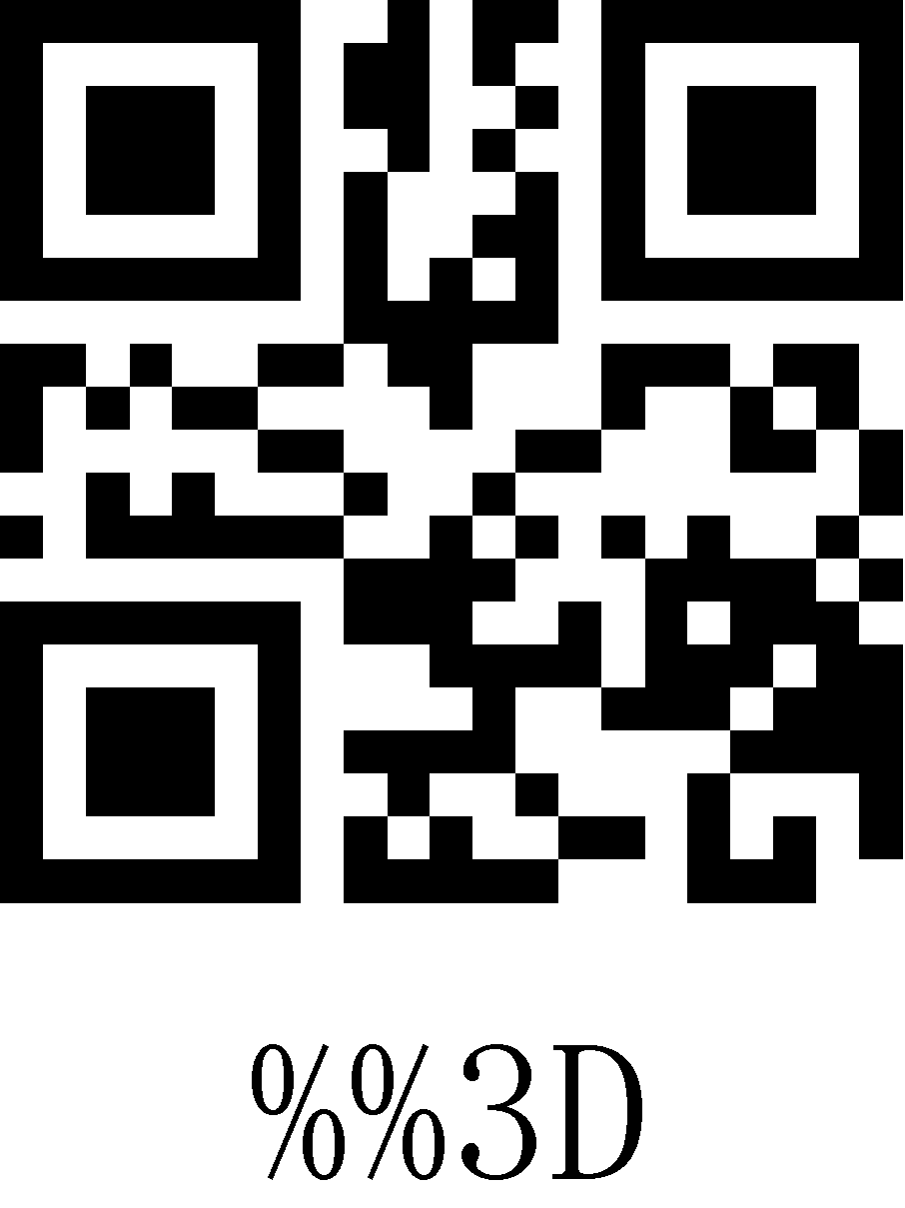
3E | 62 | > | 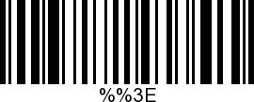 | 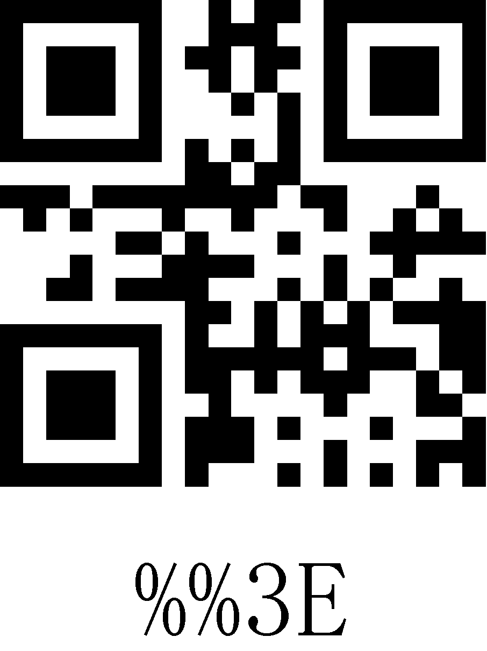
3F | 63 | ? | 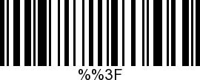 | 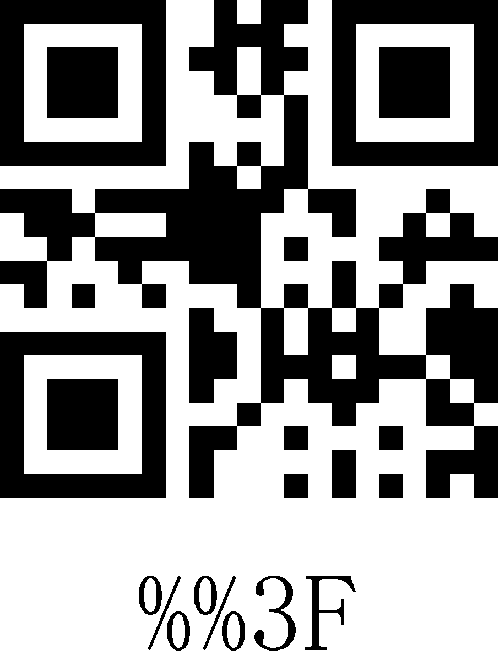
40 | 64 | @ | 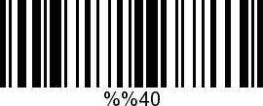 | 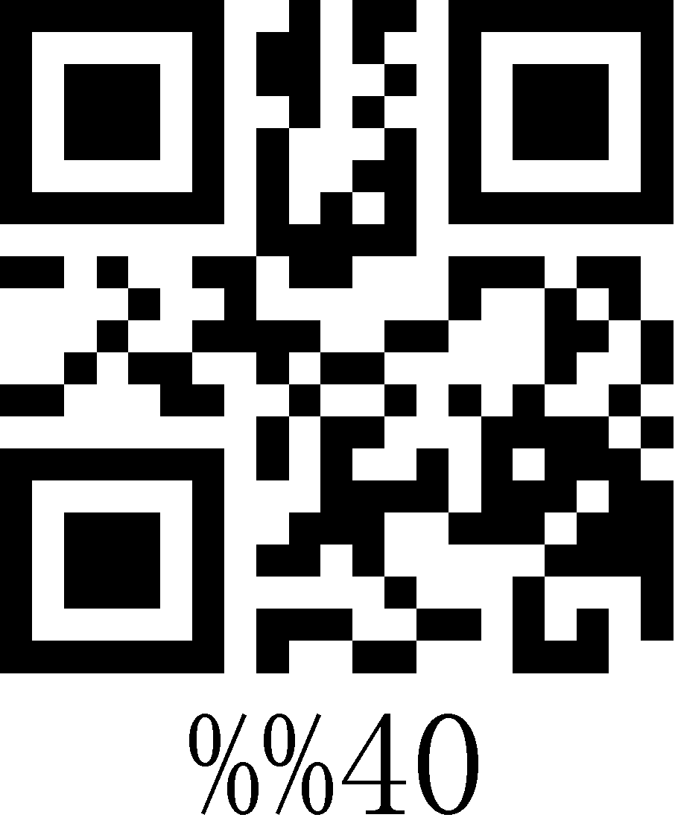
41 | 65 | A | 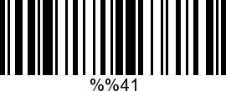 | 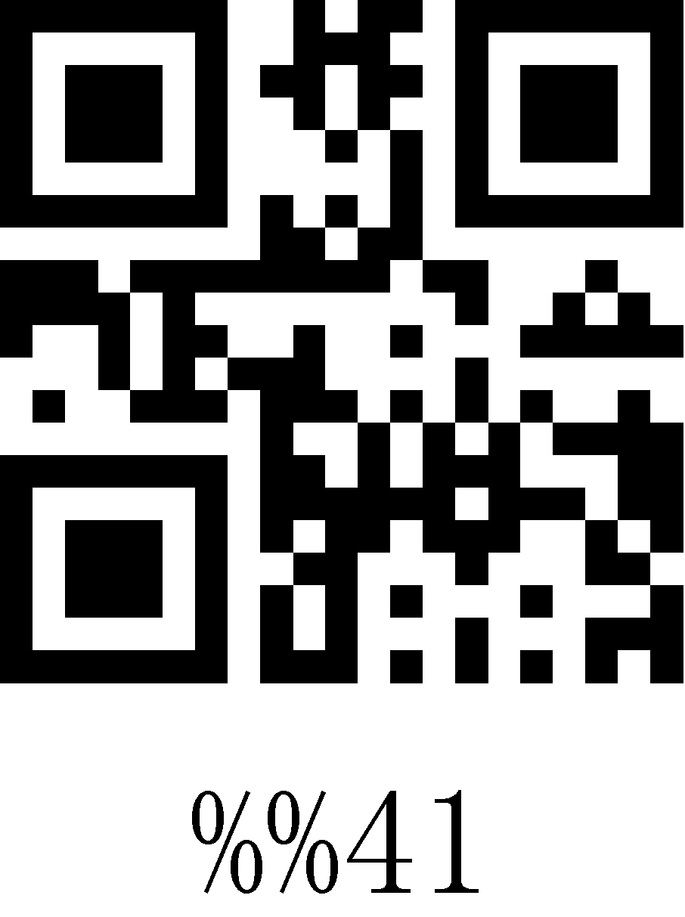
42 | 66 | B | 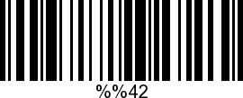 | 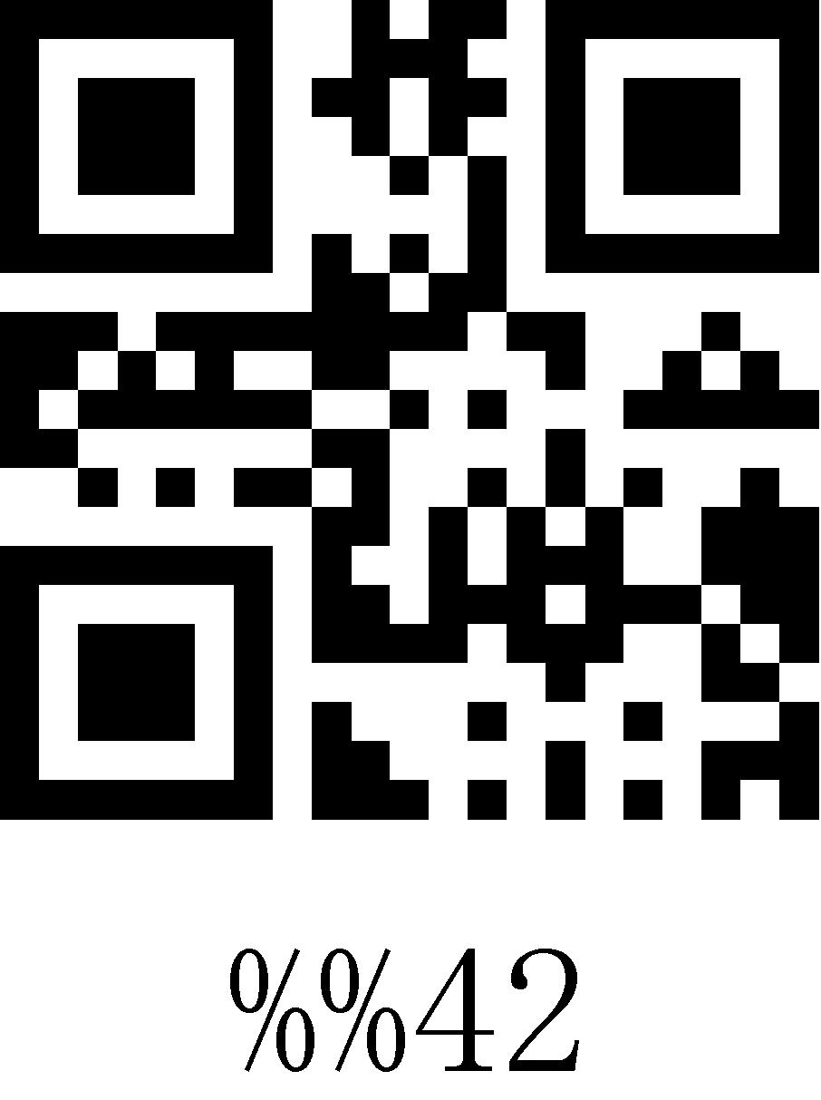
43 | 67 | C | 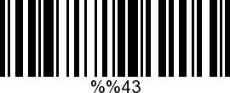 | 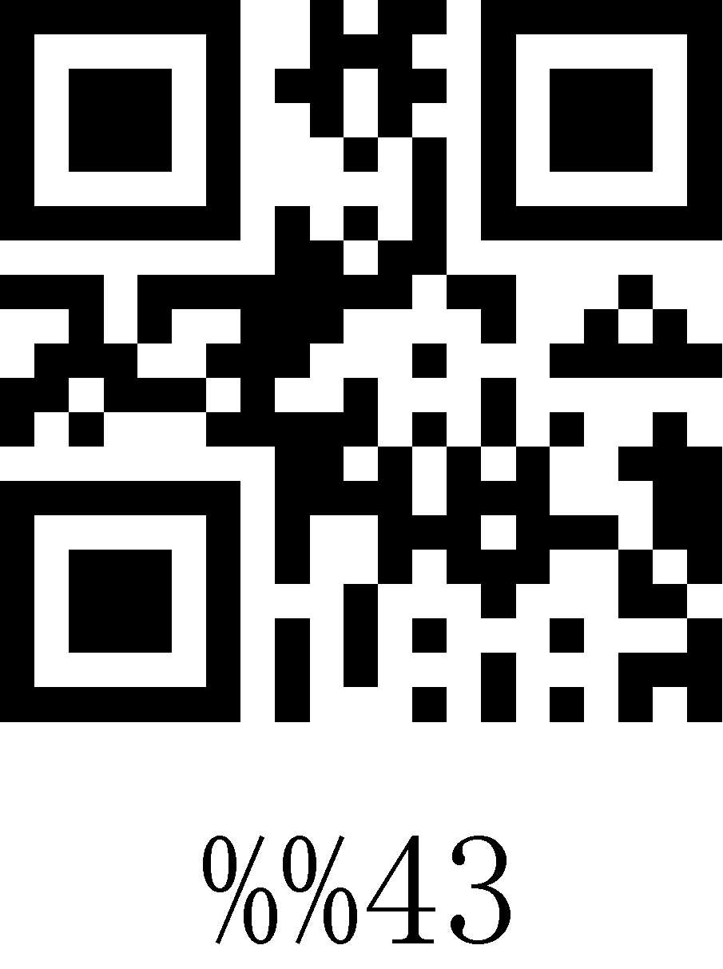
44 | 68 | D | 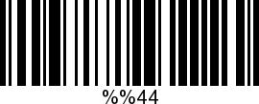 | 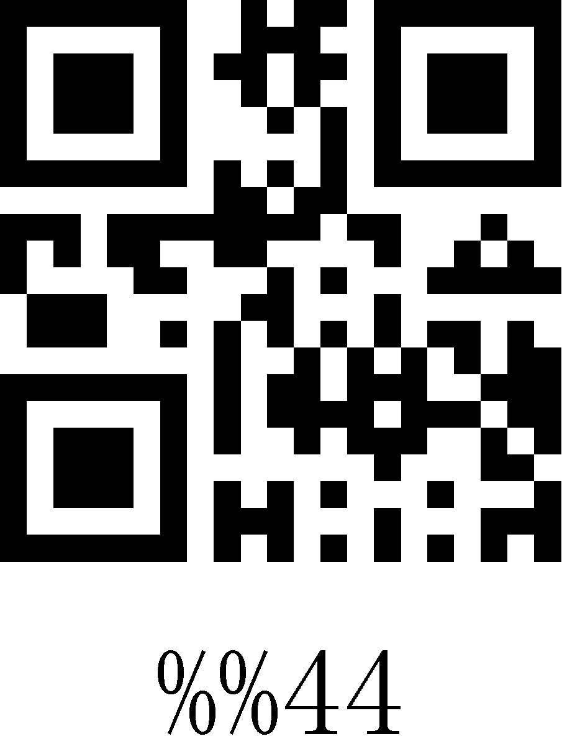
45 | 69 | E | 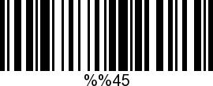 | 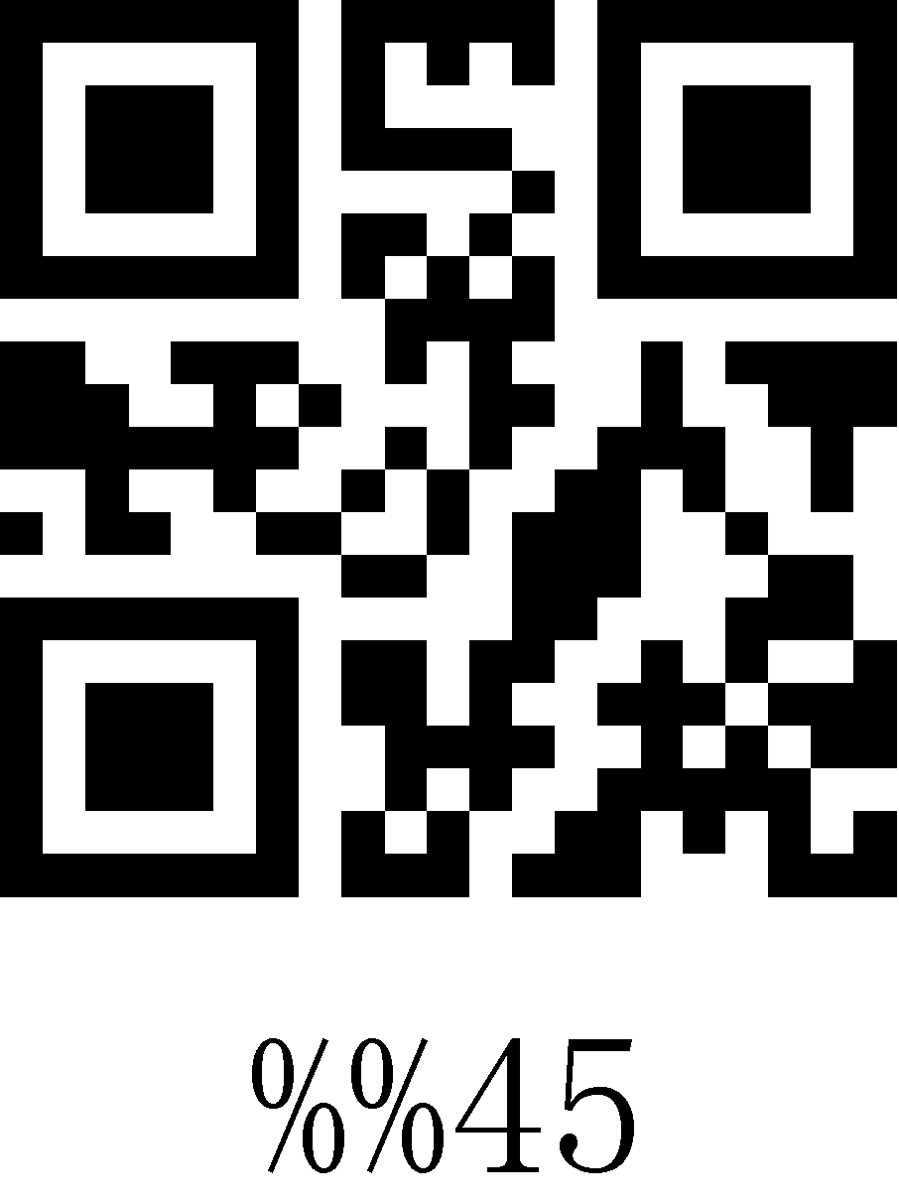
46 | 70 | F | 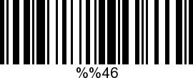 | 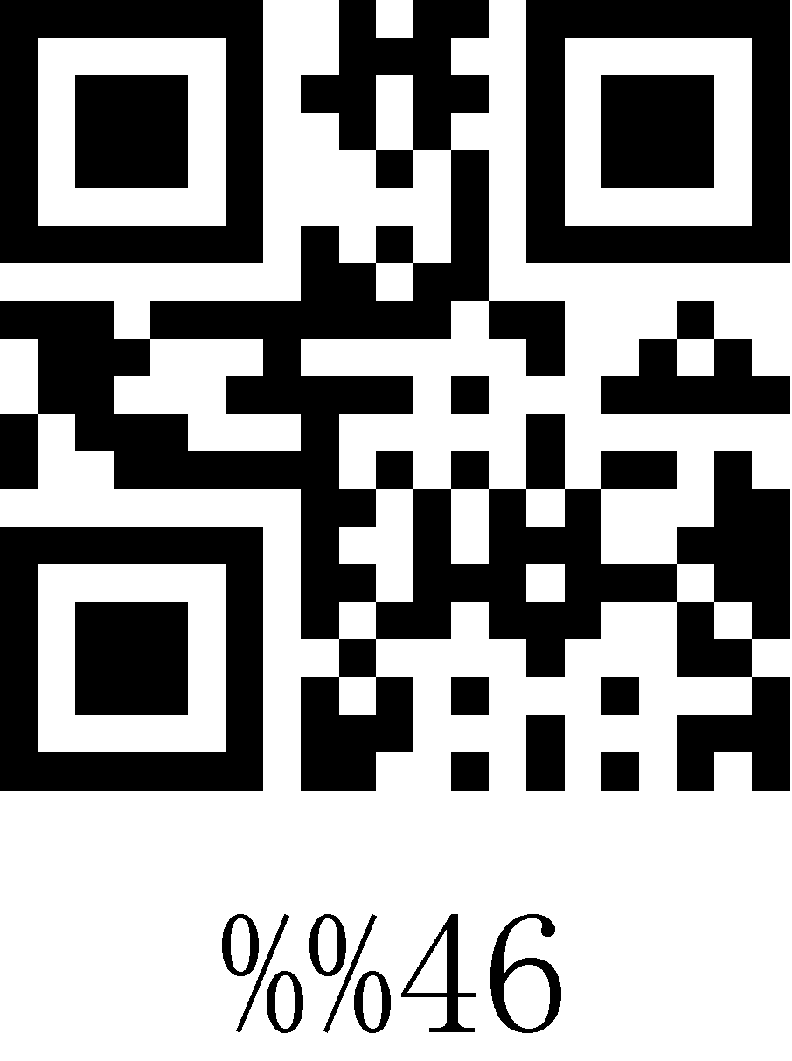
47 | 71 | G | 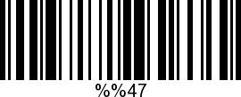 | 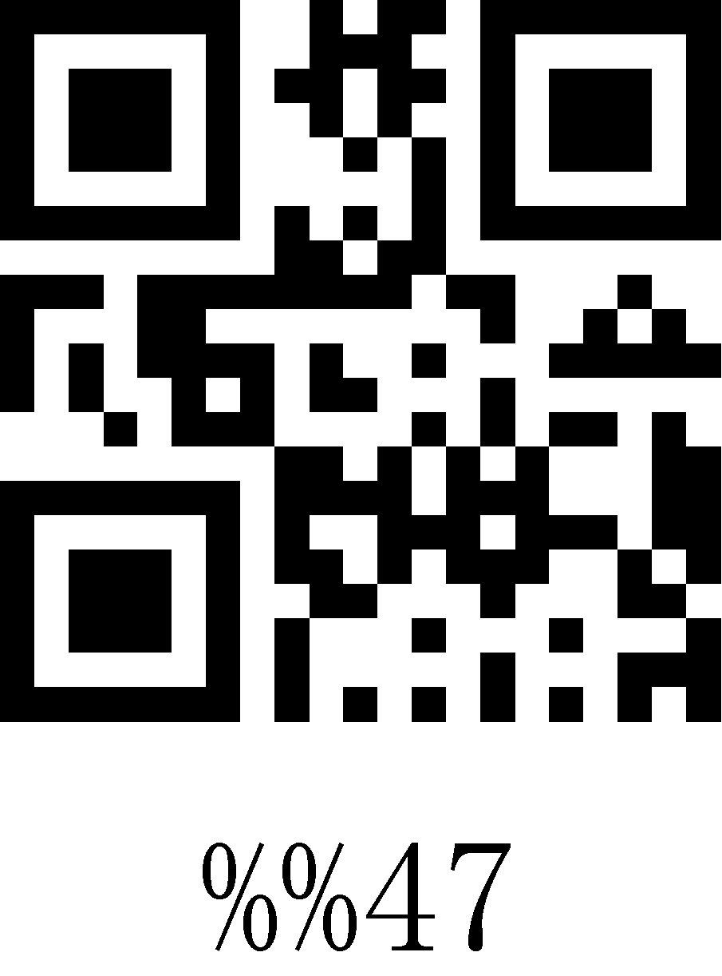
48 | 72 | H | 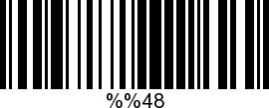 | 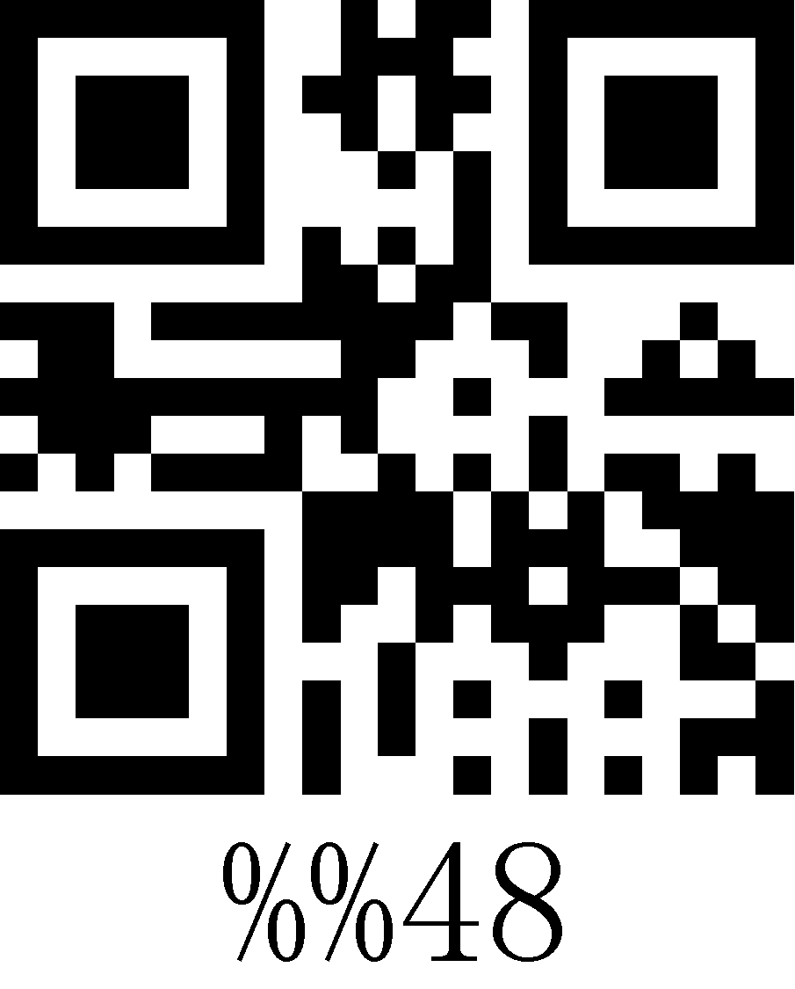
49 | 73 | I | 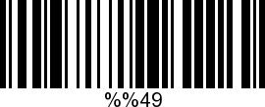 | 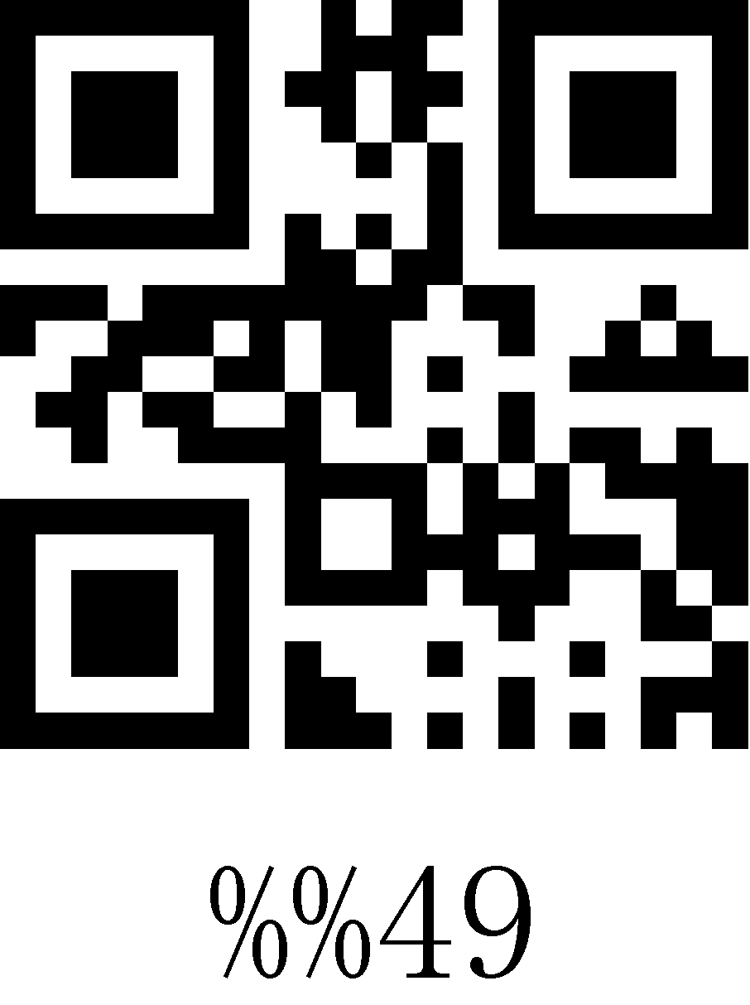
4A | 74 | J | 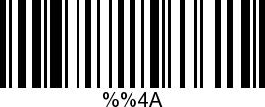 | 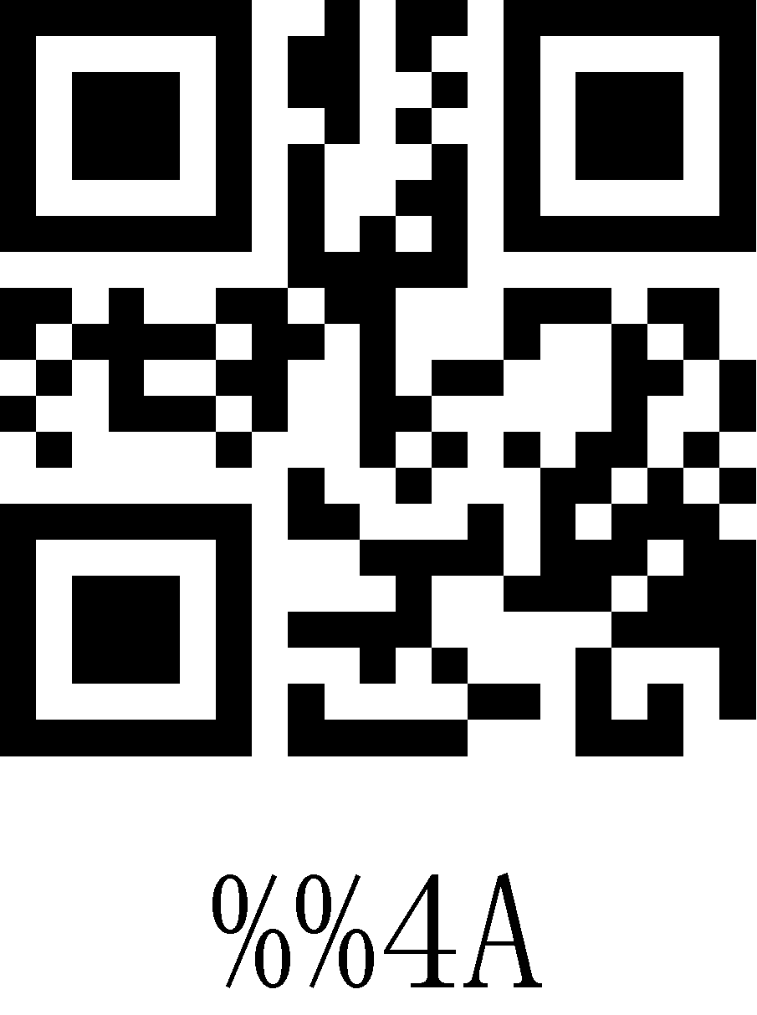
4B | 75 | K | 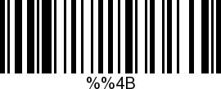 | 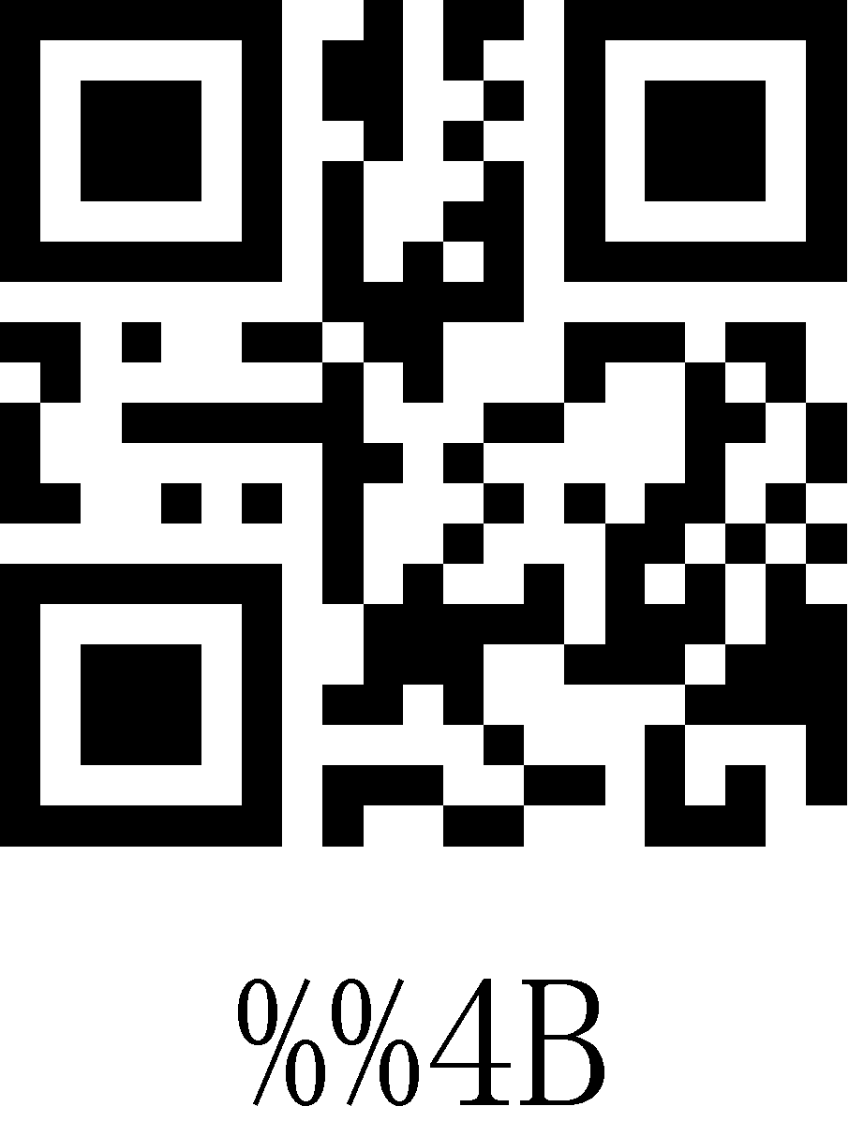
4C | 76 | L | 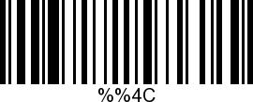 | 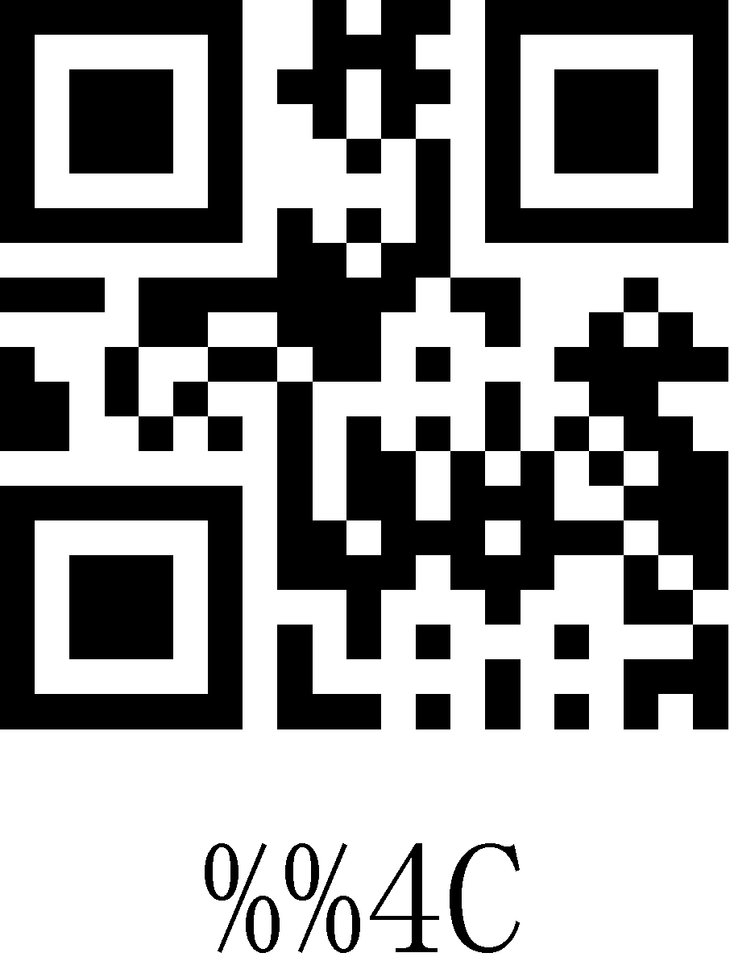
4D | 77 | M | 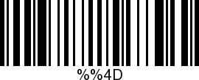 | 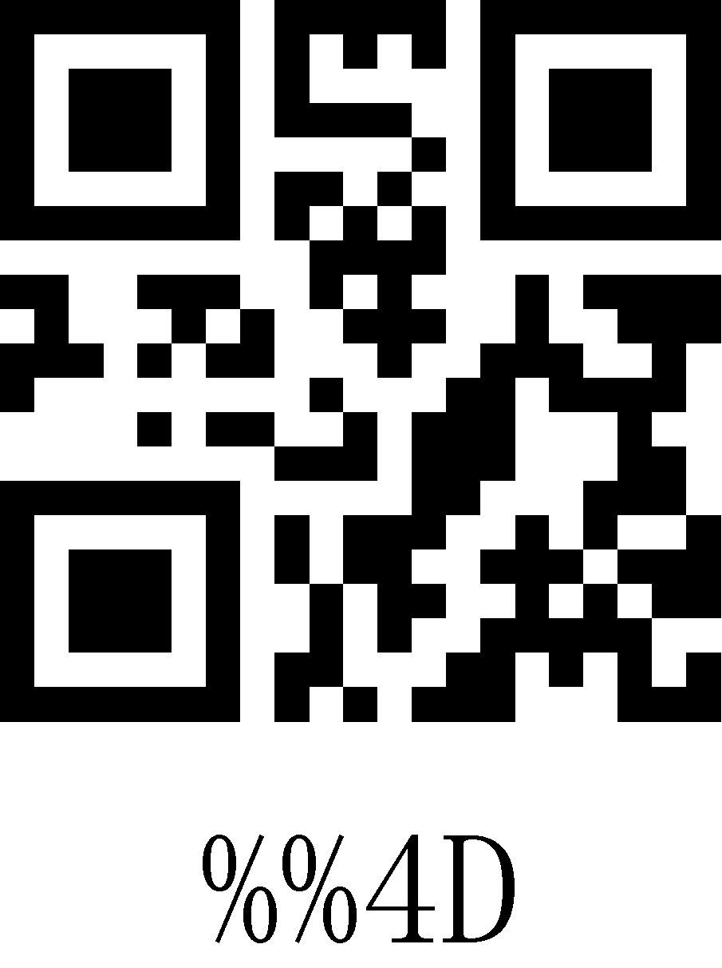
4E | 78 | N | 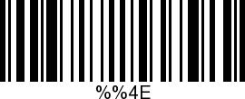 | 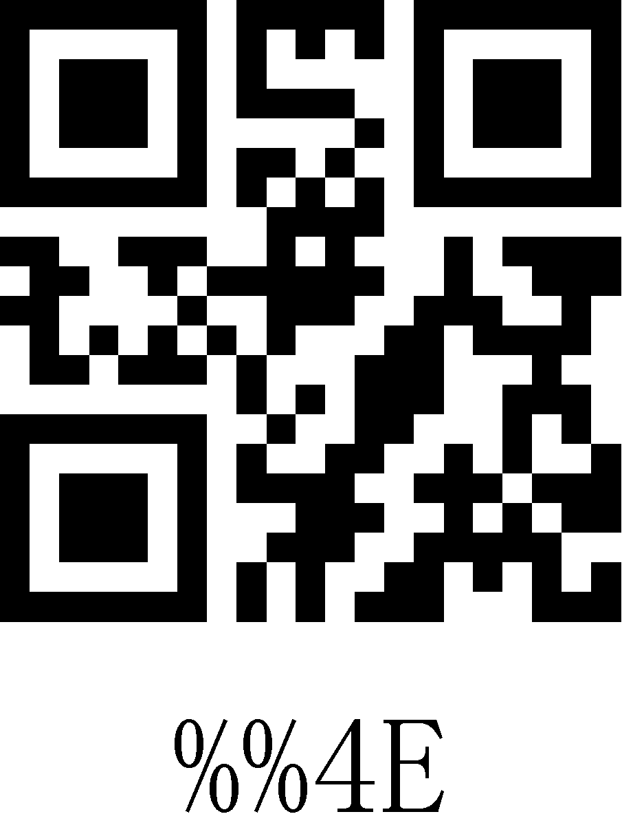
4F | 79 | O | 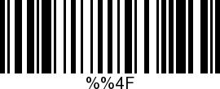 | 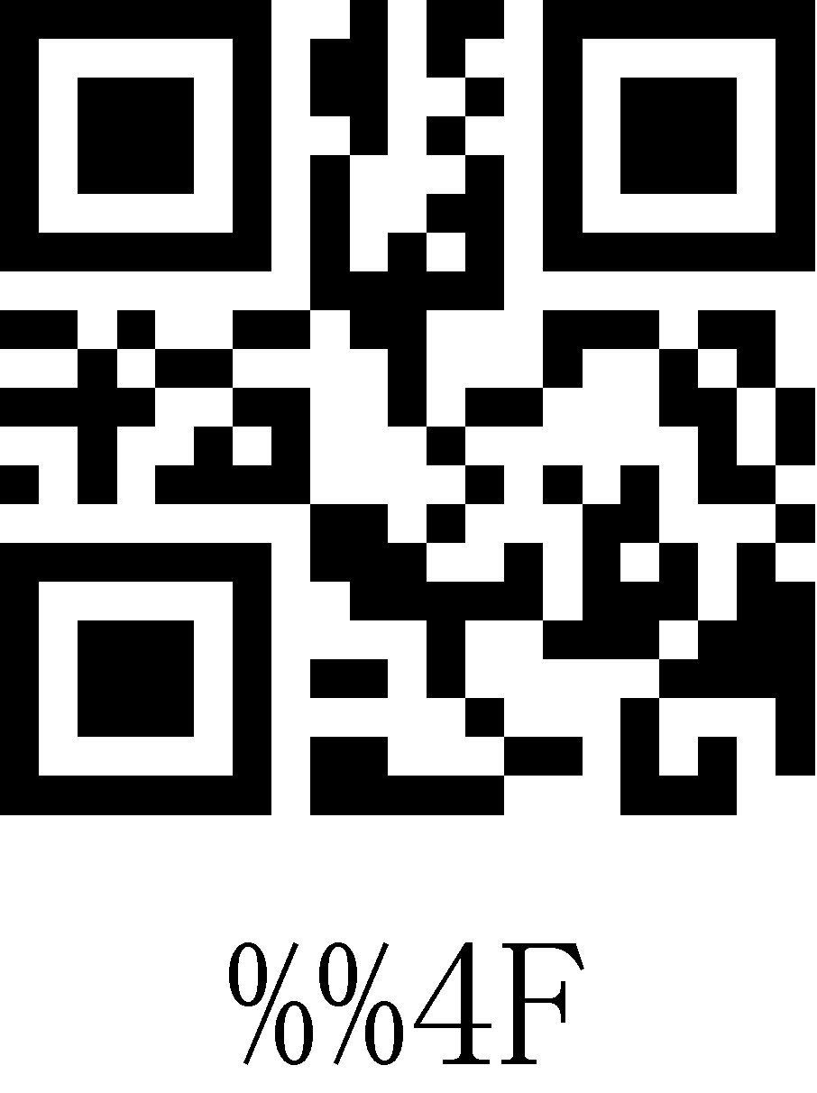
50 | 80 | P | 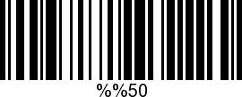 | 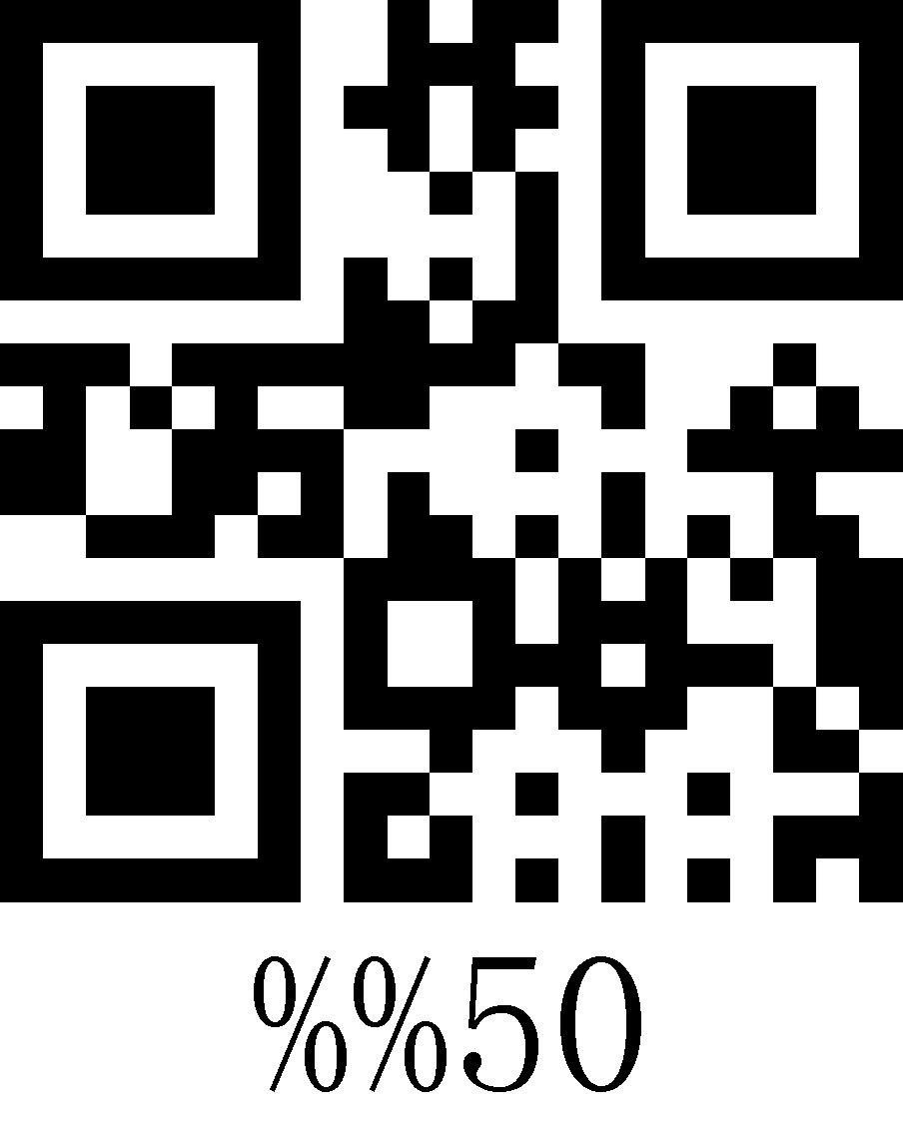
51 | 81 | Q | 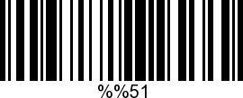 | 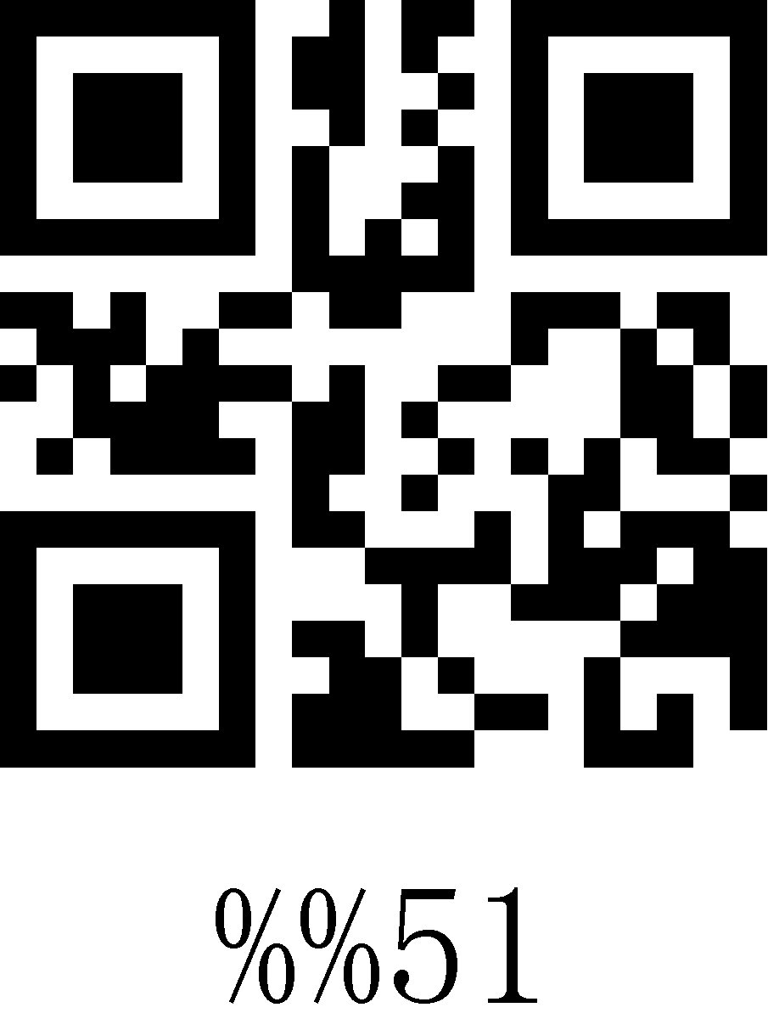
52 | 82 | R | 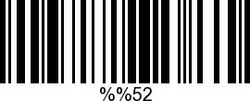 | 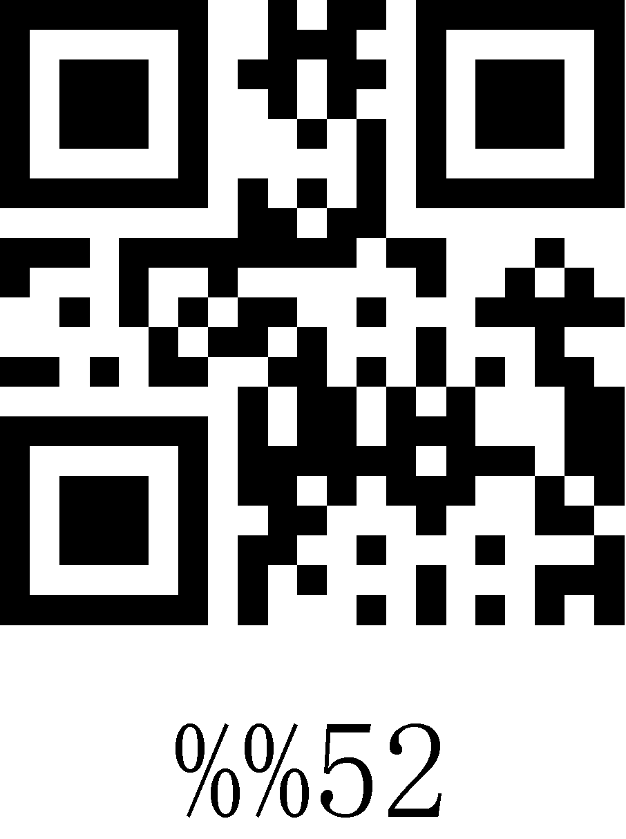
53 | 83 | S | 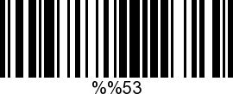 | 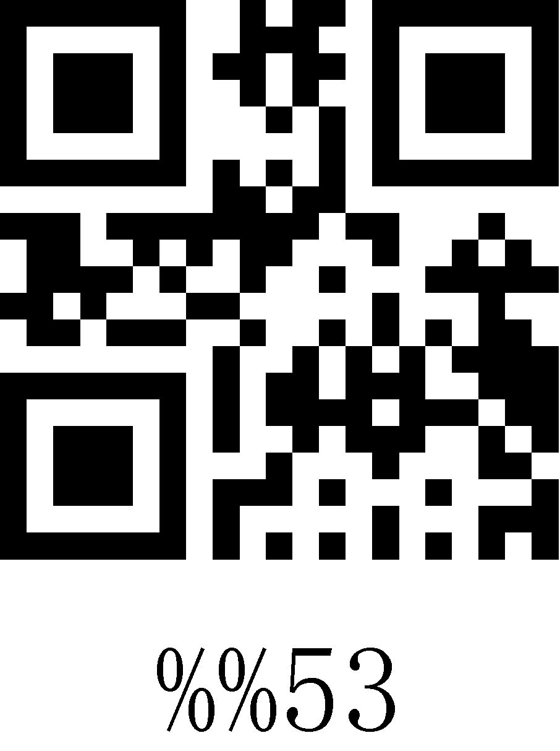
54 | 84 | T | 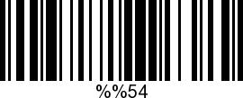 | 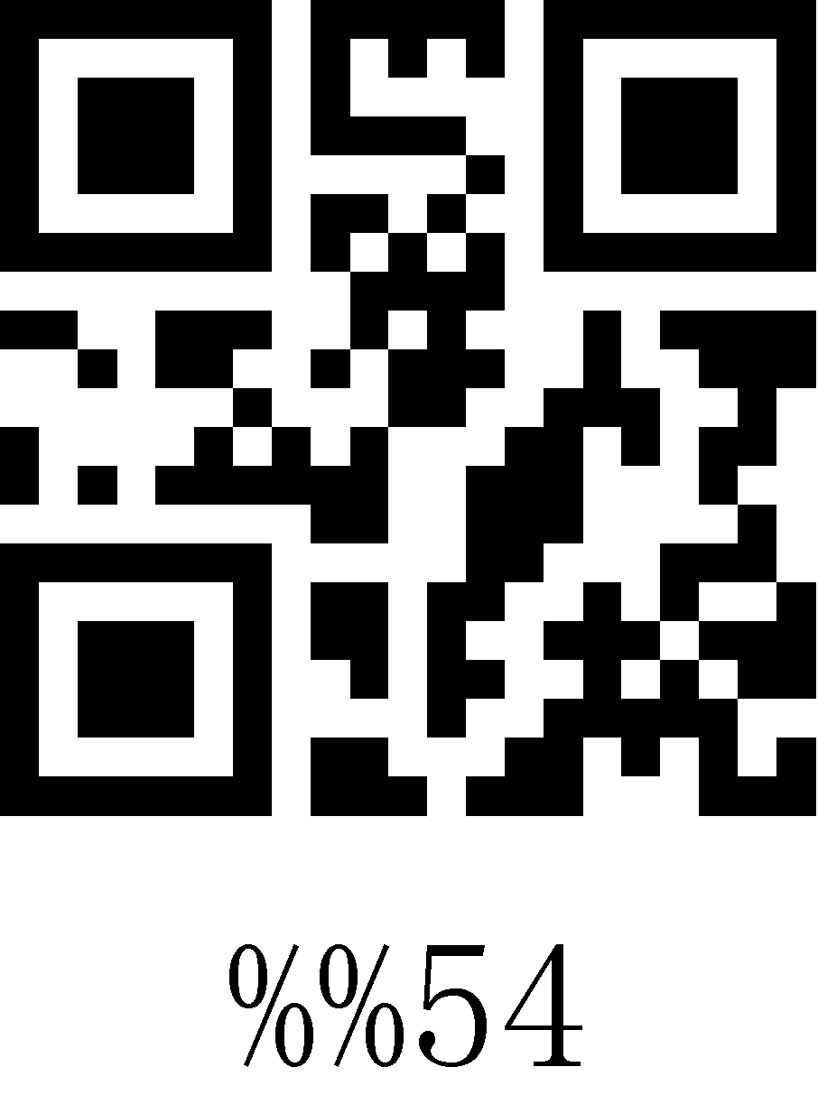
55 | 85 | U | 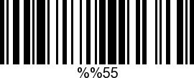 | 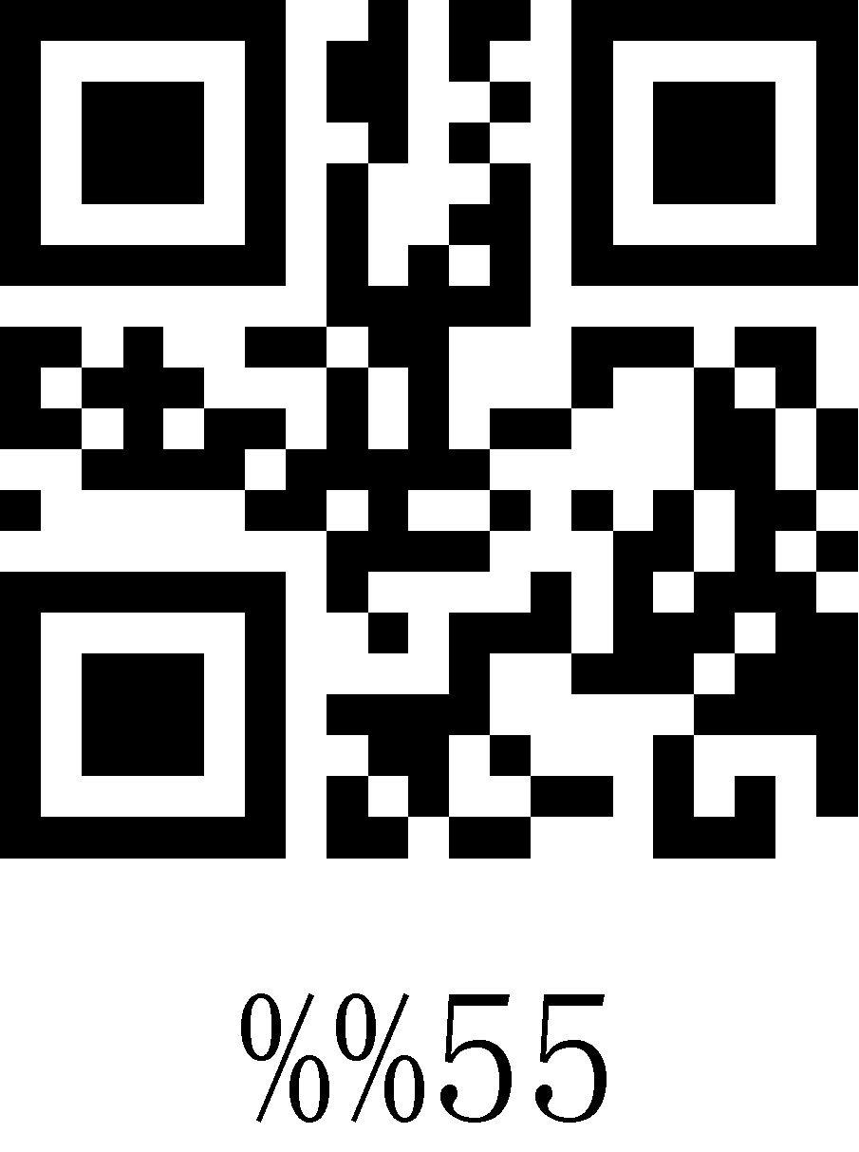
56 | 86 | V | 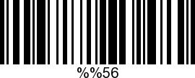 | 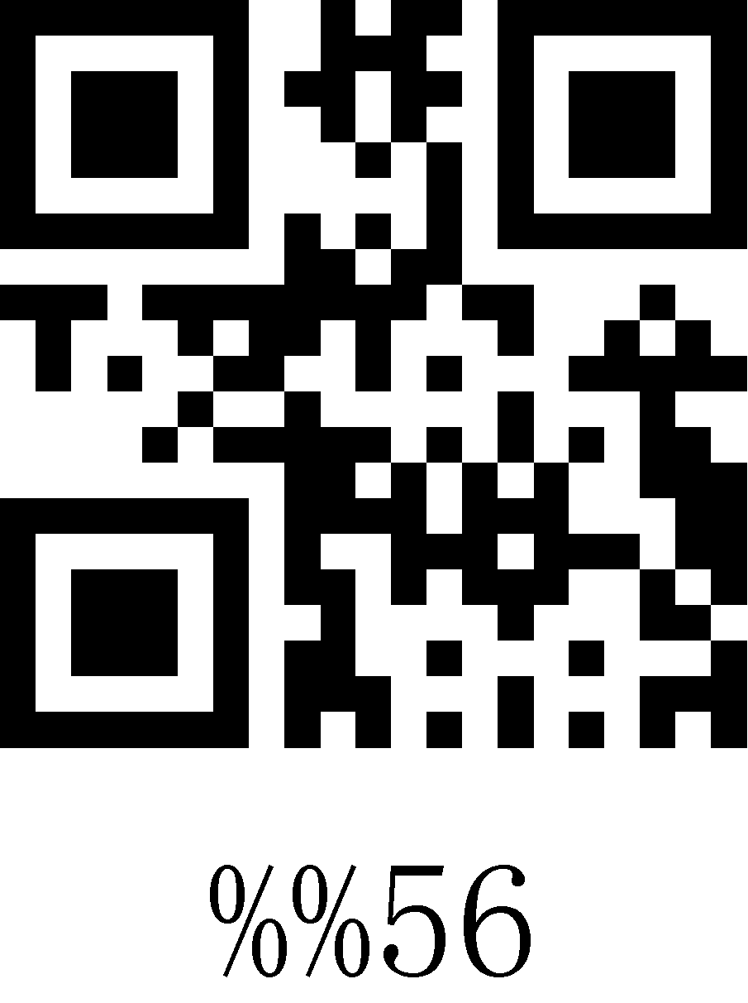
57 | 87 | W | 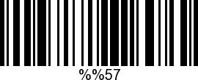 | 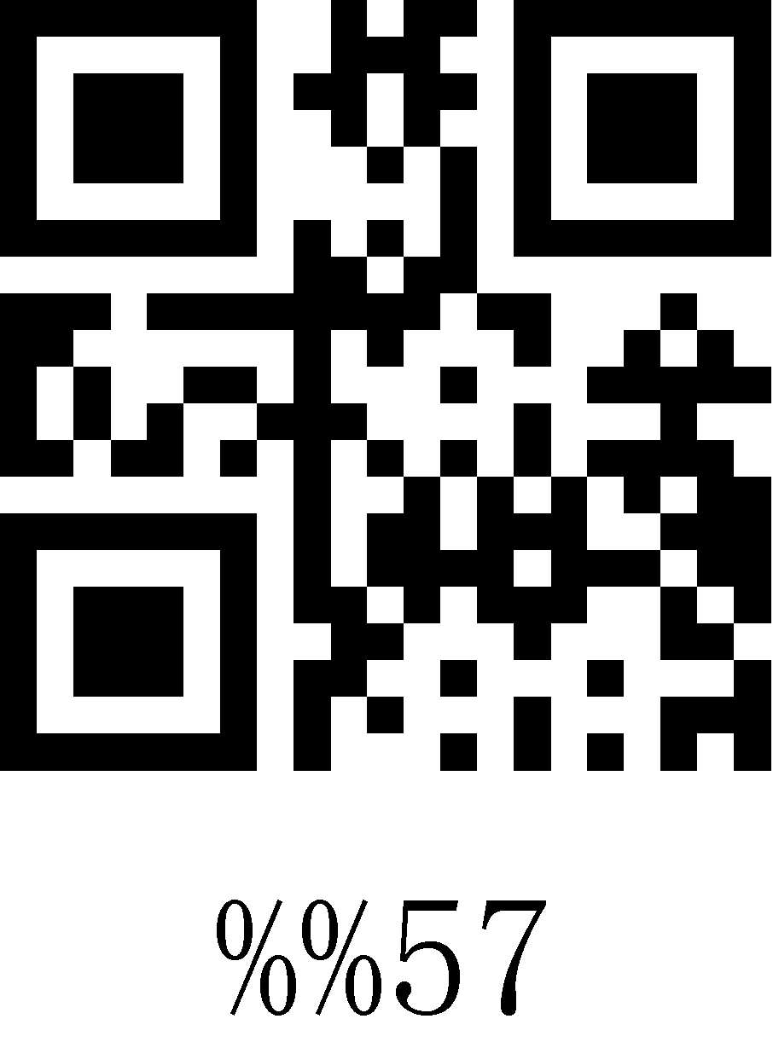
58 | 88 | X | 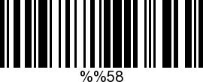 | 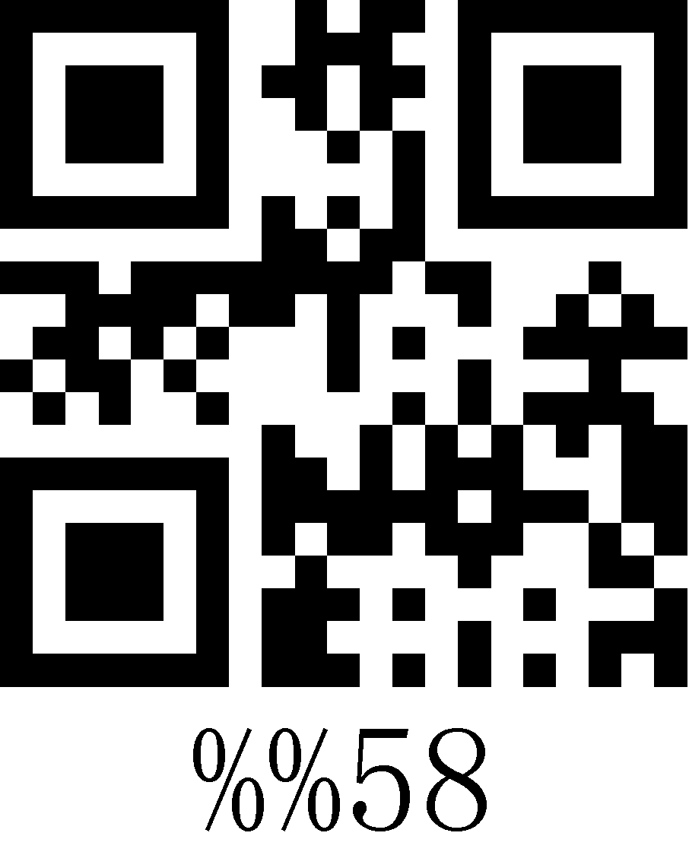
59 | 89 | Y | 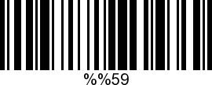 | 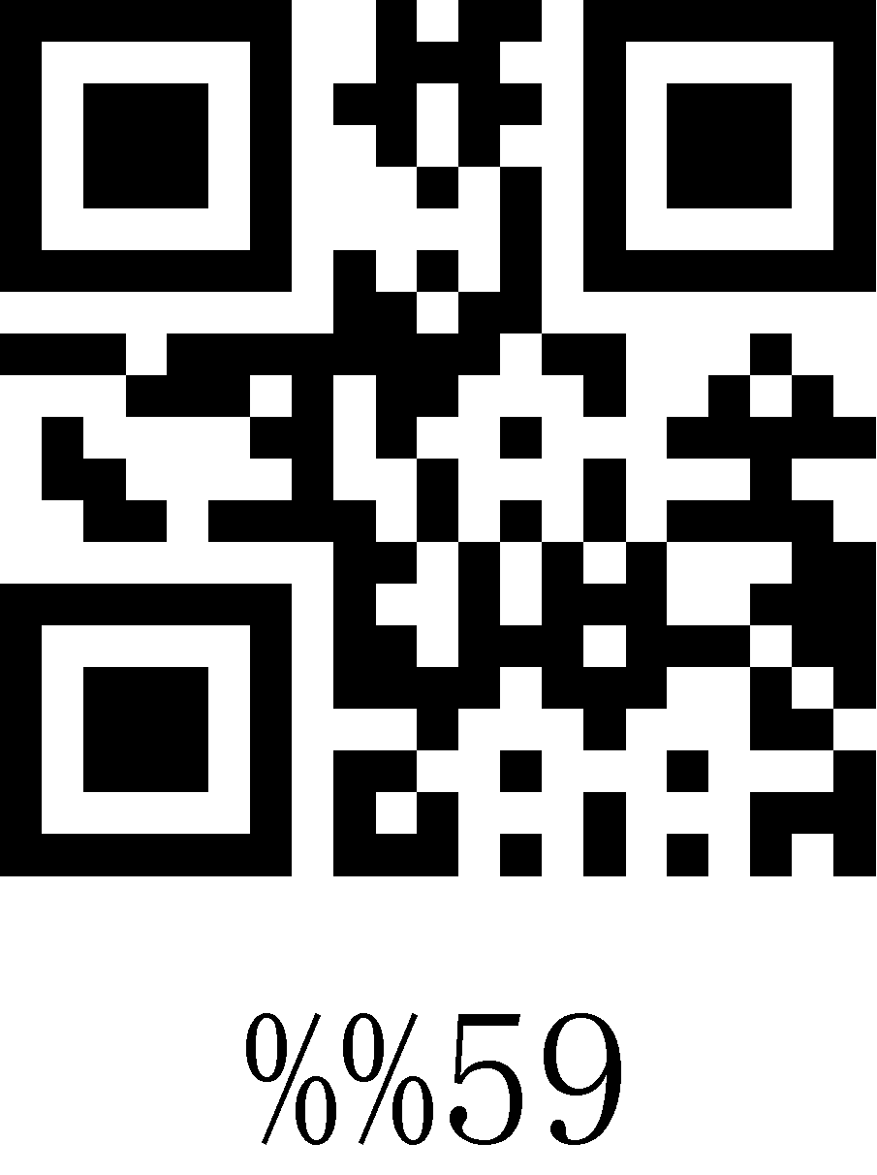
5A | 90 | Z | 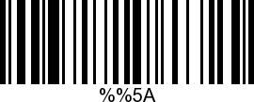 | 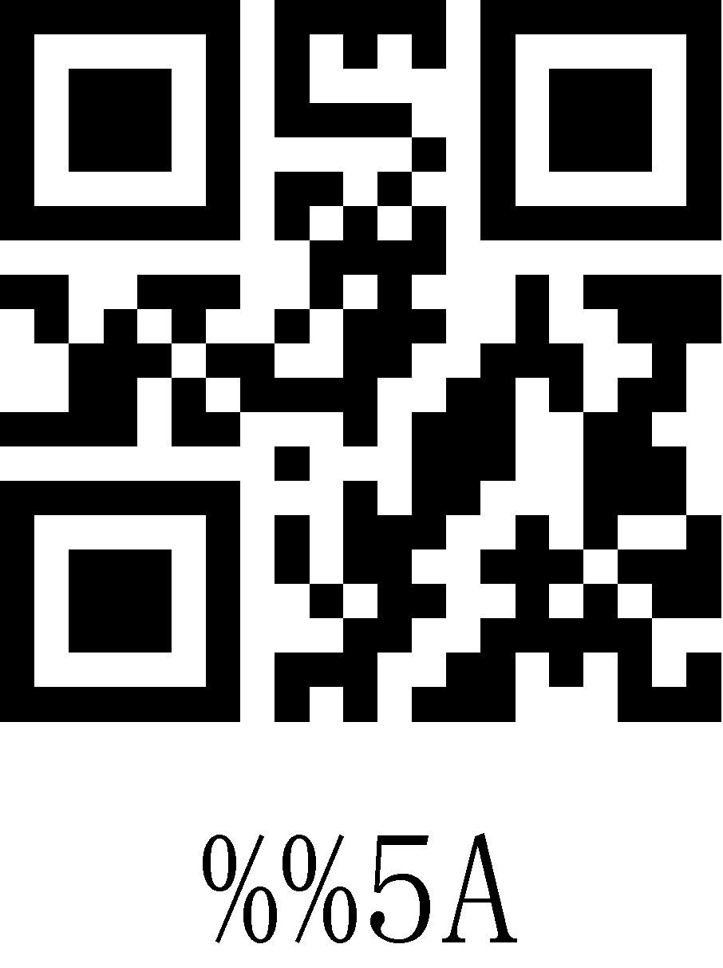
5B | 91 | [ | 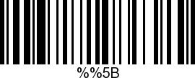 | 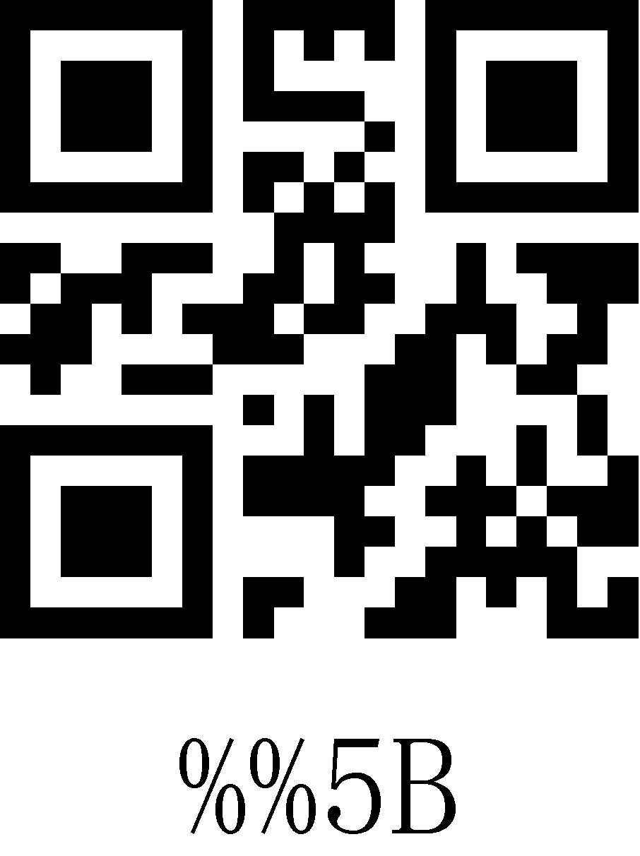
5C | 92 | \ | 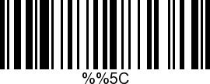 | 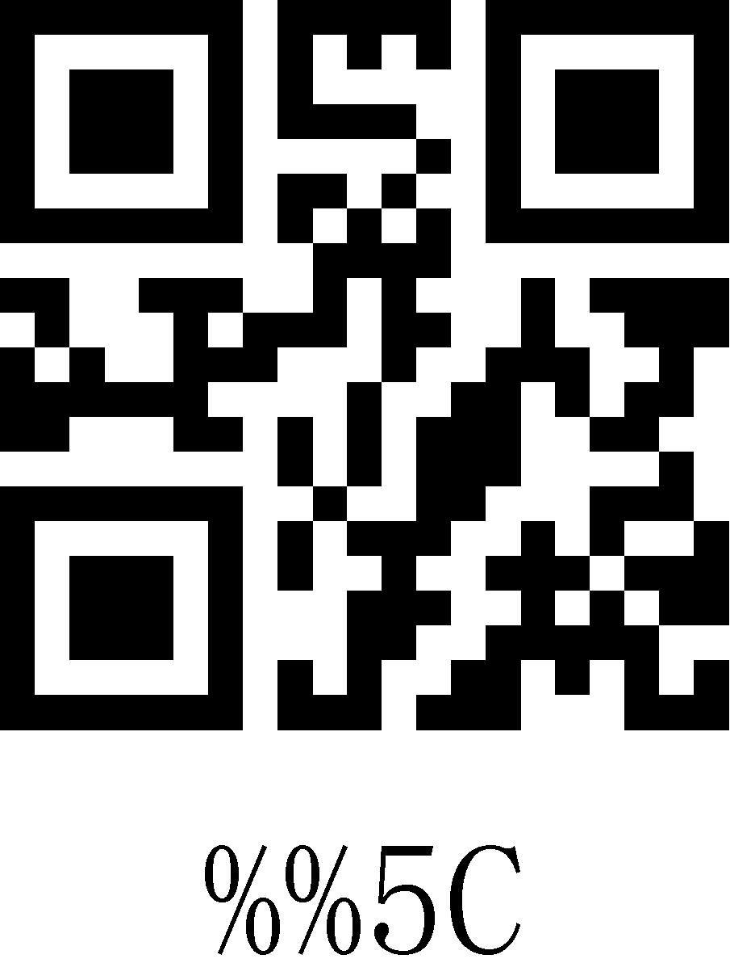
5D | 93 | ] | 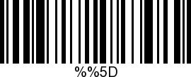 | 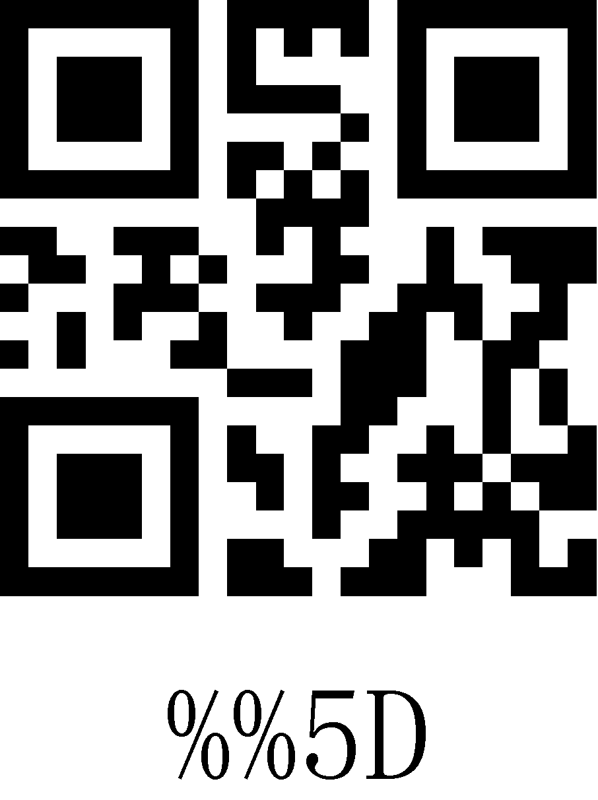
5E | 94 | ^ | 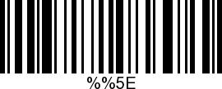 | 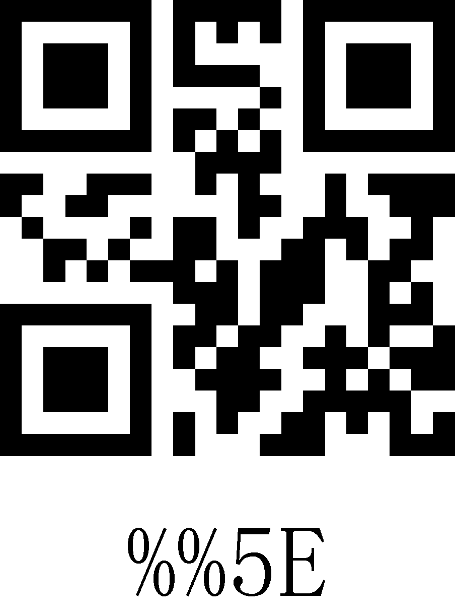
5F | 95 | _ | 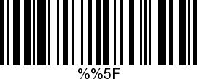 | 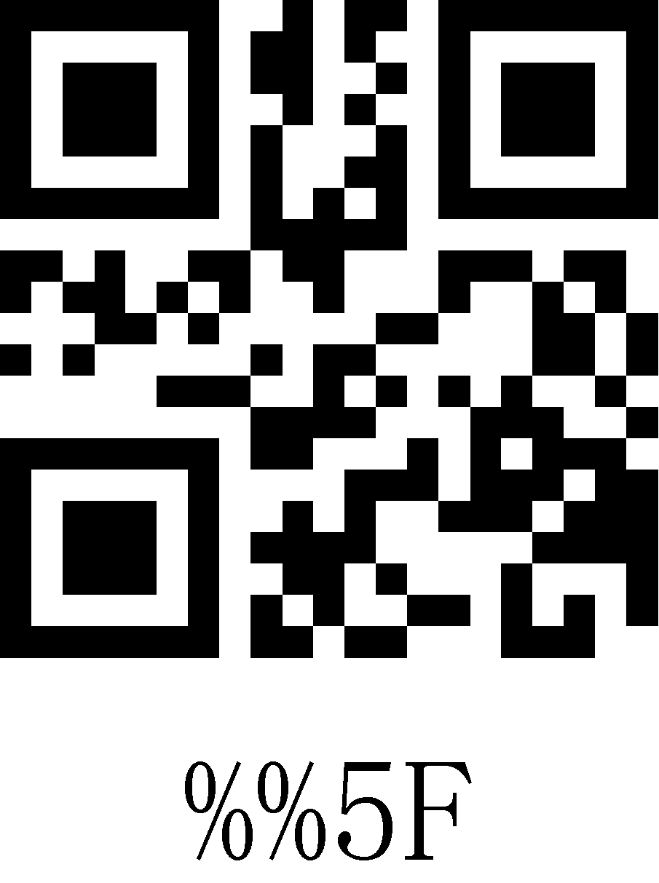
60 | 96 | ' | 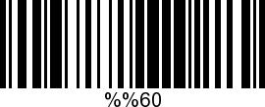 | 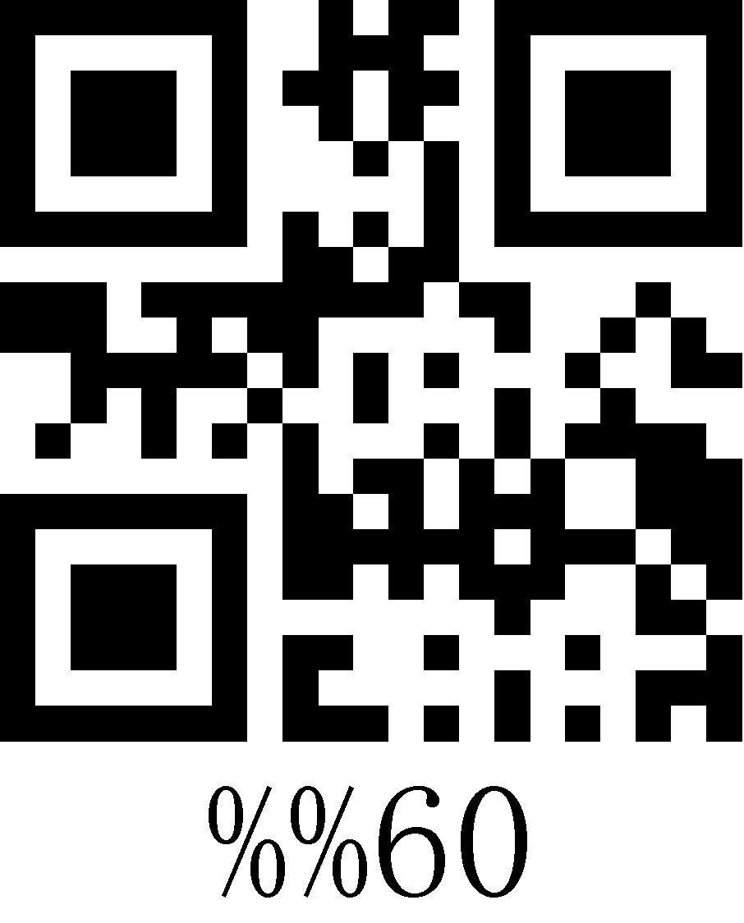
61 | 97 | a | 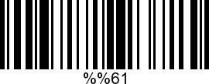 | 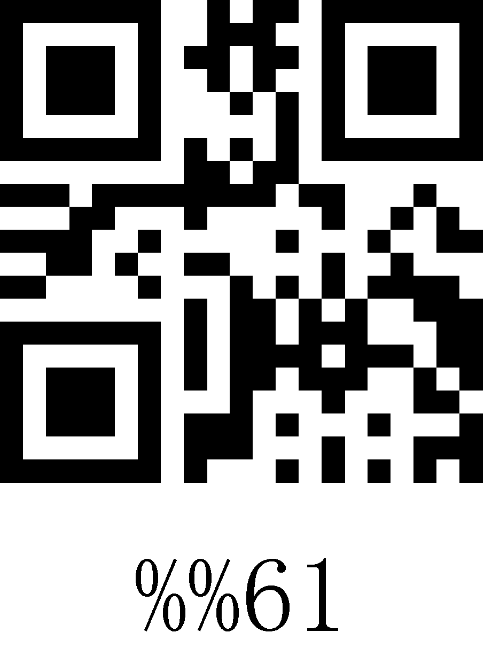
62 | 98 | b | 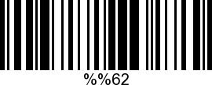 | 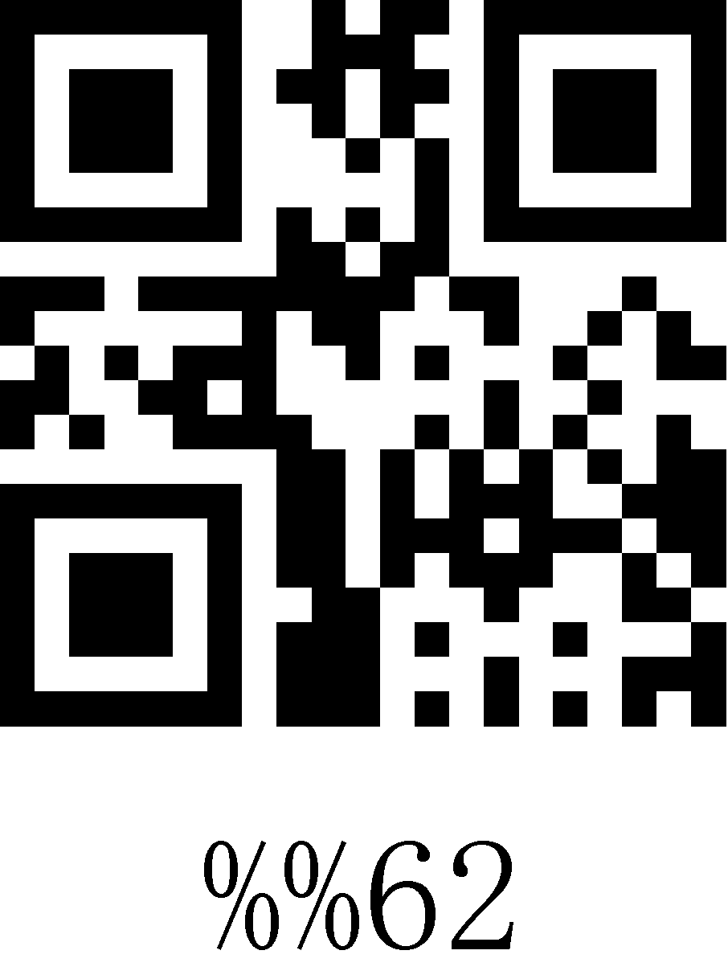
63 | 99 | c | 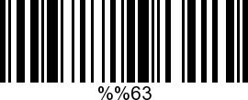 | 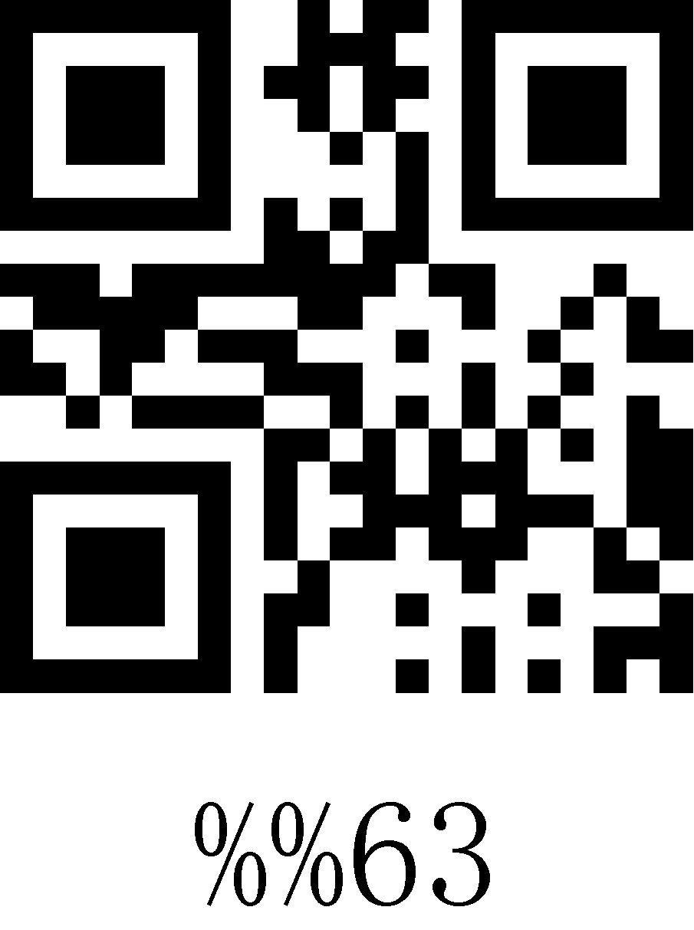
64 | 100 | d | 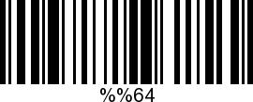 | 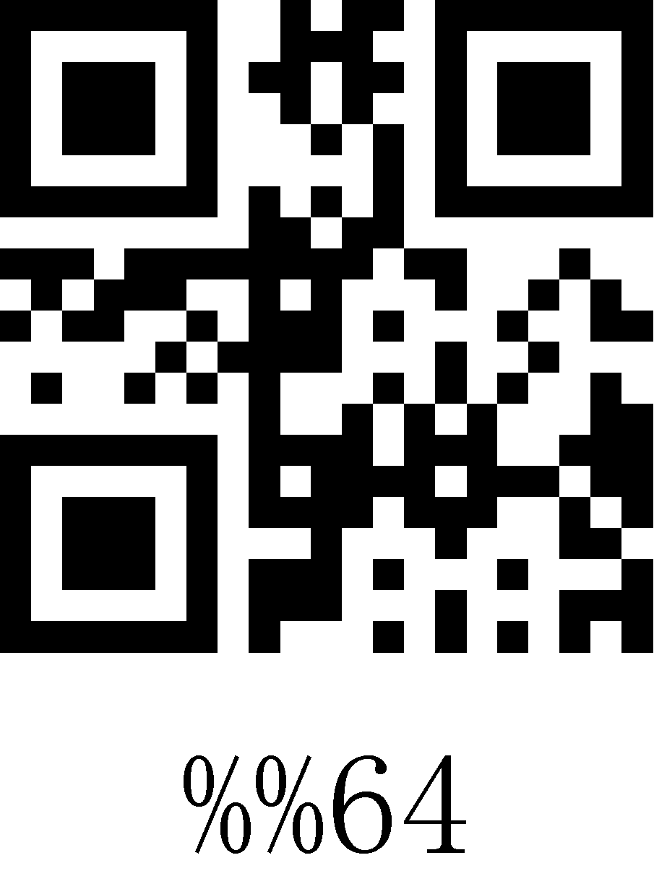
65 | 101 | e | 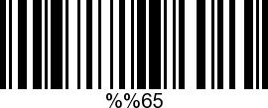 | 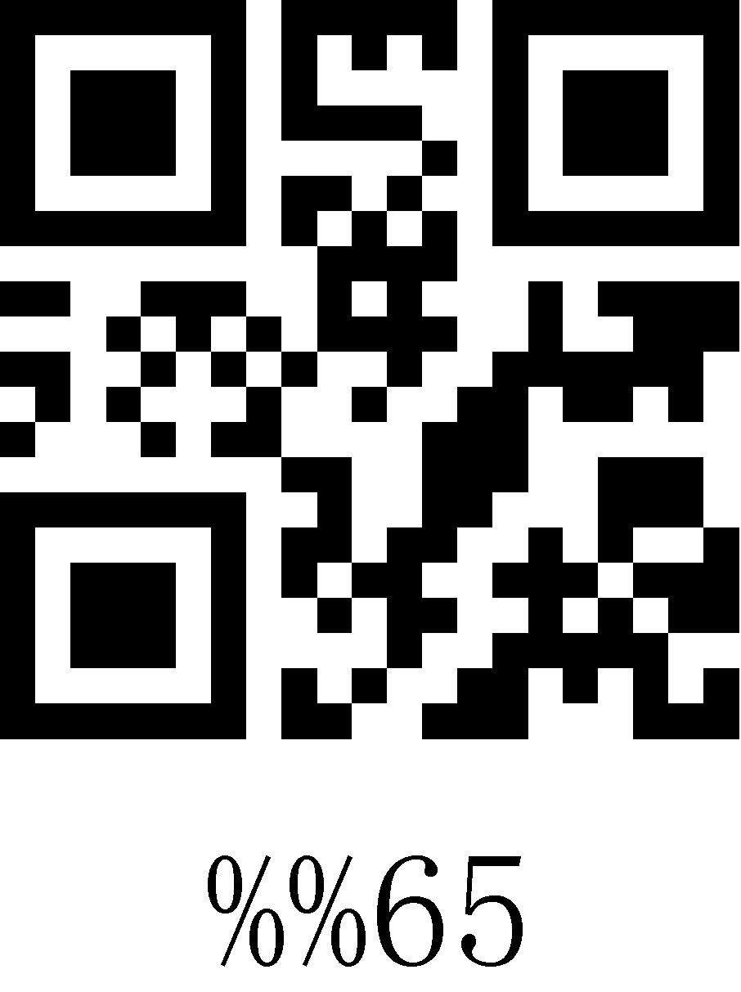
66 | 102 | f | 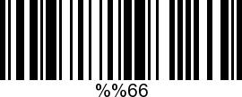 | 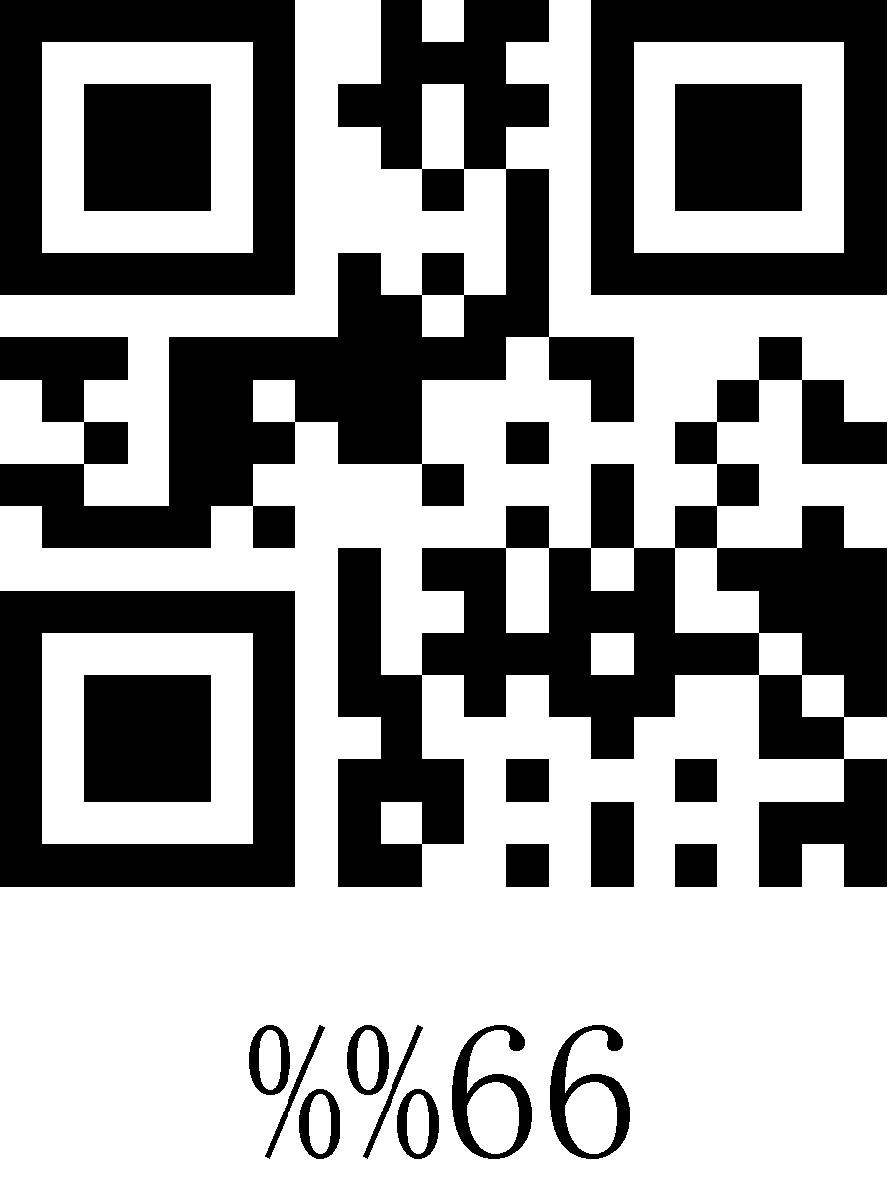
67 | 103 | g | 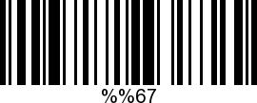 | 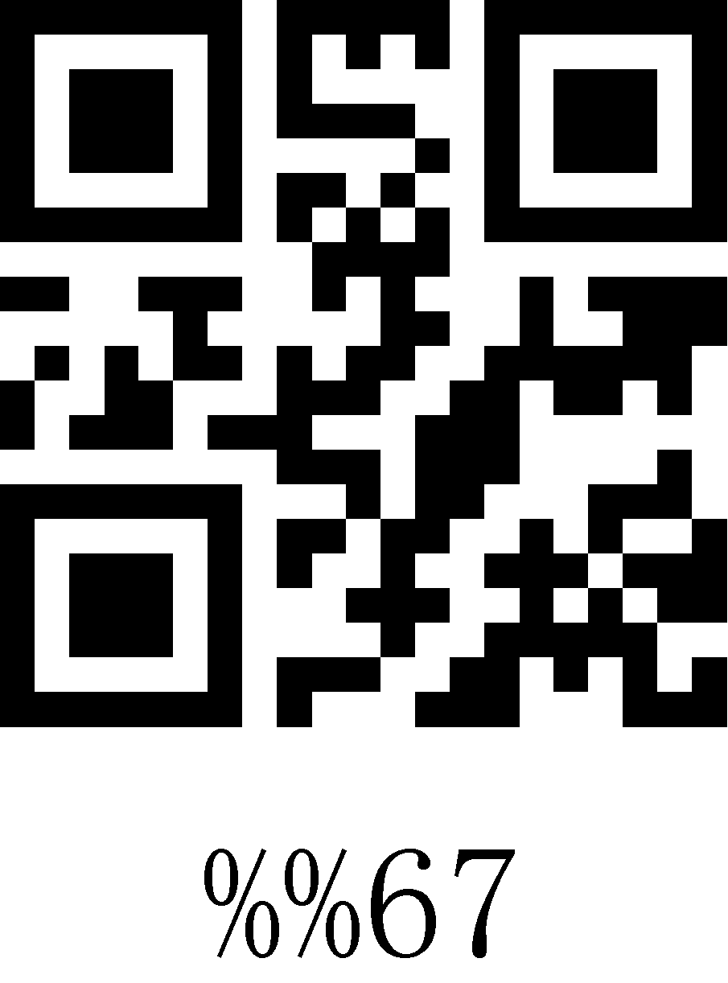
68 | 104 | h | 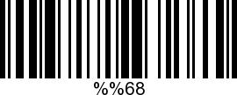 | 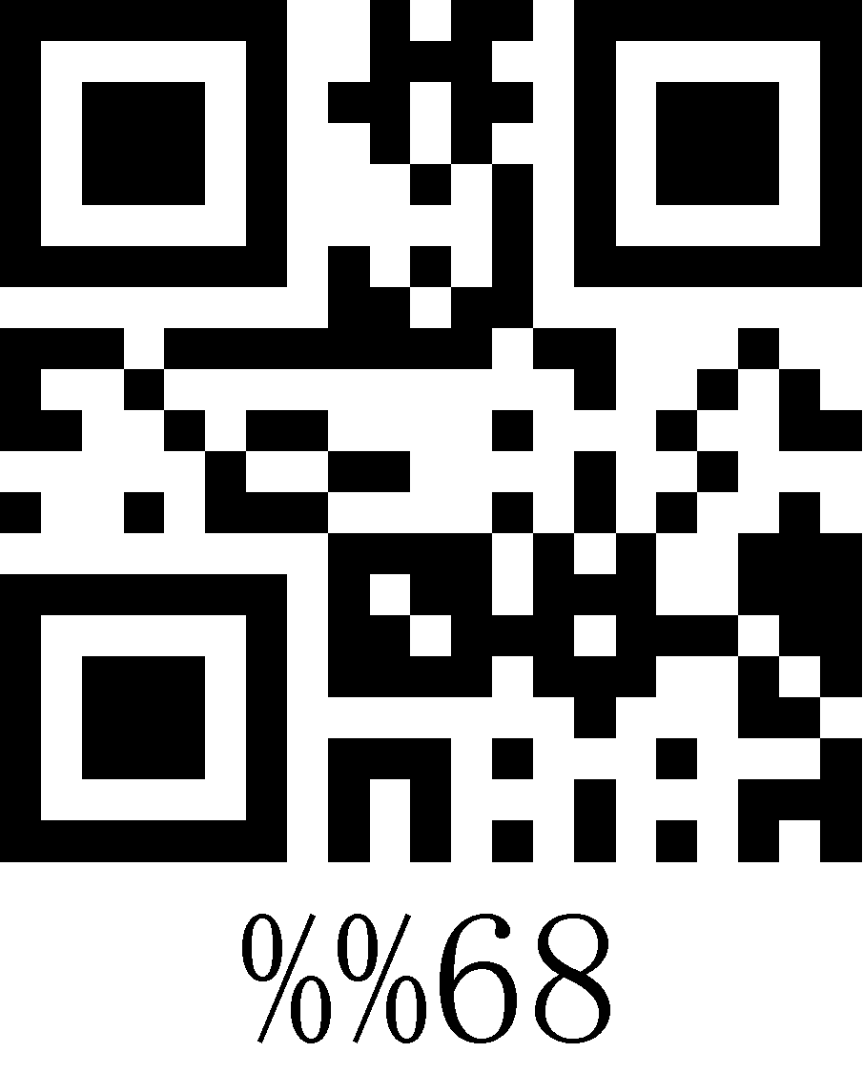
69 | 105 | i | 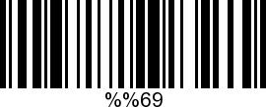 | 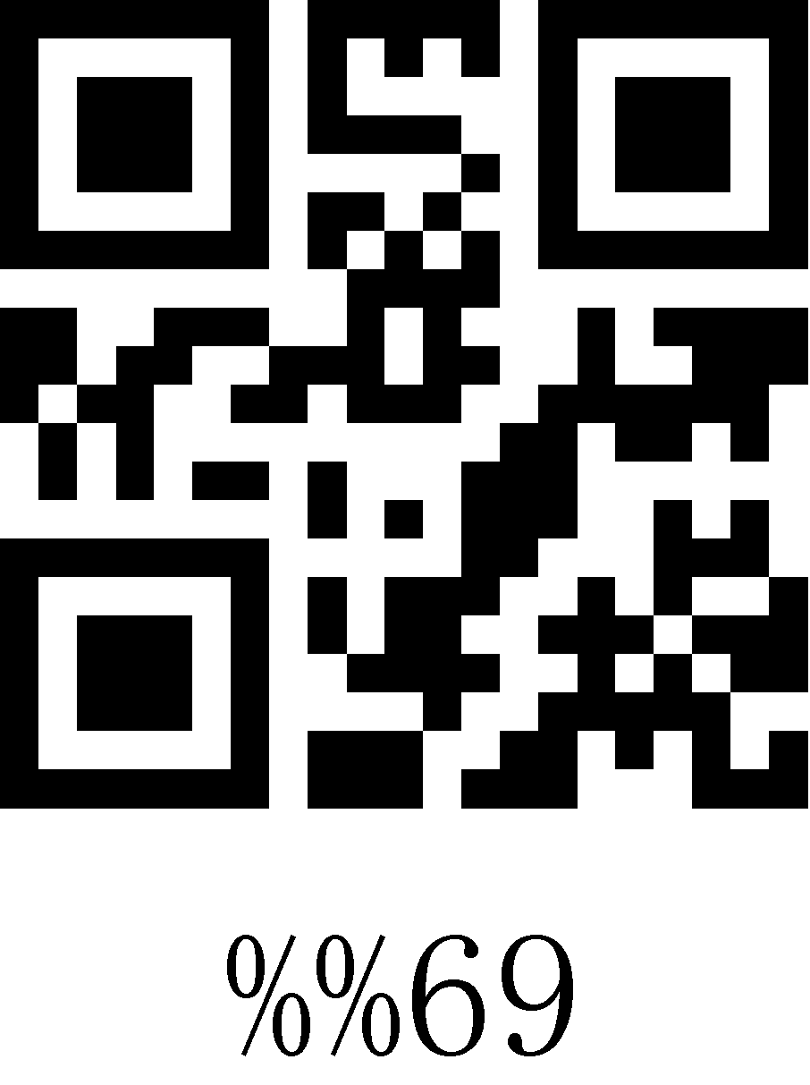
6A | 106 | j | 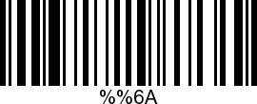 | 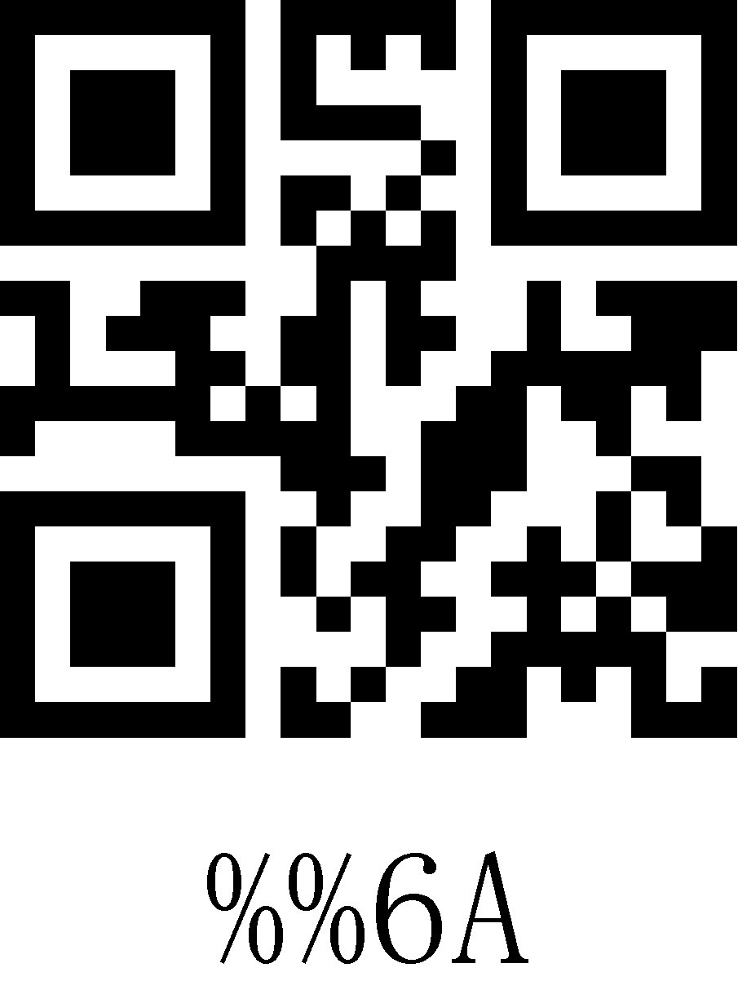
6B | 107 | k | 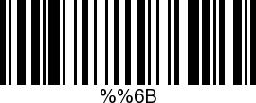 | 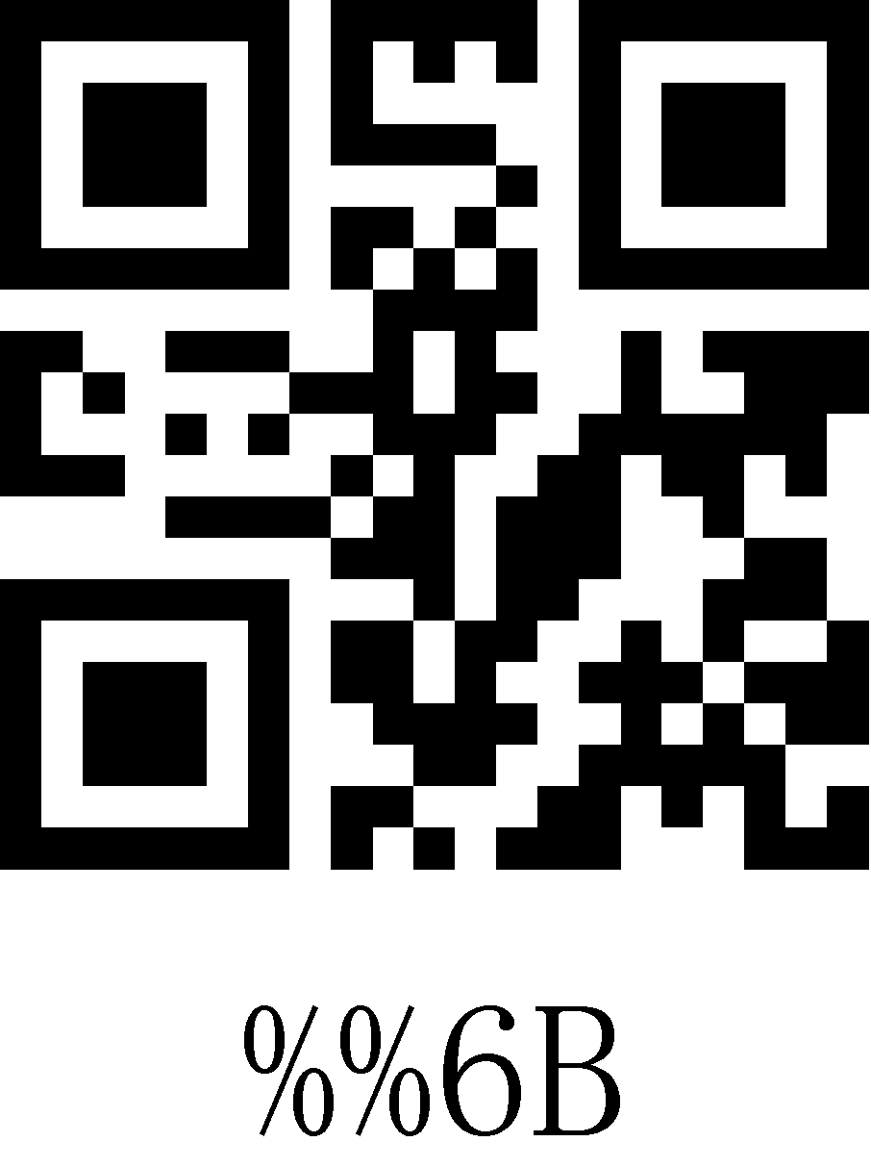
6C | 108 | l | 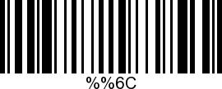 | 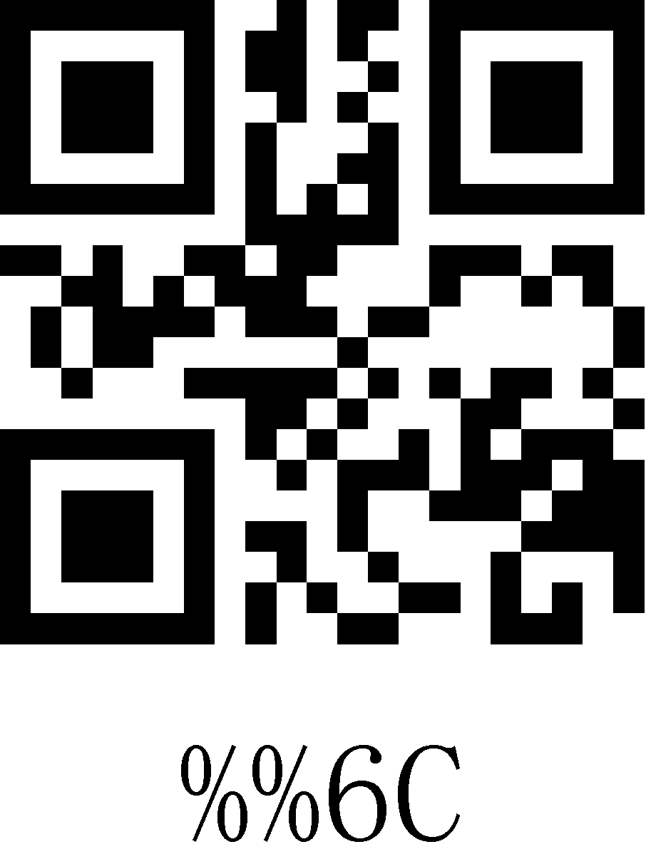
6D | 109 | m | 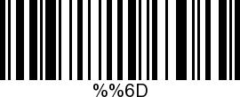 | 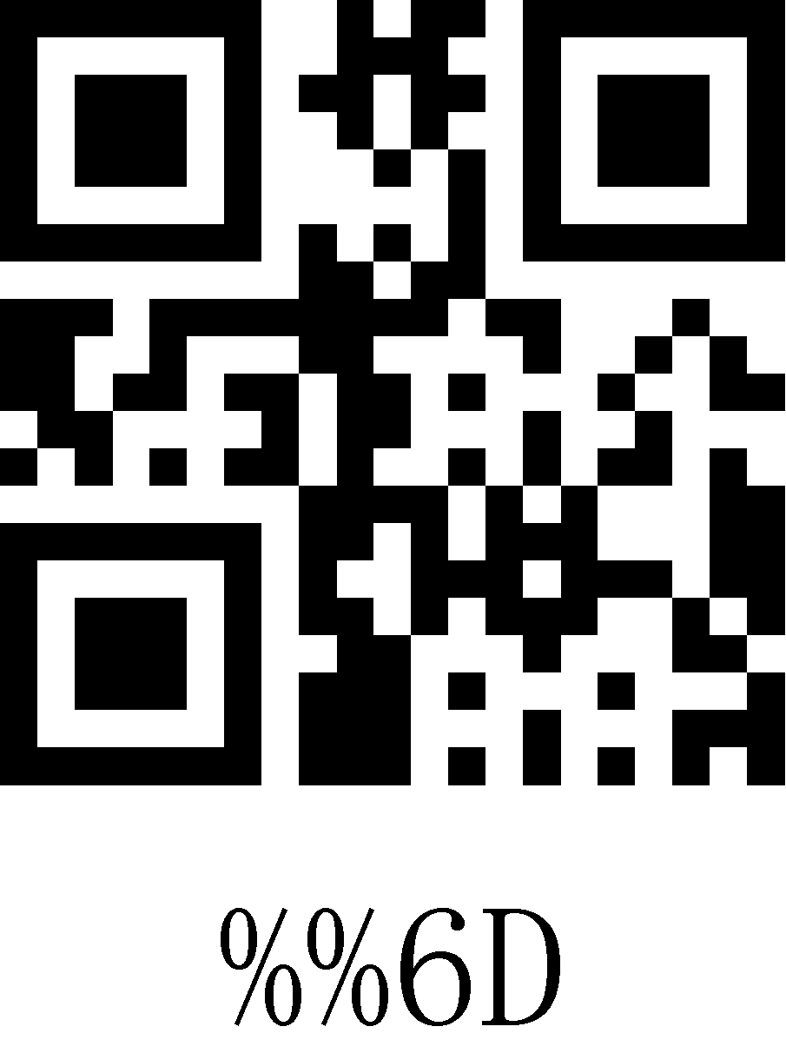
6E | 110 | n | 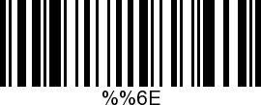 | 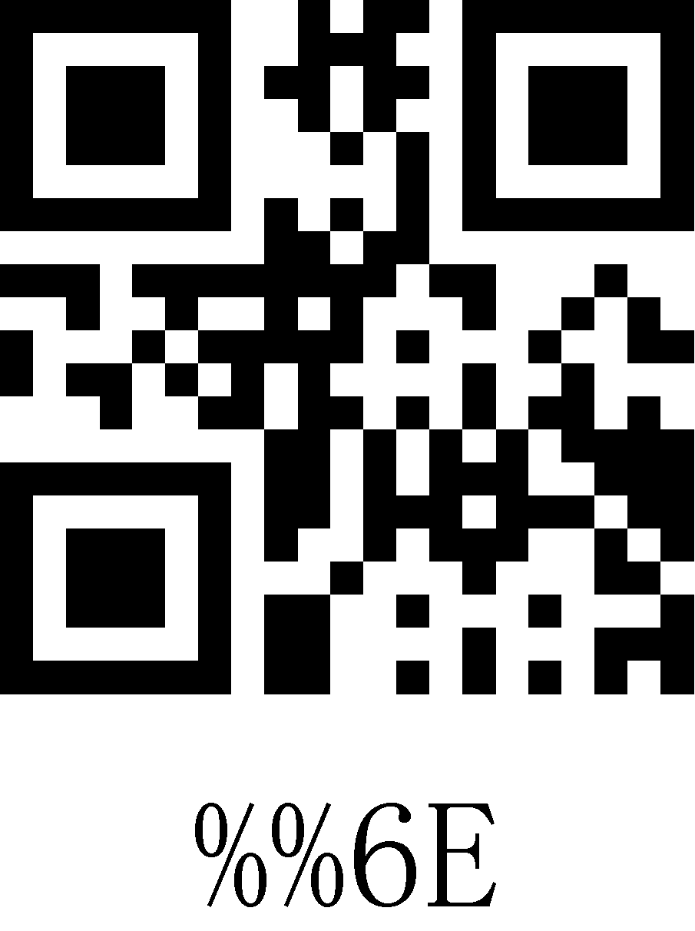
6F | 111 | o | 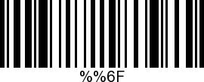 | 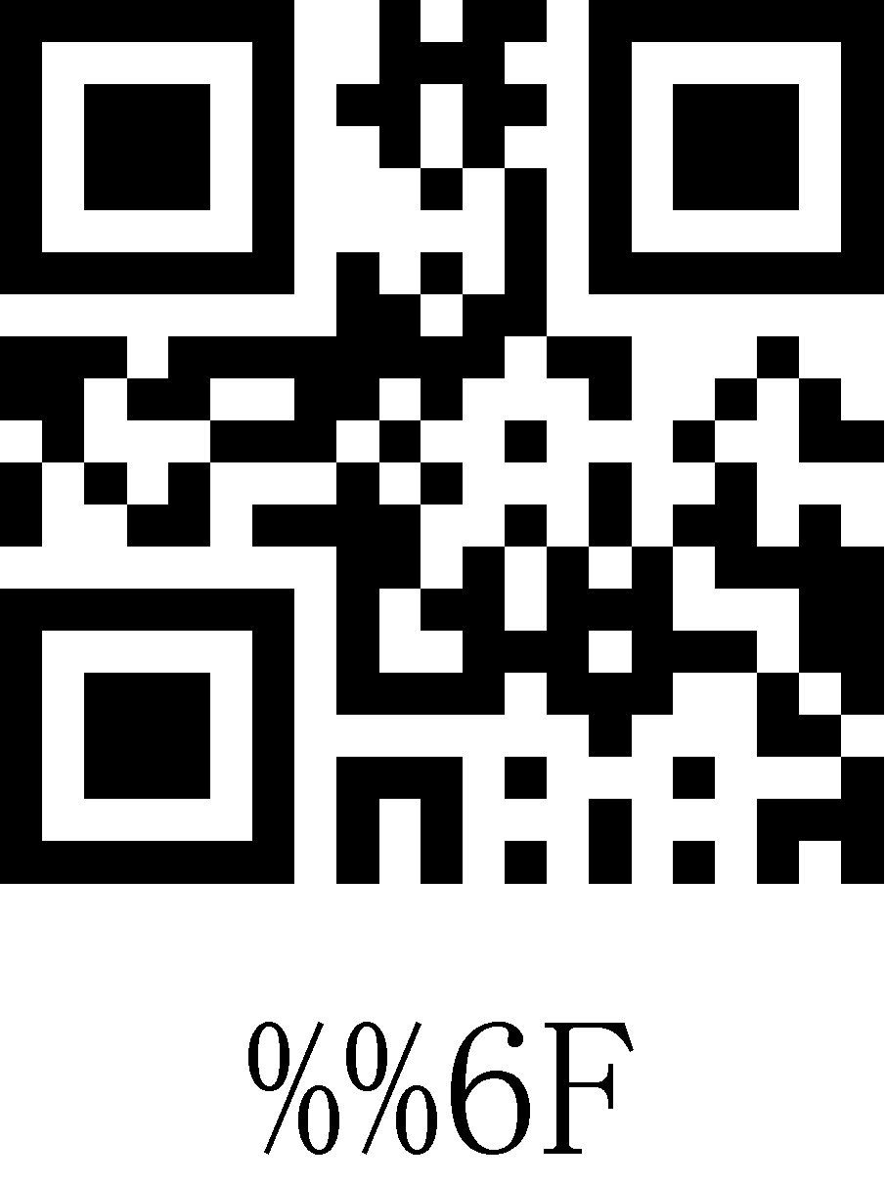
70 | 112 | p | 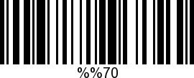 | 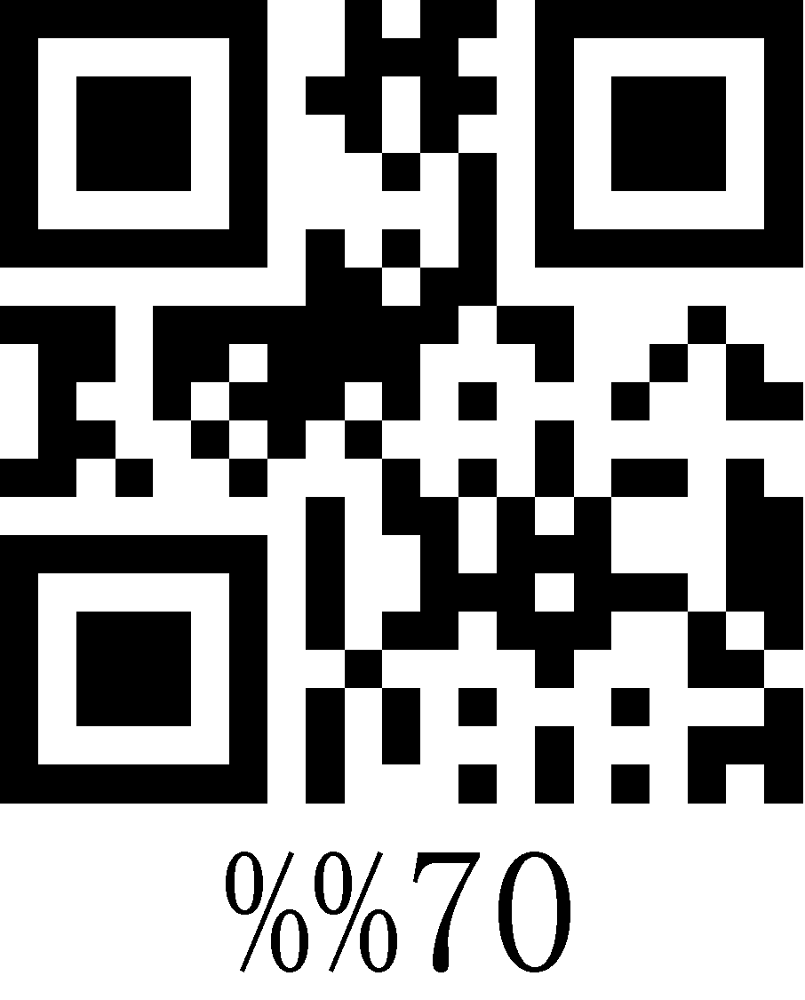
71 | 113 | q | 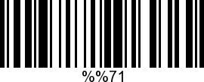 | 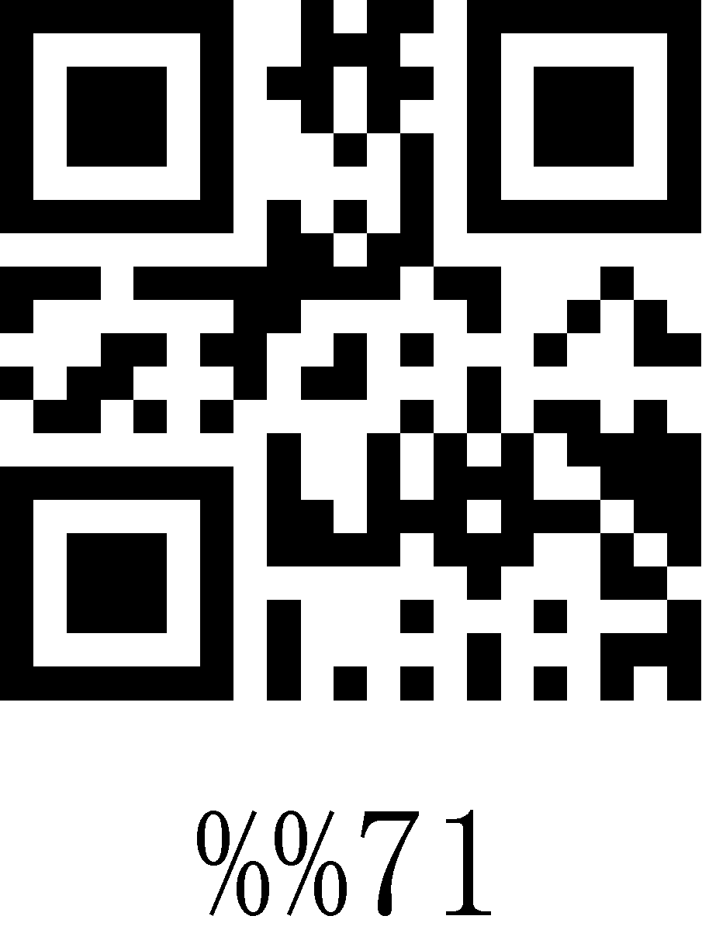
72 | 114 | r | 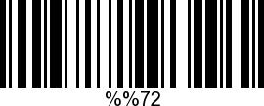 | 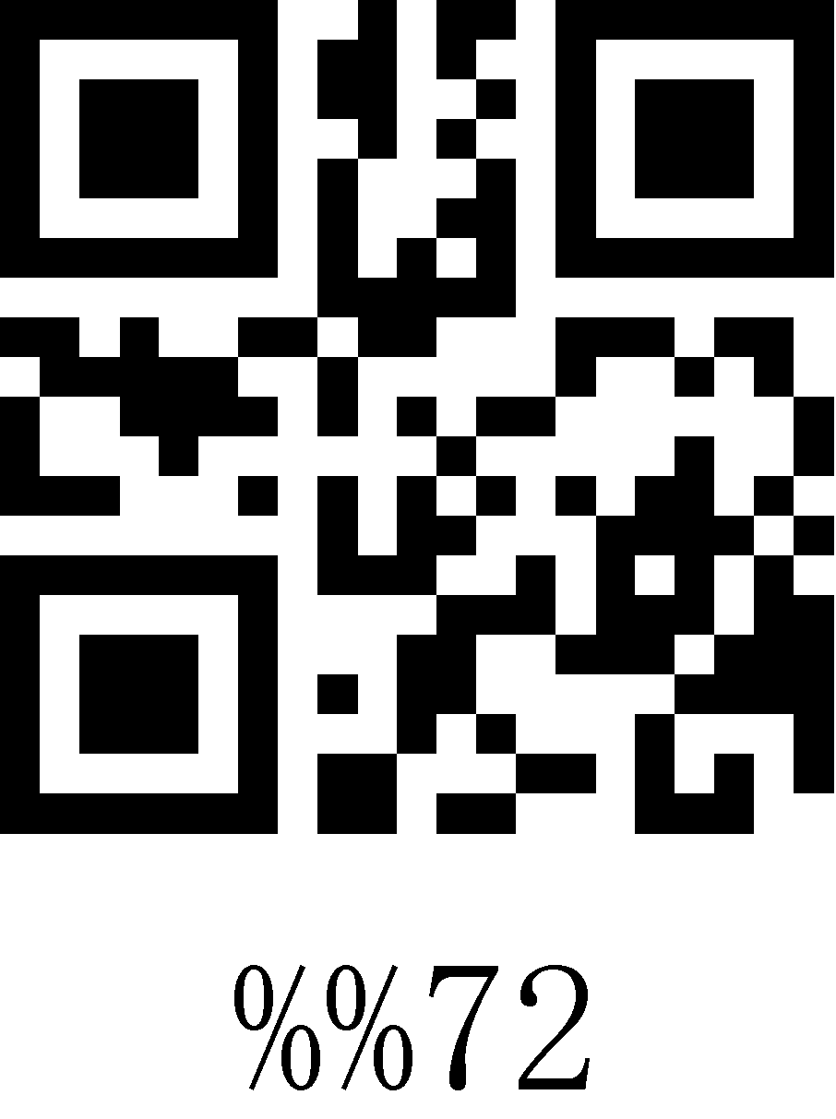
73 | 115 | s | 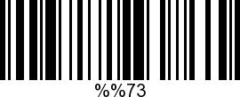 | 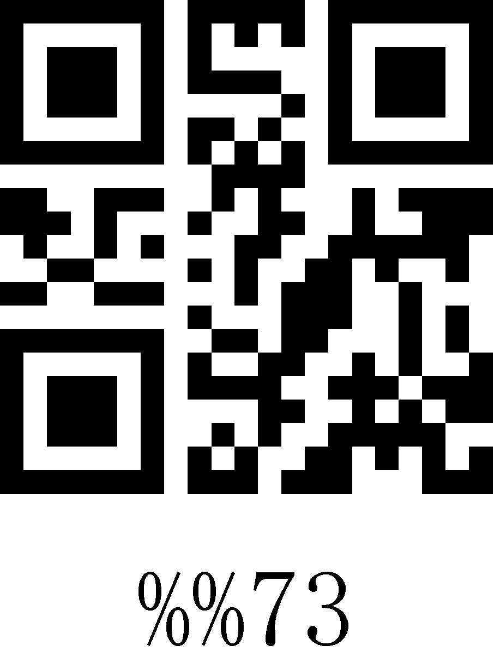
74 | 116 | t | 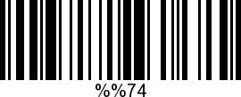 | 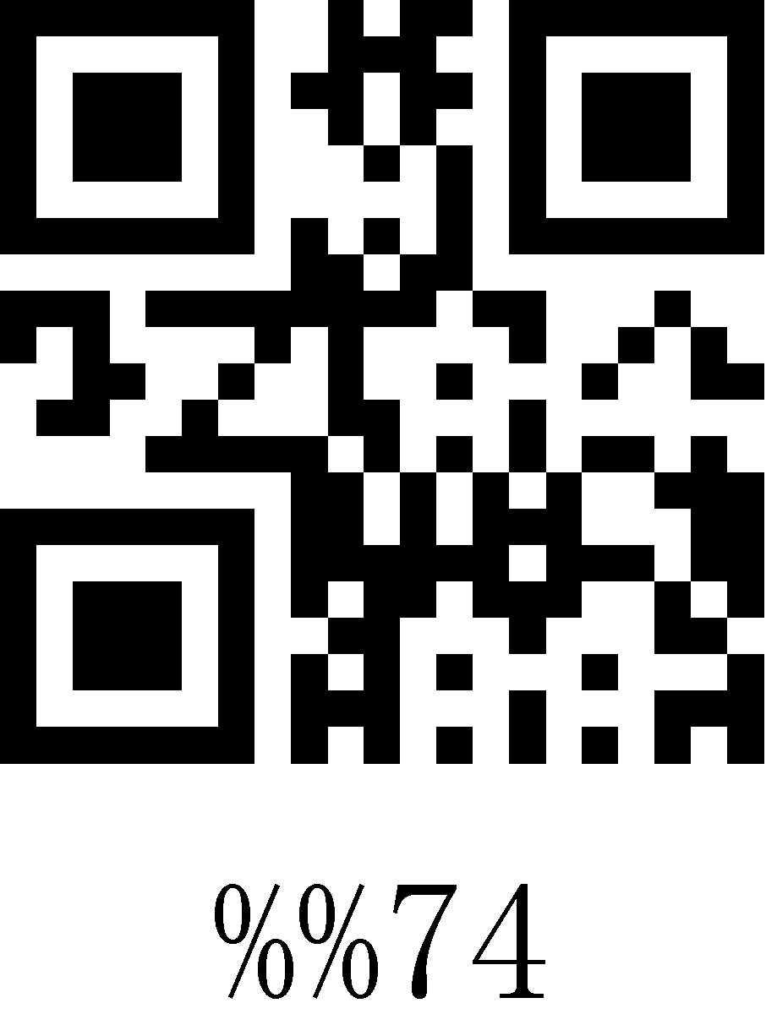
75 | 117 | u | 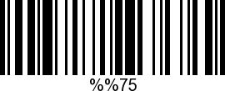 | 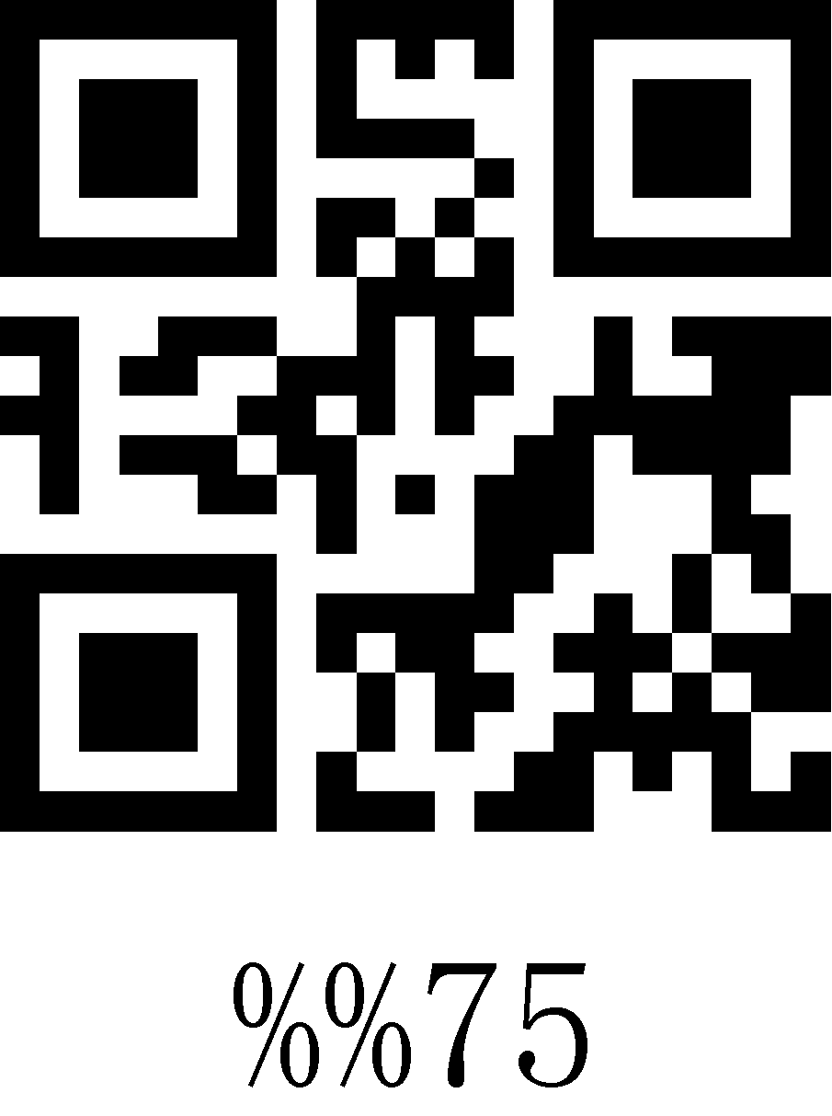
76 | 118 | v | 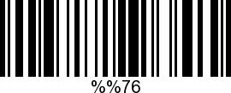 | 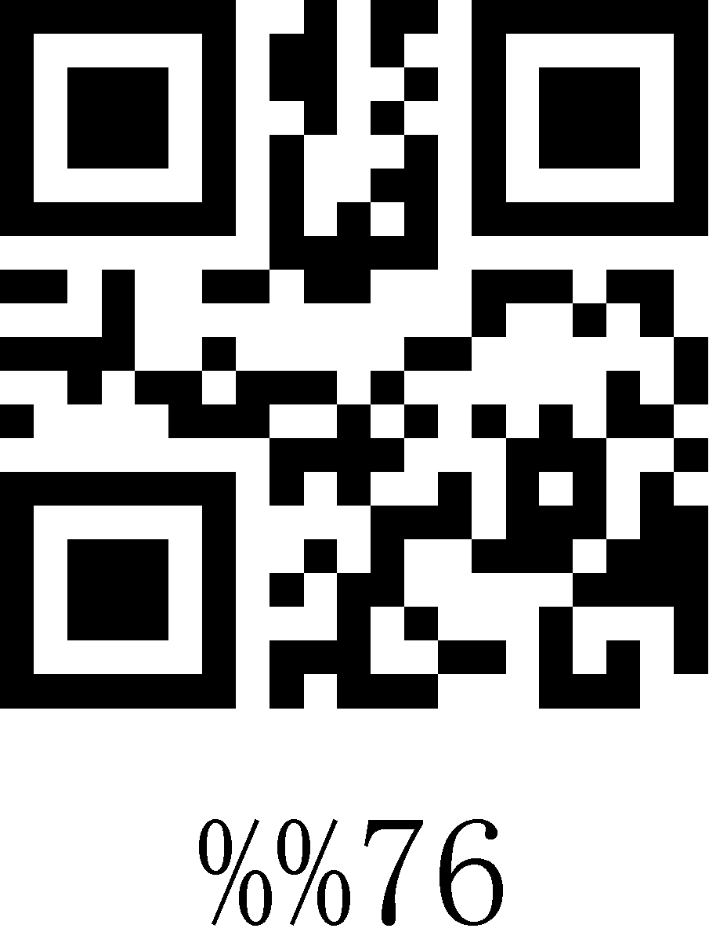
77 | 119 | w | 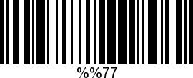 | 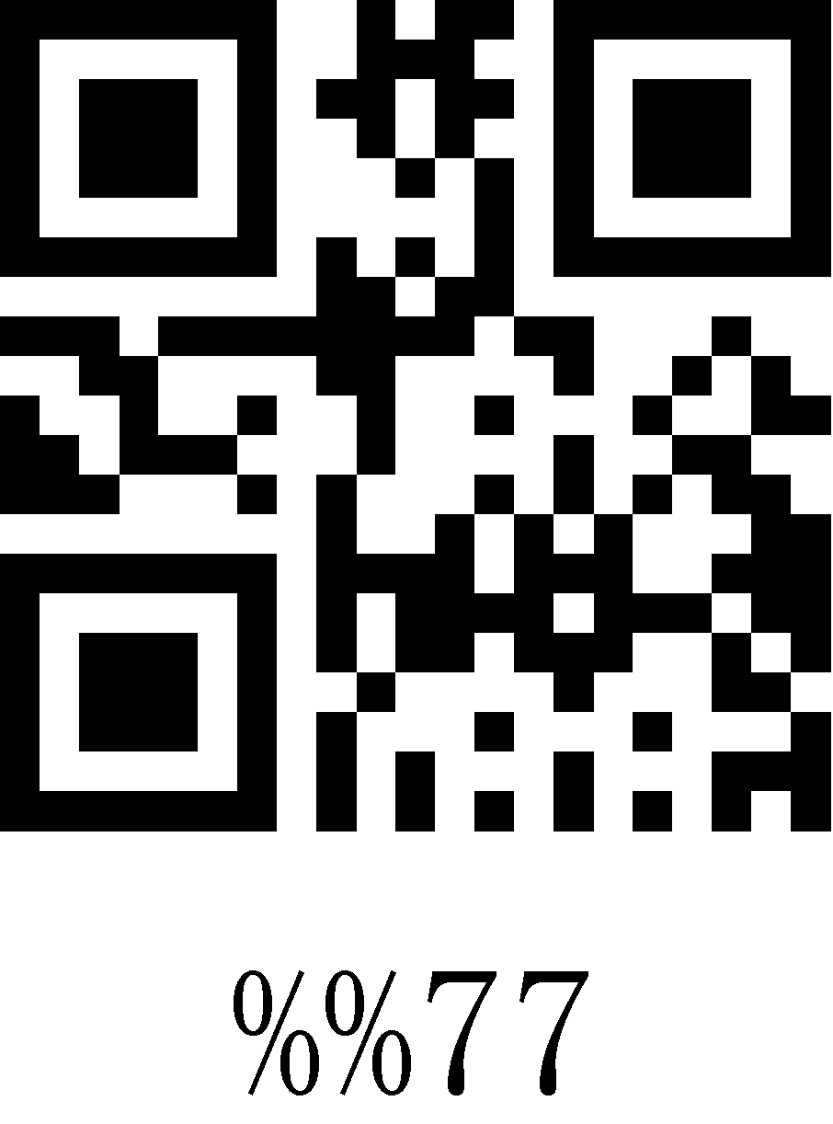
78 | 120 | x | 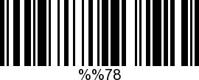 | 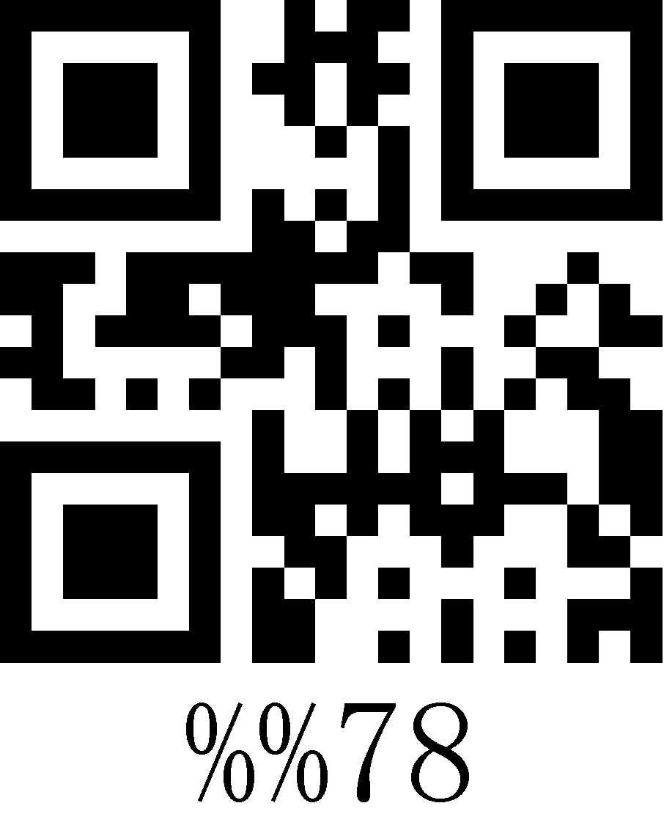
79 | 121 | y | 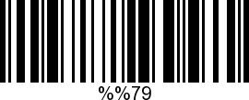 | 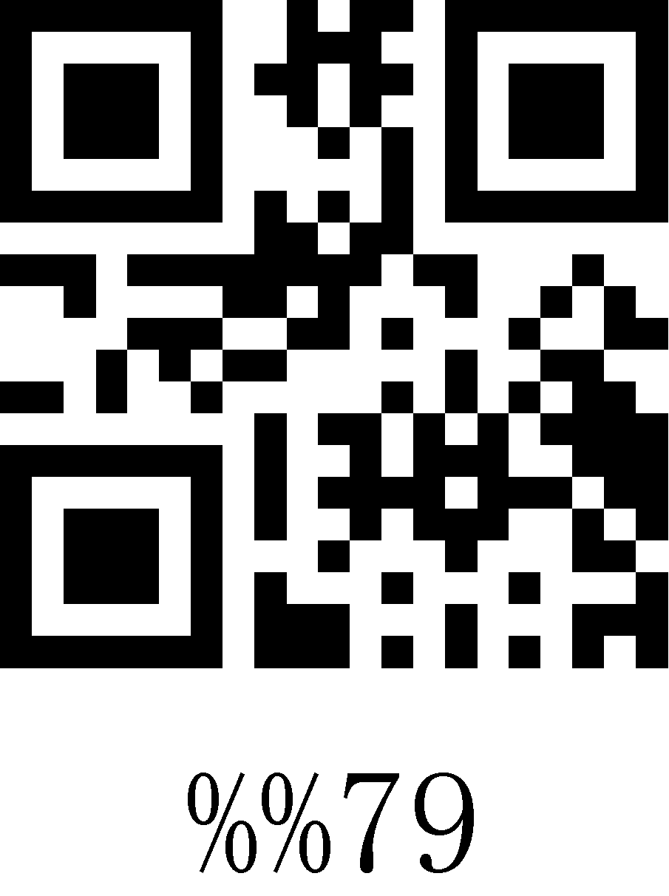
7A | 122 | z | 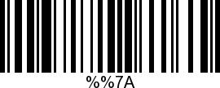 | 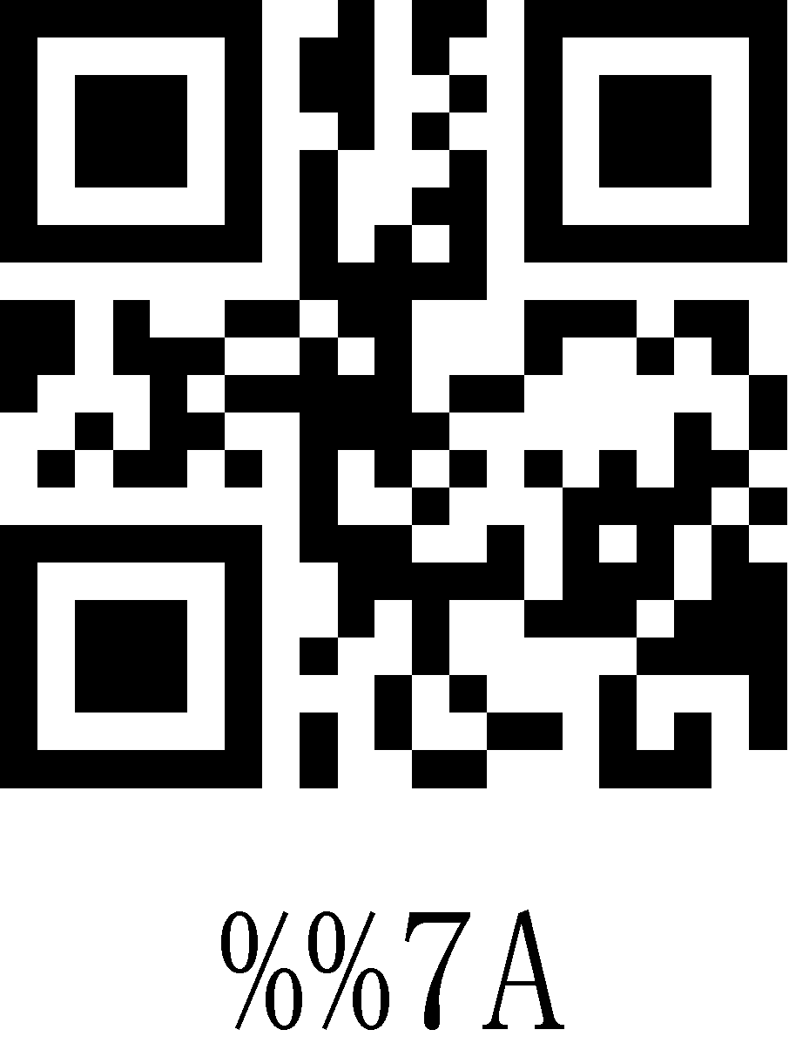
7B | 123 | { | 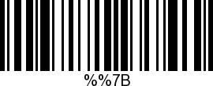 | 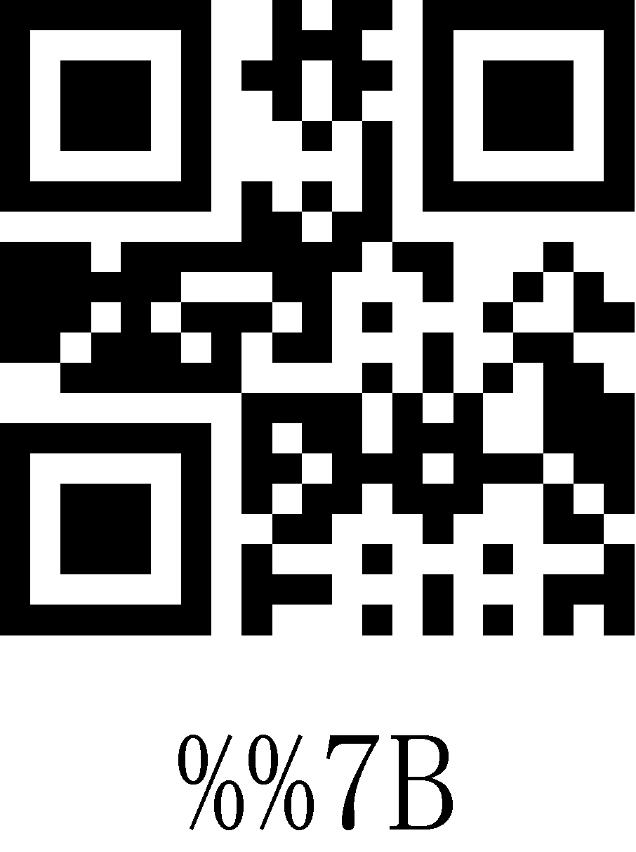
7C | 124 | | | 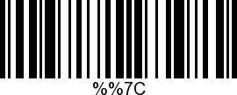 | 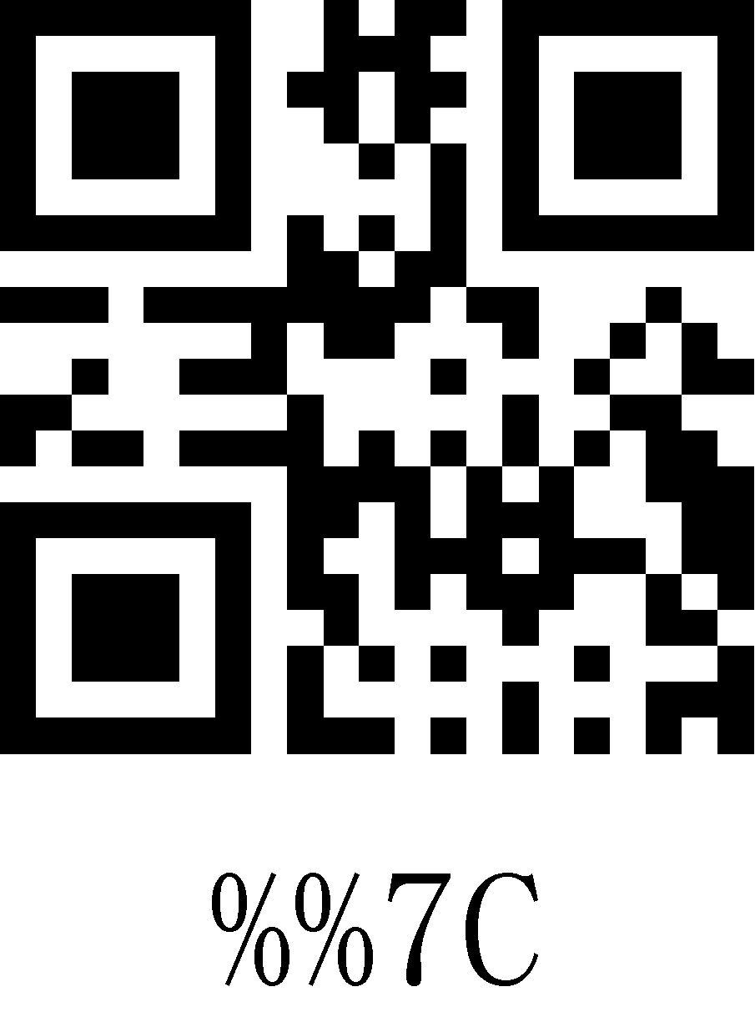
7D | 125 | } | 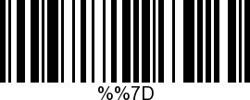 | 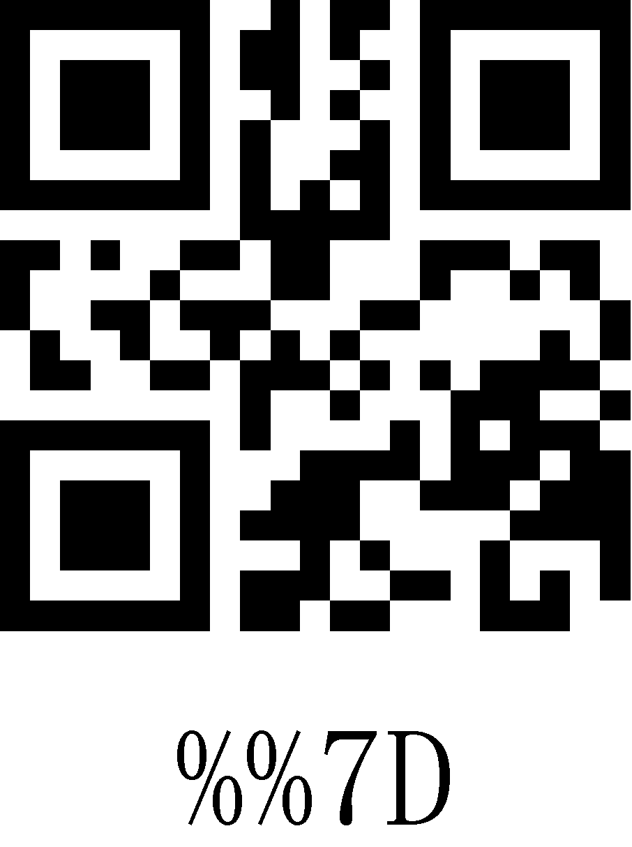
7E | 126 | ~ | 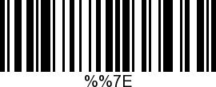 | 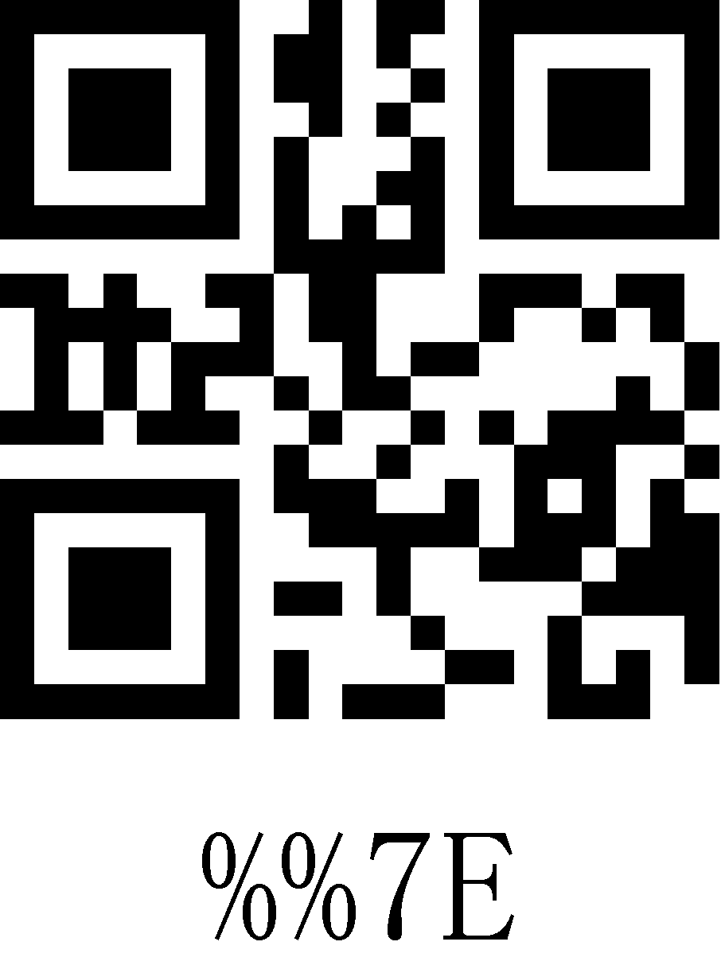
7F | 127 | DEL | 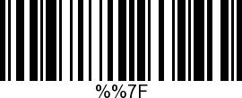 | 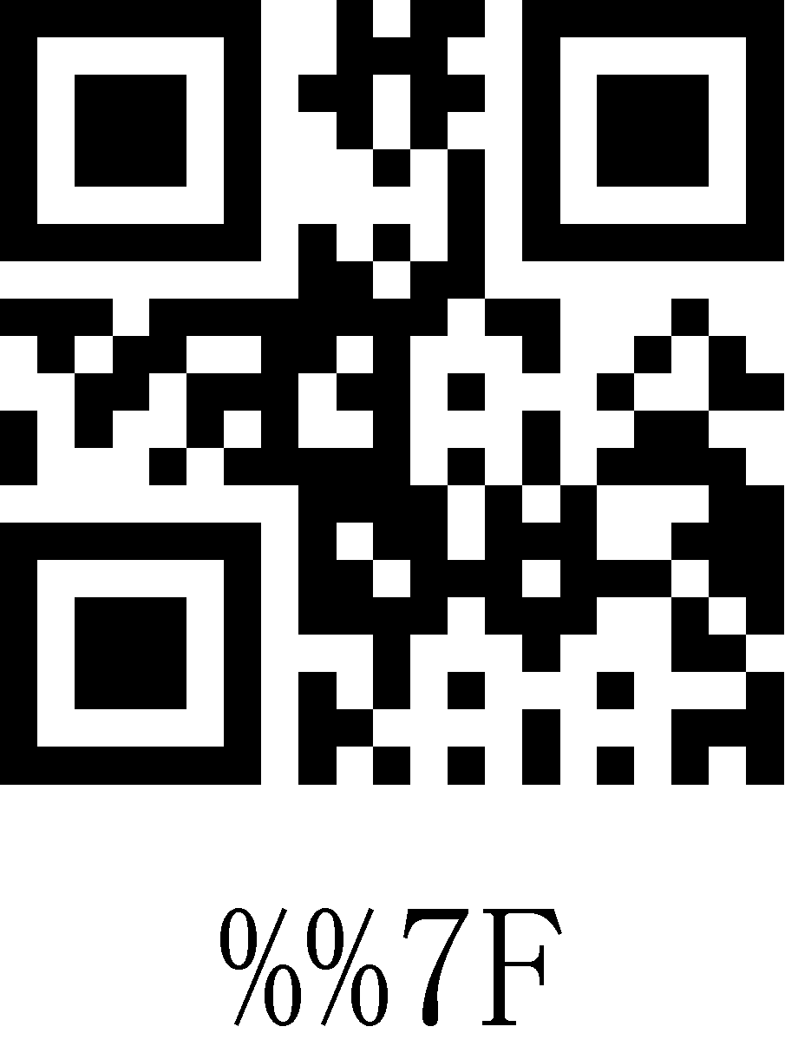
C7 | 199 | Ç | 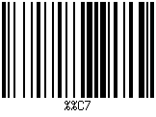 | 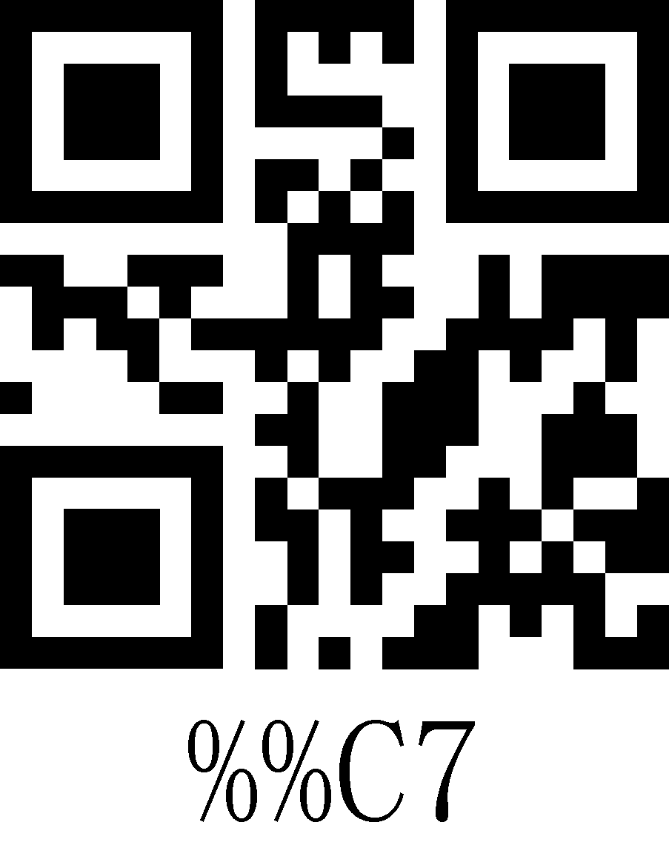
E7 | 231 | ç | 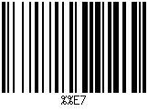 | 