M6 Cash Drawer RJ11 Interface Description

The M6 motherboard has an RJ11 interface, mainly for connecting the cash drawer. The cash drawer can be directly connected to the interface below the motherboard.
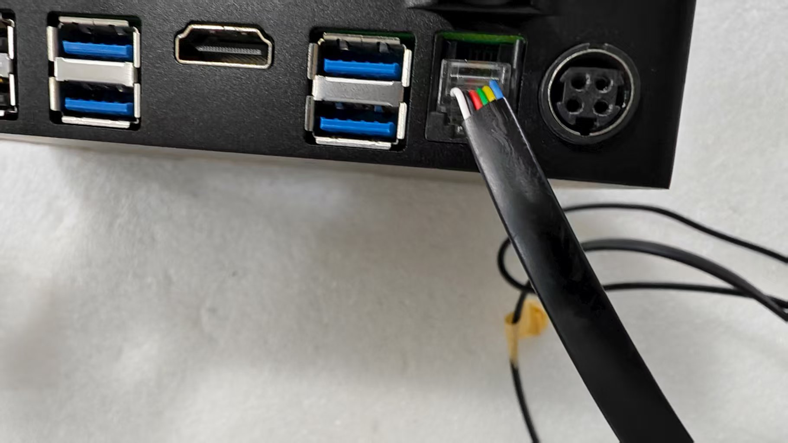
The following is the interface definition of the cash drawer:
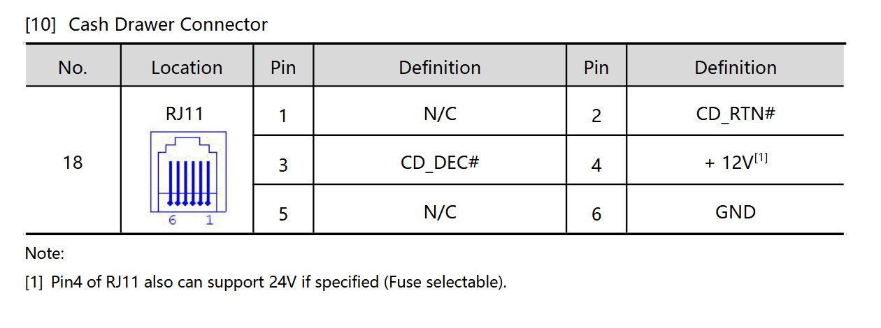
After connecting the cash drawer, the following software can be used for testing:
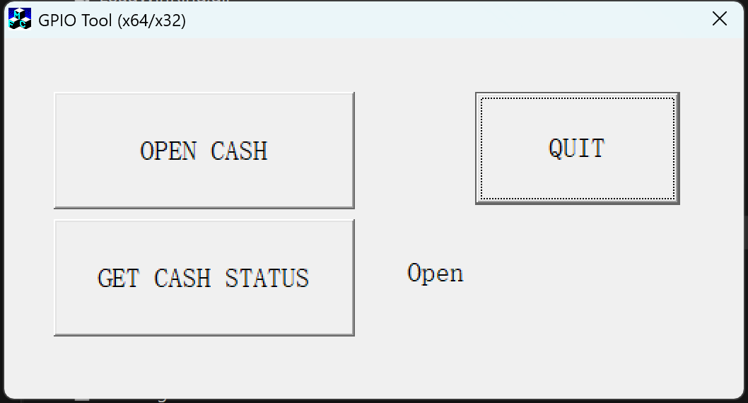
Press “Open Cash” button to open the cash drawer, after opening the cash drawer manually close the cash box.

The “Get Cash STATUS” can query the status of the cash drawer, displaying "on" or "off" on the right side.

Press the “QUIT” button to close the the tool.

