Before upgrade, please download these 3 RARs to your computer from this link:

<https://we.tl/t-SB0UOdyPCf>

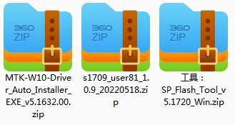

**Step-1**

1. Extract the content of 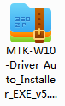, run “DriverInstall.exe” .
2. Once the driver is successfully installed, it may ask you to restart your computer.

**Step-2**

Extract the content of 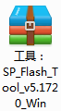, run “**flash_tool.exe**”

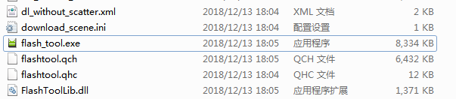

You will see a dialog box like this:

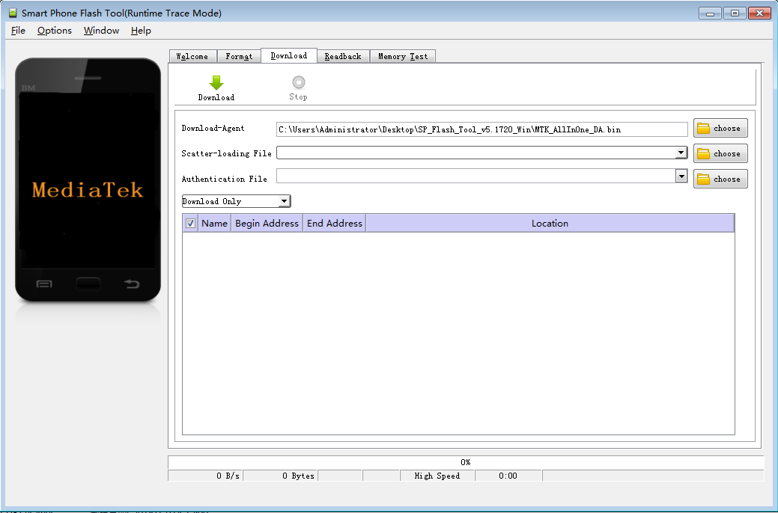

**Step-3**

1. Extract the content of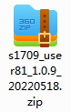 , among which you will find “**MT6580_Android_scatter.txt**”, we will need it later.

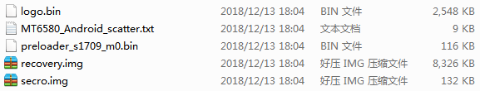

1. Back to the dialog box you opened in Step-2, click here:



1. Find “**MT6580_Android_scatter.txt**” and open it.

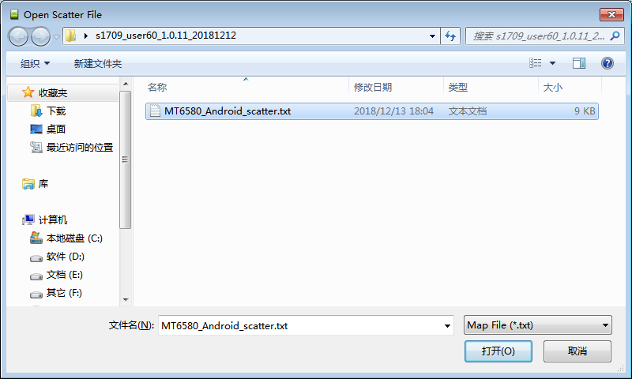

1. You will then see the dialog box change like this:

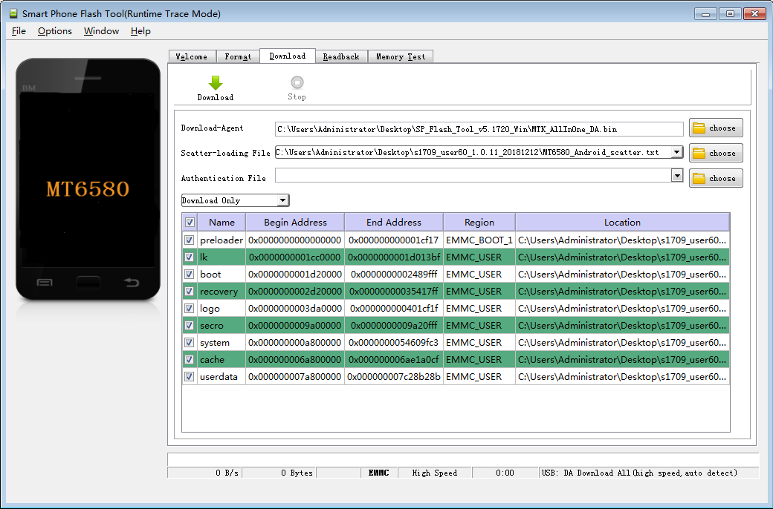

1. Select “Firmware Upgrade” here.

**Step-4:**

1. **Turn off** the AP02 which you are going to upgrade its firmware.
2. Connect a USB cord to your computer, but **DO NOT** connect this USB cord to AP02 now.
3. Back to this dialog, click “Download” first, then you can connect the USB cord to AP02.

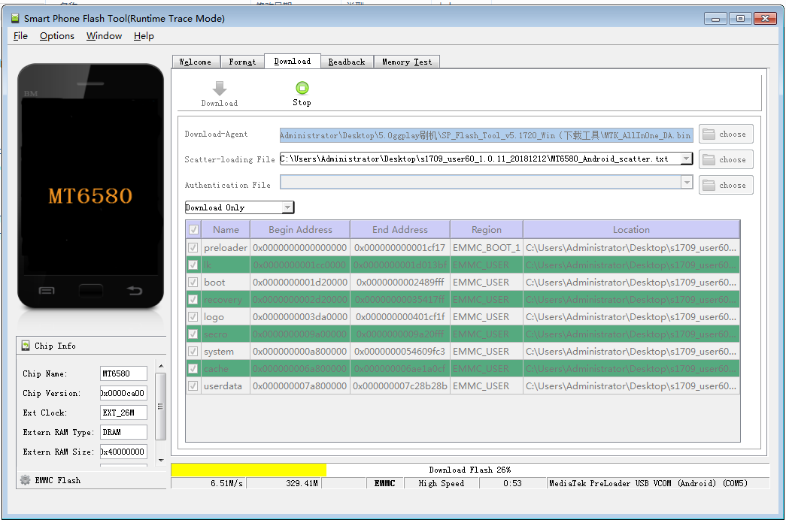

1. If the connection is good, you will see this yellow progress bar, which means the installation is running.
2. Once the installation is completed, you will see this notice:

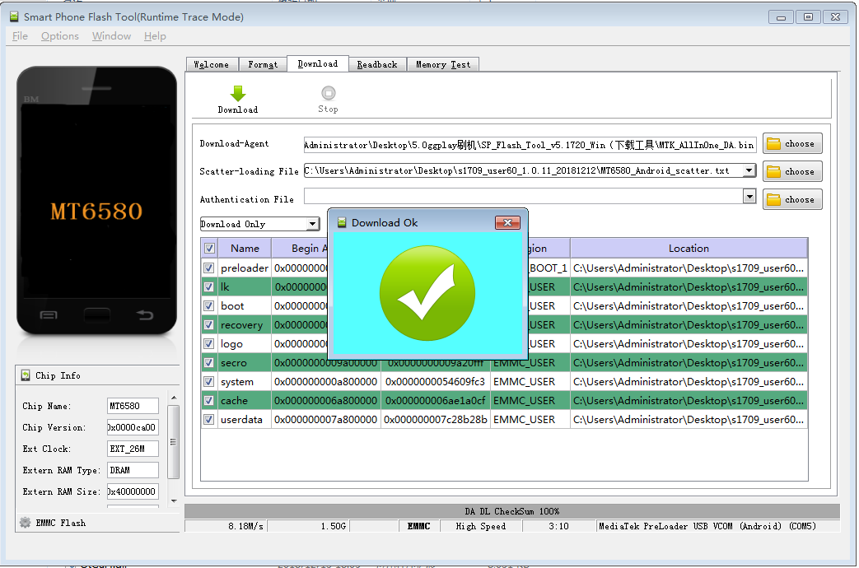

Now the firmware is successfully upgraded, you have only 2 final steps to make the device ready for use:

1. Turn on the device(you will find that the starting process is very long, this is a common phenomenon for all first-run devices), leave the device for 15 minutes or so.
2. **Restart** the device, leave it for about 10 minutes, then it is ready for use.