HOW TO USE RS-232 SIMULATOR PROGRAM
- Please first check ECR Comm. Type of PD-II.
- Please select TYPE-4 for ECR comm. Type.
ECR Comm. Type 을 TYPE-4 로 설정 합니다.
→ Please kindly refer the service manual.
- Please check RS-232C cable of the scale and PC whether they are connected properly.
→ Pin Connection (RS-232 Standard : 2,3,5 Pin)
→ For the detail information, please refer the service manual.
- Please execute “RS232C SIMULATOR” program.
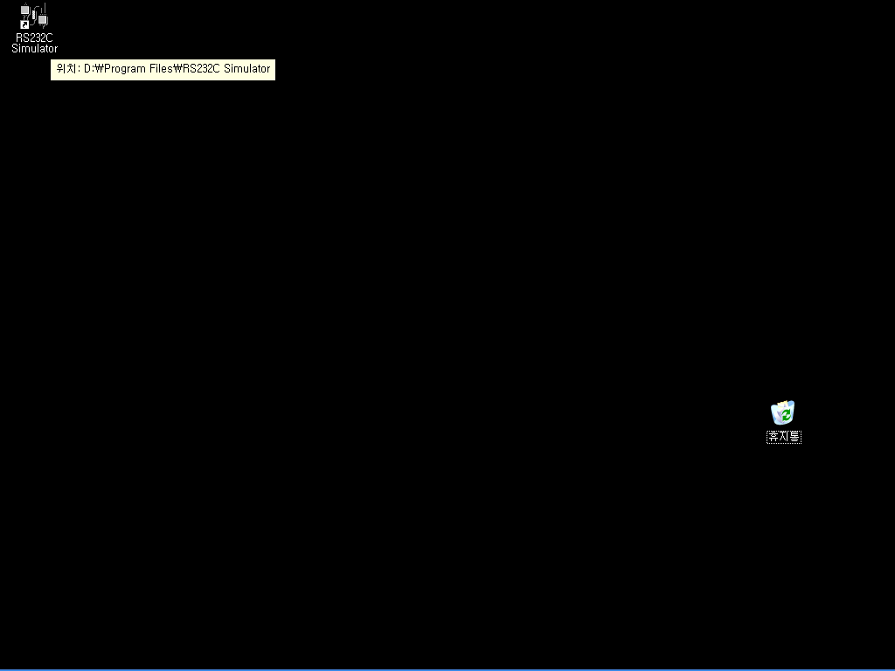
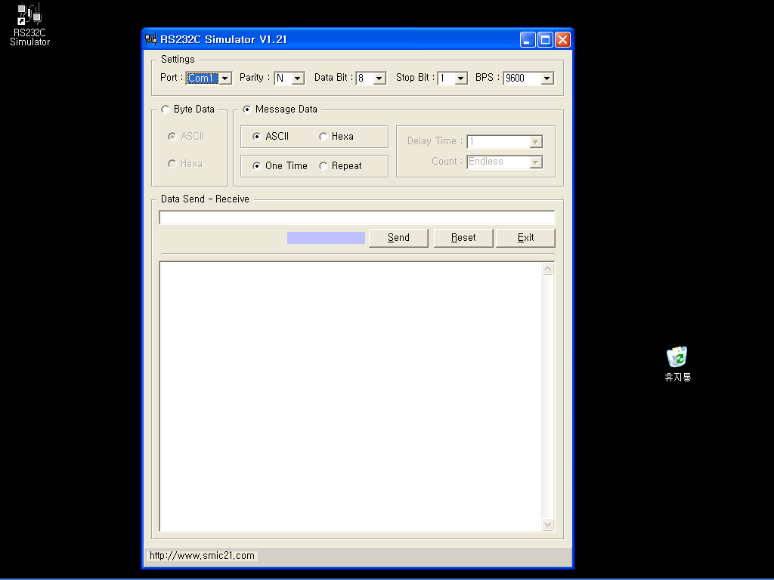
- Please check the PORT from the SETTING display.
- Please check “Parity, Data, Stop Bit”.
- Please check BPS.
➔The setting No. 6.7 of PD-II for Type-4 communication Settings value is as below;
Parity bit : Even Parity. → Setting value = E
Data bit : 7 data bit → Setting value = 7
Stop bit : 1 Stop bit → Setting value = 1
BPS : 9600 BPS → Setting value = 9600

- Please select “Message Data” and then, HEXA. The rest of the setting will remain the same as below;

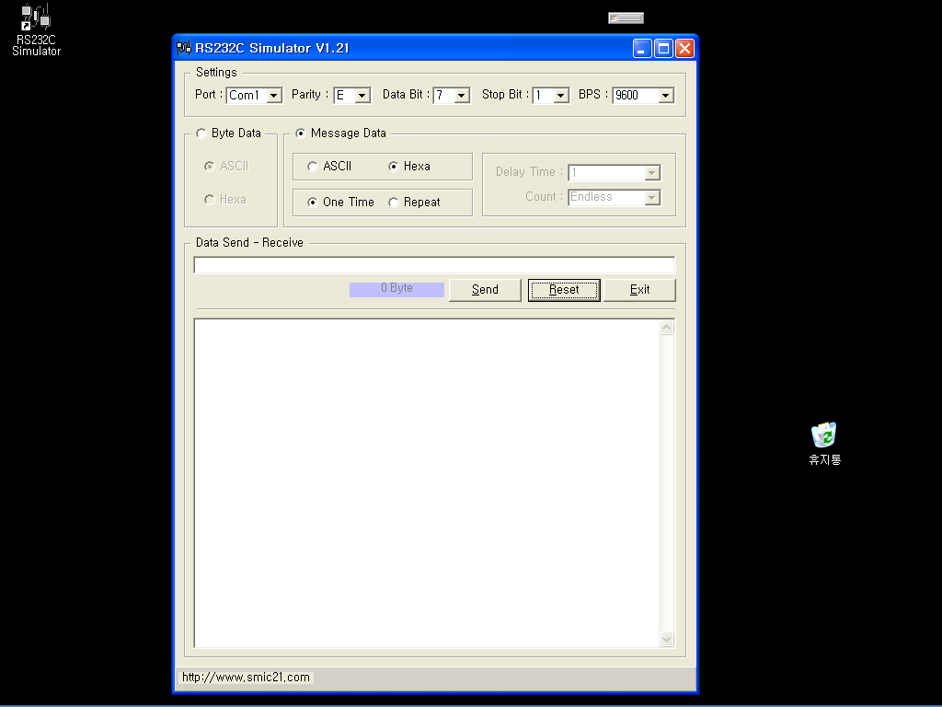

- In the DATA SEND, please put the value “57” which is the communication command value for the Type 4 and then, press ENTER KEY.
- In the DATA SEND, please input again “0D” and then, press “ENTER” KEY.

➔ “W” ASCII value = HEXA value is “57”
➔ “CR” ASCII = HEXA Value = “0D”

- If the display appear as below, it means that the scale and PC is communicating properly.
