Table of Contents
Chapter 1 IntroductioN 2
1.1 Features 2
1.2 Outline 3
Chapter 2 General specification 4
2.1 Tube Display 4
2.2 Electricity 5
2.3 Overall dimensions 6
2.4 Environment 6
2.5 Driver interface 6
2.6 DIP switch 7
2.6.1 DSP-800F dip switch setting 7
2.6.2 DSP-900 dip switch setting 9
Chapter 3 Interface 10
3.1 Interface 10
3.2 Interface conversion adapter 12
Chapter 4 Command Description 15
4.1 DSP-800F command set 15
4.1.1 DSP-800F command mode 15
4.1.2 EPSON command mode 17
4.1.3 UTC/S command mode 18
4.1.4 UTC/P command mode 18
4.1.5 AEDEX command mode 19
4.1.6 ULTIMATE command mode 19
4.1.7 DSP800 command mode 21
4.1.8 CD5220 command mode 22
4.2 DSP-900 command set 24
Chapter 5 character set 26
5.1 Control code set 26
5.2 U.S.A font set 26
5.3 International character selection 27
Chapter 6 INSTALLATION GUIDE 28

Chapter 1 Introduction

1.1 Features

■ The DSP-800F is a Vacuum Fluorescent Display which displays 20 columns and 2 lines, and the DSP-900 is a Vacuum Fluorescent Graphic Display which displays 192x16 dots.

■ Blue-green fluorescent color is easy on the eyes.

■ The display panel is movable so that it can be adjusted for the best viewing angle.

■ The customer display have different height by adjusting the support.

■ The interface of customer display is RS-232C, with baud rates from 1200 up to 9600 bps.

■ The customer display have provided the pass through function to reduce the cable connection.

■ The selftest function check the circuit board and performs each function for diagnostic purpose.

■ The user defined and international character sets are the standard of customer display.

■ The DSP-900 has support 512K bytes customer character ROM.

1.2 Outline

The customer display outline have included of three parts: the panel, the support, and the interface adapter

your VFD customer display should has following accessories:
Item | Part Number | Dimension (mm) | Qty | Description
1 | MP221R44VFD01 |  | 1 | Utility Diskette
2 | MP150CD200200 |  | 1 | User Menu
3 | MP01FIN5V1AK0* | 46 (W) x 71 (D) x 40 (H) | 1 | Adapter 5V/1A (UL, TUV,CSA)
4 | MP53TP308DNI0 |  | 4 | Screw P3x8 for Interface conv. unit
5 | MP53WF3R1FCL0 |  | 4 | Screw for F3.1x15 interface conv. unit
6 | SA02CD2002A00 | 224 (W) x 92(D) x 48(H) | 1 | Panel for DSP-800F
7 | MP44VFDSUPTS0 | 88 (H), 25 (dim.) | 1 | Support (short)
8 | MP44VFDSUPTS0 | 220 (H), 25 (dim.) | 1 | Support (long)
9 | MP07BASE00ICD | 182(W)x860(D)x3(H) | 1 | Metal parts
10 | SA01CD2002BV2 | 186(W)x950(D)x50(H) | 1 | Interface conversion adapter
11 | SA02CD9216A00 | 224 (W) x 92(D) x 48(H) | 1 | Panel for DSP-900

Chapter 2 General specification

2.1 Tube Display

(i) DSP-800F
Customer display | Vacuum Fluorescent Display  Blue green
Display pattern | 5 x 7 dot matrix
Brightness | 700 cd/m2
Character type | 95 Alphanumeric & 32 international characters
Character size | 6.4 mm (W) x 9.2 mm (H)
Character number | 20 x 2
Character pitch | Refer the figure 2.1

(ii) DSP-900
Customer display | Vacuum Fluorescent Graphic Display  Blue green
Display pattern | 8x8 or 16x16 dot matrix
Display Area (X x Y) | 140.6 x 35.0 mm
Number of dots (X x Y) | 192x16
Dot size (X x Y) | 0.4 x 0.4 mm
Luminance | 515 cd /m2
Character type | 95 Alphanumeric & 32 international characters (for 8x8 font)

2.2 Electricity

Power source | DC +5V
Power consumption | 15 watts maximum  3 watts average
Central control unit | CPU  ROM  RAM | 8031 BH  32K flash ROM  32K SRAM
Speed | CPU | 11.0592 MHz
Connector | 8 pins phone jack, D-SUB 9, and 25 pins (female) connector

2.3 Overall dimensions

Dimension (panel) | 225 mm (W) x 50 mm (D) x 92 mm (H)
Dimension (support) | (382/298/160/74) mm (H) x 33 dia. mm
Dimension (base) | 190 mm (W) x 96 mm (D) x 27 mm (H)
Viewing angle | Max. 45°
Horizontal rotation | Max. 340°
Weight | About 0.8 Kg

2.4 Environment

Operating temperature | +10℃ to +40℃
Storage temperature | -10℃to +50℃
Relative humidity | 0% to 90% RH

2.5 Driver interface

Driver interface | RS232

2.6 DIP switch settings

The default protocol is 9600 bps, non-parity, 8 data bits, 1 stop bit and with DTR/DSR control.

2.6.1 DSP-800F dip switch setting (Version 3.04)

(i) baud Rate select
SW number SW1 | Function description baud rate(bps)
OFF | 9600
ON | 4800

(ii) command type select
SW number |  |  | Function description | Software Defined
SW4 | SW3 | SW2 | Command type | Hex code
OFF | OFF | OFF | DSP-800F | 00
OFF | OFF | ON | EPSON Pos D101/D202 | 01
OFF | ON | OFF | UTC/S | 02
OFF | ON | ON | UTC/P | 03
ON | OFF | OFF | AEDEX | 04
ON | OFF | ON | ULTIMATE | 05
ON | ON | OFF | DSP800 | 06
ON | ON | ON | CD5220 | 07
(iii) international character set
SW number |  |  |  | Function description
SW8 | SW7 | SW6 | SW5 | International character set(code 20H-7FH) | Code table  (code 80H-FFH)
OFF | OFF | OFF | OFF | U.S.A. | PC-437  (USA, standard European)
OFF | OFF | OFF | ON | FRANCE | PC-850(multilingual)
OFF | OFF | ON | OFF | GERMANY | PC-850(multilingual)
OFF | OFF | ON | ON | U.K. | PC-850(multilingual)
OFF | ON | OFF | OFF | DENMARK I | PC-850(multilingual)
OFF | ON | OFF | ON | SWEDEN | PC-850(multilingual)
OFF | ON | ON | OFF | ITALY | PC-850(multilingual)
OFF | ON | ON | ON | SPAIN | PC-850(multilingual)
ON | OFF | OFF | OFF | JAPAN | Katakana
ON | OFF | OFF | ON | NORWAY | PC-850(multilingual)
ON | OFF | ON | OFF | DENMARK II | PC-850(multilingual)
ON | OFF | ON | ON | SLAVONIC/RUSSIAN
ON | ON | OFF | OFF | Factory define
ON | ON | OFF | ON | Factory define
ON | ON | ON | OFF | Factory define
ON | ON | ON | ON | Factory define

2.6.2 DSP-900 dip switch setting

(i) baud Rate setting:
SW8 | SW7 | Baud rate(bps)
OFF* | OFF* | 9600
OFF | ON | 4800
ON | OFF | 2400
ON | ON | 1200

(ii) power on string function enable/disable:
SW2 | Function description
OFF* | Enable
ON | Disable

(iii) selftest function:
SW1 | Function description
OFF* | Disable
ON | Enable

Chapter 3 Interface

3.1 Interface

-Specifications

Data transmission method : Asynchronous Serial.
Handshaking : DTR/DSR control
Default protocol : 9600 bps, non-parity, 8 data bits, 1 stop bit.

-Interface connector (display panel side)
-RJ45 type 8 pin modular jack
-Pin assignment:

-Connector signal assignment
Pin no. |  | I/O | Description
1 | NC |  | No connection
2 | TXD | OUTPUT | Transmit data
3 | RXD | INPUT | Receive data
4 | DSR | INPUT | Data set ready (from the printer)
5 | GROUND
6 | DTR | OUTPUT | Data terminal ready (from the display)
7 | Vp |  | Power supply (+5V)
8 | Vgnd |  | Power supply (GND)

-Communication Protocol

1. Receive data.

The DTR signal is as follows:
[HIGH] This indicates that the display isn't ready to receive data.
It depend on the following conditions:

❑ The period from when the power is turned on to when the printer first becomes ready to receive data.
❑ When the remaining space in the receive buffer becomes 128 bytes or less.
❑ When the DTR signal of the printer is HIGH when the printer is selected using the command.

[LOW] This indicates that the display is ready to receive data.
It depend on the following conditions:

❑ When the printer first becomes ready to receive data after power-on.
❑ When the remaining space in the receive buffer becomes 128 bytes or more.
❑ When the DTR signal of the printer is LOW when the printer is selected using the command.

2. Transmit data.
After confirming the DSR is LOW, data is transmitted to printer.

3.2 Interface conversion adapter

The interface adapter section has connectors for the display panel, the printer, the power supply, and host computer. All the data transmitted from the host computer will be received by the display. If this data is for the display, the data will be processed, and if it is for the printer, it will be transmitted to the printer. Whether the data is for the display or the printer can be switched using the peripheral device selection command.

D-sub 25 pin connector signal assignment
Pin no. |  | I/O | Description
1 | N.C. |  | No Connection
2 | TXD | OUTPUT | Transmit Data
3 | RXD | INPUT | Receive Data from DB-9 Pin#2
4 | By Selection |  | N.C. or +5V
5 | GND |  | Power GND
6 | DSR | INPUT | Data Set Ready
7 | GND |  | Power GND
20 | DTR | OUTPUT | Data Terminal Ready from DB-9 Pin#4
22 | By Selection |  | N.C. or +5V

D-sub 9 pin connector signal assignment
Pin no. |  | I/O | Description
1 | NC |  | No Connection
2 | By Pass |  | Connect with DB-25 Pin#3
3 | RXD | INPUT | Receive Data
4 | By Pass |  | Connect with DB-25 Pin#20
5 | GND |  | Power GND
6 | DTR | OUTPUT | Data Terminal Ready
7 | By Selection |  | N.C. or +5V
8 | GND |  | Power GND
9 | By Selection |  | N.C. or +5V

D-sub 9 pin & 25 pine Power Source signal assignment

Jumper number | Description
1-2 | The +5V power source is assign to No. 9 of 9 pin D-sub
3-4 | The +5V power source is assign to No. 7 of 9 pin D-sub
5-6 | The +5V power source is assign to No. 22 of 25 pin D-sub
7-8 | The +5V power source is assign to No. 4 of 25 pin D-sub

The factory setting for this jumper is NULL, that means the customer display must have the +5V DC adapter. If there has any reason that user doesn't want to use the adapter, the engineer should set this jumper and provide the +5V power source to the correct pin number.

Chapter 4 Command Description

4.1 DSP-800F command set (Version 3.04)

4.1.1 DSP-800F command mode

Command | Code description(hex) | Function description
HT | 09 | Move cursor right(only valid in overwrite mode)
BS | 08 | Move cursor left(only valid in overwrite mode)
CR | 0D | Move cursor to left-most position(only valid in overwrite mode)
ESC @ | 1B 40 | Initialize customer display to initial state, clears display buffer, set display mode to shift and sets current display row to upper row
ESC U | 1B 55 | Select upper row as current row(initial default)
ESC D | 1B 44 | Select lower row as current row
ESC Aψ | 1B 41ψ | Sets customer display disable or enable  ψ- ’D’=disable,’E’=enable
ESC C r c | 1B 43 r c | Move cursor to specified position(only valid in overwrite mode)  -r Row( ‘U’=upper, ’D’=lower  -c Column number(range from 1~20)
ESC E rψ | 1B 45 rψ | Set special effect or display mode of specified row
ESC R n | 1B 52 n | Set international font sets  -n international fonts code
ESC = n | 1B 3D n n=’1’-’3’ | Select peripheral  -n ‘1’=printer only, ‘2’=customer display only, 3=both peripheral
ESC % n | 1B 25 n | Set font pattern  -n 0=normal font set, 1=user font set
ESC & n s [p] | 1b 46 n s data | Define user font pattern  -n code for first character  -s code for last character  -data 5 bytes required for each character

(REMARK)*Using commands “ESC E rψ”, the value of parameter
r 58=all rows
55=upper row
44=lower row
ψ special function, the value is one of
30= shift mode(default display mode)
31=rotation mode
32=blink mode
33=clear this row and switch to shift mode
34=overwrite mode
35=vertical mode

*Set international font set
n | International font set
30h  31h  32h  33h | U. S.A  GERMANY  FRANCE  JAPAN

4.1.2 EPSON command mode

Command | Code description(hex) | Function description
HT | 09 | Move cursor right
BS | 08 | Move cursor left
US LF | 1F 0A | Move cursor up
LF | 0A | Move cursor down
US CR | 1F 0D | Move cursor to right-most position
CR | 0D | Move cursor to left-most position
HOM | 0B | Move cursor to home position
US B | 1F 42 | Move cursor to bottom position
US $ x y | 1F 24 x y  x=1-20 y=01,02 | Move cursor to specified position
CLR | 0C | Clear display screen
CAN | 18 | Clear cursor line
US X n | 1F 58 n 01<=n<=04 | Brightness adjustment
US E n | 1F 45 n n=00-ff | Blink display screen
ESC @ | 1B 40 | Initialize display
ESC t n | 1B 74 n n=00-0f | Select character code table
ESC R n | 1B 52 n n=00-0f | Select international character set
US r n | 1F 72 n n=00,01 | Select/cancel reverse character
US MD1 | 1F 01 | Specify overwrite mode
US MD2 | 1F 02 | Specify vertical scroll mode
US MD3 | 1F 03 | Specify horizontal scroll mode
ESC & s n m [a(pl..pa)x m-n | 1B 26 1 n m [a(pl..pa)]x  m-n 20<n<=m<=ff | Define download characters  20<n<=m<=ff a=1-5 p1..p5=row1..row5
ESC ? n | 1B 3F n n= 20-7e | Cancel user-defined characters
ESC % n | 1B 25 n n=00,01 | Select/cancel download character set
ESC W n s x1y1x2y2 | 1b 57 n s x1 y1 x2 y2  n=1,2,3,4  s=0,1 | Specify/cancel the window range  1<=x1<=x2<=20  1<=y1<=y2<=2
ESC = n | 1B 3D n  n=1,31 ,select printer  n=2,32 ,select display | Select peripheral device
US : | 1F 3A | Set starting/ending position of macro definition
US ^ n m | 1F 5E n m  00<=(n,m)<=ff | Execute and quit macro
US @ | 1f 40 | Execute self-test
US T h m | 1f 54 h m  0<=h<=17 , 0<=m<=3b | Dispaly time
US U | 1F 55 | Display time continuously

4.1.3 UTC/S command mode(UTC standard mode)

Command | Code description(hex) | Function description
BS | 08 | Back space
HT | 09 | Horizontal tab
LF | 0A | Line feed
CR | 0D | Carriage return
DLE | 0F | Display position
DC1 | 11 | Over write display mode
DC2 | 12 | Vertical scroll mode
DC3 | 13 | Cursor on
DC4 | 14 | Cursor off
ESC d | 1B 64 | Change to UTC enhanced mode
US | 1F | Clear display

4.1.4 UTC/P command mode(UTC enhanced mode)

Command | Code description(hex) | Function description
ESC u A_.CR | 1B 75 41 [ data x 40]0D | Upper line display
ESC u B_.CR | 1B 75 42 [ data x 40]0D | Bottom line display
ESC u D_.CR | 1B 75 44 [ data x 40]0D | Upper line message scroll continuously
ESC u E_.CR | 1B 75 45 hh ‘:’ mm o 0D  h,m=’0’-‘9’ | Display time
ESC u F_.CR | 1B 75 46 [ data x 40]0D | Upper line message scroll once pass
ESC u H_.CR | 1B 75 48 n m 0D  20h<=n,m | Change attention code
ESC u 1_.CR | 1B 75 49 [ data x 40]0D | Two line display
ESC RS_.CR | 1B 0F 0D | Change to UTC standard mode

4.1.5 AEDEX command mode

Command | Code description(hex) | Function description
! # 1_.CR | 21 23 31 [ data x 40]0D | Upper line display
! # 2_.CR | 21 23 32 [ data x 40]0D | Bottom line display
! # 4_.CR | 21 23 34 [ data x 40]0D | Upper line message scroll continuously
! # 5_.CR | 21 23 35 hh ‘:’ mm o 0D  h,m=’0’-‘9’ | Display time
! # 6_.CR | 21 23 36 [ data x 40]0D | Upper line message scroll once pass
! # 8_.CR | 1B 75 48 n m 0D  20h<=n,m | Change attention code
! # 9_.CR | 21 23 39 [ data x 40]0D | Two line display

4.1.6 ULTIMATE command mode

(1) Line Feeding
Command | Code description(hex) | Function description
Cntrl | 0A | DC 1 Mode The cursor moves up or  down to another row staying on  the same line.  DC 2 Mode When the cursor is in  the second row the character  displayed there, is shifted up to  the first row, leaving the cursor  at its present position, then the  second row is cleared. When the  cursor is in the first row, the  cursor moves down to the second  row.
Cntrl M | 0D | The cursor moves to the least significant position of the same row.
Cntrl P | 10 | Instead of writing a character in the current position, the write-in starting position can be pointed by using this function. After writing 10HEX to prepare module for this command, another HEX byte is written to specify the position desired. A third byte reprexenting data is then sent.

ROW CHARACTER POSITION CHART (HEX)
1 | 00 | 01 | 02 | 03 | 04 | 05 | 06 | 07 | 08 | 09 | 0A | 0B | 0C | 0D | 0E | 0F | 10 | 11 | 12 | 13
2 | 14 | 15 | 16 | 17 | 18 | 19 | 1A | 1B | 1C | 1D | 1E | 1F | 20 | 21 | 22 | 23 | 24 | 25 | 26 | 27

(2) Normal Display Mode (DC 1)
Command | Code description(hex) | Function description
Cntrl Q | 11 | After writing a character, the cursor is shifted to the right one position automatically. When the cursor is on the most significant position of the first row. The cursor moves to the least significant position of the second row, when the cursor is on the most significant position of the second row, the cursor moves to the least significant position of the first row.

(3) Vertical Scroll Mode (DC 2)
Command | Code description(hex) | Function description
Cntrl R | 12 | After writing the characters up to the most significant position of the second row, all characters displayed in the second row are shifted to the upper row (first row), clearing the second row. When the power is turned on, this DC 2 Mode is selected, and will be held until another mode is selected.
Cntrl -- | 1F | Resetting the module. All characters displayed are erased, then the write-in position (cursor position) is set on the least.

4.1.7 DSP800 command mode

Command | Code description(hex) | Function description
EOT SOH I n ETB | 04 01 49 n 17 | Select international character set.
EOT SOH P n ETB | 04 01 50 n 17 n=31-58 | Move cursor to specified position
EOT SOH C n m ETB | 04 01 43 n m 17  31<=n<=m<=58 | Clear display range from n position to m position and move cursor to n position.
EOT SOH S n ETB | 04 01 53 n 17 n=31-33 | Save the current displaying data to n layer for demo display
EOT SOH D n m ETB | 04 01 44 n 17  n=31-37 m=31-33 | Display the saved data
EOT SOH A n ETB | 04 01 41 n 17 n=31-34 | Brightness adjustment
EOT SOH F n ETB | 04 01 46 n 17  00<=n<=FF | Blink display screen
EOT SOH = n ETB | 04 01 3D n 17  n=’1’,’2’ | Select peripheral device  N=’1,’, printer n=’2’, display
EOT SOH % ETB | 04 01 25 17 | Initialize display
EOT SOH @ ETB | 04 01 40 17 | Execute self-test

(REMARK)* About the command display the saved data
n | lay select | n | lay select | m | show mode
bit 0=1 | lay 1 | bit 3=1 | lay 4 | bit 0=1 | show mode 1
bit 1=1 | lay 2 | bit 4=0 | lay 5 | bit 1=1 | show mode 2
bit 2=1 | lay 3

4.1.8 CD5220 command mode

Command | Code description(hex) | Function description
ESC DC1 | 1B 11 | Overwrite mode
ESC DC2 | 1B 12 | Vertical scroll mode
ESC DC3 | 1B 13 | Horizontal scroll mode
ESC Q A CR | 1B 51 41 [N]x20 0D | Set the string display mode, write string to upper line
ESC Q B CR | 1B 51 42 [N]x20 0D | Set the string display mode, write string to lower line
ESC Q D CR | 1B 51 44 [N]xm20 0D  m<40 | Upper line message scroll continuously
ESC [ D | 1B 5B 44 | Move cursor left
BS | 08 | Move cursor left
ESC [ C | 1B 5B 43 | Move cursor right
HT | 09 | Move cursor right
ESC [ A | 1B 5B 41 | Move cursor up
ESC [ B | 1B 5B 42 | Move cursor down
LF | 0A | Move cursor down
ESD [ H | 1B 5B 48 | Move cursor to home position
HOM | 0B | Move cursor to home position
ESC [ L | 1B 5B 4C | Move cursor to left-most position
CR | 0D | Move cursor to left-most position
ESC [ R | 1B 5B 52 | Move cursor to right-most position
ESC [ K | 1B 5B 4B | Move cursor to bottom position
ESC l x y | 1B 6C x y  1<=x<=20, y=1,2 | Move cursor to specified position
ESC @ | 1B 40 | Initialize display
ESC W s x1 x2 y | 1B 57 1 x1 x2 y  1<=x1<=x2<=20 y=1,2 | Set or cancel the window range at horizontal scroll mode
CLR | 0C | clear display screen, and clear string mode
CAN | 18 | clear cursor line, and clear string mode
ESC * n | 1B 2A n 1<=n<=4 | brightness adjustment
ESC & s n m  [a(pl..pa)]x (m-n+1) | 1b 26 1 n m  [a(pl..pa)]x (m-n+1)  20<=n<=m<=7F | define download characters  a=1-5  p1..p5=row1..row5

ESC ? n | 1B 3F n 20<=n<=7F | delete download characters
ESC % n | 1B 25 n n=1,0 | select/cancel download character set.
ESC _ n | 1B 5F n n=1,0 | set cursor ON/OFF
ESC f n | 1B 66 n | select international fonts set
ESC c n | 1B 63 n | select fonts, ASCII code or JIS code
ESC = n | 1B 3D n  n=1,2,3,31,32,33 | select peripheral device, Display or Printer

(REMARK)
*While using command “ESC QA” or “ESC QB”, these two commands could using combine with terminal printer—TP 2688 or TP3688
* If using commands “ESC QA” or “ESC QB”, others commands cannot be used except using command “CLR” or “CAN” to change operating mode.
* If using commands “ESC QD”, upper line message move continuously, till receive a new command, and clear upper line and move cursor to upper line left-most position.
Set international font set Select code Table
n | International font set | n | International font set |  | n | International
A  G  I  J  U  F  S | U. S.A  GERMANY  ITALY  JAPAN  U. K.  FRANCE  SPAIN | N  W  D  E  L  R | NORWAY  SWEDEN  DENMARK I  DENMARK II  SLAVONIC  RUSSIA  Reserved |  | A  J  R  L | compliance with ASCII code  compliance with JIS cocde  compliance with RUSSIA code  compliance with SLAVONIC code

4.2 DSP-900 command set

Command | Code description(hex) | Function description
HT | 09 | Move cursor right(only valid in overwrite mode)
BS | 08 | Move cursor left(only valid in overwrite mode)
CR | 0D | Move cursor to left-most position(only valid in overwrite mode)
ESC @ | 1B 40 | Initialize customer display to initial state, clears display buffer, set display mode to shift and sets current display row to upper row
ESC U | 1B 55 | Select upper row as current row(initial default)
ESC D | 1B 44 | Select lower row as current row
ESC Aψ | 1B 41ψ | Sets customer display disable or enable  ψ- ’D’=disable, ’E’=enable
ESC C r c | 1B 43 r c | Move cursor to specified position(only valid in overwrite mode)  -r Row( ‘U’=upper,’ D’=lower  -c Column number(range from 1~20)
ESC E rψ | 1B 45 rψ | Set special effect or display mode of specified row
ESC R n | 1B 52 n | Set international font sets  -n international fonts code
ESC = n | 1B 3D n n=’1’-’3’ | Select peripheral  -n ‘1’=printer only,  ‘2’=customer display only  ‘3’=both peripheral
ESC % n | 1B 25 n | Set font pattern  -n 0=normal font set  1=user font set  2=chinese character font
ESC & n s [p] | 1b 46 n s data | Define user font pattern  -n code for first character  -s code for last character  -data 5 bytes required for each character
ESC * x y w h [b] | 1b 2A x y w h [b] | -x Initial upper left x position(0 to  191)  -y Initial upper left x position(0/1)  -w bit image width (1 to 192)  -h bit image height(1/2)  -[b] bit image string

(REMARK)
*Display Chinese font
step 1: send “ESC % 2” to let DSP-900 enter Chinese mode
step 2: send any ‘BIG 5’ code to DSP-900 for Chinese character display

*Using commands “ESC E rψ”, the value of parameter
r 58=all rows
55=upper row
44=lower row
-ψ special function, the value is one of
30=shift mode(default display mode)
31=rotation mode
32=blink mode
33=clear this row and switch to shift mode
34=overwrite mode
35=vertical mode

*Set international font set
n | International font set
30h  31h  32h  33h | W. S.A  GERMANY  FRANCE  JAPAN
Chapter 5 Character Set

(1)Control code set

HEX | CODE | HEX | CODE
00H | NULL | 10H | DLE
01H | MD1 | 11H | DC1
02H | MD2 | 12H | DC2
03H | MD3 | 13H | DC3
04H | MD4 | 14H | DC4
05H | MD5 | 15H
06H | MD6 | 16H
07H | MD7 | 17H
08H | BS,MD8 | 18H | CAN
09H | HT | 19H
0AH | LF | 1AH
0BH | HOM | 1BH | ESC
0CH | CLR | 1CH
0DH | CR | 1DH
0EH | SLE1 | 1EH | SF1
0FH | RS,SLE2 | 1EH | US,SF2

(2)U.S.A font set

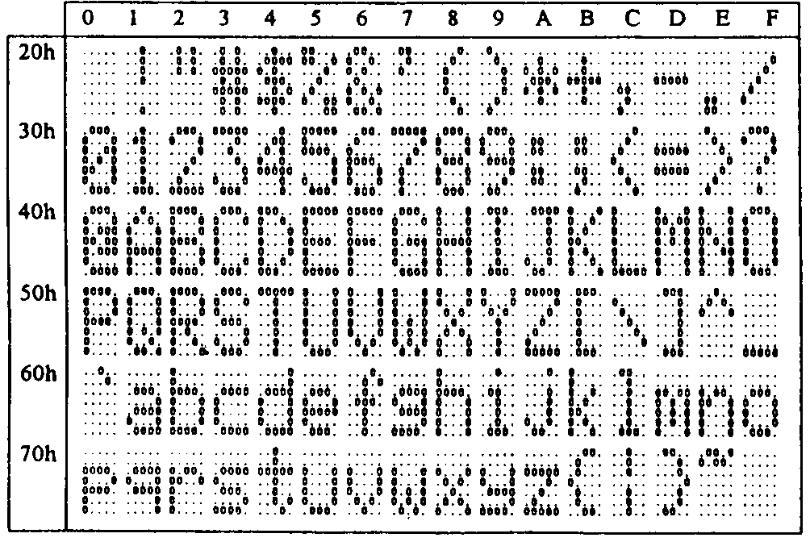

(3)International character selection( Indicated character selection by dip switch or command )

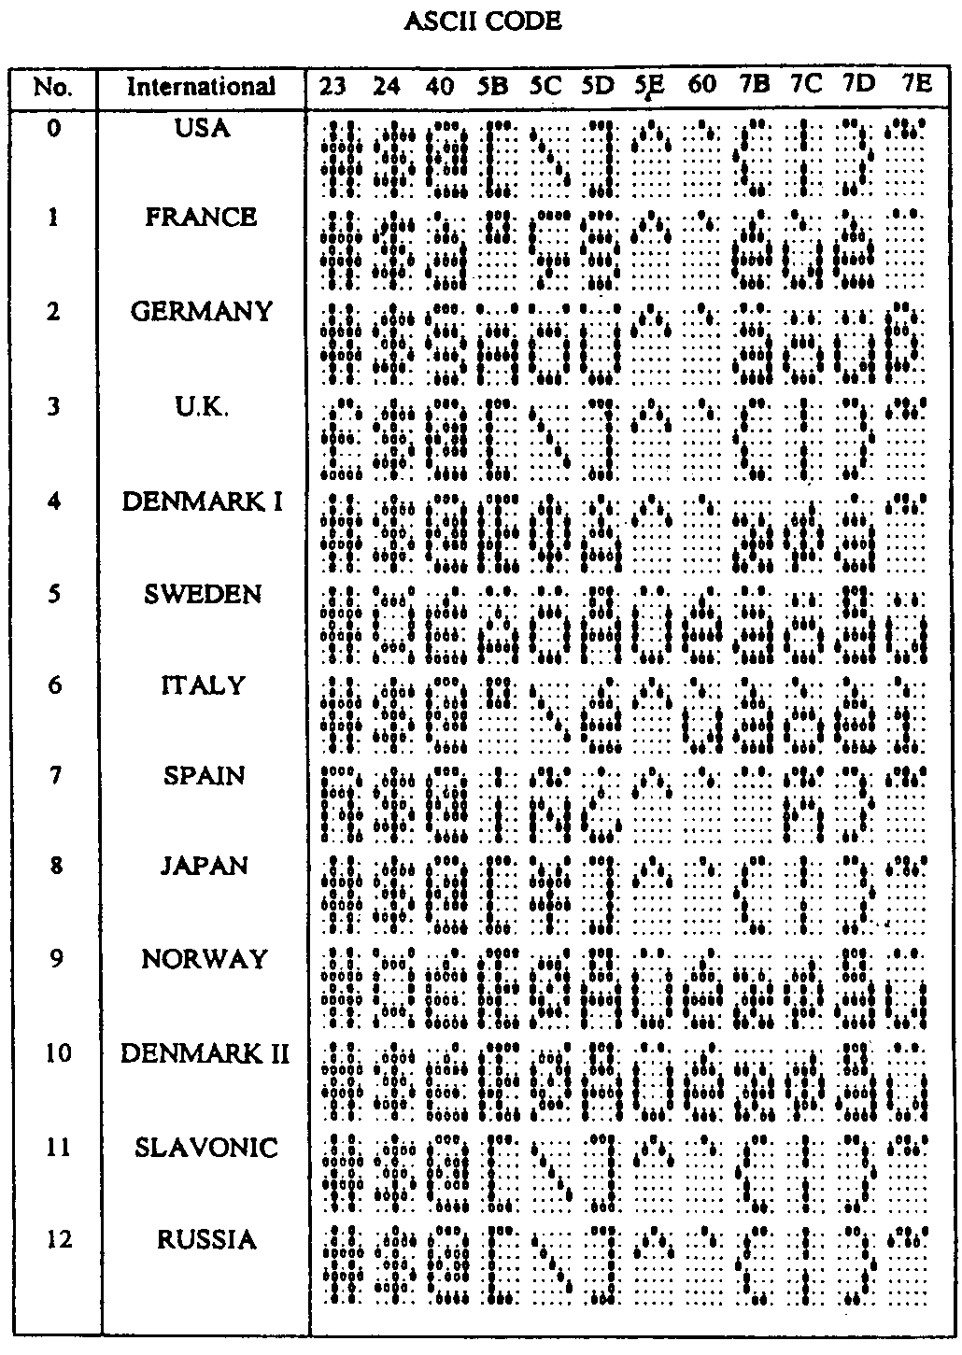

CHAPTER 6 INSTALLATION GUIDE

