DIBALSCOPDEMOC# MANUAL

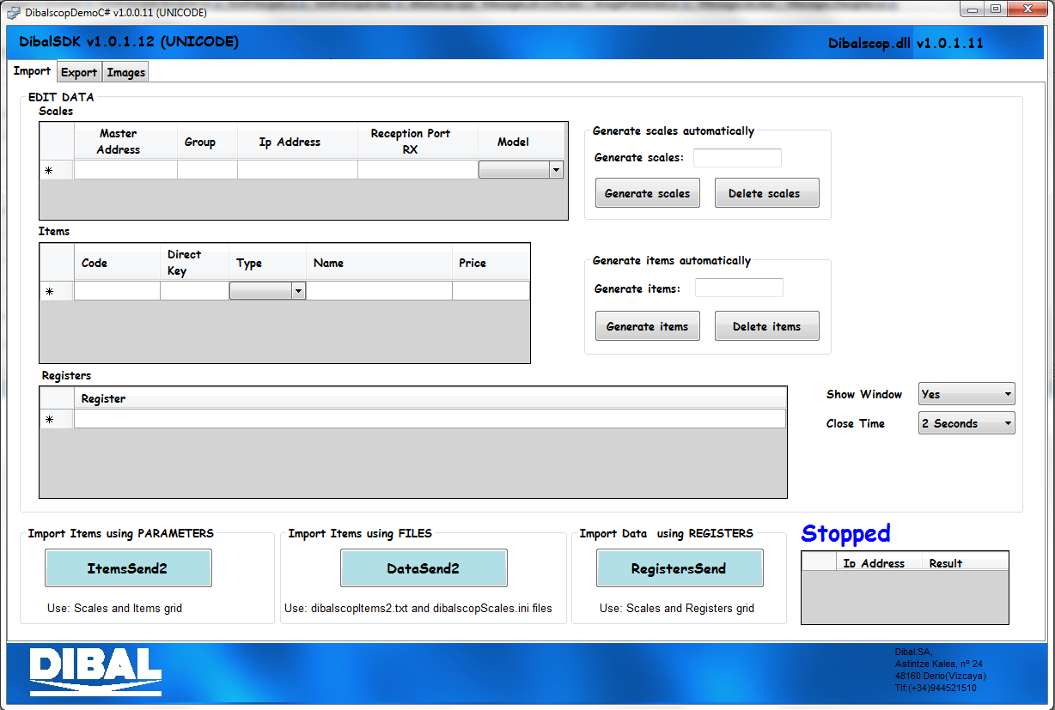



INDEX
1- INTRODUCTION 3
2- IMPORT 4
2.1 ItemsSend2 5
2.2 DataSend2 6
2.3 RegistersSend 6
3- EXPORT 7
4- IMAGES 9
4.1 ImageFileGenerator 10
4.2 Send Images 11

INTRODUCTION

This is a manual which explains the functionalities of the program DibalscopDemo. It is an application that does basic operations. Its purpose is to show the user a way of using/calling the functions of Dibalscop.dll and DibalImage.dll libraries.

There are two different version of DibalSDK:

- DibalSDK: This version manages the data with ANSI/ASCII encoding. This means that the string contains narrow characters (1 byte).
- DIbalSDK_UNICODE: This version manages the data with UNICODE encoding. This means that the string contains wide characters (2 bytes). If CHINESE characters are used it is necessary to use this version.

If someone wants to add those functions to their own program, they should read the manuals of Dibalscop.dll and DibalImage.dll that provide further information of the functions.

The program includes three tabs:

- Import: It must used to send information to the scales.
- Export: It must used to received information of the scales
- Image: It must used to manage images (Conversion and sending)

IMPORT

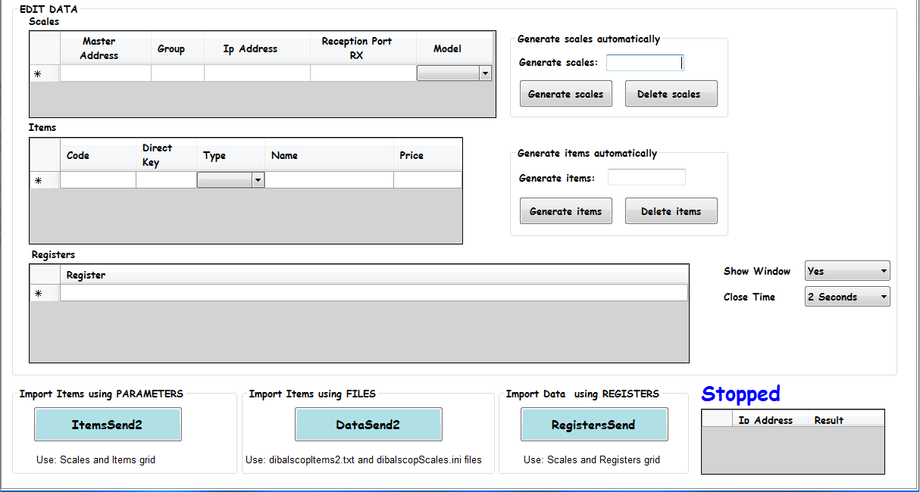

In this tab three different operations are available:

- ItemsSend2: This function sends item information to the scale. The information is obtained from the scales’ grid and items’ grid. The button is named like this because it uses ItemsSend2 function. (See Dibalscop manual for further information about this function).
- DataSend2: This function sends item information to the scale. The information is obtained from the files dibalscopItems2.txt and dibalscopScales.ini. It uses DataSend2 function. (See Dibalscop manual for further information about this function).
- RegistersSend: This function sends registers to the scale. The registers are obtained from the Registers’ grid. It uses RegistersSend function. (See Dibalscop manual for further information about this function).

ItemsSend2

If we want to use ItemsSend2, first it is necessary to fill the grid of scales and items.

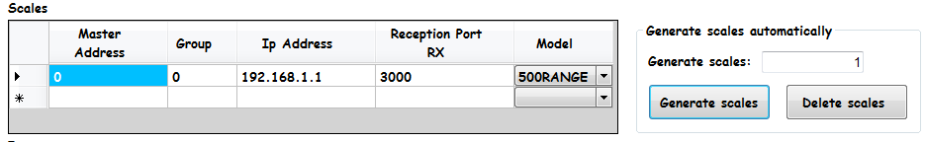

If we click in Generate Scales a number of rows of scales will be generated automatically. The values inside each row are completed by default.

We must to create as many rows as scales we want to communicate with.

The fields are the following:

- Master Address: A number(0-99) to define the Master Address of the scale
- Group: A number (0-99) to define the group of the scale
- IP Address: IP address of the scale(IPv4)
- Reception Port RX: The reception port(RX) of the scale, The default value is 3000.
- Model: A combo-box to define the model of the scale. Two possibilites: “500RANGE” or “LSERIES”

Also it is necessary to fill the items’ grid. There must be as many rows as items we want to send to the scale/s.

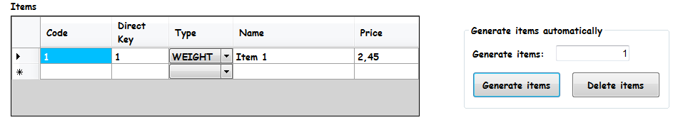

The fields are the following:

- Code: Code of the item(0-999999)
- Direct Key: Direct key assigned to the article(0-999)
- Type: Type of the item. Weight or Unit.
- Name: Name of the item. The maximum length is 20 characters(36 for China)
- Price: Price of the item.

We must also select if we want the program to show or not a communication status window. If we set the window to be visible we must set the time to close the window after the process ends.

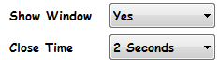

- Show Window: To make the window visible or not
- Close Time: The time to maintain the window visible after communication ends.

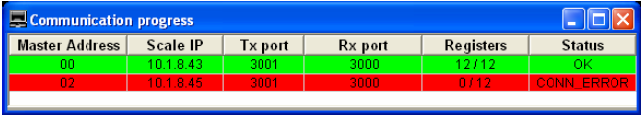

Once the data is filled in the grids we can call ItemsSend2 button. The result of the operation will be shown the result grid.

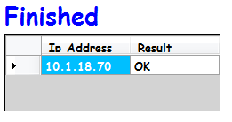

DataSend2

To use DataSend2 it is not necessary to fill any grid. However the information is picket from two files:

- dibalscopScales.ini: It is the file to define the information of the scales to communicate with. The structure of this file is defined in Dibalscop manual. There is an example of this file in Example Files.
- dibalscopItems2.txt: It is the file to include the items to send to the scales. The structure of this file is defined in Dibalscop manual. There is an example of this file in Example Files.

Both files must be located in the folder where the executable files is.

It is recommendable to read Dibalscop manual before using this feature.

The setting of the communication windows is like ItemsSend2 and after the process ends the Result grid is updated.

RegistersSend

This feature is to send Dibal registers. The structure of each Dibal register is contained in the Communication registers Database.

In order to use this functionality the user must use the scales’ grid and registers’ grid. The user must include the scales’ info in the same way as ItemsSen2.

In the registers’ grid the user must add the registers to send without including Master Address at the beginning. An example:

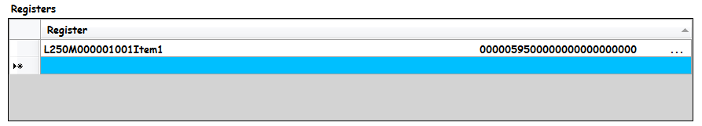

The setting of the communication windows is like ItemsSend2 and after the process ends the Result grid is updated.

EXPORT

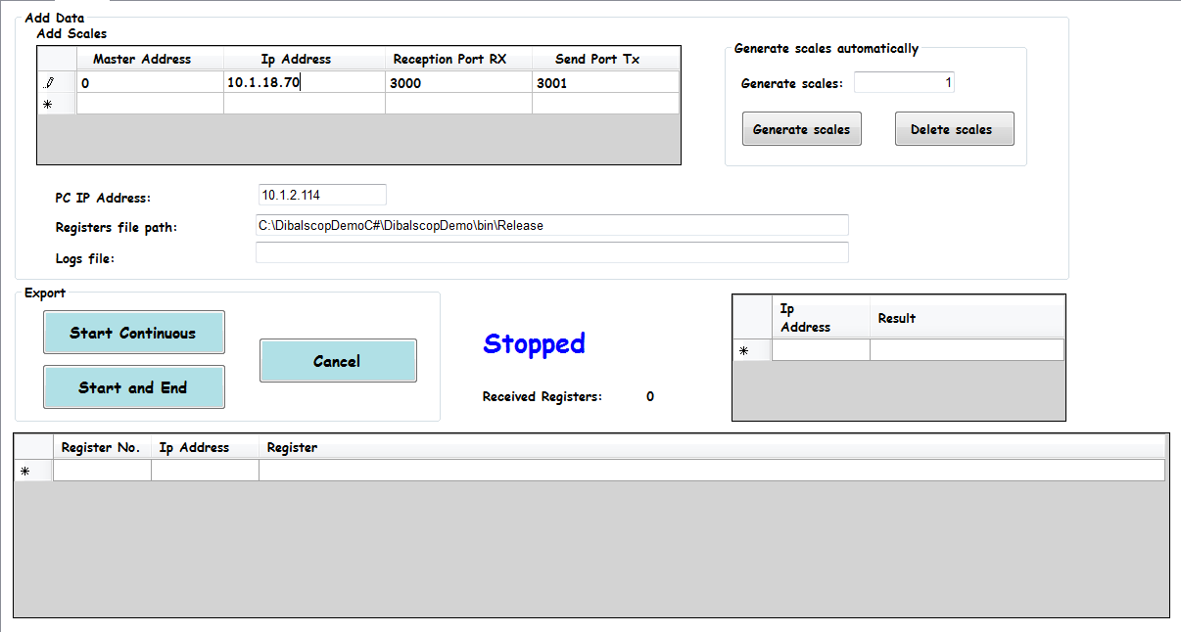

This tab is used to receive information from the scale (e.g. sales).

In the scale grid we must set the info of the scale that we want to communicate with:

- Master Address: A number(0-99) to define the Master Address of the scale
- IP Address: IP address of the scale(IPv4)
- Reception Port RX: The reception port(RX) of the scale, The default value is 3000.
- Send Port TX: The transmission port(TX) of the scale, The default value is 3001.

In addition there are other fields that must be filled as well:

- PC IP Address: The IP address of the PC where the application is running. This is because there can be more than one interface network available on the PC.
- Registers file path: The folder where the application will create the files which contain the received registers.
- Logs File: The path and the name of the logs file. This field is optional.

There are three buttons available in the menu:

- Start continuous: The process starts to receive information from the scale and it continues doing it until cancel button is pressed.
- Start and End: The process starts to receive information and ends when there is nothing left to read.
- Cancel: In order to stop the process of receiving.

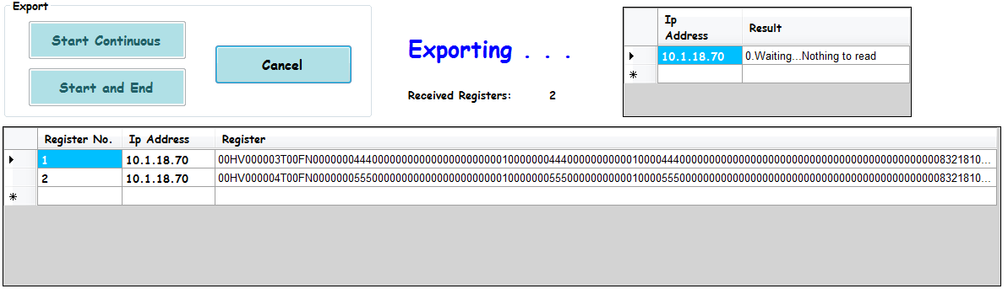

IMAGES

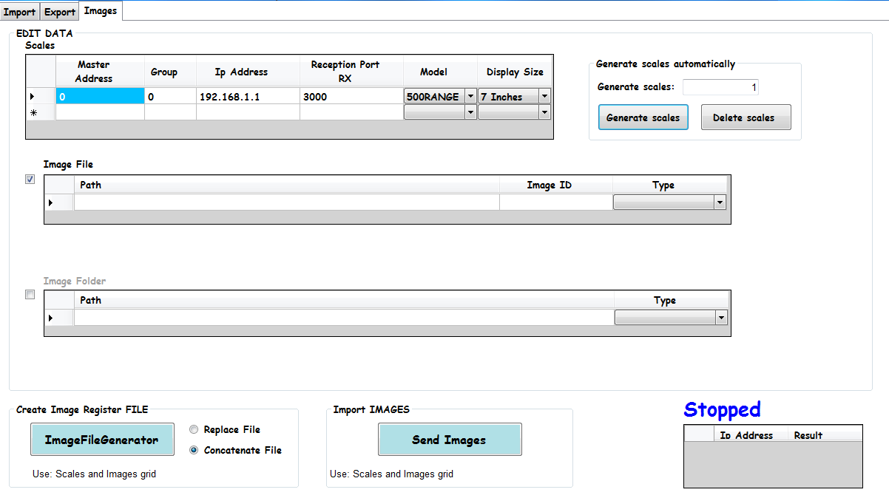

In the tab of images is the possibility of converting and sending images or converting and storing registers into a file.

In that fashion two operations are available in this tab:

- ImageFileGenerator: It converts an image obtained in the Image File grid into a registers. Those registers are stored in a file. The file name and its location will be defined by the user through a dialog window.
- Send Images: This functionality converts the image obtained in the grid of images or the group of images located in the folder set in Image Folder grid. The converted registers are sent to the scales which are defined in scales’ grid.

The scales’ grid contains the following fields or parameters:

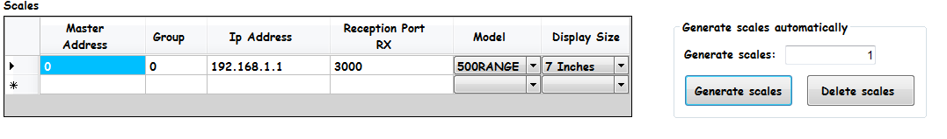

- Master Address: A number(0-99) to define the Master Address of the scale
- Group: A number (0-99) to define the group of the scale
- IP Address: IP address of the scale(IPv4)
- Reception Port RX: The reception port(RX) of the scale, The default value is 3000.
- Model: A combo-box to define the model of the scale. Two possibilites: “500RANGE” or “LSERIES”
- Display size: it permits to define the size of the display, 7 inches, 12 inches or 15 inches.

ImageFileGenerator

It converts an image obtained in the Image File grid into a registers. Those registers are stored in a file.

The file name and its location will be defined by the user through a dialog window.

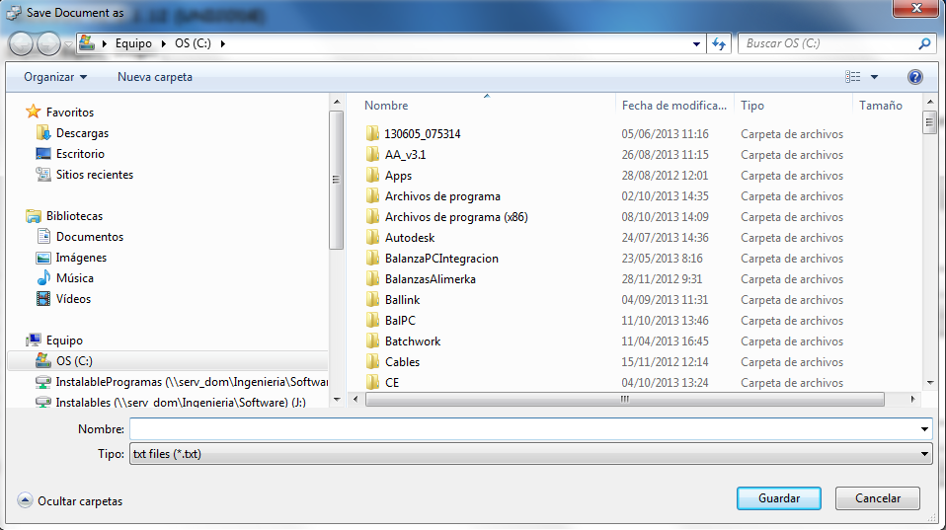

If Image Folder is checked this button will be disabled.

There is the possibility of selecting two different modes to write into the file:

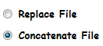

- Replace File: If the file exists the data contained is erased and it starts to write at the beginning of the file. If the file does not exist it is created.
- Concatenate File: If the file exits the new data is appended at the end of the file maintaining the previous data. If the file does not exist it is created.

Send Images

The program gives the opportunity of sending one image or a group of images located in a folder.

If we want to send a single image we should check Image File and fill its fields:

- Path: The full path of the image to import including its name.
- Image ID: The index or code of the image. (1-200 for Publicity images, 1-999999 for Article images)
- Type: Type of the image

  - Publicity: The image is a publicity Image.
  - Article/Order: The image is an item image and it is not assigned to any article automatically.
  - Article/PLU: The image is an item image and it is assigned to an item whose code matches with Image ID. (e.g. If the Image ID was 1 the image would be assigned to the item 1(code). If the item does not exist it is created.

If we want to send a group of images we should check Image Folder its fields. If we choose this option only “Send Images” operation can be used. The fields of the Image Folder grid are the following:

- Path: The full path of the folder where the images are located. It is possible to apply a filter like this:

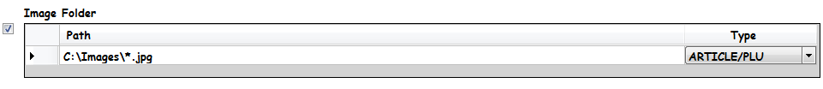

In this example only .jpg files are picked.

- Type: Type of the image

  - Publicity: The image is a publicity Image.
  - Article/Order: The image is an item image and it is not assigned to any article automatically.
  - Article/PLU: The image is an item image and it is assigned to an item whose code matches with Image ID. (e.g. If the Image ID was 1 the image would be assigned to the item 1(code). If the item does not exist it is created.

For using this option it is necessary the files to follow a certain format. The name of the file must be a numeric value and it must contain an extension. An example:

“1.bmp” -> Image ID is 1 and its extension is bmp.

Once all the data is set correctly we can call “Send Images” button to start the process. Depending of the result the image is moved to a different subfolder:

- Image_Processed: The image has been processed and sent successfully.
- Image_ErrorCom_A.B.C.D: The image has been processed successfully but the image can not be sent to the scale whose IP address is A.B.C.D.
- Image_FormatError: The format of the name is not valid, the format of the image is not supported or it is not an image file.

When the process ends the result grid is updated with the result like the rest of tabs.

It is recommendable to read DibalImage manual to obtain further information.

