Nome: _________________________________________
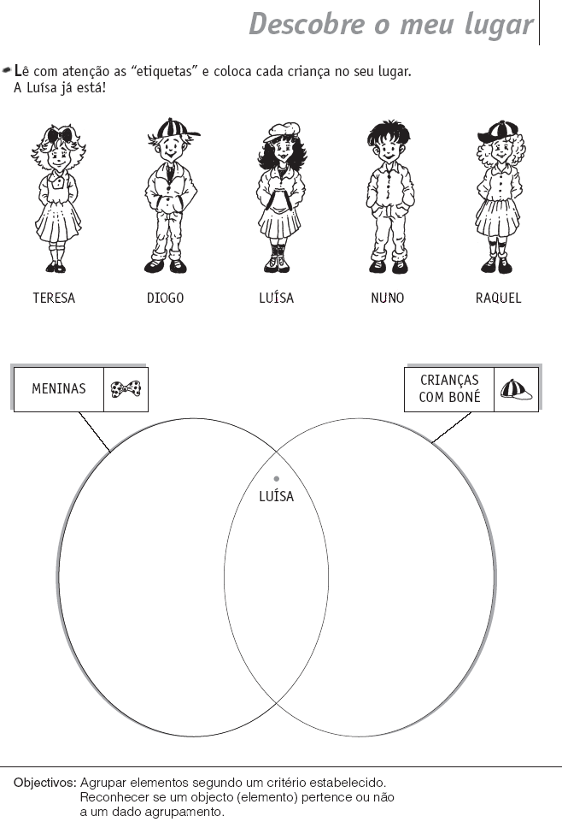
Data: _________________________________________

